WORKSHEET **– 2.2**

**STUDENT’S NAME –** HIMANSHU

**STUDENT’S UID –** 20BCS7944

**CLASS –** 20BCS802

**Section –**  A

**SUBJECT NAME –** PROGRAMMING IN PYTHON LAB

SUBJECT CODE – 20CSP – 259

SEMESTER – 04

**BRANCH –** CSE

**DATE OF PERFORMANCE –** March 27, 2021

**Aim:**

To study strings and its all related function.

**Task to be done:**

1. Write a Python program to get a list, sorted in increasing order by the last element in each tuple from a given list of non-empty tuples.
2. Write a Python program to print a specified list after removing the 0th, 4th and 5th elements, Sample List : ['Red', 'Green', 'White', 'Black', 'Pink', 'Yellow'],Expected Output : ['Green', 'White', 'Black'].

Program code:

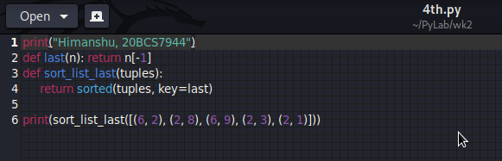

OUTPUT:

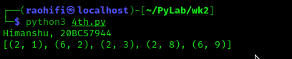

Program code:

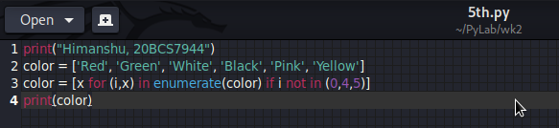

OUTPUT:

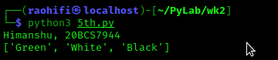

Observation:

* There is no error encounter during execution of program.

**Learning outcomes (what I had learnt):**

1. Learn how the tuples works in python.
2. Tuples are immutable.

**Evaluation Grid (To be created as per the SOP and Assessment guidelines by the faculty):**

|  |  |  |  |
| --- | --- | --- | --- |
| Sr. No. | Parameters | Marks Obtained | Maximum Marks |
| 1. |  |  |  |
| 2. |  |  |  |
| 3. |  |  |  |
|  |  |  |  |