WORKSHEET **– 2.3**

**STUDENT’S NAME –** HIMANSHU

**STUDENT’S UID –** 20BCS7944

**CLASS –** PH20BCS804

**Section –**  A

**SUBJECT NAME –** PROGRAMMING IN PYTHON LAB

SUBJECT CODE – 20CSP – 259

SEMESTER – 04

**BRANCH –** CSE

**DATE OF PERFORMANCE –** March 27, 2021

**Aim:**

To study strings and its all related function.

**Task to be done:**

1. Write a Write a Python program to combine two dictionary adding values for common keys.d1 = {'a': 100, 'b': 200, 'c':300},d2 = {'a': 300, 'b': 200, 'd':400}.
2. Write a Python program to find the highest 3 values of corresponding keys in a dictionary.

Program code:

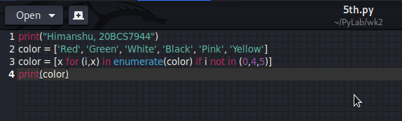

OUTPUT:

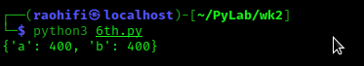

Program code:

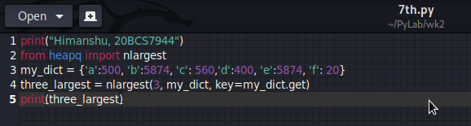

OUTPUT:

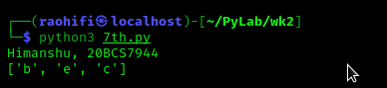

Observation:

* There is no error encounter during execution of program.

**Learning outcomes (what I had learnt):**

1. Learn how the dictionaries works in python.

**Evaluation Grid (To be created as per the SOP and Assessment guidelines by the faculty):**

|  |  |  |  |
| --- | --- | --- | --- |
| Sr. No. | Parameters | Marks Obtained | Maximum Marks |
| 1. |  |  |  |
| 2. |  |  |  |
| 3. |  |  |  |
|  |  |  |  |