WORKSHEET **– 2.4**

**STUDENT’S NAME –** HIMANSHU

**STUDENT’S UID –** 20BCS7944

**CLASS –** PH20BCS804

**Section –**  A

**SUBJECT NAME –** PROGRAMMING IN PYTHON LAB

SUBJECT CODE – 20CSP – 259

SEMESTER – 04

**BRANCH –** CSE

**DATE OF PERFORMANCE –** April 05, 2021

**Aim:**

To study strings and its all related function.

**Task to be done:**

1. Write a Python program to replace last value of tuples in a list.
2. Write a Python program to remove an empty tuple(s) from a list of tuples.
3. Write a Python program calculate the product, multiplying all the numbers of a given tuple.
4. Write a Python program to convert a tuple of string values to a tuple of integer values.
5. Write a Python program to check if a specified element presents in a tuple of tuples.

Program code:

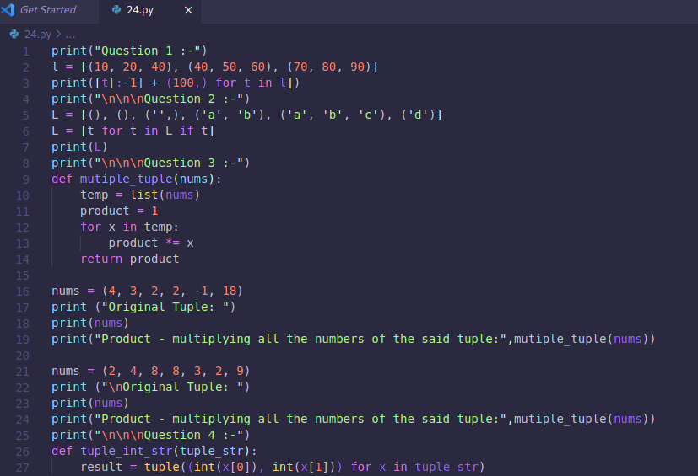

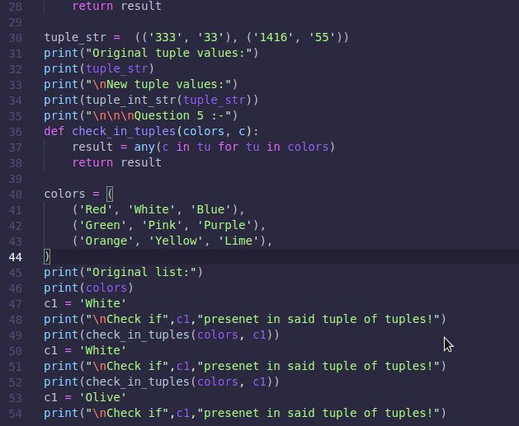

OUTPUT:

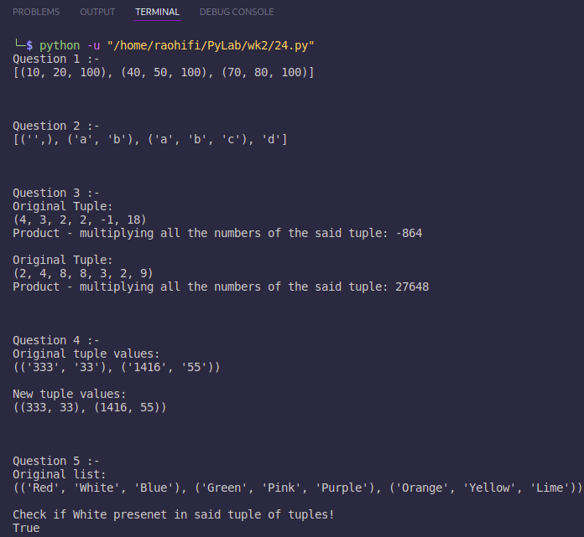

Observation:

* There is no error encounter during execution of program.

**Learning outcomes (what I had learnt):**

1. Learn how the tuple works in python.
2. Different function related to tuples.

**Evaluation Grid (To be created as per the SOP and Assessment guidelines by the faculty):**

|  |  |  |  |
| --- | --- | --- | --- |
| Sr. No. | Parameters | Marks Obtained | Maximum Marks |
| 1. |  |  |  |
| 2. |  |  |  |
| 3. |  |  |  |
|  |  |  |  |