LAB MST

**STUDENT’S NAME –** HIMANSHU

**STUDENT’S UID –** 20BCS7944

**CLASS –** 20BCS802

**Section –**  A

**SUBJECT NAME –** PROGRAMMING IN PYTHON LAB

SUBJECT CODE – 20CSP – 259

SEMESTER – 04

**BRANCH –** CSE

**DATE OF PERFORMANCE –** March 22, 2021

**Task to be done:**

1. Write a program to create a class having student records.

Program code:

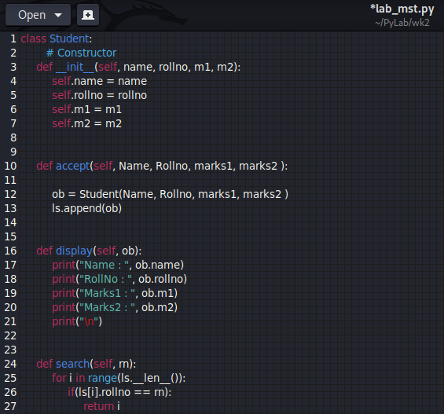

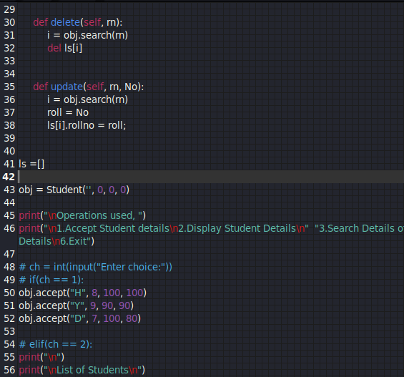

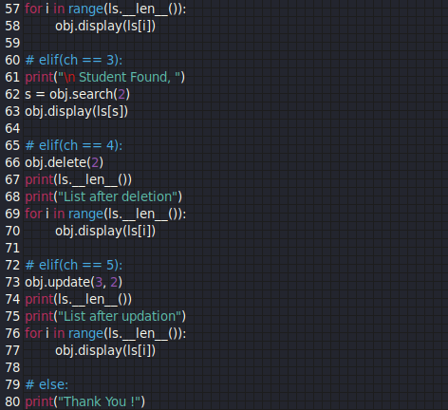

OUTPUT:

