
COMPUTER SCIENCE & ENGINEERING

Experiment1.1

Student Name: Himanshu UID:20BCS7944 Branch: CSE Section/Group:905/A
Semester:6th Date of Performance:08/02/2023 Subject Name:Competitive Coding-II Subject Code:20CSP-351

Aim:
  - To implement the concept of arrays, queues , stacks and Linked-list.

Objective:
  - The objective is to build problem solving capability and to learn the basic concepts of data structures.
  - The implementation of Jump Game-II which shows and brushes up the concept of arrays.
  - The implementation of removing the duplicacy in the linked-list.

Leetcode code and output:

- JUMP GAME-II

Code-

class Solution{
public int jump(int[] num){
if(num == null || num.length == 0){
return 0;
}
int len = num.length, maxPosition = 0, end = 0, step = 0;
for(int i = 0; i < len - 1; i++){
maxPosition = Math.max(maxPosition, i + num[i]);
if(i == end){
end = maxPosition;
step++;
}
}
return step;
}
}

COMPUTER SCIENCE & ENGINEERING

OUTPUT-

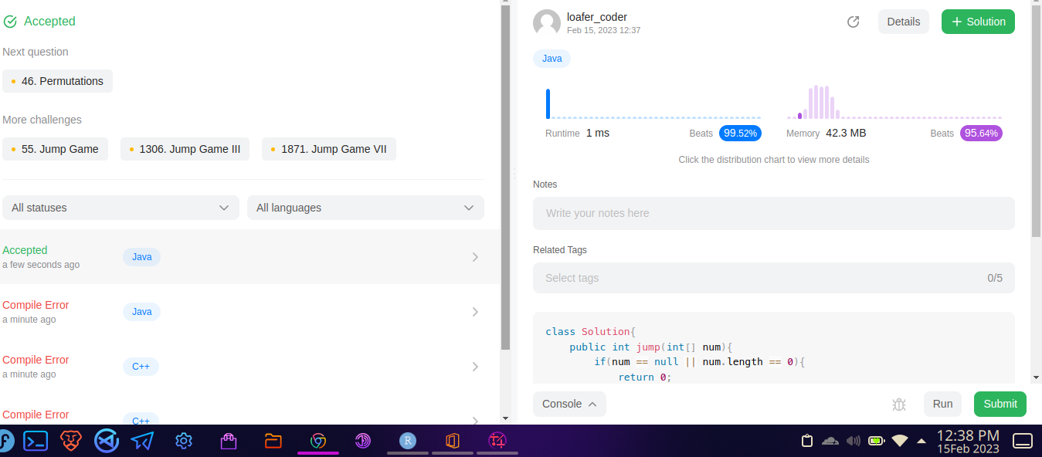

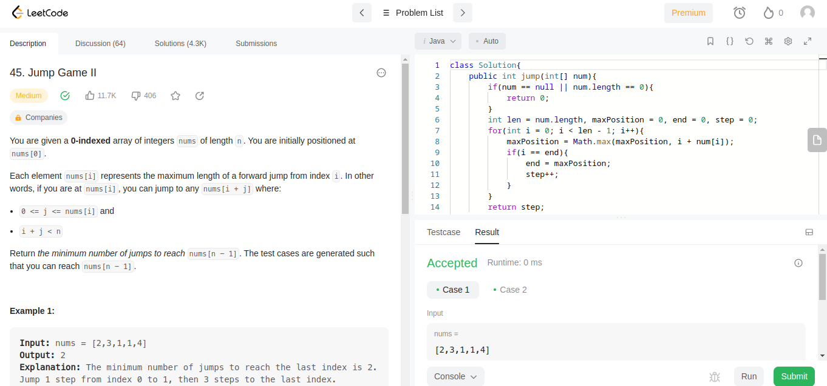

COMPUTER SCIENCE & ENGINEERING

- REMOVING THE DUPLICATE ELEMENTS IN THE LINKED-LIST

CODE-
class Solution {
public ListNode deleteDuplicates(ListNode head) {
HashSet<Integer> set=new HashSet<Integer>();
while(head!=null){
set.add(head.val);
head=head.next; }
List<Integer> list=new ArrayList<Integer>(set);
Collections.sort(list);
ListNode dummy=new ListNode();
ListNode temp=dummy;
for(int i=0;i<list.size();i++){
ListNode Head=new ListNode(list.get(i));
dummy.next=Head;
dummy=dummy.next; }
return temp.next;
}



