
COMPUTER SCIENCE & ENGINEERING

Experiment1.2

Student Name: Himanshu UID: 20BCS7944 Branch: BE-CSE Section/Group: 905/A
Semester: 6th Date of Performance: 15/02/2023 Subject Name: Competitive Coding-II Subject Code: 20CSP-351

Aim:
To implement the concept of string manipulation.

Objective:
- The objective is to build problem solving capability and to learn the basic concepts of data structures.
- The implementation of rotate string which shows and brushes up the concept of strings and can be solved through various approaches.
- The implementation of repeated string matching in which the concept of npos was introduced.

LeetCode code and output:

- ROTATE STRING

class Solution {
public:
bool rotateString(string s, string goal)
{
if (s.size()!=goal.size()) return false;
string str=s+s;
return str.find(goal)!=string::npos;
}
};

COMPUTER SCIENCE & ENGINEERING

OUTPUT:

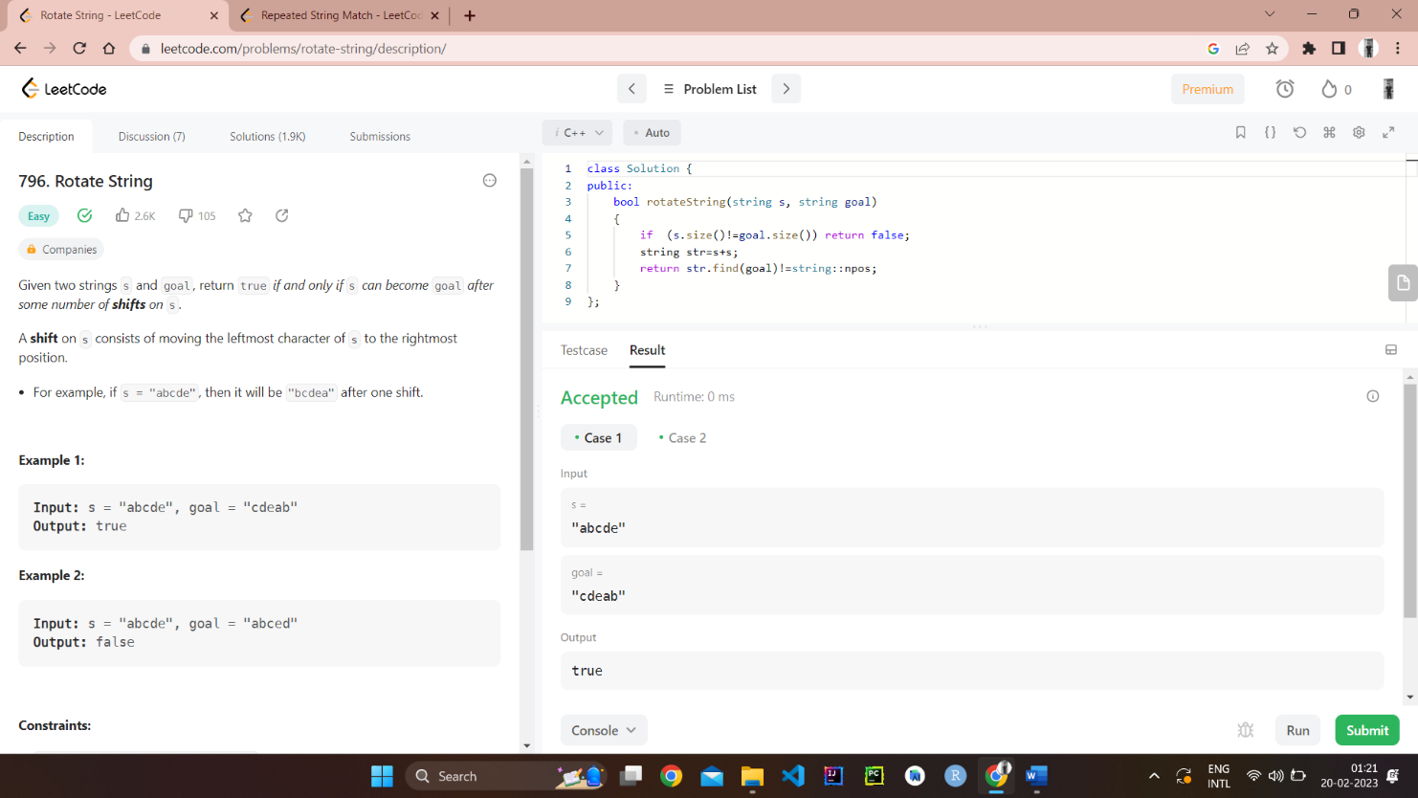

- REPEATED STRING MATCHING

class Solution {
public:
int repeatedStringMatch(string a, string b) {
string ans=a;
while (a.length()<b.length())
{
a+=ans;
}
if (a.find(b)!=string::npos) return a.length()/ans.length();
a+=ans;
if (a.find(b)!=string::npos) return a.length()/ans.length();
a+=ans;
if (a.find(b)!=string::npos) return a.length()/ans.length();
return -1;
}
};
COMPUTER SCIENCE & ENGINEERING

OUTPUT:

