
COMPUTER SCIENCE & ENGINEERING

Experiment1.3

Student Name: Himanshu UID: 20BCS7944 Branch: BE-CSE Section/Group: 905/A
Semester: 6th Date of Performance: 22/02/2023 Subject Name: Competitive Coding-II Subject Code: 20CSP-351

Aim:
To implement the concept of string heap model.

Objective:
- The objective is to build problem solving capability and to learn the basic concepts of data structures.
- The implementation of last weight stone which shows and brushes up the concept of heap data structures.
- The implementation of cheapest flight within k-stops + in which the concept of kmp was introduced.

LeetCode code and output:

- LAST STONE WEIGHT-

class Solution {
public:
int lastStoneWeight(vector<int>& stones) {
priority_queue<int> pq(stones.begin(),stones.end());
while(pq.size()!=1){
int a = pq.top();
pq.pop();
int b = pq.top();
pq.pop();
pq.push(a-b);
}
return pq.top();
}
};

COMPUTER SCIENCE & ENGINEERING

OUTPUT:

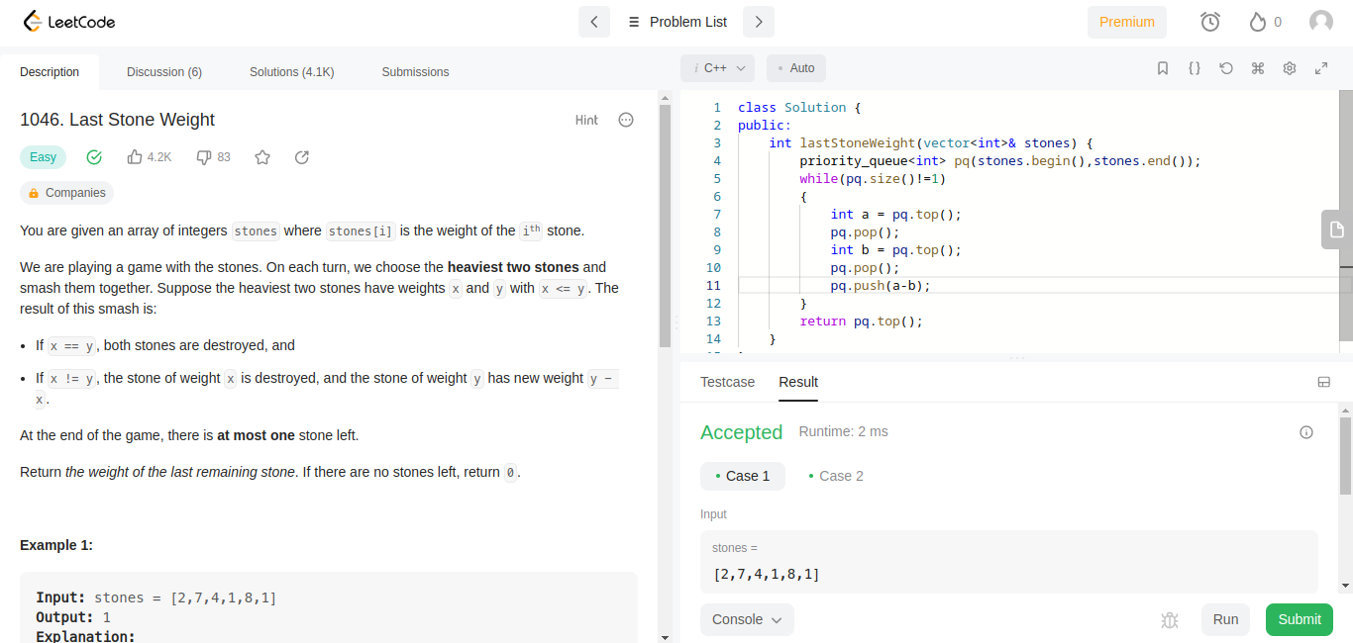

- CHEAPEST FLIGT WITHIN K-STOPS

class Solution {
const int inf = 1e8;
int dp[101][101];

public:
int dfs(int node, int k, int dest, vector<vector<int>> &cost, vector<int> adj[])
{
if (k < 0)
return inf;

if (node == dest)
return 0;

if (dp[node][k] != -1)
return dp[node][k];

int ans = inf;
for (auto i : adj[node])
ans = min(ans, cost[node][i] + dfs(i, k - 1, dest, cost, adj));

COMPUTER SCIENCE & ENGINEERING

return dp[node][k] = ans;
}
int findCheapestPrice(int n, vector<vector<int>> &flights, int src, int dst, int k){
memset(dp, -1, sizeof dp);

vector<vector<int>> cost(n, vector<int>(n));
vector<int> adj[n];
for (auto e : flights){
adj[e[0]].push_back(e[1]);
cost[e[0]][e[1]] = e[2];
}

int ans = dfs(src, k + 1, dst, cost, adj);
return ans == inf ? -1 : ans; }
};

OUTPUT:

