
COMPUTER SCIENCE & ENGINEERING

Experiment1.4

Student Name: Himanshu UID: 20BCS7944 Branch: BE-CSE Section/Group: 905/A
Semester: 6th Date of Performance: 22/03/2023 Subject Name: Competitive Coding-II Subject Code: 20CSP-351

Aim:
To demonstrate the concept of hashing problem.

Objective:
- The objective is to build problem solving capability and to learn the basic concepts of data structures.
- The implementation of missing numbers which shows and brushes up the concept of map and hashing.
- The implementation of longest substring without repeating in which the concept of hashing was introduced.

LeetCode code and output:

- Longest substring withour repeating characters -

class Solution {
public:
int lengthOfLongestSubstring(string s) {
if(s.length()==0)return 0;
unordered_map<char,int> m;

int i=0,j=0,ans=INT_MIN;
while(j<s.length()){
m[s[j]]++;

if(m.size()==j-i+1){
ans = max(ans,j-i+1);
}

else if(m.size()<j-i+1){
while(m.size()<j-i+1){
m[s[i]]--;
if(m[s[i]]==0){
m.erase(s[i

COMPUTER SCIENCE & ENGINEERING

if(m[s[i]]==0){
m.erase(s[i])
i++;
}
j++;
}
return ans;

};

OUTPUT:

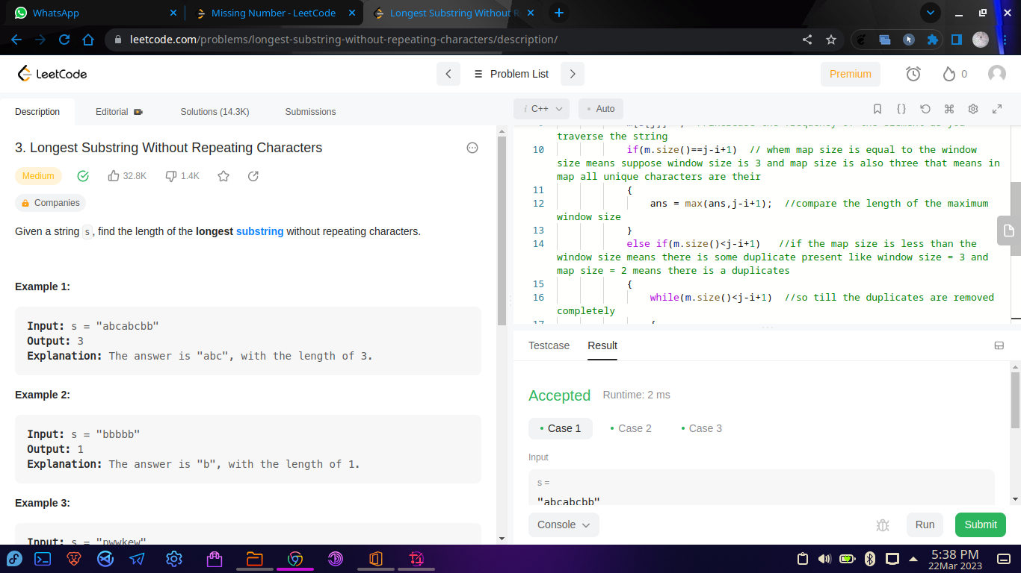

COMPUTER SCIENCE & ENGINEERING

- Missing numbers -

class Solution {
public:
int missingNumber(vector<int>& nums) {
int n = nums.size();
vector<bool> check(n, false);
for(int i=0;i<nums.size();i++){
check[nums[i]] = true;
}
for(int i = 0; i < n ; i++){
if(! check[i]) return i;
}
return n;
}
};

OUTPUT:

