
COMPUTER SCIENCE & ENGINEERING

Experiment-2.1

Student Name: Himanshu UID: 20BCS7944 Branch: BE-CSE Section/Group: 905/A
Semester: 6th Date of Performance: 30/03/2023 Subject Name: Competitive Coding-II Subject Code: 20CSP-351

Aim:
To demonstrate the concept of Tree.

Objective:
- The objective is to build problem solving capability and to learn the basic concepts of Tree data structures.
- The implementation of Path Sum which shows and brushes up the concept of Tree.
- The implementation of Same Tree.

LeetCode code and output:

- Path Sum -

class Solution {
public boolean hasPathSum(TreeNode root, int sum) {
return root == null ? false : DFS(root, 0, sum);
}
public boolean DFS(TreeNode node, int tmp, int sum){
boolean flag = false;
tmp += node.val;
if(node.left == null && node.right == null){
return tmp == sum;
}
if(node.left != null){
flag = flag || DFS(node.left, tmp, sum);
}
if(!flag && node.right != null){
flag = flag || DFS(node.right, tmp, sum);
}
return flag;
}
}

COMPUTER SCIENCE & ENGINEERING

OUTPUT:

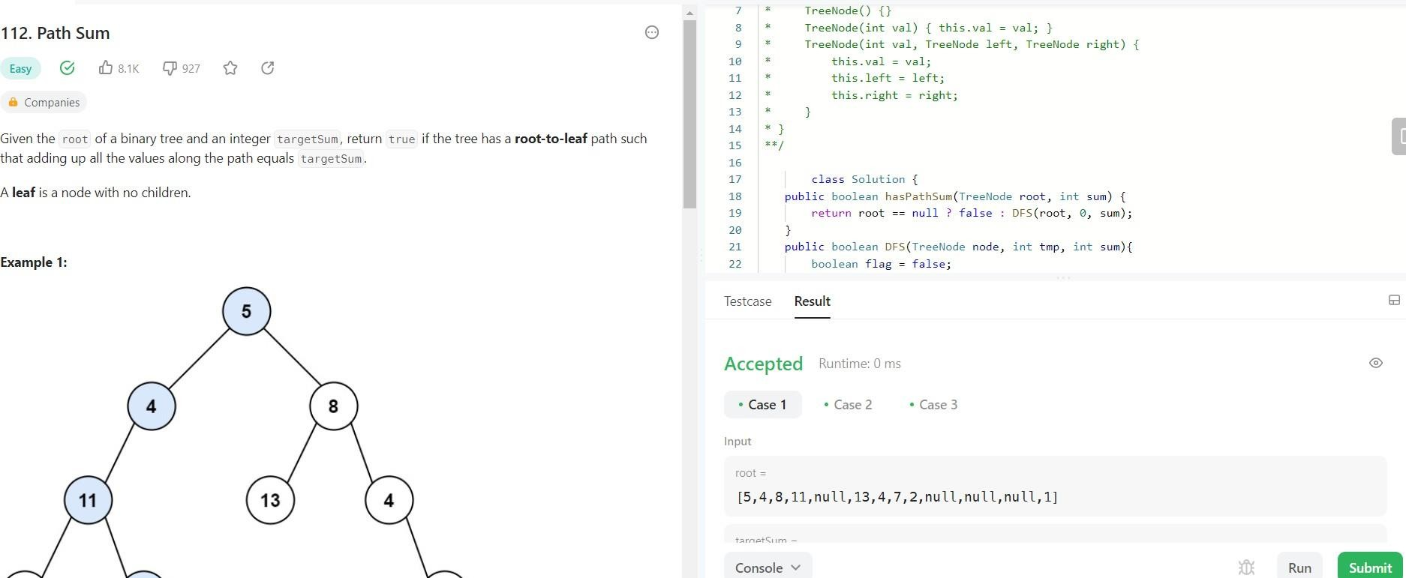

- Same Tree -
class Solution {
public boolean isSameTree(TreeNode p, TreeNode q) {
if(p==null || q==null)
return (p==q);
return (p.val==q.val) && isSameTree(p.left,q.left) && isSameTree(p.right,q.right);
}
}

COMPUTER SCIENCE & ENGINEERING

OUTPUT:

