Experiment-2.3

Student Name: Himanshu UID: 20BCS7944
Branch: CSE Section: 905/A
Semester: 6 Date of Performance: 30/03/2023
Subject Name: Competitive Coding-II Subject Code: 20CSP-351

Aim:
To demonstrate the concept of Divide and Conqueror algorithm.

Objective:
- The objective is to build problem solving capability and to learn the basic concepts of divide and conqueror algorithm.
- The implementation of Median of two sorted arrays which shows and brushes up the concept of Tree.
- The implementation of Maximum subarray.

LeetCode code and output:

- Median of two sorted arrays -

class Solution {
public boolean hasPathSum(TreeNode root, int sum) {
return root == null ? false : DFS(root, 0, sum);
}
public boolean DFS(TreeNode node, int tmp, int sum){
boolean flag = false;
tmp += node.val;
if(node.left == null && node.right == null){
return tmp == sum;
}
if(node.left != null){
flag = flag || DFS(node.left, tmp, sum);
}
if(!flag && node.right != null){
flag = flag || DFS(node.right, tmp, sum);
}
return flag;
}}

OUTPUT:

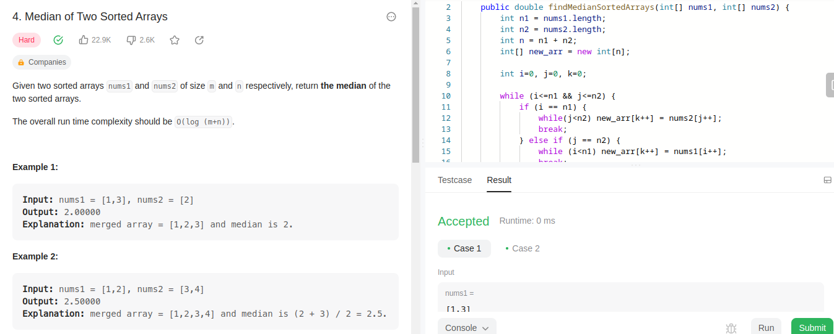

- Median of two sorted arrays -

class Solution {
public int maxSubArray(int[] nums) {
int sum = 0 , maxi = Integer.MIN_VALUE;
int (i = 0 , j = 0;while(j<nums.length){
if(sum < 0 && nums[j] >= sum){
sum = 0;
i = j;
}
sum += nums[j];
maxi = Math.max(maxi , sum);
j++;
}
return maxi;
}}

OUTPUT:

