# Assignment 2: Loops

due: Sep 9, 11:45am

**1) Task:**

To develop a Python script that computes the factorial of a non-negative integer number through two approaches: (1) a *while* loop, and (2) a *for* loop.

**2) Program functionality:**

a) User input

The user of the program is asked to provide a number between 1 and 20. If the user input is not an integer number or the integer number is not between 1 and 20 a message will be shown which asks the user to input a correct number. This input process is repeated until a correct number is provided by the user.

b) Computation

Once the user input is correct, the program uses a while loop and a for loop to compute the factorial (!) of n.

c) Output: The results of both loops are printed as a string.

Below (Figure 1) is a sample sequence of incorrect and correct user inputs and corresponding program responses when running the code in PyCharm. To verify the correct functionality of your program, check whether your program replicates these responses based on the input values.

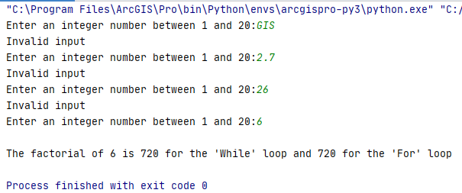

Figure 1: Interaction with program

**3) Implementation details:**

1) Create a user-defined function called *stringCheck* that tests whether the user input (a string) can be converted to an integer number between 1 and 20. This method needs to be called once (before any subsequent computations).

Use the [*isdigit()*](https://www.programiz.com/python-programming/methods/string/isdigit) method to check if all the characters in the text are digits. If that’s the case, use the [*int()*](https://careerkarma.com/blog/python-string-to-int/) function to convert the input to an integer number. You can find many online examples that demonstrate the functionality of these two methods.

If the user input is a number between 1 and 20, the the *stringCheck* method should return this integer number. If the input does not satisfy the criteria (e.g., if it is a float number), the return value should be -1, and a message regarding invalid input should be printed.

2) Input loop

The request for a user input together with the *stringCheck* function should be embedded in a while loop that repeats until the user provides a correct input value (i.e. until the result of the *stringCheck* function is different from -1).

3) Computation loops.

Use the returned value from the *stringCheck* function (n) to compute the factorial (!) of n. The factorial is a product of all positive integers less than or equal to n. For example, the factorial of 5 is computed as

5! = 5 x 4 x 3 x 2 x 1 = 120

Create a *for* and *while* loop that compute the factorial. In each loop it is best to initialize the factorial as n, then multiply this by (n-1), then again by (n-2), etc. until 1 is reached. The product is then the factorial.

All this can be achieved in around 30 lines of Python code.

Here is the suggested structure of your program:

def stringCheck(s)...:  
 ... # check for correct input  
 ...   
 print(**"Invalid input"**)  
 return -1  
  
def whileLoop()...:  
 ...

while i>1:  
 ...   
 return fact  
  
def forLoop()...:  
 ...  
 return fact  
  
# main program starts here

n=-1  
while n == -1:  
 ...# check user input here

... # call while-loop function

... # call for-loop function

... # print result of while and for loops

4) Testing the program:

a) Run your program in PyCharm

b) Use $, -5, 25, and 7 as four sequential input values

c) Take a screen capture of the console window (should look similar to Figure 1) and paste it

< HERE >

4) Hand in:

A zip file containing:

1) This MS Word document with the inserted screen capture.

2) A Python script file with your code.

Good luck!

def stringCheck(s):

return s.isnumeric() and 1 <= int(s) <= 20

# This part is just for testing

print(stringCheck("")) # False

print(stringCheck("a")) # False

print(stringCheck("0")) # False

print(stringCheck("1")) # True

print(stringCheck("20")) # True