Memory manager strategy – JSON Object

|  |  |  |  |  |  |
| --- | --- | --- | --- | --- | --- |
| **Identifier** | **Malloc cycles** | **Free cycles** | **Outside cycles** | **Total cycles** | **Average frag** |
| Th0 | 9196197 | 52735854 | 2925702301 | 2987634352 | 21.806% |
| FF0 | 8112905 | 60129749 | 1287226694 | 1355469348 | 19.613% |
| Occ0 | 8307874 | 43116161 | 1703423738 | 1754847773 | 16.796% |
| Th1 | 10887212 | 104773877 | 2675671769 | 2791332858 | 37.336% |
| FF1 | 9021202 | 127572876 | 1204814570 | 1341408648 | 19.613% |
| Occ1 | 8951780 | 70205471 | 1579621728 | 1658778979 | 16.796% |
| Th2 | 9189385 | 52410259 | 2925544045 | 2987143689 | 21.787% |
| FF2 | 5311264 | 36866790 | 1448131879 | 1490309933 | 17.859% |
| Occ2 | 9048344 | 35874563 | 1691508273 | 1736431180 | 16.668% |

Parameters:

Threshold[M][I] - Threshold for memory architecture M with index I

Threshold0 = 50   
Threshold1 = 50   
Threshold21 = 32   
Threshold22 = 64

Total heap size 384 KB

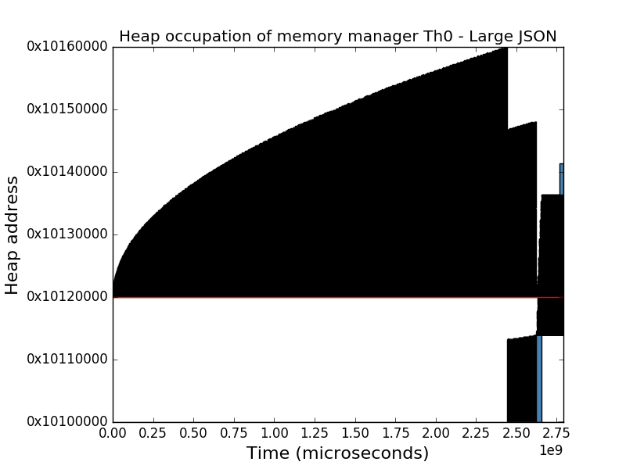Memory architecture 0

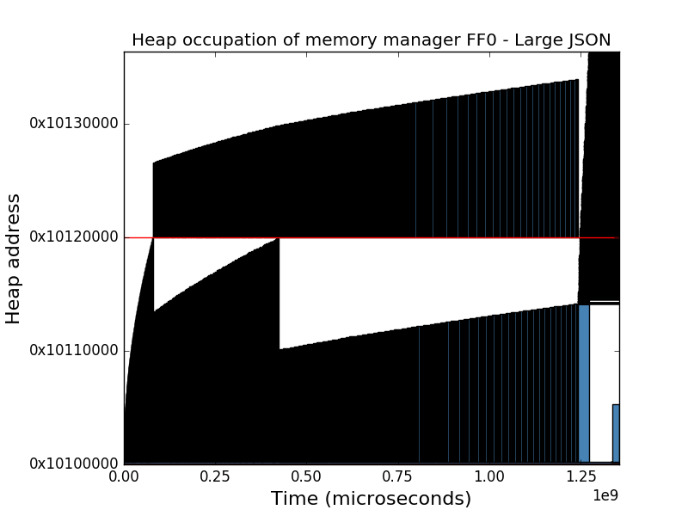

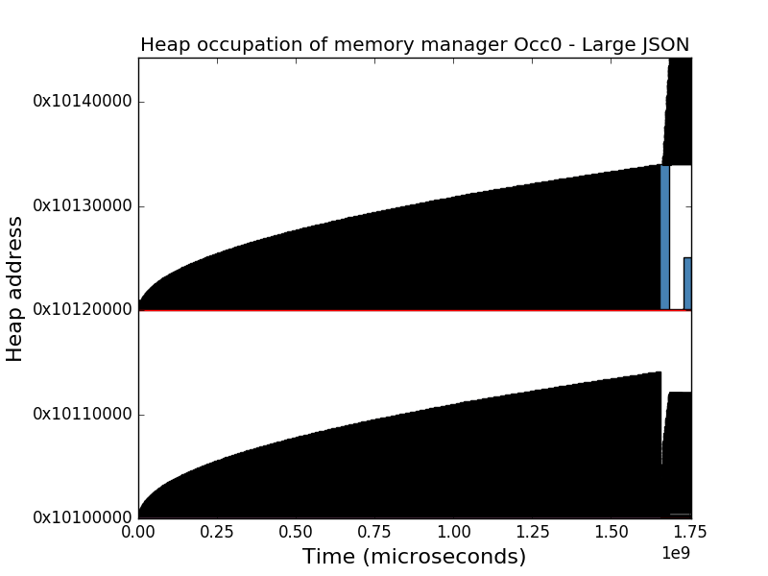

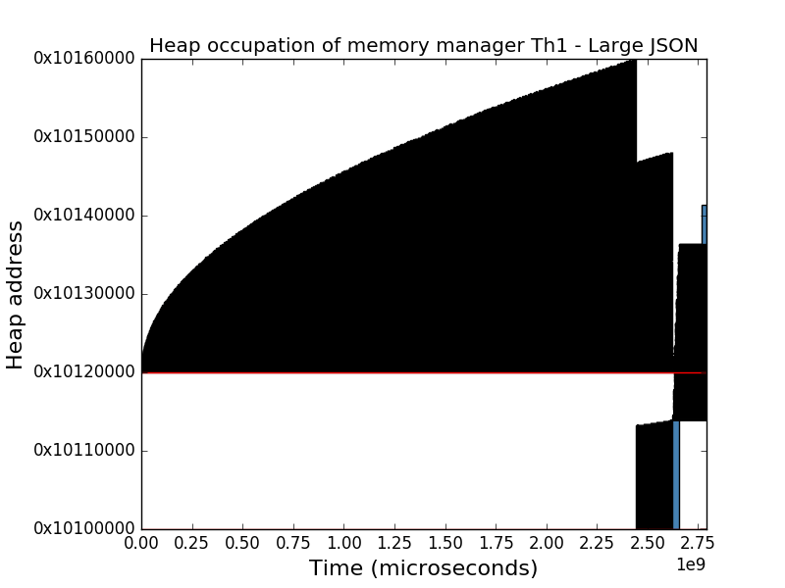Memory architecture 1

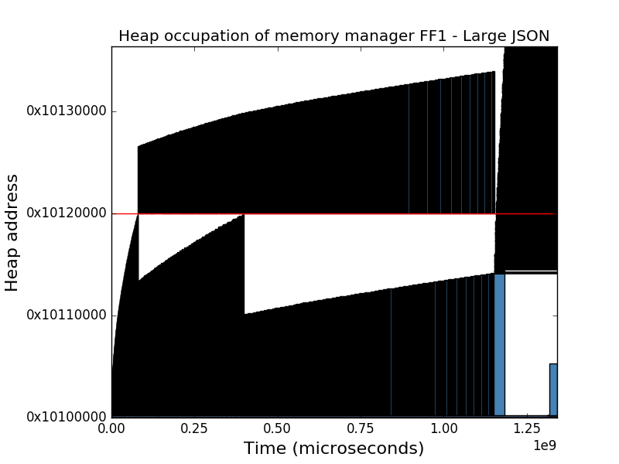

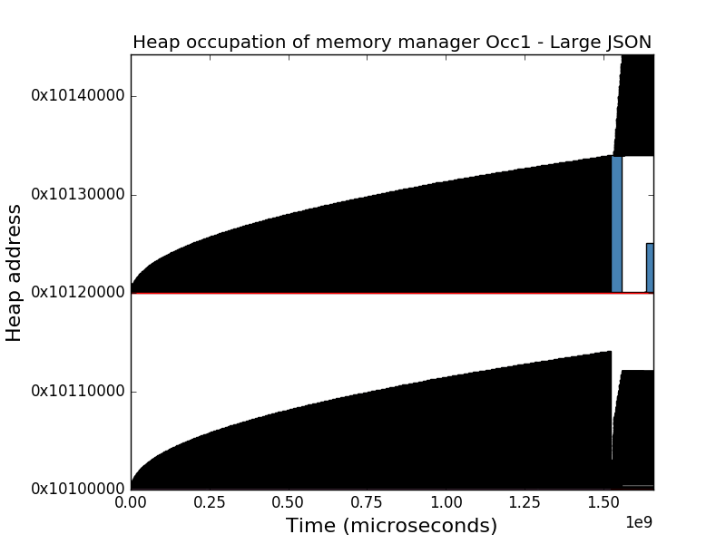

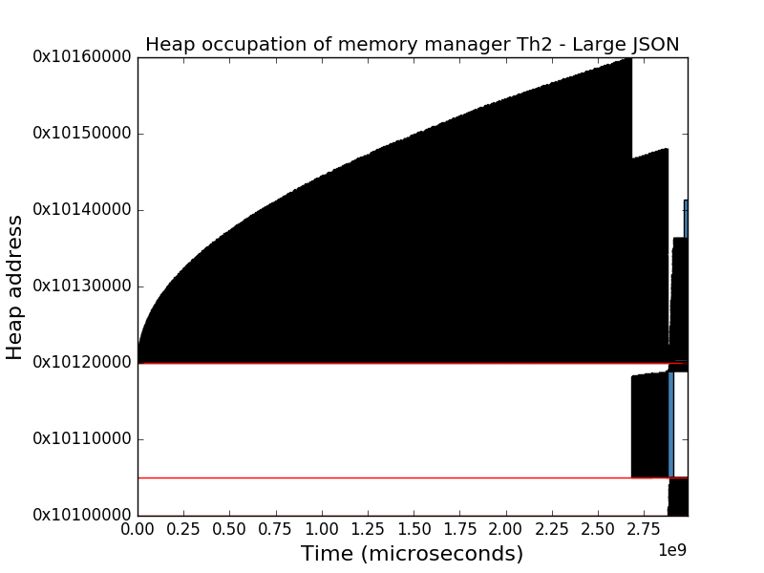Memory architecture 2

