Memory manager strategy – Small JSON Object

|  |  |  |  |  |  |
| --- | --- | --- | --- | --- | --- |
| **Identifier** | **Malloc cycles** | **Free cycles** | **Outside cycles** | **Total cycles** | **Average frag** |
| Th0 | 917478 | 1659297 | 67244789 | 69821564 | 46.618% |
| FF0 | 595446 | 1554747 | 12560276 | 14710469 | 40.26% |
| Occ0 | 1557323 | 2675800 | 41959091 | 46192214 | 13.572% |
| Th1 | 956360 | 1706240 | 62785070 | 65447670 | 46.618% |
| FF1 | 595376 | 1554781 | 12560212 | 14710369 | 40.26% |
| Occ1 | 1751767 | 4924879 | 40913034 | 47589680 | 13.572% |
| Th2 | 882047 | 1632024 | 67196606 | 69710677 | 46.618% |
| FF2 | 613410 | 1523364 | 9398786 | 11535560 | 16.888% |
| Occ2 | 1490574 | 1972295 | 38868513 | 42331382 | 13.129% |

Parameters:

Threshold[M][I] - Threshold for memory architecture M with index I

Threshold0 = 50   
Threshold1 = 50   
Threshold21 = 32   
Threshold22 = 64

Total heap size 384 KB

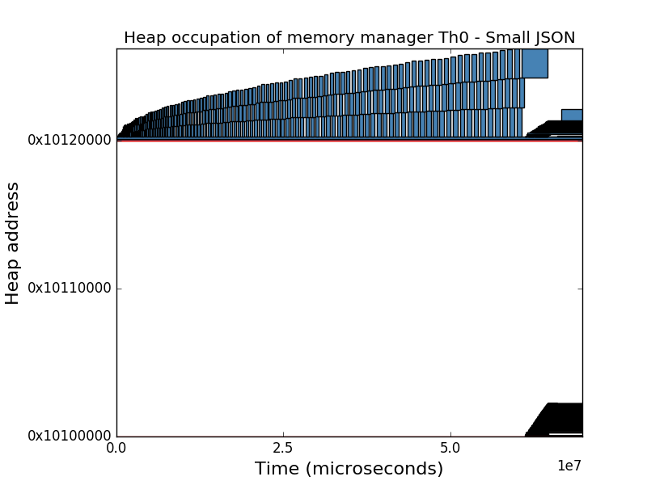Memory architecture 0

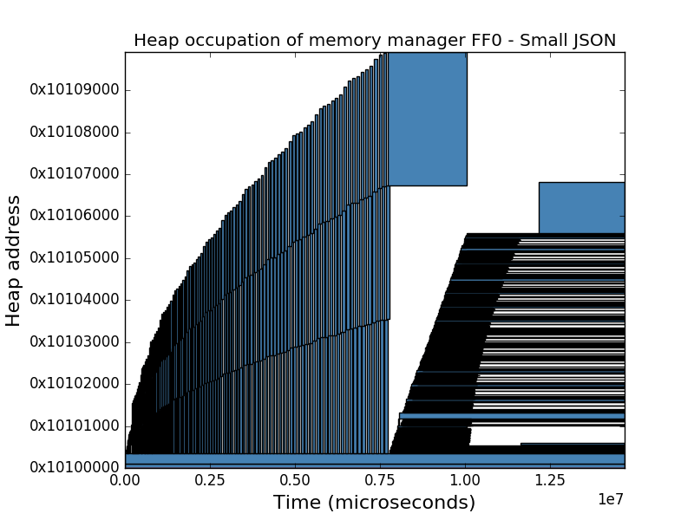

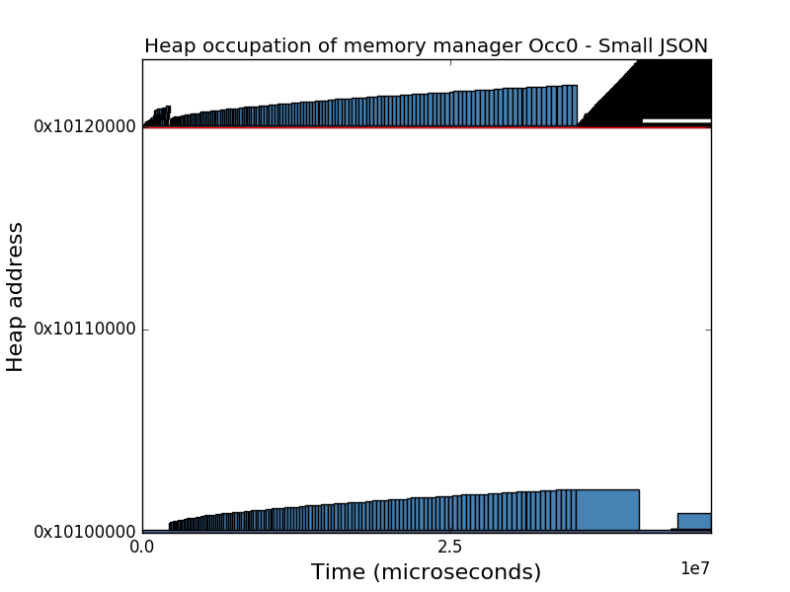

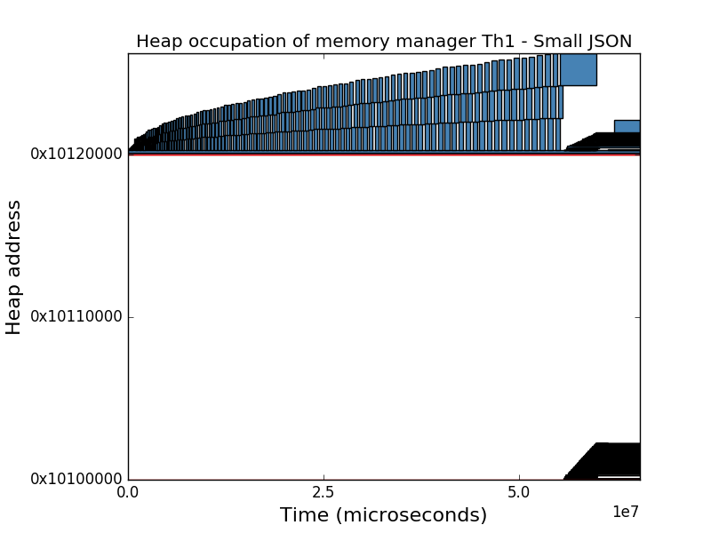Memory architecture 1

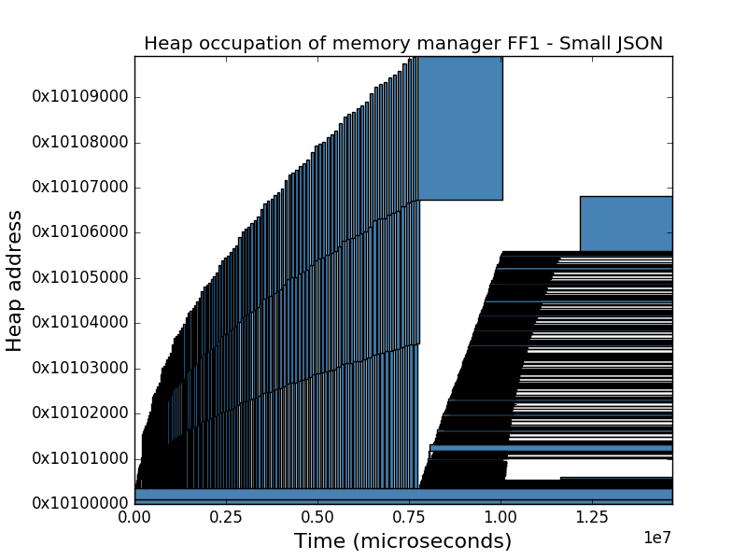

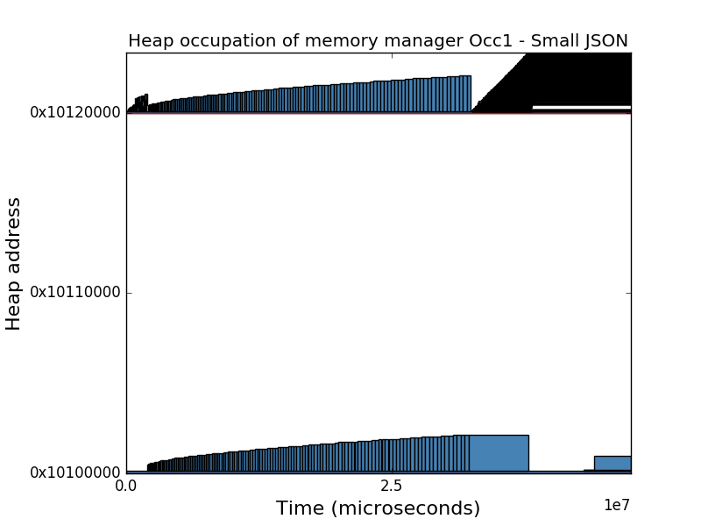

Memory architecture 2

