Results of Profiling

|  |  |  |  |  |  |  |
| --- | --- | --- | --- | --- | --- | --- |
| **Identifier** | **Malloc cycles** | **Free cycles** | **Outside cycles** | **Total cycles** | **Fragmentation at LMF** | **LMF** |
| **FL-Pl** | 2260472 | 1641896 | 3294064 | 7196432 | 27.649% | 5888 |
| **BMP-Pl** | 19964032 | 2609494 | 3294489 | 25868015 | 50.493% | 8120 |
| **B-Pl** | 7200209 | 2933358 | 3298701 | 13432268 | 40.436% | 7152 |
| **FL-Ra** | 17359953 | 12612828 | 3166199 | 33138980 | 17.164% | 119894 |
| **BMP-Ra** | 213226118 | 2346166 | 3164519 | 218736803 | 61.493% | 258586 |
| **B-Ra** | 34028366 | 2642408 | 3165352 | 39836126 | 61.492% | 258582 |
| **FL-Pe** | 2257091 | 19085922 | 3284664 | 24627677 | 65.373% | 111484 |
| **BMP-Pe** | 391214122 | 2606520 | 3282325 | 397102967 | 67.744% | 260577 |
| **B-Pe** | 36298554 | 2938646 | 3280224 | 42517424 | 67.743% | 260573 |
| **FL-Ap** | 476296 | 1506849 | 8972302 | 10955447 | 64.299% | 40598 |
| **BMP-Ap** | 61671154 | 1590591 | 8971744 | 72233489 | 96.652% | 235012 |
| **B-Ap** | 21112853 | 598198 | 8971868 | 30682919 | 96.716% | 239624 |

Identifier format: [data structure]-[access profile]  
LMF: Largest Memory footprint

Results of Memory Manager Strategies

|  |  |  |  |  |  |  |
| --- | --- | --- | --- | --- | --- | --- |
| **Identifier** | **Malloc cycles** | **Free cycles** | **Outside cycles** | **Total Cycles** | **frag at LMF** | **LMF** |
| **Th0** | 7128696 | 56217081 | 57626718 | 120972495 | 82.015% | 241550 |
| **FF0** | 7148216 | 59373510 | 48773748 | 115295474 | 59.812% | 238484 |
| **Occ0** | 6891723 | 42122169 | 59166620 | 108180512 | 81.778% | 238412 |
| **Th1** | 12243797 | 58409346 | 59579448 | 130232591 | 82.015% | 241550 |
| **FF1** | 8076860 | 126816324 | 56706990 | 191600174 | 59.812% | 238484 |
| **Occ1** | 7581377 | 69209245 | 63928516 | 140719138 | 81.778% | 238412 |
| **Th2** | 6541644 | 34112540 | 57431095 | 98085279 | 63.349% | 241058 |
| **FF2** | 7194603 | 58234704 | 48561622 | 113990929 | 58.169% | 238487 |
| **Occ2** | 7498708 | 34883744 | 59005738 | 101388190 | 81.763% | 238208 |

Identifier format: [Strategy][memory arhictecture]  
LMF: Largest Memory footprint

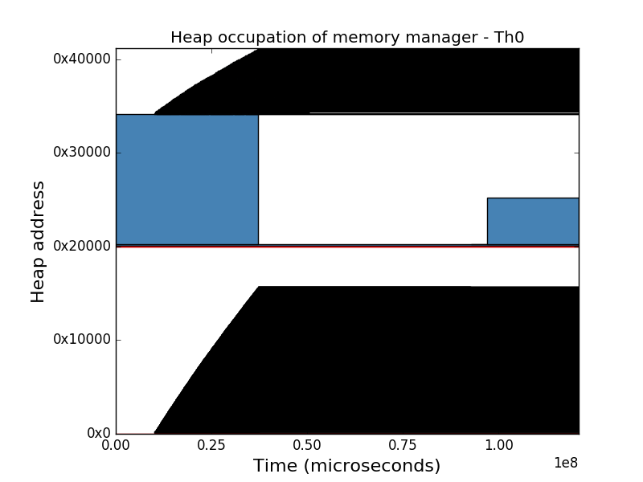Threshold

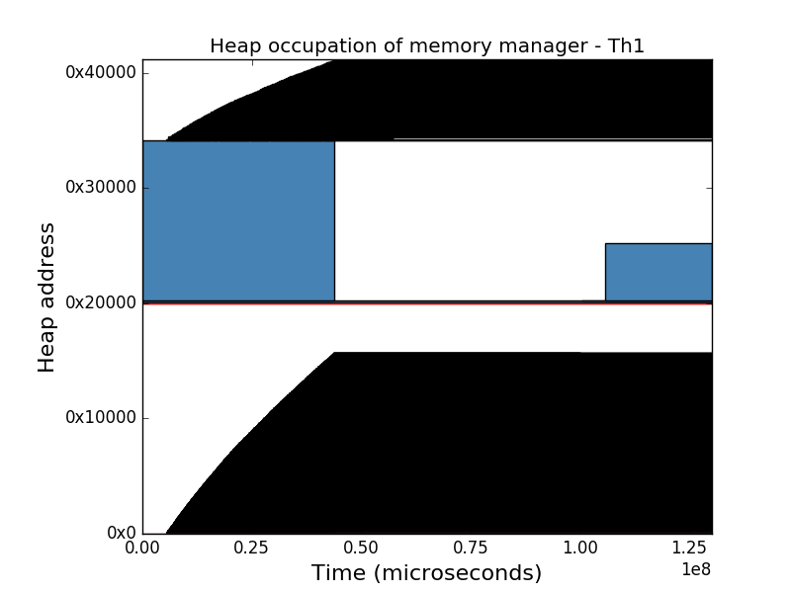

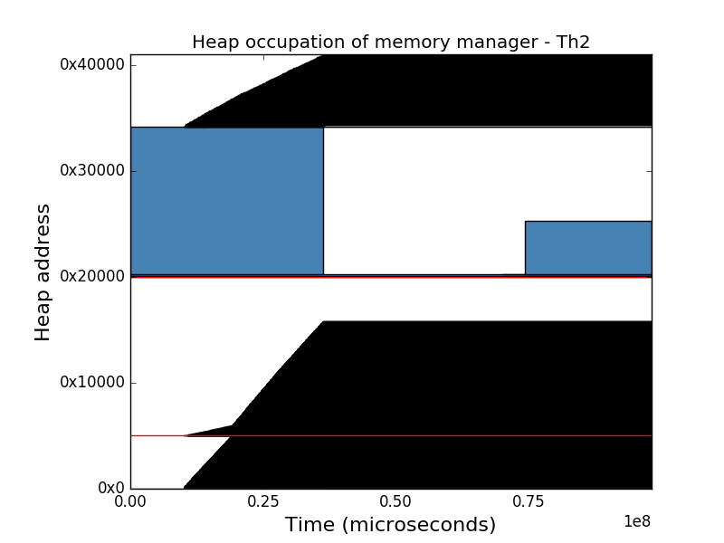

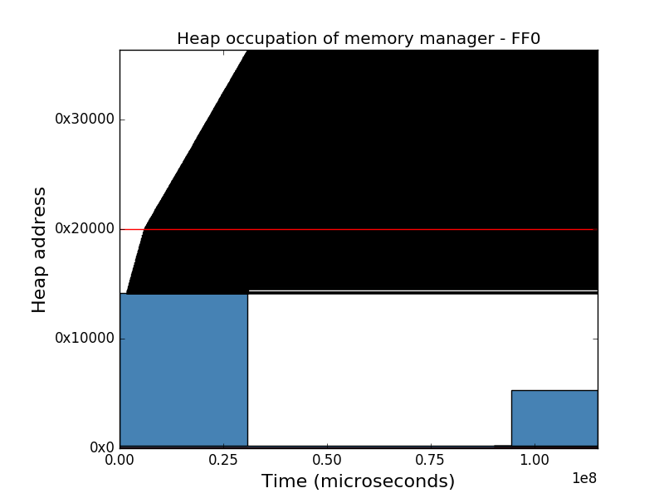Fastest first

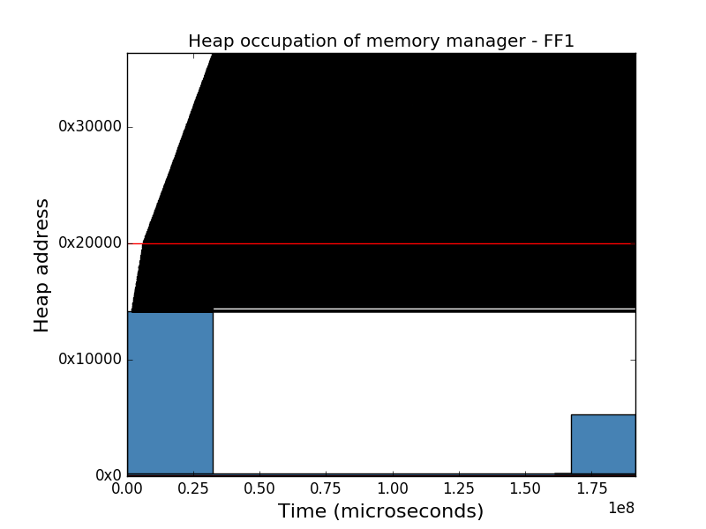

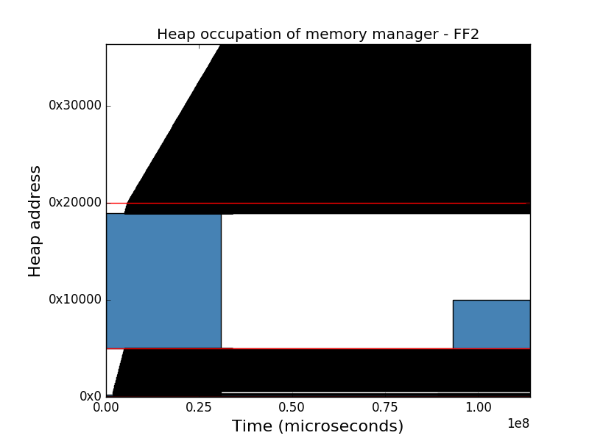

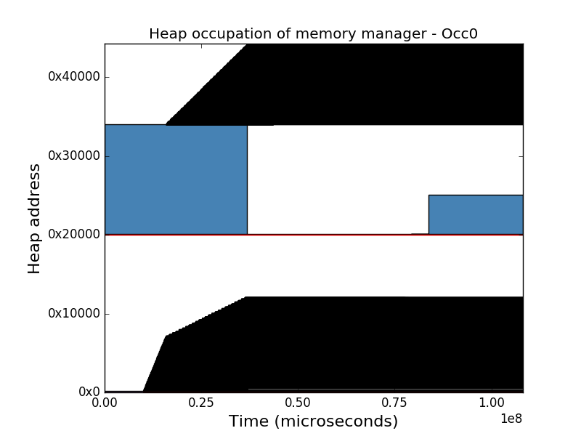Occupancy

