

Dynamic allocation for embedded heterogenous memory

A study of trade-offs

Thomas Peterson

KTH ROYAL INSTITUTE OF TECHNOLOGY
INFORMATION AND COMMUNICATION TECHNOLOGY
Abstract
Write an abstract. Introduce the subject area for the project and describe the problems that are solved and described in the thesis. Present how the problems have been solved, methods used and present results for the project.

The presentation of the results should be the main part of the abstract. Use about ½ A4-page.

Keywords
Memory management, NVRAM, Scratchpad memory, Embedded systems
Abstract
Svensk version av abstract – samma titel på svenska som på engelska.

Nyckelord
Minneshantering, NVRAM, Scratchpad minne, Inbyggda system
Table of Contents
1 Introduction 1
1.1 Background 1
1.2 Problem 2
1.3 Purpose 2
1.4 Goal 3
1.5 Methodology 3
1.6 Delimitations 4
1.7 Outline (Disposition) 4
2 Theoretic Background 4
2.1 Tracing 5
2.2 Dynamic Datastructures 5
2.3 NVRAM 5
3 Methodologies 6
3.1 Agile Development 6
3.2 Evaluation criteria 6
3.3 Research Method: 6
4 Contribution 7
4.1 Structure Of The Memory Allocator 7
4.2 Memory Areas 7
5 Results 7
6 Conclusions and Further Work 7
6.1 Conclusions 7
6.2 Further work 7
References 9
Appendix A 1
Appendix B 1

Introduction
With the evolution of technologies and the increasing demand for technical products, more and more computing devices are produced and deployed. In our everyday life, we may stumble across several different embedded systems such as air conditioning systems, automotive devices as well as ATMs without reflecting to much about the complexity of the intrinsic systems. The architectures of these embedded systems must be designed, manufactured, programmed and finally deployed. Their software must then be capable of surviving with the limited hardware while using a minimal amount of power. As time passes and technology evolves, the devices become outdated. The newer hardware is not always able to run on legacy code and thus additional software must be developed.
(https://www.theengineeringprojects.com/2016/11/examples-of-embedded-systems.html)

With newly introduced architecture designs, the corresponding software must preferably be able to take advantage of various hardware properties. This is the case for most of the system’s subunits. One of those subsystems is the memory which is primarily managed by a memory allocator. Furthermore, different allocator strategies exist, helping the allocator in optimizing the memory usage. These strategies should be formed with the memory properties in mind. This thesis attempts to take a step towards solving these strategic memory allocation issues by trying to identify different trade-offs existing in a simulated embedded system with different memory properties.

This chapter introduces the paper, in it’s whole, and gives an overview over the different aspects implicitly associated with the thesis work. The second chapter gives an in-depth background and the third presents the different methods used in the degree project as well as in the thesis report writing. Following these, chapter four describes the degree project and the fifth chapter exposes the results. Finally, the sixth chapter draws conclusions and thereafter a summary concludes the thesis.

Background
This section aims at presenting a brief background for the thesis. The first section gives an overview over the company Evaderis who is issuing the request for a degree work. The second section gives a background to the problem.

…Evaderis and Dycton
//kontakta ARC för hjälp med automatisk formattering på heading
Evaderis is a company located in Grenoble.
They are currently developing their own architectures which will use
E.t.c …
"L'architecture développée par eVaderis permet de combiner dans une même puce plusieurs
régions de mémoire aux caractéristiques différentes, par exemple avec un compromis différent
entre vitesse d'écriture et densité de stockage. Il faut donc adapter en conséquence le
logiciel “

Mention simulator at INSA

…Problem Background
//kontakta ARC för hjälp med automatisk formattering på heading
The company Evaderis desires an embedded device which can operate with low power consumption. The association aims to achieve this by using checkpointing, naturally off technique and non-volatile memory. Furthermore, the device shall be off by default, meaning that it will only be turned on for a short amount of time when triggered by an interrupt. During this short timespan the device is expected to complete all of it’s computations before going back to its naturally-off state. Checkpointing is achieved by keeping necessary data in non-volatile memory. [1]

A difference between Evaderis proposed architecture compared to the common mips architecture is the fact that all caches have been substituted for scratchpads. These scratchpads uses STT-MRAM which is non-volatile and thus permits checkpointing. These scratchpads will enlarge the memory address space and indeed have different properties compared to DRAM memory. The addition of another memory unit results in a new set of addressable addresses. By using multiple memory allocators with various strategies, one can tune the strategies to optimize memory allocation. Likewise, a possibility to reach the same goal, is to combine different memory types with different allocators which implement different strategies. [1]
5-7 sidor

…Dycton project

Problem
Legacy software acting on embedded devices will not work well on an architecture consisting of several memory regions with different properties. Thus new memory allocators must be developed to accommodate for those properties. This problem can general be summed as the sentence “What is the best strategy of a memory allocator acting on heterogenous memory?”. This problem statement is complex and won’t be the main focus of this report. The main focus of this report will instead be to identify the different trade-offs that must be made when allocating heterogenous memory. The specific problem this thesis addresses can be expressed as “What trade-offs exist concerning the memory allocation of heterogenous memory?”.

Purpose
The purpose of the thesis was to evaluate different strategies for the memory allocator as well as discovering trade-offs related to the properties of the heterogeneous memory they will be operating on. The purpose of the work is to create a basic memory manager for an embedded architecture where caches have been substituted for non-volatile units termed scratchpads. As already mentioned, this memory manager ought to take memory properties into considerations when making allocation decisions. This memory properties varies with the memory type.

Goal
The primary goal of the project is for the Dycton Project to have a working bare bones memory allocator which can be adjusted to different memory properties. This will in turn help the Dycton Project achieve its goal of providing a complete runtime system for Evaderis new device architectures. By doing so the programmers won’t have to take the memory properties into account when allocating and deallocating memory blocks to the heap.

The dycton project will benefit. The company and their innovations.

Benefit ethics and sustainability

Vad har samhället och företaget fått ut av arbetet
Hållbar utveckling - Ekonomi miljö och samhälle

Resultatmål och effektmål(Project and … goals)

Resultatmålen beskrivs som resultatet av de aktiviteter som genomförs i projektet.
Effektmålen skall svara på frågan varför projektet genomförs och beskriva effekterna på kort och lång sikt. Effekterna kan vara både direkta och indirekta.

The goal means the goal of the degree project. Present following: the goal(s), deliverables and results of the project.

Describe who will benefit from the degree project, the ethical issues (what ethical problems can arise) and the sustainability aspects of the project.

Use references!

Methodology
There was three persons involved in the degree project. Tristan Delizy is the main author of the simulator and primary person to work on the Dycton project.

Tristan Delizy is going to be responsible for the simulator and weekly meetings will be conducted between the three persons involved.

Introduce, theoretically, the methodologies and methods that can be used in a project and, then, select and introduce the methodologies and methods that are used in the degree project. Must be described on the level that is enough to understand the contents of the thesis.

Agile method
Induktiv – drar slutsater av erfarnhet.

Use references!
Preferably, the philosophical assumptions, research methods, and research approaches are presented here.

Detailed description of these methodologies and methods should be presented in Chapter 3. In chapter 3, the focus could be research strategies, data collection, data analysis, and quality assurance.

Delimitations
The aim of the delimitations of the degree project is not to prevent discoveries. Rather, the delimitations exist to improve focus which in turn permits us to go deeper. Possible delimitations are, for example, which data structures to use. This project work will be delimited to three data structures. These are a Bitmap, a Buddy System and a Free list. These data structures will be matched with different memory types and be judged with the help of different evaluation criteria. These criteria are access pressure, runtime and heap fragmentation. The criteria are described more in depth in section 3.2. The memory properties on which the allocators are operating will only be of type NVRAM. Namely, the ones we choose to limit ourselves to are
…

Outline (Disposition)
In chapter 2 … is presented e.t.c

In text, describe what is presented in Chapters 2 and forward. Exclude the first chapter and references as well as appendix.

Background
5-7 sidor In this chapter, a detailed description about background of the degree project is presented together with related work. Discuss what is found useful and what is less useful. Use valid arguments.

Explain what and how prior work / prior research will be applied on or used in the degree project /work (described in this thesis). Explain why and what is not used in the degree project and give valid reasons for rejecting the work/research.

Use references!

The simulator
Architecture, 1 processor
Arbitrary amount of memory devices

Tracing
Stochastic VS real program tracing

Dynamic Datastructures
This chapters presents different dynamic datastructures commonly used the Freelist
Bitmap
Buddy system
Strategies(First,Next,Best,worse fit)

Plateaus, Ramps and Peaks
In the typical heap allocation of programs can be observed as combinations of three different characteristic allocations. These are plateaus, ramps and peaks. This can be seen in figure x.

Plateaus are long lived memory allocations. Usually, when the program starts, it allocates a distinguishable amount of data. This data is then only deallocated when the program stops. This behavior is what we call a plateau. With the platea.

Peak, important part since allocator is stressed.

NVRAM
Non-volatile random access memory
Types of of NVRAMs + chosen ones for the study
SSTRAM
2.3.x [NVRAM Type X used in research]

If figures are used, write Figure 1 in text to refer to the figure.

Figure 1. Text

If tables are used, refer to the table by Table 1.

Table 1. Text for the table

THE TABLE

Figures and Tables are numbered independently.

Methodologies
This chapter describes the degree work and its strategies for attacking the thesis problem. It contains a description of the way of working, a brief desctiption of the implementation and

Agile Development
Describe the agile way of working and compare it to the traditional way.

Weekly meetings and weekly sprints with different responsibilities.

French Supervisor = Product owner

Implementation
Describe the context of memory areas.
Future programmers using the develop

Memory Allocator Structure
The memory allocatorMain allocator
Sub allocator responsible for memory space

Figure for illustration

Simulating Real Program behavior
Describe the JSON Parser case study used to allocate and deallocate different sized objects.
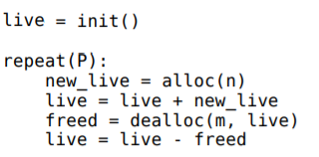

Evaluation
The Evaluation criteria which will be used to evaluate the degree work will be Fragmentation, access pressure and runtime.

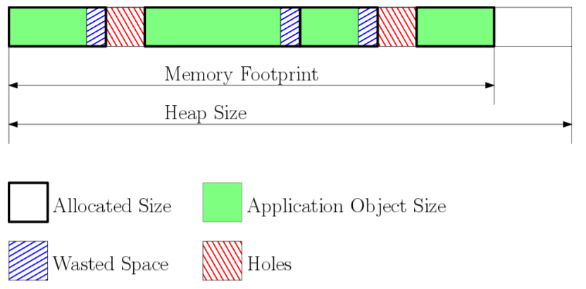
Figure 1: The heap and its parts illustrated.
Acces pressure

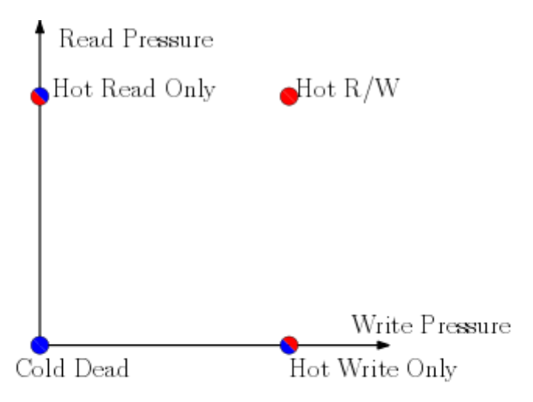
Figure 2: Example of different access pressures.

The heap object access pressure is defined as the access count of the object during its lifespan divided by the object lifespan duration and the object size. We define respectively the Read pressure and the Write pressure as the access pressure on the object considering only Read (resp. Write) accesses. It represent the spatiotemporal density of (resp. read/write) access on an object for a given program execution.

Applying engineering-related and scientific skills; modeling, analyzing, developing, and evaluating engineering-related and scientific content; correct choice of methods based on problem formulation; consciousness of aspects relating to society and ethics (if applicable).

As mentioned earlier, give a theoretical description of methodologies and methods and how these are applied in the degree project.

Present evaluation criterias: Performance, Energy Consumption and Endurance

Present the case study and motivate why it’s good.
The case study used to evaluate the allocators will be a program making malloc and free request in a random manner. running JSON parser.
As

Results
5-7 sidor
Describe the results of the degree project.

By sampling data linked to the evaluation criteria using the simulator the necessary data was acquired.

Conclusions and Further Work

Conclusions

Further work

Describe the conclusions (reflect on the whole introduction given in Chapter 1).

Discuss the positive effects and the drawbacks.

Describe the evaluation of the results of the degree project.

Describe valid future work.

References
IEEE Editorial Style Manual:
http://www.ieee.org/documents/stylemanual.pdf

KTH Templates for style:
http://intra.kth.se/polopoly_fs/1.391641!/Menu/general/column-content/attachment/KTH%20Formatmallar_text.pdf

Use one style (preferably Oxford) and be consistent. See IEEE Editorial Style Manual.

Glossary
Dycton Project: A project aiming at creating the software for Evaderis new architectures

Evaderis: A company working with NVRAM located in Grenobles.

Appendix A

Appendix B
To create a cover for the thesis, use the link:

http://intra.kth.se/kth-cover/

En litteraturstudie är genomförd och innehåller beskrivning av tillämpliga metoder inom ämnesområdet och orientering i aktuellt forsknings- och utvecklingsarbete. Vald metod är motiverad och baserad på vetenskap eller beprövad erfarenhet. Relevanta kunskaper från utbildningens kurser används på ett adekvat sätt

Examensarbetets uppgift hanteras till stor del självständigt. Väl valda databaser och sökverktyg används. Relevant litteratur och kunskap integreras i examensarbetet. Behovet av ytterligare kunskap diskuteras

Examensarbetet innehåller en tydlig problemformulering och en progression i hanterandet av denna. En kritisk diskussion förs kring relevanta företeelser, frågeställningar och situationer kopplade till arbetet. Adekvata bedömningar kopplade till examensarbetets frågeställning(ar) genomförs.

Den arbetsplan som tagits fram under inledningen av examensarbetet har följts. Arbetet är utfört inom överenskommen tid och med den metodik som överenskommits. Eventuella ändringar i planeringen eller i arbetet utgörs av överenskommelser mellan student och handledare

Rapporten är välorganiserad, språkligt välformulerad och sammanhängande. Referaten av källorna har relevans, är självständigt formulerade och väl integrerade. Såväl muntlig presentation och opposition som kommunikation under arbetets gång påvisar förmågan att presentera och lyhört diskutera arbetet med olika parter t.ex. uppdragsgivare, handledare, lärare, forskare och studenter.

Examensarbetet visar på bedömningsförmåga, till exempel att kunna förklara, motivera, kritisera och rekommendera. Relevanta ämnesmässiga bedömningar med vetenskaplig grund eller beprövad erfarenhet har gjorts i examensarbetet. Examensarbetet innehåller reflektion över samhälleliga och etiska aspekter om detta inte motiverats som irrelevant

Studenten sätter sig väl in i arbetsuppgiften och visar förmåga till delaktighet i den arbetskultur som är rådande där uppgiften ska lösas. Studenten visar förmåga att pröva och värdera information i diskussioner av uppgiften. Studenten visar på initiativförmåga och är öppen för handledning och kritik. Examensarbetet utförs till stora delar självständigt.

