PROGRAM 1
a=5
b=10
def add():
return a+b

def sub():
print(a-b)
return

result1=add()
result2=sub()
print(result1)
print(result2)
OUTPUT
15
-5
PROGRAM2
import random
d={1:'R',2:'P',3:'S'}
c=d[random.randint(1,3)]
while(True):
p=input("enter'R','P','S'")
if(c==p):
print("tie")
elif(c=='R'and p=='S' or c=='P'and p=='R' or c=='S'and p=='P'):
print("computer wins")
else:
print("player won")
break

OUTPUT
enter'R','P','S'S
computer wins
enter'R','P','S'R
tie
enter'R','P','S'P
player won
PROGRAM 3
import smtplib
import getpass

myemail=input("your email id : ")
password=getpass.getpass()
recemail=input("Reciever's email id :")

#create SMTP session
s=smtplib.SMTP('smtp.gmail.com',587)

#start TLS for security
s.starttls()

#authentication
s.login(myemail,password)

#message to be sent
message="Hey bro9ther"

#sending the mail
s.sendmail(myemail,recemail,message)

#terminating the sesion
s.quit()
OUTPUT
your mail id : alapatisai10@gmail.com
password
Receiver's mail id :pramodhkprem@gmail.com
PROGRAM 4
import os
i=0
while(i<=5):
os.system("fswebcam -F 4 --fps 30 -r 1200*1000 /home/pi/group2/"+str(i)+".jpg")
i=i+1
print("pic taken")
OUTPUT
pic taken
pic taken
pic taken
pic taken
pic taken

PROGRAM 5
import matplotlib.pyplot as plt

#x-co ordinateof left sides of bars
left=[1,2,3,4,5]

#height of bars
height=[10,24,36,40,5]

#labels for bars
tick_label=['one','two','three','four','five']

#plotting a bar chart
plt.bar(left,height,tick_label=tick_label,width=0.8,color=['red','yellow'])

#naming x-axis
plt.xlabel("x-axis")

#naming y-axis
plt.ylabel("y-axis")

#plot title
plt.title("my first graph")

#function to show the plot
plt.show()
OUTPUT
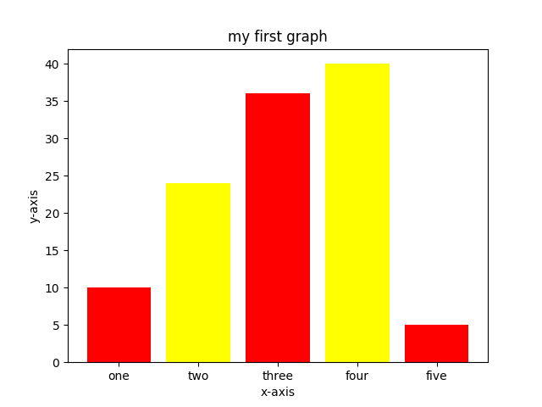
PROGRAM 6
import matplotlib.pyplot as plt
import csv

x = []
y = []

with open('3.csv','r') as csvfile:
plots = csv.reader(csvfile, delimiter=',')
for row in plots:
x.append(int(row[0]))
y.append(int(row[1]))

plt.plot(x,y, label='Loaded from file!')
plt.xlabel('x')
plt.ylabel('y')
plt.title('Interesting Graph\nCheck it out')
plt.legend()
plt.show()
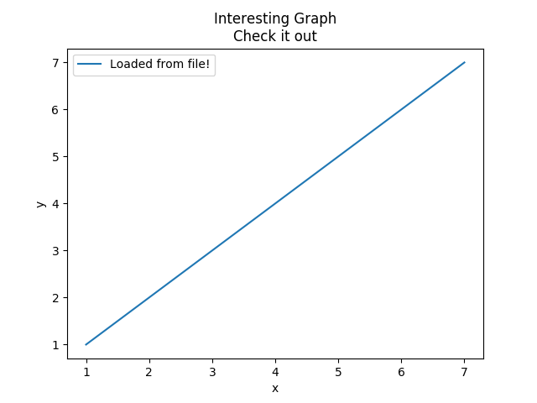
OUTPUT

PROGRAM 7
import matplotlib.pyplot as plt
x=[1,2,3]
y=[1,4,9]
plt.plot(x,y)
plt.xlabel("x-axis")
plt.ylabel("y-axis")
plt.title("my first graph")
plt.show()
OUTPUT
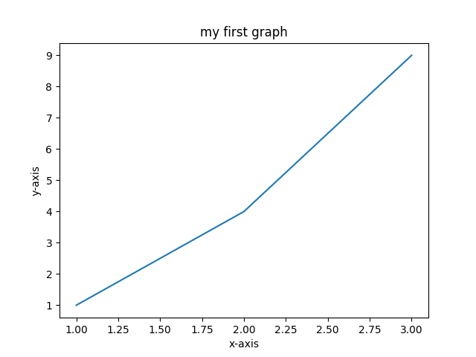

PROGRAM 8
import numpy as np
import matplotlib.pyplot as plt
import matplotlib.patches as mpatches

x = np.arange(0, 10, 0.005)
y = np.exp(-x/2.) * np.sin(2*np.pi*x)

fig, ax = plt.subplots()
ax.plot(x, y)
ax.set_xlim(0, 10)
ax.set_ylim(-1, 1)

plt.show()
OUTPUT
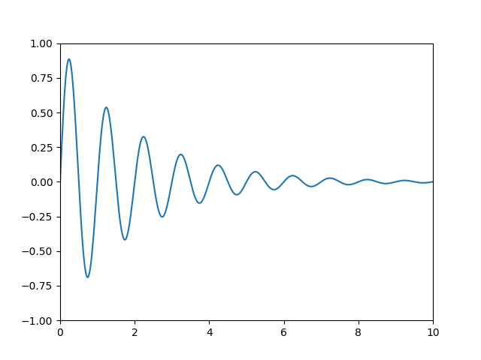

PROGRAM 9
import RPi.GPIO as GPIO
import os
import time
GPIO.setmode(GPIO.BCM)
pirPin=6
GPIO.setup(pirPin, GPIO.IN)
counter=1
time.sleep(4)
while(counter<=4):
if(GPIO.input(pirPin)):
print("motion detected!!!")
os.system("fswebcam -F 4 --fps 20 -r 800*600 /home/pi/rasp/"+str(counter)+".jpeg")
print("nyc pic")
time.sleep(1)
counter=counter+1
print("testing")
exit()

PROGRAM 10
#!/usr/bin/python
#+-+-+-+-+-+-+-+-+-+-+-+-+-+-+-+-+-+-+-+-+-+
#|R|a|s|p|b|e|r|r|y|P|i|-|S|p|y|.|c|o|.|u|k|
#+-+-+-+-+-+-+-+-+-+-+-+-+-+-+-+-+-+-+-+-+-+
#
# ultrasonic_1.py
# Measure distance using an ultrasonic module
#
# Author : Matt Hawkins
# Date : 09/01/2013

# Import required Python libraries
import time
import RPi.GPIO as GPIO

# Use BCM GPIO references
# instead of physical pin numbers
GPIO.setmode(GPIO.BCM)

# Define GPIO to use on Pi
GPIO_TRIGGER = 23
GPIO_ECHO = 24

print "Ultrasonic Measurement"

# Set pins as output and input
GPIO.setup(GPIO_TRIGGER,GPIO.OUT) # Trigger

GPIO.setup(GPIO_ECHO,GPIO.IN) # Echo

# Set trigger to False (Low)
GPIO.output(GPIO_TRIGGER, False)

# Allow module to settle
time.sleep(0.5)

# Send 10us pulse to trigger
GPIO.output(GPIO_TRIGGER, True)
time.sleep(0.00001)

GPIO.output(GPIO_TRIGGER, False)
start = time.time()

while GPIO.input(GPIO_ECHO)==0:
start = time.time()

while GPIO.input(GPIO_ECHO)==1:
stop = time.time()

# Calculate pulse length
elapsed = stop-start

# Distance pulse travelled in that time is time
# multiplied by the speed of sound (cm/s)
distance = elapsed * 34300

# That was the distance there and back so halve the value
distance = distance / 2

print "Distance : %.1f" % distance

# Reset GPIO settings
GPIO.cleanup()

