**TO know about postman:-**

<https://www.blazemeter.com/blog/how-use-postman-manage-and-execute-your-apis>

**To install postman:-**

<https://www.getpostman.com/downloads/>

**To select required Method**

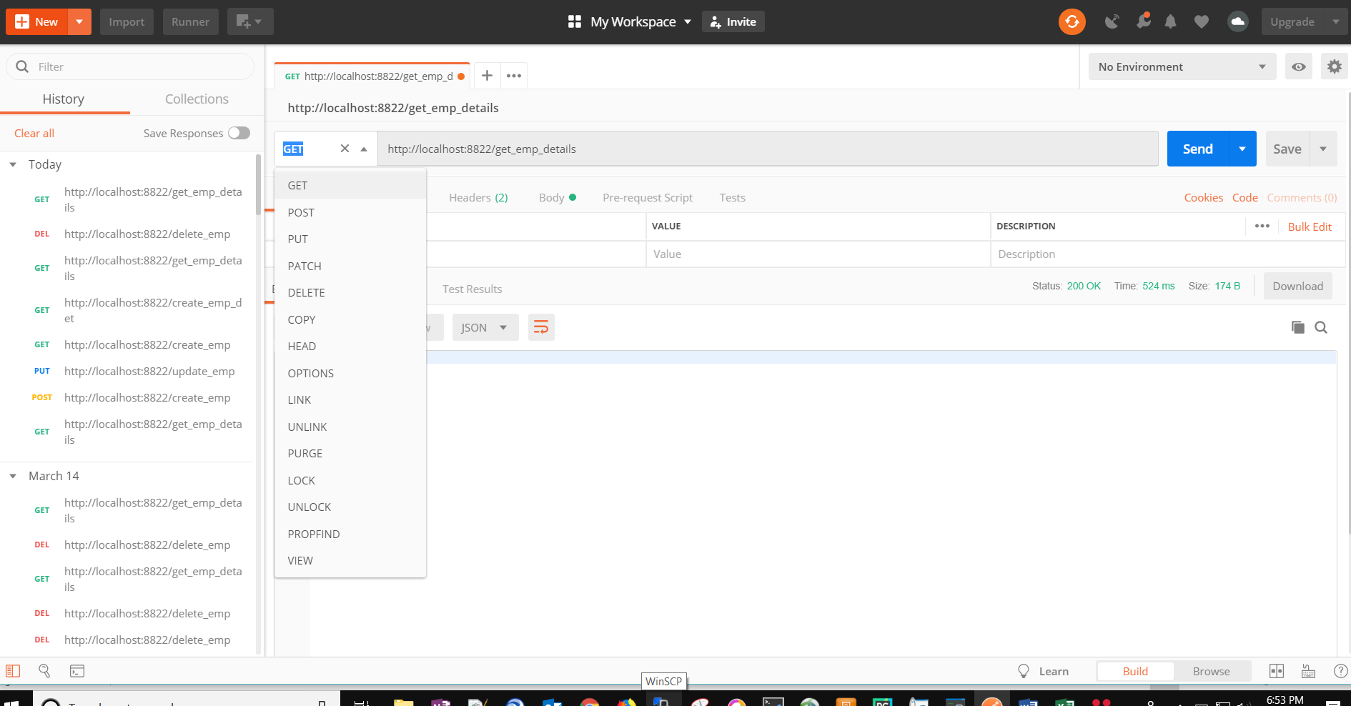

**To Pass credentials if required:-**

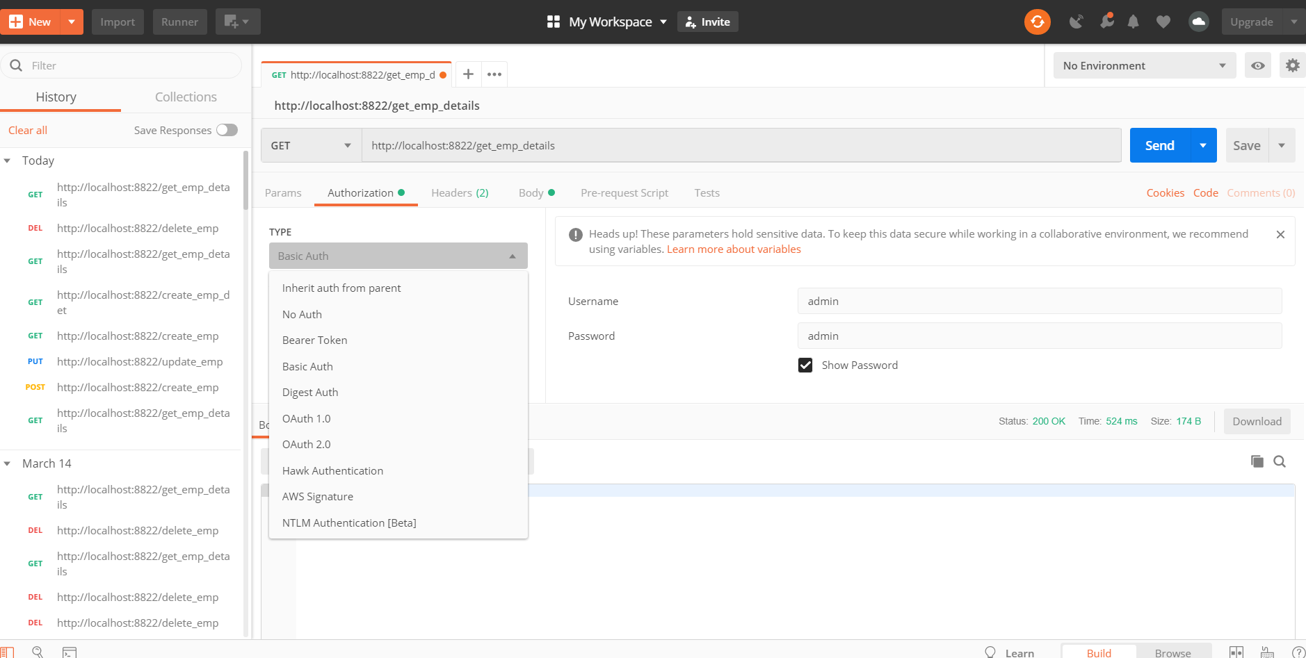

**To Send request data:-**

