File Handling
Read() ,Readline() and Readlines()
5. How to open the text file and read the data from the File
File :
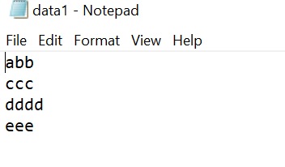
Read() - all the data
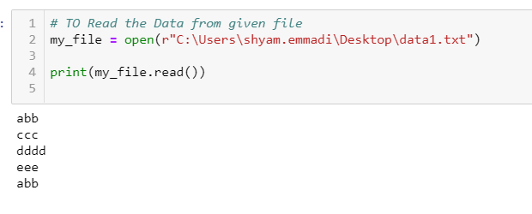
Readline() – It will Print 1st Line of String
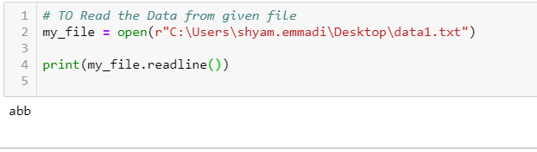
Readlines() – It will print the data in List format with “\n”
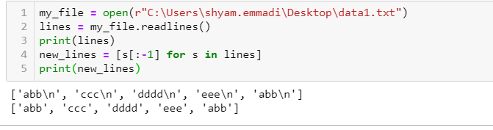

Write()
he method write() writes a string str to the file. There is no return value. Due to buffering, the string may not actually show up in the file until the flush() or close() method is called.
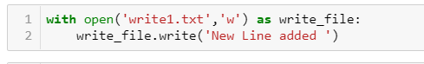
Writeable() –
The writable() method returns True if the file is writable, False if not.
A file is writable if it is opened using "a" for append or "w" for write.
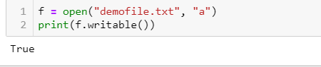
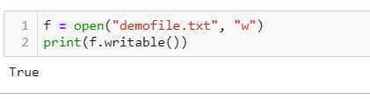
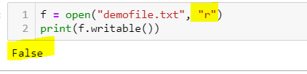

Writelines()
The writelines() method writes the items of a list to the file.
Where the texts will be inserted depends on the file mode and stream position.
"a": The texts will be inserted at the current file stream position, default at the end of the file.
"w": The file will be emptied before the texts will be inserted at the current file stream position, default 0.

Open the file with "a" for appending, then add a list of texts to append to the file:

f = open("demofile3.txt", "a")
f.writeline(["See you soon!", "Over and out."])
f.close()
#open and read the file after the appending:
f = open("demofile3.txt", "r")
print(f.read())
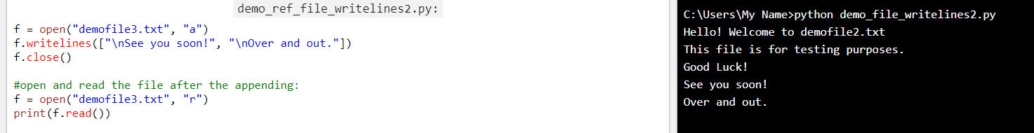

What is tell() :
To know the File handler position
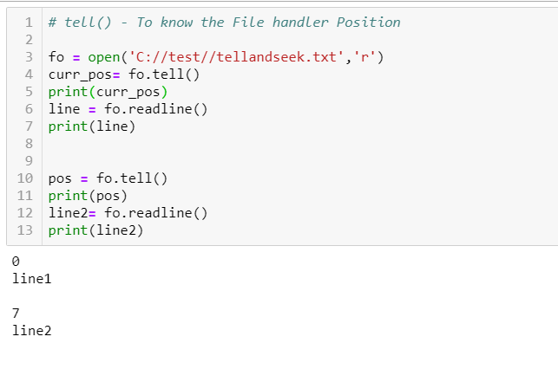
What is Seek():
To bring the File handler position where ever we required
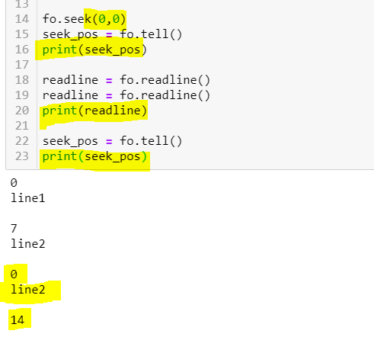
Difference between open and with open as
Open with open as
1.We can Open only one File 1.We can open multiple files at a time
2.We have to close the opened file 2.No need to close the opened fiel

JSON File Handling :
Precondition : Import json module
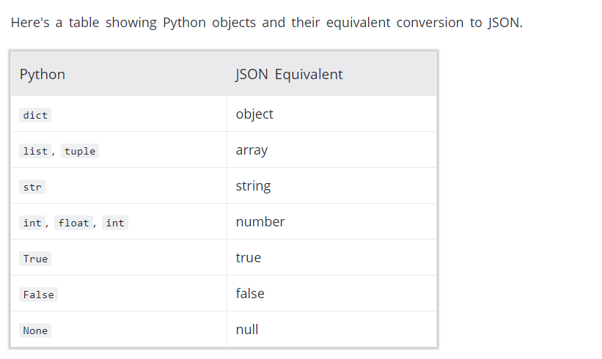

Loads() (JSON TO DICT)-You can parse a JSON string using json.loads() method. The method returns a dictionary.
Dumps() (DICT TO JSON) You can convert a dictionary to JSON string using json.dumps() method.

Load() – (READ FILE CONT JSON) You can use json.load() method to read a file containing JSON object.
Dump()- Then, json.dump() transforms person_dictto a JSON string which will be saved in the person.txt file.

Example 1: Python JSON to dict
You can parse a JSON string using json.loads() method. The method returns a dictionary.

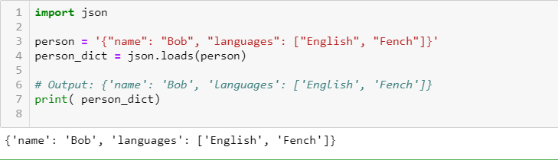

Example 2: Python read JSON file
You can use json.load() method to read a file containing JSON object.
Suppose, you have a file named person.json which contains a JSON object.

{"name": "Bob",
"languages": ["English", "Fench"]
}
import json

with open('path_to_file/person.json') as f:
data = json.load(f)

# Output: {'name': 'Bob', 'languages': ['English', 'Fench']}
print(data)

Example 3: Convert dict to JSON
You can convert a dictionary to JSON string using json.dumps() method.

import json

person_dict = {'name': 'Bob',
'age': 12,
'children': None
}
person_json = json.dumps(person_dict)

# Output: {"name": "Bob", "age": 12, "children": null}
print(person_json)

Example 4: Writing JSON to a file

import json

person_dict = {"name": "Bob",
"languages": ["English", "Fench"],
"married": True,
"age": 32
}

with open('person.txt', 'w') as json_file:
json.dump(person_dict, json_file)
In the above program, we have opened a file named person.txt in writing mode using 'w'. If the file doesn't already exist, it will be created. Then, json.dump() transforms person_dictto a JSON string which will be saved in the person.txt file.
When you run the program, the person.txt file will be created. The file has following text inside it.
{"name": "Bob", "languages": ["English", "Fench"], "married": true, "age": 32}

