Python Interview Questions:

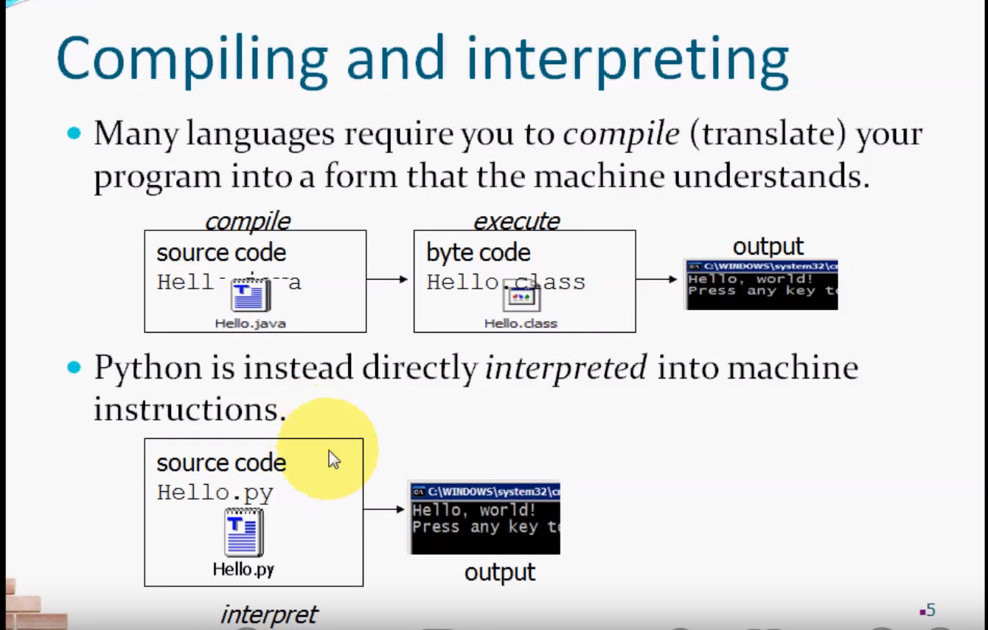

Python language is an interpreted language. Python program runs directly from the source code. It converts the source code that is written by the programmer into an intermediate language, which is again translated into machine language that has to be executed.
Python Source Code – Translated to machine Language – And it Executed
Interpreter Executes – code line by line at a time – This Makes debugging easy

Python Features?

1) Easy to Learn and Use
Python is easy to learn and use. It is developer-friendly and high-level programming language.

2) Expressive Language
Python language is more expressive means that it is more understandable and readable.

3) Interpreted Language
Python is an interpreted language i.e. interpreter executes the code line by line at a time. This makes debugging easy and thus suitable for beginners.

4) Cross-platform Language
Python can run equally on different platforms such as Windows, Linux, UNIX and Macintosh etc. So, we can say that Python is a portable language.

5) Free and Open Source
Python language is freely available at address. The source-code is also available.
Therefore it is open source.

6) Object-Oriented Language
Python supports object oriented language and concepts of classes and objects come into existence.

7) Extensible
It implies that other languages such as C/C++ can be used to compile the code and thus it can be used further in our python code.

8) Large Standard Library
Python has a large and broad library and provides rich set of module and functions for rapid application development.

9) GUI Programming Support
Graphical user interfaces can be developed using Python.

How Memory Managed in Python ?
How is memory managed in Python?
- Python memory is managed by Python private heap space.
- All Python objects and data structures are located in a private heap.
- The programmer does not have an access to this private heap and interpreter takes care of this Python private heap.
- The allocation of Python heap space for Python objects is done by Python memory manager. The core API gives access to some tools for the programmer to code.
Python also have an inbuilt garbage collector, which recycle all the unused memory and frees the memory and makes it available to the heap space
Creation (Object : Object creation)→ Constructor (To Perform Intialization)→Use that Object →destructor(To Perform cleanup activity) →GC Destroy the Object

What is Garbage collection in Python ?
1.To destroy unused/useless objects
When we say that the object is eligible for garbage collection?
If and only if that the Object doesn’t contain any reference Variables

How to enable or disable the GC in our Program?
By default gc in enabled in Python
Import gc
gc.isenabled() -TRUE
gc.disable()
gc.isenabled() -FALSE
gc.enable()
gc.isenabled() -TRUE
gc.enable() _TRUE
What are destructers ?
Constructor : __init__(self)
Destructers: __del__(self)
- To perform Cleanup activity then destroy the object
- Closing database connections
Creation (Object : Object creation)→ Constructor (To Perform Intialization)→Use that Object →destructor(To Perform cleanup activity) →GC Destroy the Object
How to find no.of references to an Object?
Note : Internally self also an reference object hence the total reference objects are 4
Import sys
class Test():
def __init__(self):
print("Creating Intilization object / Constructor Execution")
def __del__(self):
print("Perform Cleanup Activities / Desctructor Execution")
t1=Test()
t2=t1
t3=t2
print(sys.getrefcount(t1))

# Garbase collection Example
import time
class Test():
def __init__(self):
print("Creating Intilization object / Constructor Execution")
def __del__(self):
print("Perform Cleanup Activities / Desctructor Execution")
t1=Test()
t2=t1
t3=t2
del t1
time.sleep(10)
print("Object not yet destroyed after deleting t1")
del t2
time.sleep(10)
print("Object not yet destroyed after deleing t2")
del t3
time.sleep(10)
print("End of Application ")
--------

What is Library in Python ?
Python library is a collection of functions and methods that allows you to perform lots of actions without writing your own code.

What are Library are used in your Framework
Requets, wxpython ,Beautifulsoap, numpy, pandas, Selenium ,HTML TestRunner ,Logging
List ,tuple,dict ,string ,number

--------------------------------------------------------------------------------------------------------------------------------------

Package: -- Collection of modules/ Python files
A package is basically a directory with Python files and a file with the name __init__.py. This means that every directory inside of the Python path, which contains a file named __init__.py, will be treated as a package by Python. It's possible to put several modules into a Package.
Any Sub Packages also “__init__.py” mandatory to import the sub packages
What are all Packages are Used in your Framework ?
Json, unit test, pytest, robotframework, HtmlTestRunner
-----------------------------------------------------------------------------------------------------------------------------------
What is module?
In Python Modules are python files with a .py extension
A Python module can have a set of functions, classes or variables defined and implemented.
What are all Modules used in your Framework ?
Unit test, json, traceback, xlrd, heapq ,Configparser – to work with INI files
--------------------------------------------------------------------------------------------------------------------------------------
What is a Method () in Python?
A method is a function that takes a class instance as its first parameter
What are all Methods used in your framework :
Dump() , Convert the JSON data to File
dumps() – Convert Python Object to JSON STRING
load(), - read json data from a file
loads() – convert the JSON string to Python
loads() – convert the JSON string to Python

Python slice() | creates a slice object specified by range()
Python sorted() | returns sorted list from a given iterable

Python eval() | Runs Python Code Within Program
Python abs() | returns absolute value of a number
Python all() | returns true when all elements in iterable is true
Python any() | Checks if any Element of an Iterable is True
Python ascii() | Returns String Containing Printable Representation
Python bin() | converts integer to binary string
Python bool() | Converts a Value to Boolean
Python bytearray() | returns array of given byte size
Python bytes() | returns immutable bytes object
Python callable() | Checks if the Object is Callable
Python chr() | Returns a Character (a string) from an Integer
Python classmethod() | returns class method for given function
Python compile() | Returns a Python code object
Python complex() | Creates a Complex Number
Python delattr() | Deletes Attribute From the Object
Python dict() | Creates a Dictionary
Python dir() | Tries to Return Attributes of Object
Python divmod() | Returns a Tuple of Quotient and Remainder
Python enumerate() | Returns an Enumerate Object
Python eval() | Runs Python Code Within Program
Python exec() | Executes Dynamically Created Program
Python filter() | constructs iterator from elements which are true
Python float() | returns floating point number from number, string
Python format() | returns formatted representation of a value
Python frozenset() | returns immutable frozenset object
Python getattr() | returns value of named attribute of an object
Python globals() | returns dictionary of current global symbol table
Python hasattr() | returns whether object has named attribute
Python hash() | returns hash value of an object
Python help() | Invokes the built-in Help System
Python hex() | Converts to Integer to Hexadecimal
Python id() | Returns Identify of an Object
Python input() | reads and returns a line of string
Python int() | returns integer from a number or string
Python isinstance() | Checks if a Object is an Instance of Class
Python issubclass() | Checks if a Object is Subclass of a Class
Python iter() | returns iterator for an object
Python len() | Returns Length of an Object
Python list() Function | creates list in Python
Python locals() | Returns dictionary of a current local symbol table
Python map() | Applies Function and Returns a List
Python max() | returns largest element
Python memoryview() | returns memory view of an argument
Python min() | returns smallest element
Python next() | Retrieves Next Element from Iterator
Python object() | Creates a Featureless Object
Python oct() | converts integer to octal
Python open() | Returns a File object
Python ord() | returns Unicode code point for Unicode character
Python pow() | returns x to the power of y
Python print() | Prints the Given Object
Python property() | returns a property attribute
Python range() | return sequence of integers between start and stop
Python repr() | returns printable representation of an object
Python reversed() | returns reversed iterator of a sequence
Python round() | rounds a floating point number to ndigits places.
Python set() | returns a Python set
Python setattr() | sets value of an attribute of object
Python slice() | creates a slice object specified by range()
Python sorted() | returns sorted list from a given iterable
Python staticmethod() | creates static method from a function
Python str() | returns informal representation of an object
Python sum() | Add items of an Iterable
Python super() | Allow you to Refer Parent Class by super
Python tuple() Function | Creates a Tuple
Python type() | Returns Type of an Object
Python vars() | Returns __dict__ attribute of a class
Python zip() | Returns an Iterator of Tuples
Python __import__() | Advanced Function Called by import

What is Setup() and Teardown() ?
Setup() -- > It will run every test starts
Teardown() -- > It will run after every test
Class Level :
setupClass() : It will run only once before all tests , we use decorators called “@classmethod”
teardownClass() : It will run only once after all tests, we use decorators called “@classmethod”

What is ‘as’ in Python?
as is used to create an alias while importing a module.
It means giving a different name (user-defined) to a module while importing it.
What is .pyc
This is in Python 2
When a module is imported for the first time, or when the source is more recent than the current compiled file, a .pyc file containing the compiled code will usually be created in the same directory as the .py file.
When you run the program next time, Python uses this file to skip the compilation step.
This is in Python 3
It will compile and store in same directory as __pychache__
For example, if you have a script file abc.py that imports another module xyz.py, when you run abc, xyz.pyc will be created since xyz is imported, but not abc.pyc file will be created since abc.py isn’t being imported.

What is module ?
In Python Modules are python files with a .py extension
A Python module can have a set of functions, classes or variables defined and implemented.
Example :
demo.py
from calc import add → it will import the calc module and add fun only
from calc import * → it will import the calc module and all the funs in calc module
a = 9
b = 7

calc.py
def add(a,b):
return a + b
def sub(a,b):
retun a - b
def div(a,b):
return a/b
def mul(a,b):
return a * b

1.what are Data types in Python ?
Python has 5 Data Types ,They are:
1.Numbers
2.String
3.List
4.Tuple
5.Dictonary
6.sets
3.What is diff between list, tuple and dictionary?

List Tuple Dictionary

1.List is Mutable 1.Tuple is Immutable 1.Dictionary is Mutable
2.Lists Can be Modified 2. Tuple Can Not be Modified 2. 2.Dictinary Key and Value
after they Created after they Created Can be Modified after crted
3. Lists have Order 3. Tuples have Structure 3. It is Not Ordered

Sets:
Sets are collection of unique items,
Sets are Unordered / items in a set are not ordered
Sets are defied in {}
Sets are can not update but we can add
It Does not support for index
Which one is faster in performance wise ?
- Tuples in Python is faster in execution because it is of immutable(values cannot be modified) data type iterating through is faster than list.
- Tuples element can be used as a key for dictionary, but in list it is not possible.
- Data’s in tuples are write protected.

What is diff list and tuple explain how memory allocated in list and tuple

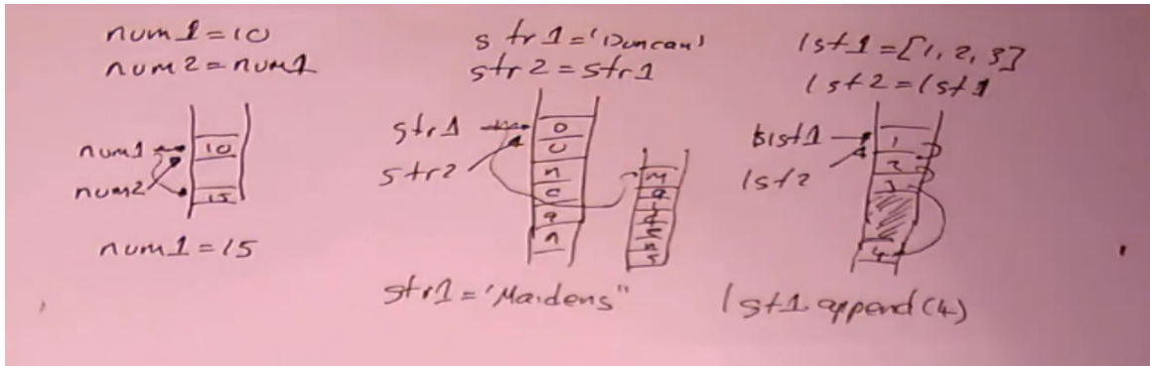
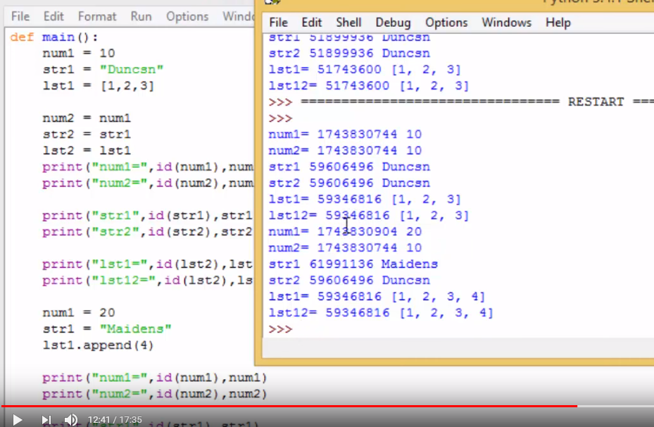

Preceeding Operators :
Python Preceeding rule – it will calculate high value operator
5+4*2
13
(5+4)*2
18
What is Mebership Operartors ?
in , not in
IT will Check give string is available in a string or not
str = ‘ my string is python ‘
python is in str
True
What is identity Operators?
is , is not -- > It will check the Same value and Data Type of the given variables
a = 10
b = ‘str’
a is b → False
a = ‘10’
b = ‘str’
a is b → True
String Functions :

Lst = [1,2,3,9]
Len(lst) -→ 4
Max(lst )→ 9
Min(lst)→ 1
-----------------------------------------------------------
Syntax : String.replace(old, new, count)
Str = ‘hello’
Str.replace(‘l’, ‘b’,2) → replace(‘old’, ‘new’, count)
Str-→ hebbo
------------------------------------------------------------------
Slice() - The slice() constructor creates a slice object representing the set of indices specified by range(start, stop, step).
Syntax : slice(start, stop, step)
pyString = 'Python'

# contains indices (0, 1, 2)
# i.e. P, y and t
Object = slice(3)
print(pyString[sObject]) -→ Pyt

# contains indices (1, 3)
# i.e. y and h
Object = slice(1, 5, 2)
print(pyString[sObject]) →yh
----------------------------------------------------------------------
Str = ‘python Language’
Str.capitalize() -→ ‘Python Languange’
Str.title() →’Python Language’
----------------------------------------------------------------------------
Str = ‘abc@gmail.com’
Str.endswith(‘.com’) -→ True
---------------------------------------------------------------------------
Str = ‘ this is python scripting’
Str.find (‘python) -→ 8
Str =’pyhton’
Str.find(‘s’) --→ -1
---------------------------------------------------------------------------
Str =’Python Language’
Str.split() → [‘python’, ‘Language’]
------------------------------------------------------------------------------
Str =’ this is python languange’
Str.title() → ‘This Is Python Language’
---------------------------------------------------------------------------------
Str = ‘ I love python ‘
Str.swapcase() --→’ I LOVE PYTHON ‘
Str =’I LOVE PYTHON’
Str.swapcase() →’ I love python’
------------------------------------------------------------------------------------
L =[1,2,3,3,4,5]
l.count(3) -→ 2
----------------------------------------------------------------------------------------
L=[1,2,3,4,5]
l.append(6) → [1,2,3,4,5,6]
------------------------------------------------------------------------------------------
L= [1,5,8]
L.insert(1,9) → [1,9,5,8]

-------------------------------------------------------------------------------------------

L1=[1,2]
L2=[3,4]
L1.extend(L2)
L1 --→ [1,2,3,4]
------------------------------------------------------------------------------------------------
# Remove - remove removes the first matching value, not a specific index:
A=[0,2,3,2]
a.remove(2)
a →[0,3,2]
--------------------------------------------------------------------------------------------------------------------
# del Deletes the item at specific index
B =[3,2,2,1]
Del b[1]
b→[3,2,1 ]
------------------------------------------------------------------------------------------------------------------------
# pop, removes the item at a specific index and returns it
P =[4,3,5]
a.pop(1)
a→[4,5]
-------------------------------------------------------------------------------------------------------------------------

23. Built-in Methods in List?
Append, insert, remove, pop, reverse, count and index
24. Built-in Methods in Tuple?
Count and index
How to find id of a variable?
a=1
Print Id(a) – it returns integer (long integer)
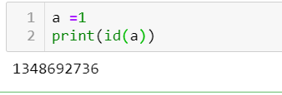

What is reverse ,split and join
Join() - String Method()
The join() is a string method which returns a string concatenated with the elements of an iterable.
If the iterable contains any non-string values, it raises a Type Error exception.

What is constructor method
__New__ and __init__
New is used to create a constructor ,
init is used to initiate object
__.def __init__():
# body of the constructor
Constructor are used for instantiating an object.
The __init__() method is called the constructor and is always called when an object is created.
What is Self?
It is used refer the Class, based on the self only the method get to know for which instance to call
What is file filehandling explain read , readline, readlines
F = open(“r c:\data\f1.txt”,r)
f.read() -- > It will print complete data
f.readline → line1
f.readlines() →[‘line1\n’, ‘line2\n’, ‘line3\n’]

What is repr() in Python?
The repr() method returns a printable representation of the given object.
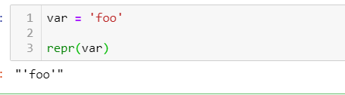

What is exception handling
An exception is an error that happens during execution of a program. When that error occurs, Python generate an exception that can be handled, which avoids your program to crash

Try , except ,finally:
try:
Execute the block of the code
Except :
If try fails to execute then it will throw the exception
Finally :
It always execute the close.browser() , database close()

Raise Exception :
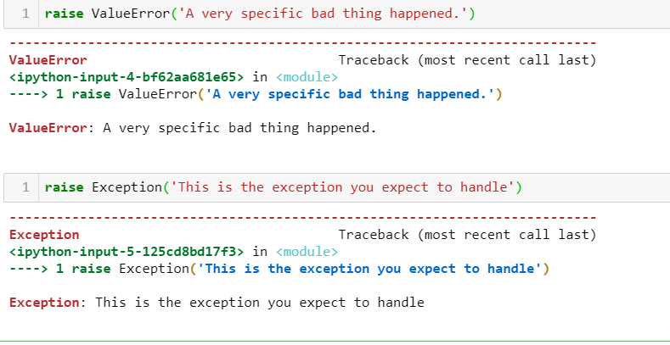
Loop Contorl Statements : while and for loop
What is break , continue and Pass in Python
Break – break statements terminate the current loop and it will continue the execution of next statement
Example :
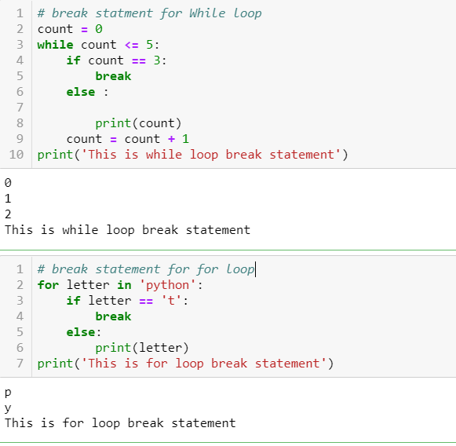

Continue – It is used to skip the part of the loop
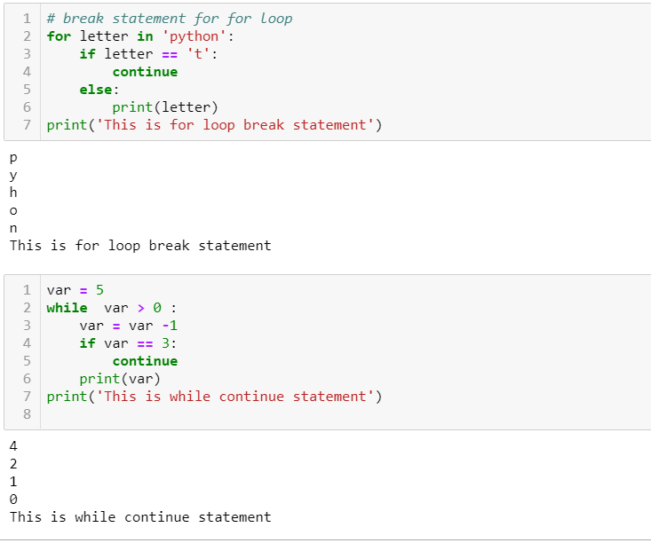

**************************************USTG**************************************
2.What is diff between function and methods in Pyhon?
Method (Instance or Object of the Class)
Method can't be called by its Name
We need to invoke the class by reference of that class in which it is defined
i.e., method is defined within and hence they are dependent on that class
(DEPENDENT)
It may or may not return any data
It will use ‘self’ keyword to instance the class

Function -INDEPENDENT
Functions can be called by only its Name as it is defined independently (INDEPENDENT)
Functions does not deal with class
It may or may not return any data
6.What is constructor method in Python ?
__init__ () -It is constructor method for a class when a instance of a class is created
7.Explain about __init__ method in python?
When a class defines an __init__() method, class instantiation automatically invokes __init__() for the newly-created class instance.
example
class Complex():
... def __init__(self, realpart, imagpart):
... self.r = realpart
... self.i = imagpart
...
>>> x = Complex(3.0, -4.5)
>>> x.r, x.i
(3.0, -4.5)

**************************************SONY**************************************
1.What is list , tuple and dictionary in Python ?
List -Mutables
– It is a hybrid data type it contains diff data types (strings, char, number, fraction num, complex num). All the data types into list
It is defined in []
Lists are mutable – we can update, add , delete
In Lists starting position starts with “0” and Ending positions starts with “-1”
Example : lst =[1,2,3,’abc’,2.5,0]

Tuple - Immutables
-Tuples are created or used with in () and can store multiple values
Tuples are Immutable – we can not update, add ,delete the tuple values
Tuples are used to store sensitive data
We can access the data by using index
Example : t =(1,2,3,’test’,2.0)
Dictionary - Mutables
-Dicts is collections of key , Value Pairs and It is used to represent the meaning full data
Dict are Mutable – able to update, delete and insert
Dict are defined in {}
Example : { ‘name’: ‘Roger’, ‘Empno’: 10001, ‘dept’: “IT’}
Note: Can we Boolearn operator as a Key in Dict → Yes False : ‘OK’
Note:Can we use duplicate keys in dict → Yes we can ,but it will overwrites
8.Can we use lists in Dictionary?
Yes – only for Values Not for Keys
Set
-It is used to store unique Values . it is defined in {}
Once a set is created, you cannot change its items, but you can add new items.
Example : empid =(1,2,3,3,4,4)
result =set(empid)
Print(result) --→ {1,2,3,4}

2.What is Self?
Self – It is used to refer the instance of the class , based on the self only , the method get to know for which instance to call
Note: Can we create a method without the self -- >
No (It will throws an Error ,’0’ position arg 1 was given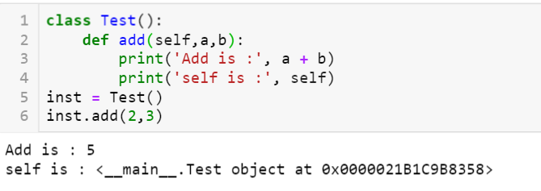

5. How to open the text file and read the data from the File
File :
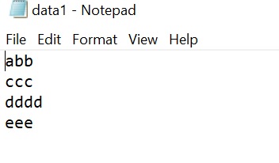
Read() – all the data
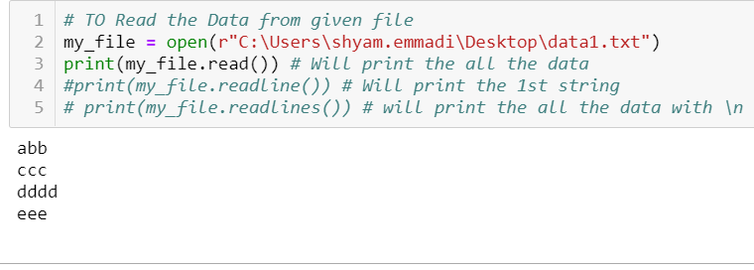
ReadiLine()- string
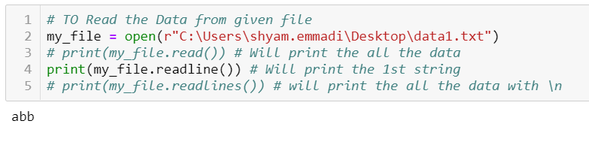
Readlines() - list
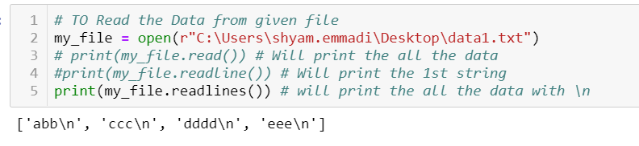

**************************************QUEST **************************************
1.What is List Comprehensive Explain about it ?
With the help of list comprehensive we can create of list in one line
It consists of brackets [ ] containing an expression followed by a for clause or if clause
The list comprehensive always returns a result list
Note: List comprehension is a complete substitute for the lambda function as well as the functions map(), filter() and reduce()
Syntax: [ expression for item in list if conditional]
Example :

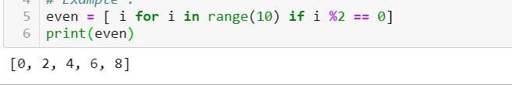

2.What is Super key /Function in Python :
Using super we can call parent class method
Example :
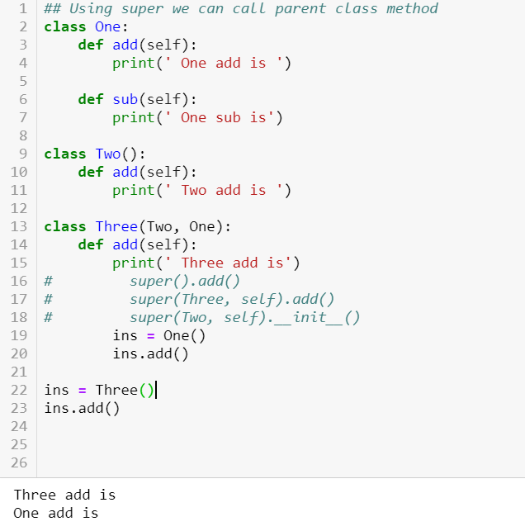

Lambda Function is called as anonymous function.
Normally we define a function with ‘def’ keyword with function name
Example:
def test_fun():
print(‘This is Function)
test_fun()

In python we can create anonymous function – function without the name .
If you want use a function only once then we will use the lambda function and we have only one expression .
Note: We can pass n num of arguments but we need to use only 1 Expression
Example:
f=lambda a : a*a
result = f(5)
print(result)
o/p - 25
f=lambda a ,b : a + b
result = f(1, 2)
print(result)
o/p – 3

**************************************HCL **************************************
1.What is lambda function in Python ?
The Lambda function / Operator is to create a anonymous functions i.e., functions with out name
What is the use of lambda function in Python ?
These lambda functions throw-away functions i.e., they are just needed where they have been created.
Note: lambda operator / function can have any num of arguments , but it can have only one expression .
It cannot contain any statement and it returns a function object which can be assigned to any variable
Syntax :
lambda argument list : expression
arguemnt_list – comma separated list of arguments
expression – arithmetic expression
you can assign the function to a variable to give it a name
----------------------------------------------------------------------------------------------------
Example :
sum =lambda x, y : x + y
sum(3,4)
o/p = 7
-----------------------------------------------------------------------------------------------------
Another way of achieving the above one
def sum(x, y):
return x + y
sum(3, 4)

What is filter ?
Python 2 we can use the map ,reduce and filter without using “list”
Note: below examples will work on only python2
Using lambda Filter lets us filter in some values based on conditional logic.
If return value is TRUE then only it stores
Syntax: filter(function, sequence)
Normal function :
def is_even(n):
n%2 == 0

Nums = [3,2,6,8,2,9]
evens = list(filter(lambda n : n%2 ==0 ,nums))
print(evens) o/p – [2,6,8,2]
--------------------------------------------------------------------------------------------------------------
What is map ?S
map() is function it takes two arguments ,
Map applies a function to every element in an iterable.
map() returns a iterator
syntax : map(fun, seq)
Example :
doubles = list(map(lambda n : n*2 ,even))
print(doubles) o/p – [4,12,16,4]

---------------------------------------------------------------------------------------------------
What is reduce ?
Reduce repeatedly reduces a sequence pair-wise until we reach a single value
sum = reduce(lambda a, b : a +b ,doubles)
print(sum ) – 4+12+16+14 -→ 46
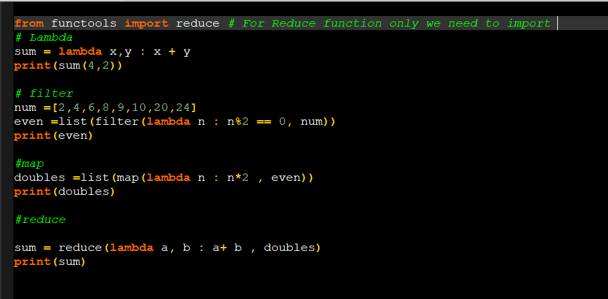
In Python 2.7
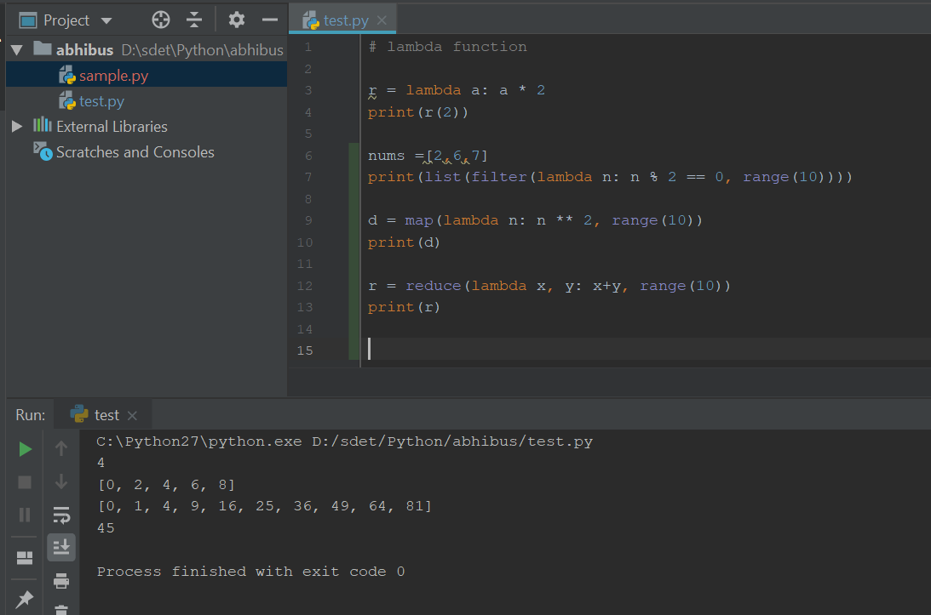
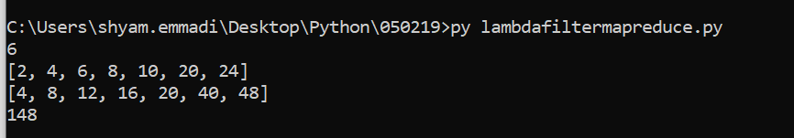

3.What is List comprehensive?
With the help of list comprehensive we can create of list in one line
It consists of brackets containing an expression followed by a for clause or if clause
The list comprehensive always returns a result list
Note: List comprehension is a complete substitute for the lambda function as well as the functions map(), filter() and reduce()
Syntax:

[ expression for item in list if conditional]
Example 1: using for clause
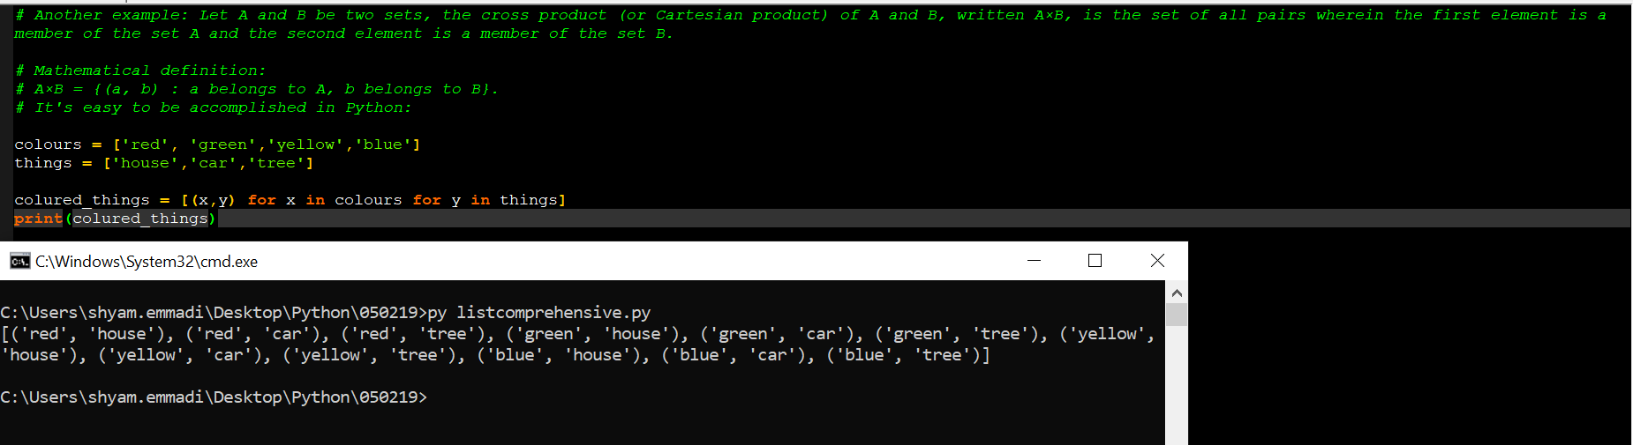
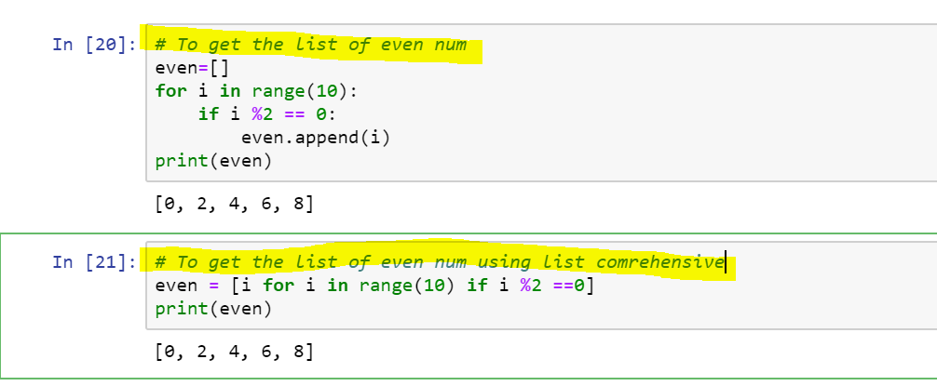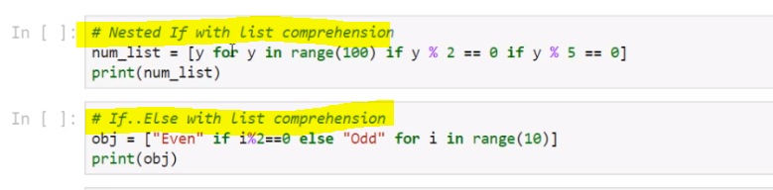

What is zip()?
The purpose of zip() is to map the similar index of multiple containers so that they can be used just using as single entity.
The zip() function take iterables (can be zero or more), makes iterator that aggregates elements based on the iterables passed, and returns an iterator of tuples.

Syntax : zip(*iterators)
Parameters : Python iterables or containers ( list, string etc )
Return Value :Returns a single iterator object, having mapped values from all the
containers.

Example : (Python27)
# initializing lists
name = [ "Manjeet", "Nikhil", "Shambhavi", "Astha" ]
roll_no = [ 4, 1, 3, 2 ]
marks = [ 40, 50, 60, 70 ]
zip(roll, marks)

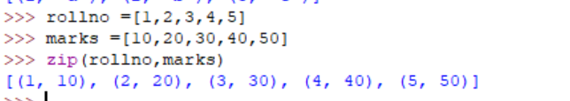

# using zip() to map values
mapped = zip(name, roll_no, marks)

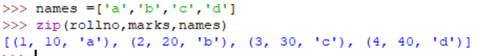
# converting values to print as set
mapped = set(mapped)

# printing resultant values
print ("The zipped result is : ",end="")
print (mapped)

# To Unzip the values
name = zip(*mapped)
print(name)

eid = zip(*mapped)
print(eid)

sal=zip(*mapped)
print(sal)

Dictionary Comprehensions:
A dictionary comprehension takes the form {key: value for (key, value) in iterable}
Convert the 2 lists into dictionary

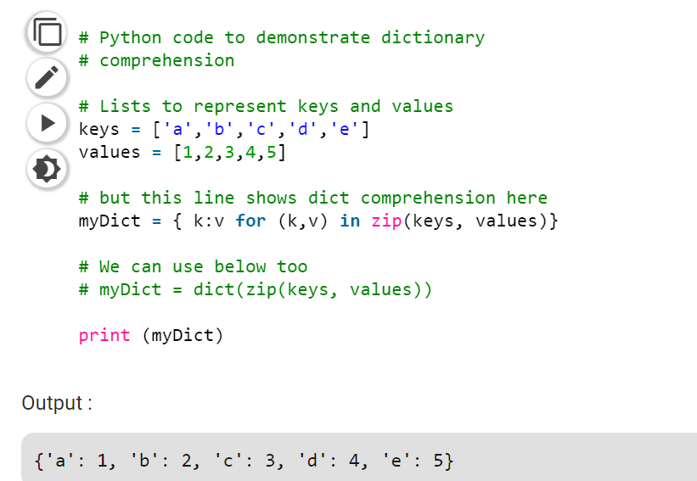

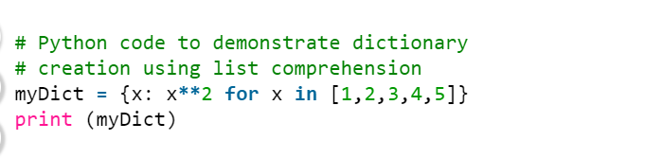
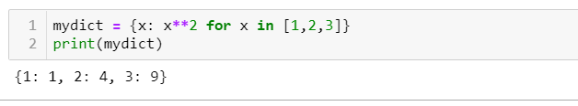
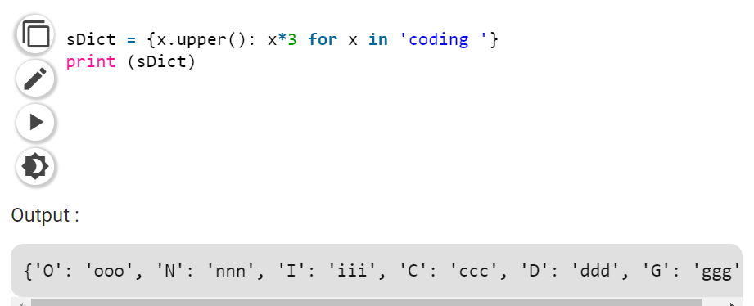

What is the diff between range() and xrange() in PYTHON 2:
Syntax: range(start, end, step)
Example : range(6) --→ [0,1,2,3,4,5]
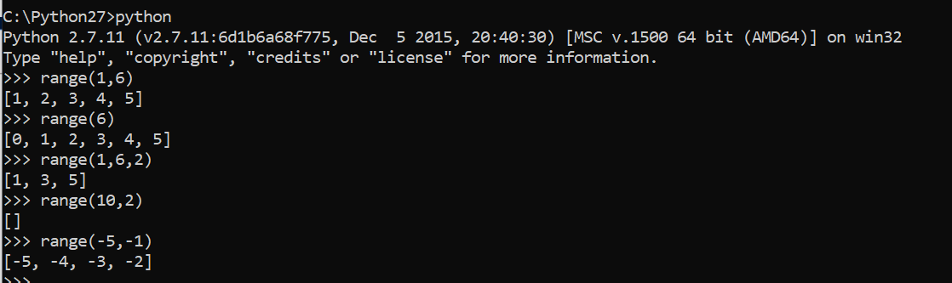
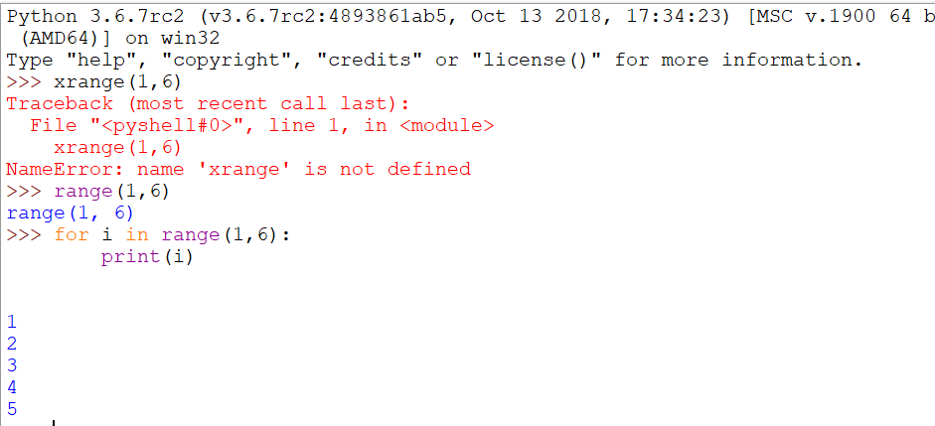

Range() : xrange():
1. It will return list of numbers 1.It will return generator object
range(1,4)
[1,2,3] To print the values need to use for loop for i in xrange(1,4): print i
o/p : 1
2
3
2.It will take more memory space 2. It will take less memory space
3.We can apply List operation 3. We can’t apply any list operations
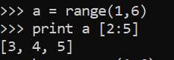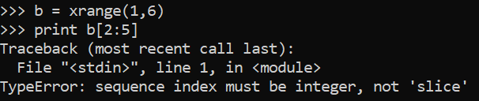

4. running the range() is faster 4.running the xrange() is slower
5.It will generate the values and stores 5.Only object – Iterate one by one value
In memory allocated at a time

Note: There is no xrange() in PYTHON3 ,it has only range() .xrange() renamed in python 3 as range().It will act same as xrange() -PYTHON2

2.What is set operators ? what is the use of set operators? How to remove duplicate values in Python?
→ It is used to store unique Values
→By using set , we can do the set operations
→ It doesn’t support for Index
It’s define in {} or () separated with ‘,’ ,set results are in { }
Eid ={1,2,3,3,4,4,5,5,’Roger’,’Roger}
Print(eid)
o/p –{1,2,3,4,5,’Roger’}
************************
eid =(1,2,2,2,3,4,4)
s =set(eid)
print(s)
o/p-{1,2,3,4}
4. What are Decorators ?
“A Decorator is a Function ,which can take other function as input and providing some output function with extended functionality ”
What is use of Decorator?
Without modifying the existing functionality , we can extended the It’s Functionality
Note: Can we call the function with decorator and without decorator ?
Yes we can call the function with and without decorator

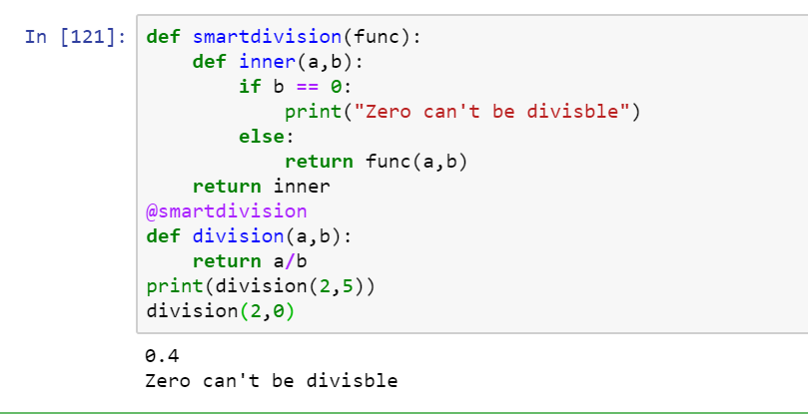

What is Generator function in Python?
“Generator is function a function which returns generator-iterator with the help of ‘Yield’ and Next Keyword .
Generator- iterator means special type of iterator
To Generate sequence of Values we will use the Generator function by using YIELD keyword and NEXT.
Note: All the generator-iterators are generators, but not all the iterators are Generators
USAGE:
1. Memory utilization will be improved and performance wise faster /Memory Efficient
2.When we compare with the normal iterators, generators are easy to use / Easy to Implement
3. Generators is best for web scrapping

4. Represent Infinite Stream
“Generators are excellent medium to represent an infinite stream of data. Infinite streams cannot be stored in memory and since generators produce only one item at a time, it can represent infinite stream of data.”

Example -What is Fibonacci Number
“The sum of the two preceding numbers. The simplest is the series 1, 1, 2, 3, 5, 8,”
What is YIELD:
Yield same as return statements it will return and will continue the statements ,Yield will not terminate the Function.

Example : To Generate Fibnaci Number # Febonaci number
def febn():
a,b = 0,1
while True:
yield a
a,b = b , a+b
for n in febn():
if n > 100:
break
print("Feb Num:", n)
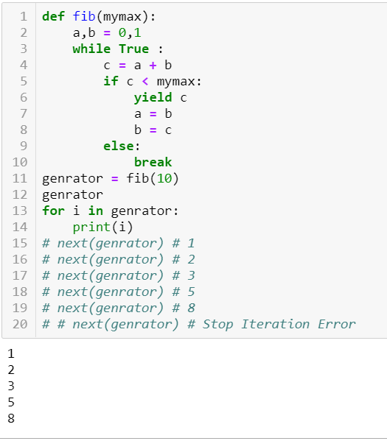

What is iterators in Python?
An Object that can be iterated Upon.,An Object which will return data , one element at a time
Iterator object must be implement with two methods __iter__() and __next__()
An Object is called iterable if we can get an iterator from it.
Most of built-in containers in Python like : list ,tuple,dict,set are iterables
Note: iter() function (which in turn calls the __iter__() method) returns an iterator from them .
Note : set and dict does not support for indexing [WHILE LOOP]
USAGE:
The Advantage of iterators is that they save resources, Storing the entire memory system in Memory .We can have infinite items in finite memory

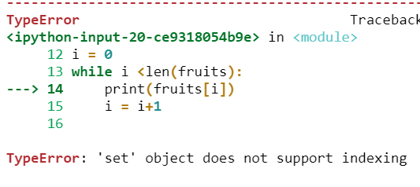
Example :
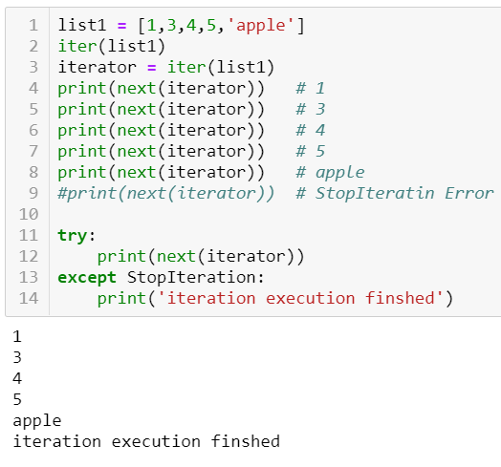
Example : Use "for" loop instead of calling next

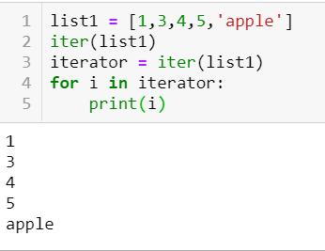

Return --
The return keyword is to exit a function and return a value.
Yield
The Yield Keyword is to continue a function and return a value

Difference between iterators and generators
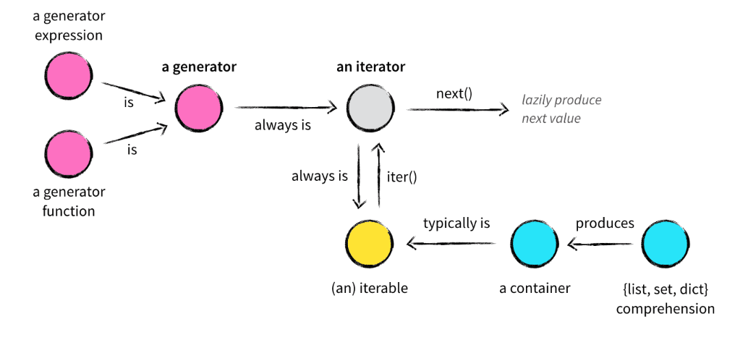

What is difference between function and method in python?
Python Method:
- Method is called by its name, but It is associated to an object (dependent).
- A method is implicitly passed the object on which it is invoked.
- It may or may not return any data.
- A method can operate on the data (instance variables) that is contained by the corresponding class

# Python 3 User-Defined Method
class ABC : /////
def method_abc (self):
print("I am in method_abc of ABC class. ")

class_ref = ABC() # object of ABC class
class_ref.method_abc()

function:
- Function is block of code that is also called by its name. (independent)
- The function can have different parameters or may not have any at all. If any data (parameters) are passed, they are passed explicitly.
- It may or may not return any data.
- Function does not deal with Class and its instance concept.

def Subtract (a, b):
return (a-b)

print( Subtract(10, 12) ) # prints -2

print( Subtract(15, 6) ) # prints 9

4. What is switch in Python ?
5.How Memory Allocation / Memory managed works in Pyhon
Dynamic memory allocation
6.What is mocking in unit testing ?
7. Mention why to choose Python over Java in Selenium?
Few points that favor Python over Java to use with Selenium is,
Java programs tend to run slower compared to Python programs.
Java uses traditional braces to start and ends blocks, while Python uses indentation.
Java employs static typing, while Python is dynamically typed.
Python is simpler and more compact compared to Java
8.How create a branches in Github?
>git branch # It will give all the branches
*Master
> git branch [branch name] thirsty
>git branch
*Master
Thirsty
>git checkout thirsty [To make thirsty branch active ]
Switched to branch thirsty
>git branch
*Master
*thirsty
9.How to rename the one file in github command , what is the command ?
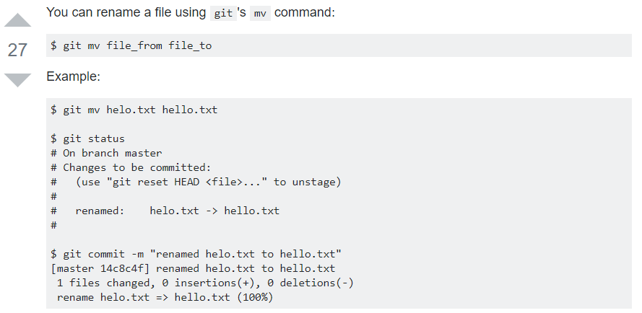10.What is difference between svn and github ?
GitHub svn
1.Git is distributed VCS 1.SVN is non-distributed VCS
2.Git has a Centralized server and repo 2.SVN does not have centralized server and repo
3.The Content in Git is stored in meta data 3.SVN stores files of content
4.Where using Git ,we can have local repo 4.We don’t have local repo
4.Git branches are easier to work with than SVN branhes
Apple:

1.parse a csv file and
extract the name, phone numebers, emails into a dict.
2. 1. How would I test a new drag-n-drop feature
3. I was given an iPad and asked to explain my general test automation strategy, then select one particular area, write test cases, a test class and a code
4. How would I test the entire API
5. What is the purpose pass statement in Python?
# pass is just a placeholder for functionality to be added later.
Suppose we have a loop or a function that is not implemented yet, but we want to implement it in the future. They cannot have an empty body. The interpreter would complain. So, we use the pass statement to construct a body that does nothing.
sequence = {'p', 'a', 's', 's'}
for val in sequence:
pass

6. How do you look for locators on a page (have you used any tools?)

IBM:
1.What is decorator
2.What is Listeners
3.In JSON Response How to get the specific record in dict? Here I want to get the id = 432
D ={
“name”: “abc”
“id”: 123
“name1”:222
“id”: 432
}
4.Write a method to iterate the values in dict ?
5.how to connect to db using python ? and get the table name
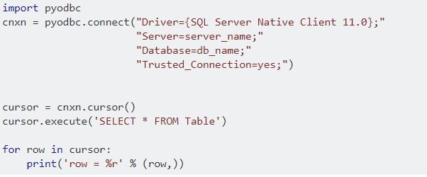

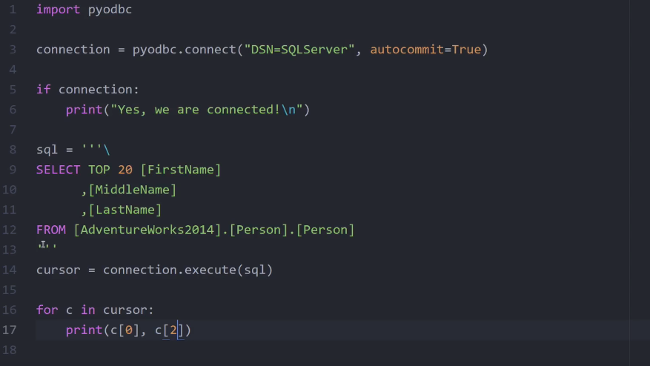
6.What are all Assertions?

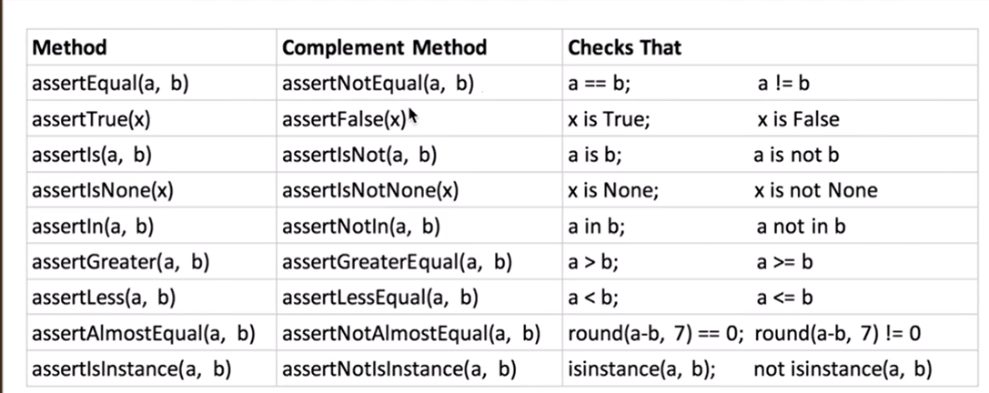
AssertEqual ,AssertEquals, AssertNotEqual
AssertTrue, AssertFalse
AssertAlmostEqual, AssertAlmostEquels
AssertGreater,AssertGreaterEquel
AssertIn,AssertRises
What are All Exceptions?
NosuchElementException
NoSuchAlertPresentException
NoSuchFrameException
NoSuchWindowException
ElementVisibleException
ElementnotSelectedException
InvalidSelectorException
TimeoutException
SeeionNotFoundException
WebdriverException
StaleElementRefrenceException

- ElementNotVisibleException: Although an element is present in the DOM, it is not visible (cannot be interacted with). E.g. Hidden Elements – defined in HTML using type=”hidden”.
- ElementNotSelectableException: Although an element is present in the DOM, it may be disabled (cannot be clicked/selected).
- InvalidSelectorException: Selector used to find an element does not return a WebElement. Say XPath expression is used which is either syntactically invalid or does not select WebElement.
- NoSuchElementException: WebDriver is unable to identify the elements during run time, i.e. FindBy method can’t find the element.
- NoSuchFrameException: WebDriver is switching to an invalid frame, which is not available.
- NoAlertPresentException: WebDriver is switching to an invalid alert, which is not available.
- NoSuchWindowException: WebDriver is switching to an invalid window, which is not available.
- StaleElementReferenceException: The referenced element is no longer present on the DOM page (reference to an element is now Stale). E.g. The Element belongs to a different frame than the current one OR the user has navigated away to another page.
- SessionNotFoundException: The WebDriver is performing the action immediately after ‘quitting’ the browser.
- TimeoutException: The command did not complete in enough time. E.g. the element didn’t display in the specified time. Encountered when working with waits.
- WebDriverException: The WebDriver is performing the action immediately after ‘closing’ the browser.

7.How do you get to know whether the textbox is able to enter text or not ?
Element.is_enabled()
8.After peer review the code , if you need to do some changes -> after some changes how to commit back it again ?
9.What area all RESTAPI methods ?
10.Tell me about Your Framework
11.how to take screenshot for single iteration in python

Differences between remove(), delete() and pop()
remove - Takes value, removes first occurrence, and returns nothing
delete - Takes index, removes value at that index, and returns nothing
pop - Takes Index and returns Value
# Remove - remove removes the first matching value, not a specific index:
A=[0,2,3,2]
a.remove(2)
a →[0,3,2]
--------------------------------------------------------------------------------------------------------------------
# del Deletes the item at specific index
B =[3,2,2,1]
Del b[1]
b→[3,2,1 ]
------------------------------------------------------------------------------------------------------------------------
# pop, removes the item at a specific index and returns it
P =[4,3,5]
a.pop(1)
a→[4,5]
-------------------------------------------------------------------------------------------------------------------------

1.What is Python? What are the benefits of using Python?

Answer: Python is a programming language with objects, modules, threads, exceptions and automatic memory management. The benefits of pythons are that it is simple and easy, portable, extensible, build-in data structure and it is an open source.

2. How Python can be used in software testing?

Answer:
1. To generate test data; parse test results; generate reports; testing API calls etc.
2. Python to extract requirements from a Word document.
3. For testing tasks automation, setting up environments for tests, extracting performance data, etc…
4. Testers use Python extensively in many companies with Selenium for test automation.
5. For writing desktop applications used by testers.
6. Test data manipulation.
7. To build test environment
8. Testing with IronPython on .NET

3.What Python frameworks do you know?

Answer: Framework called Web2py, PAMIE (Python automation Module for I. E.), The py.test framework

4.Question:What tools that helps Python development do you know?

Answer:There are good tools for helping Python development such as Notepad++ with the PyNPP plugin and Eclipse with PyDev and PyUnit.

5. The following is displayed by a print function call:
yesterday today tomorrow Please write an example of a print function.

Answer: print(‘yesterday\ntoday\ntomorrow’)

6.The following is displayed by a print function call:

Answer:hello-how-are-you

7. Please write an example of a print function.
Answer: print(‘hello’ + ‘-‘ + ‘how’ + ‘-‘ + ‘are’ + ‘-‘ + ‘you’)

8. What does the expression len(”) evaluate to?
Answer: 0

9.Considering the following code:
s = ‘catandapple’
Write an expression that evaluate to ‘apple’.
Answer: s[-5:]

10.Write an expression that evaluate to True
Answer: len(‘aaddgg’) == 6

12.What are “tuples”
Answer: Tuples are immutable sequences: they cannot be modified. Tuples use parentheses instead of square brackets: tup = (‘test’, 5, -0.2)

13. What are the rules for legal Python names?
Answer:
1. Names must start with a letter or _.

2. Names must contain only letters, digits, and _.

14.. Which command do you use to exit help window or help command prompt?

quitWhen you type quit at the help’s command prompt, python shell prompt will appear by closing the help window automatically

15. Does the functions help() and dir() list the names of all the built_in functions and variables? If no, how would you list them?

No. Built-in functions such as max(), min(), filter(), map(), etc is not apparent immediately as they are
available as part of standard module.To view them, we can pass the module ” builtins ” as an argument to “dir()”. It will display the
built-in functions, exceptions, and other objects as a list.>>>dir(__builtins )
[‘ArithmeticError’, ‘AssertionError’, ‘AttributeError’, ……… ]

16. Explain how Python does Compile-time and Run-time code checking?

Python performs some amount of compile-time checking, but most of the checks such as type, name, etc are postponed until code execution. Consequently, if the Python code references a user -defined function that does not exist, the code will compile successfully. In fact, the code will fail with an exception only when the code execution path references the function which does not exists.

17.What is a “unittest” in Python?

The unit testing framework of Python is known as “unittest”. It supports the sharing of setups, automation testing, shutdown code for tests, aggregation of tests into collections, among others.

18.Define “slicing”.

“Slicing” is a mechanism to select a range of items from sequence types like list, tuple, strings etc.

19.What are generators in Python?

Generators are the means to implement iterators. It is a normal function except that it yields “expression” in the “function”.

20.Define “docstring”.

“Docstring” is a Python documentation string. It is the means to document Python “functions”, “modules” and “classes”.

21.How do you copy an object in Python?

copy.copy () or copy.deepcopy()

22.What is a “negative index”?

Python sequences can be indexed as positive and negative numbers. For ac positive index, 0 is the first number, 1 is the second etc. For a negative index, (-1) is the last index and (-2) is the second etc.

23.How do you convert a number into a string?

By using the inbuilt function str().

24.What is the difference between “Xrange” and “range”?

“Xrange” returns the “Xrange” object
while range returns the “list” irrespective of the size of the “range”.

25.Define “module” and “package”.
A file containing a set of functions you want to include in your application
Each Python program file is a “module”, which imports other modules like “objects” and “attributes”.
package”.
A Python program folder is a “package” of “modules”.
A package can have “modules” or “subfolders”.

26.What is Python? What are the benefits of using Python?

Python is a programming language with objects, modules, threads, exceptions and automatic memory management. The benefits of pythons are that it is simple and easy, portable, extensible, build-in data structure and it is an open source.

27.What is PEP 8?

PEP 8 is a coding convention, a set of recommendation, about how to write your Python code more readable.

28.What is pickling and unpickling?

Pickle module accepts any Python object and converts it into a string representation and dumps it into a file by using dump function, this process is called pickling. While the process of retrieving original Python objects from the stored string representation is called unpickling.

29. How Python is interpreted?

Python language is an interpreted language. Python program runs directly from the source code. It converts the source code that is written by the programmer into an intermediate language, which is again translated into machine language that has to be executed.

30. How memory is managed in Python?

Python memory is managed by Python private heap space. All Python objects and data structures are located in a private heap. The programmer does not have an access to this private heap and interpreter takes care of this Python private heap.
The allocation of Python heap space for Python objects is done by Python memory manager. The core API gives access to some tools for the programmer to code.
Python also have an inbuilt garbage collector, which recycle all the unused memory and frees the memory and makes it available to the heap space.

Convert the list into Dict
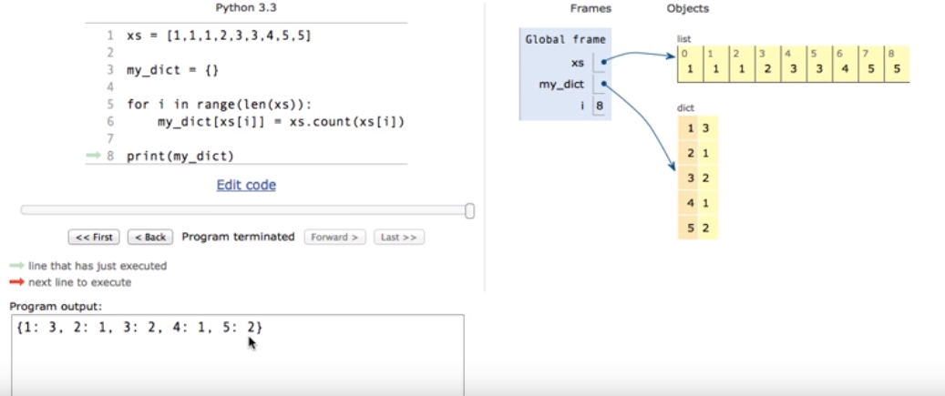

What are Python functional arguments
There are 4 types of Functional arguments
1.Required or Positional Arguments
2.Keyword arguments
3.Default Arguments
3.Variable Length Arguments *args and **kwargs

1.Required and Positional Arguments
“Required arguments are the arguments passed to a function in correct positional order. Here, the number of arguments in the function call should match exactly with the function definition.”
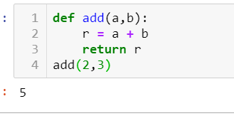
You must pass at least argument other wise it will throw positional argument error

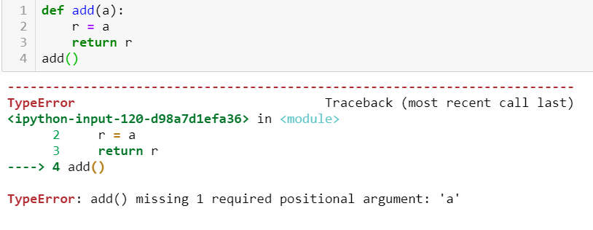

2. Keyword Arguments
“Keyword arguments are related to the function calls. When you use keyword arguments in a function call, the caller identifies the arguments by the parameter name.”
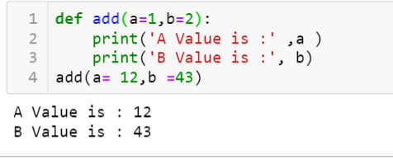

3.Default Arguments
“A default argument is an argument that assumes a default value if a value is not provided in the function call for that argument.”
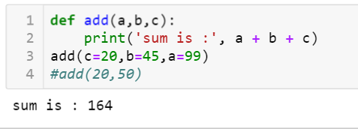
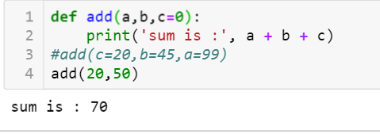
Note: Using Default arguments we can provide a default value to the parameters
Note1:If you don’t pass values to parameters then it will take default value
Note2:Default parameters should follow the Required arguments

4.Length Arguemtns
what is args and kwargs or Variable length Arguments
*args -It is used to pass a non-keyworded, variable-length argument list.
the symbol * to take in a variable number of arguments;
Note: It will give the tuple format
Example:
def add(a, b):
r = a + b
return r
print( add(2,3))
o/p – 5
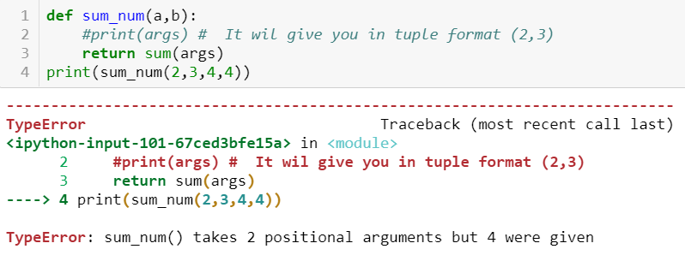
In the above example we are passing only 2 values to function if you print the fun it will return in tuple format
In case if we want to pass n num of values or arguments to fun ,in this scenario we will use * args concept Here * represents “ N” num of non keyword variable arguments passing to function
Example :
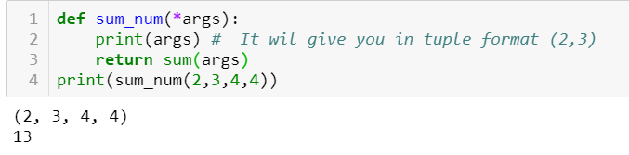
**kwargs-It is used to pass a keyworded, variable-length argument list.
We use the name kwargs with the double star. The reason is because the double star allows us to pass through keyword arguments (and any number of them).
Note : It will give the Dict format i.e. Keys and Values Format
Example:
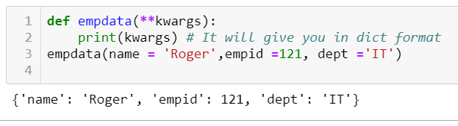

what is diff between unittest and pytest

5. What is the purpose pass statement in Python?
# pass is just a placeholder for functionality to be added later.
Suppose we have a loop or a function that is not implemented yet, but we want to implement it in the future. They cannot have an empty body. The interpreter would complain. So, we use the pass statement to construct a body that does nothing.
sequence = {'p', 'a', 's', 's'}
for val in sequence:
pass

what are concepts are implemented in your framework
what kind of report you are using
what type enhancements are used
what is decorator
what is generator
what is yield
Yield same as return statements it will return and will continue the statements
Yield will not terminate the Function .
What is Return
It will return the given value and terminate the loop

What are Sort Algorithm?
https://www.tutorialspoint.com/python/python_sorting_algorithms.htm
What are Search Algorithm?
Searching is a very basic necessity when you store data in different data structures. The simplest appraoch is to go across every element in the data structure and match it with the value you are searching for. This is known as Linear search. It is inefficient and rarely used, but creating a program for it gives an idea about how we can implement some advanced search algorithms.

Linear Search
In this type of search, a sequential search is made over all items one by one. Every item is checked and if a match is found then that particular item is returned, otherwise the search continues till the end of the data structure.

def linear_search(values, search_for):
search_at = 0
search_res = False

# Match the value with each data element
while search_at < len(values) and search_res is False:
if values[search_at] == search_for:
search_res = True
else:
search_at = search_at + 1

return search_res

l = [64, 34, 25, 12, 22, 11, 90]
print(linear_search(l, 12))
print(linear_search(l, 91))
When the above code is executed, it produces the following result −
True
False

Interpolation Search
This search algorithm works on the probing position of the required value. For this algorithm to work properly, the data collection should be in a sorted form and equally distributed. Initially, the probe position is the position of the middle most item of the collection.If a match occurs, then the index of the item is returned. If the middle item is greater than the item, then the probe position is again calculated in the sub-array to the right of the middle item. Otherwise, the item is searched in the subarray to the left of the middle item. This process continues on the sub-array as well until the size of subarray reduces to zero.
There is a specific formula to calculate the middle position which is indicated in the program below.

def intpolsearch(values,x ):
idx0 = 0
idxn = (len(values) - 1)

while idx0 <= idxn and x >= values[idx0] and x <= values[idxn]:

# Find the mid point
mid = idx0 +\
int(((float(idxn - idx0)/( values[idxn] - values[idx0]))
* ( x - values[idx0])))

# Compare the value at mid point with search value
if values[mid] == x:
return "Found "+str(x)+" at index "+str(mid)

if values[mid] < x:
idx0 = mid + 1
return "Searched element not in the list"

l = [2, 6, 11, 19, 27, 31, 45, 121]
print(intpolsearch(l, 2))
When the above code is executed, it produces the following result −
Found 2 at index 0

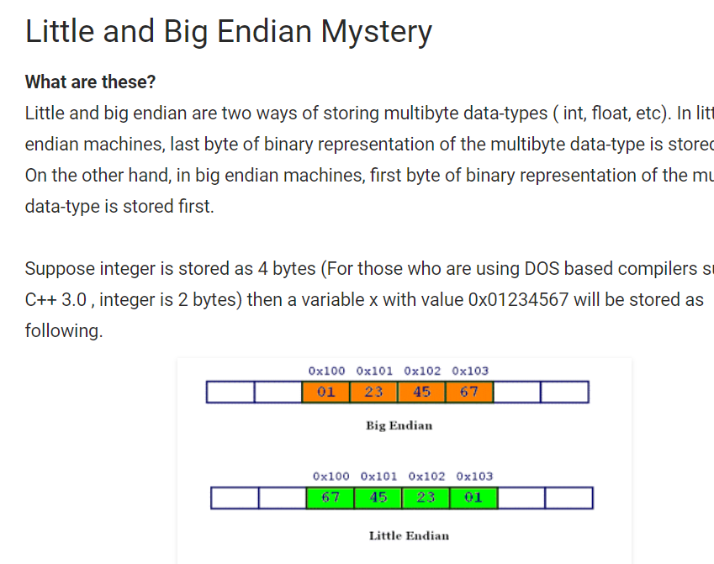
To get the All the HyperLinks in the given WebPage:
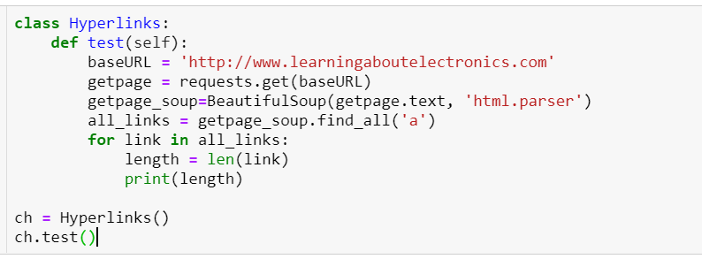
To get the broken Links in give Web Page:
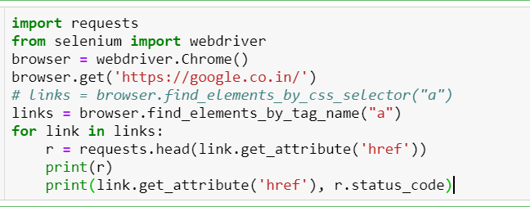

Difference between JSON and XML
- JSON doesn't use end tag
- JSON is shorter
- JSON is quicker to read and write
- JSON can use arrays
The biggest difference is:
XML has to be parsed with an XML parser. JSON can be parsed by a standard JavaScript function.

Why JSON is better than XML
XML is much more difficult to parse than JSON.
JSON is parsed into a ready-to-use JavaScript object.

How can you generate random numbers in Python?
Random module is the standard module that is used to generate the random number. The method is defined as
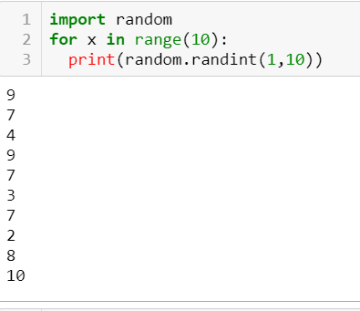
How do you split the words?
split() – uses a regex pattern to “split” a given string into a list.
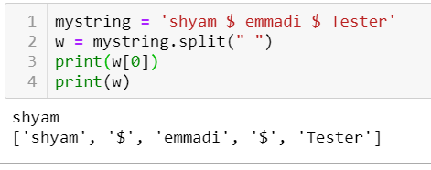
What is docstring in Python?/documentation string
Docstring – multi line string
It describe what the function does
“ ” ”
“ ” ”
Python documentation strings (or docstrings) provide a convenient way of associating documentation with Python modules, functions, classes, and methods. As you can see, even for a relatively simple function, documenting using comments quickly makes it unpleasant and difficult to read. So, to solve this, the docstring was introduced. A docstring is simply a multi-line string, that is not assigned to anything. It is specified in source code that is used to document a specific segment of code. Unlike conventional source code comments, the docstring should describe what the function does, not how.
Explain how to delete a file in Python?
os.remove (filename) or os.unlink(filename)
What are Stubs?
For example, in a situation where one has three different modules: Login, Home, User. Suppose login module is ready for test, but the two minor modules Home and User, which are called by Login module are not ready yet for testing. At this time, a piece of dummy code is written, which simulates the called methods of Home and User. These dummy pieces of code are the stubs.
How to remove extensions from a file?
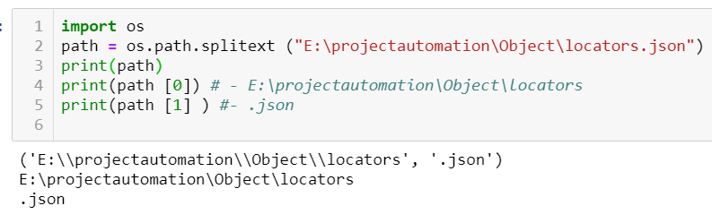

How do you design your individual test script?
Try:
Open browser
Function 1
…………..
…………..
Function n
Do assertion/validation
Clear the test data to ready for next run
Except Exception:
Take screenshot
Exception handling
Fail the test script
Finally:
Close browser
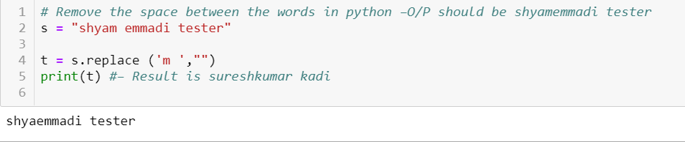

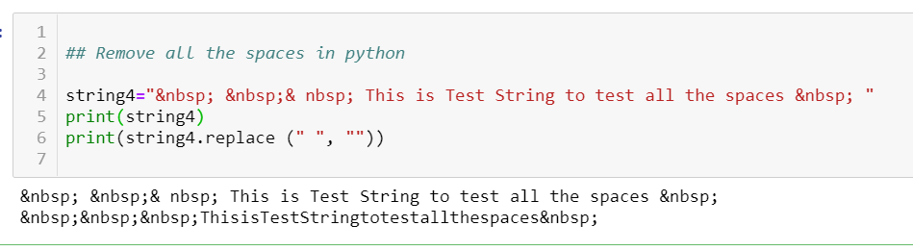

Difference between shallow copy and deep copy()?
Shallow Copy: Shallow copy creates a copy of the object but references each element of the object
Deep copy: Deep copy creates a copy of the object and elements of the object

How to configure the logging in your project /framework?
With the logging module imported, you can use something called a “logger” to log messages that you want to see. By default, there are 5 standard levels indicating the severity of events. Each has a corresponding method that can be used to log events at that level of severity. The defined levels, in order of increasing severity, are the following:
- DEBUG
- INFO
- WARNING
- ERROR
- CRITICAL
