Write a function to sum of the given list

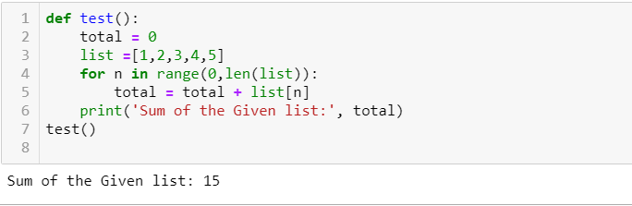

We can use reduce() for sum of the given list

List =[1,2,3,4,5,6]

Sum = reduce(lambda a,b: a+b , list)

Print(sum)

1.Write a Febnoci program / Mathematical Logic to remember
Fn = Fn-1 + Fn-2

F0 = 0 and F1 = 1.

def Fibonacci(n):
if n<0:
print("Incorrect input")
# First Fibonacci number is 0
elif n==1:
return 0
# Second Fibonacci number is 1
elif n==2:
return 1
else:
return Fibonacci(n-1)+Fibonacci(n-2)

# Driver Program

print(Fibonacci(9))

#This code is contributed by Saket Modi

Reverse Sentence

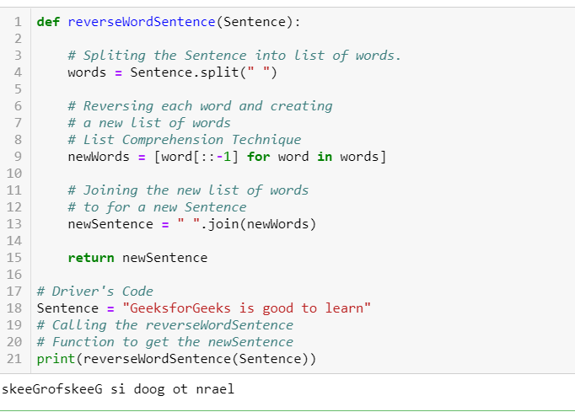

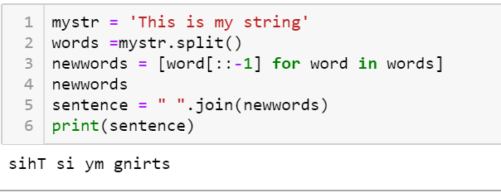

Reverse String with Reverse method

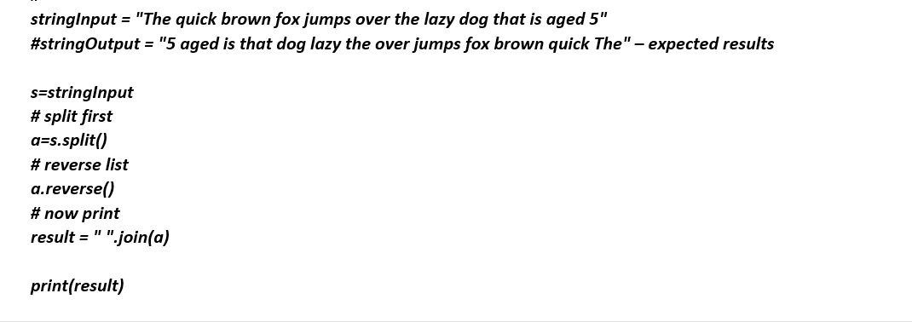

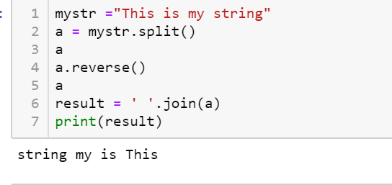

Reverse String Without Reverse Method

Refer - https://www.w3resource.com/python-exercises/python-functions-exercise-4.php

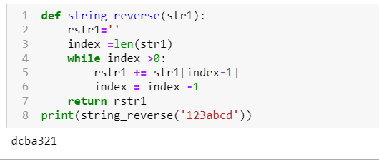

Gmail Id matching using Regular Expressions

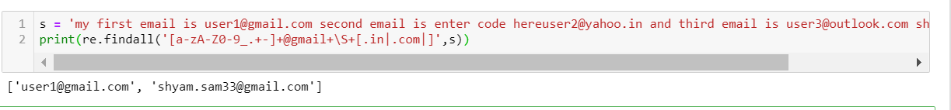

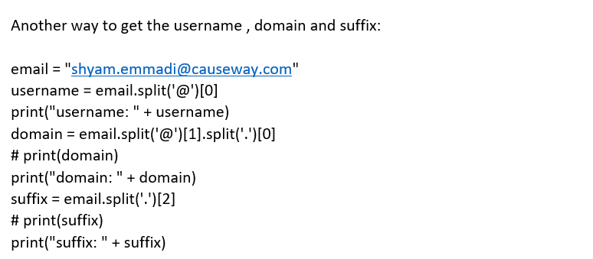

Swap the Two values of 2 variables without using third Variable

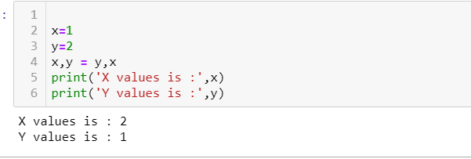

Find Max and Min Values without min() and max() functions

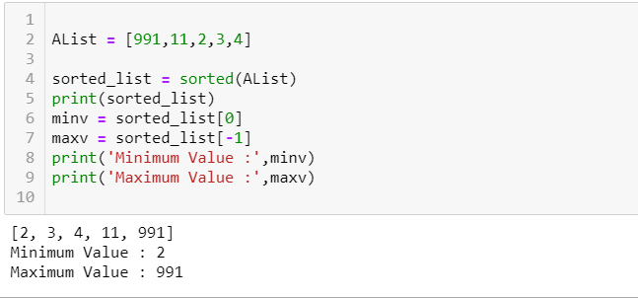

Finding Missing Numbers in a Given List

Note: When you use the ^ operator, behind the curtains the method __xor__ is called.
a^b is equivalent to a.__xor__(b).
Also, a ^= b is equivalent to a = a.__ixor__(b) (where __xor__ is used as a fallback when __ixor__ is implicitly called via using ^= but does not exist).
In principle, what __xor__ does

To explain one of your own examples:
>>> 8^3
11
Think about it this way:
1000 # 8 (binary)
0011 # 3 (binary)
---- # APPLY XOR ('vertically')
1011 # result = 11 (binary)

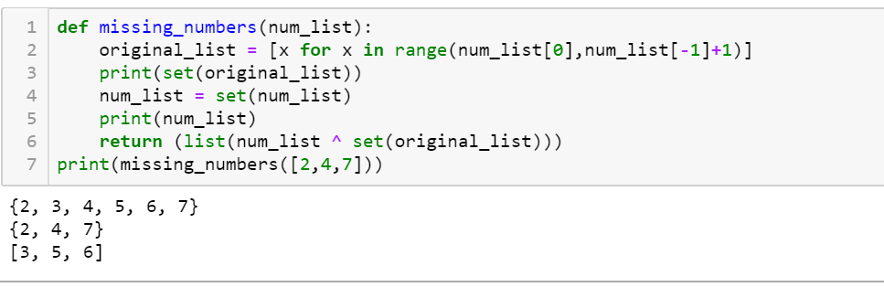

Remove duplicate Chars in a given String
"".join() --> It joins two adjacent elements in
# iterable with any symbol defined in
# "" ( double quotes ) and returns a
# single string

An OrderedDict is a dictionary that remembers the order of the keys that were inserted first. If a new entry overwrites an existing entry, the original insertion position is left unchanged.

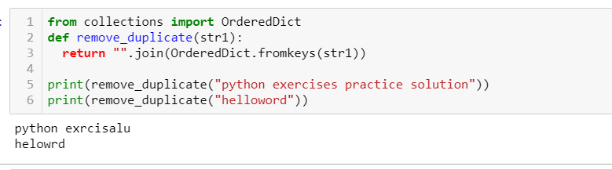

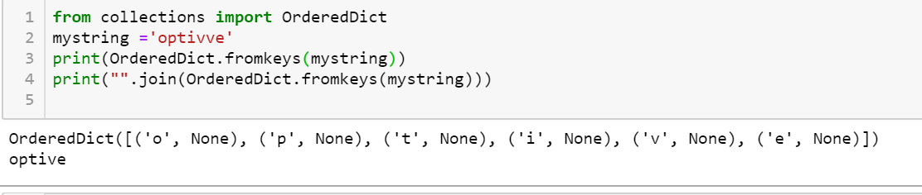
3. Remove duplicate values in a given list
L = [1,1,2,2,4] o/p l=[1,2,4] Write a function to get the above output
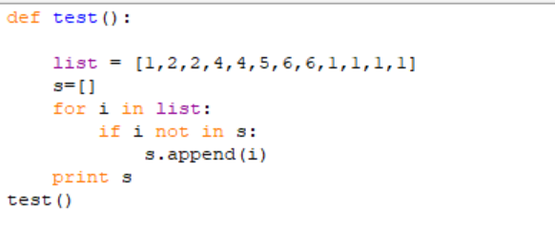

Get words count in a given file

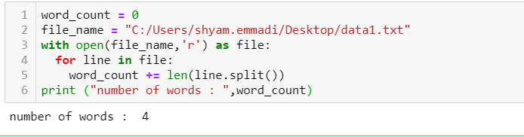

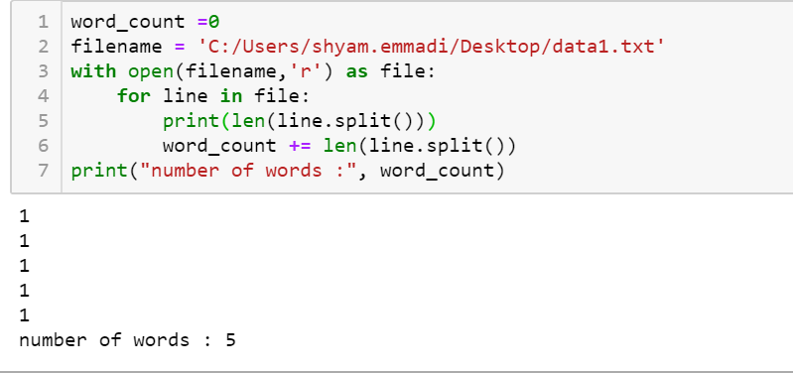

Get Repeated words count in a given file

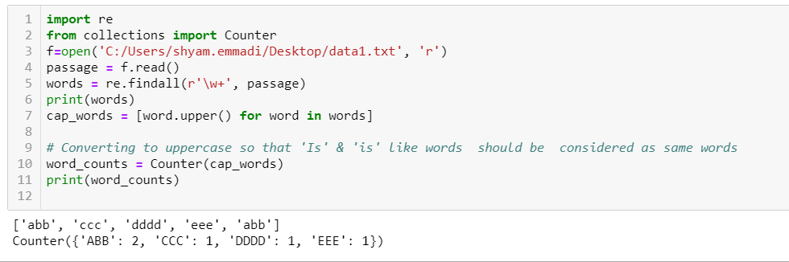

Char Count from the Given File

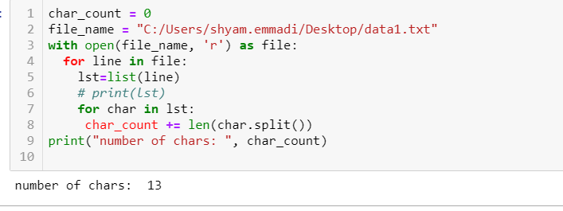

Get all Permutations and combinations of a given string

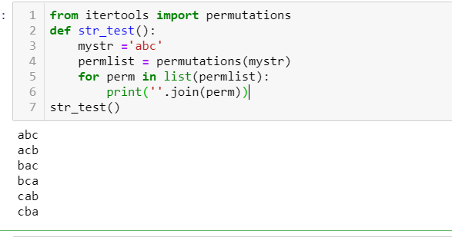

1.Char Count -Counting repeated characters in a given string in Python

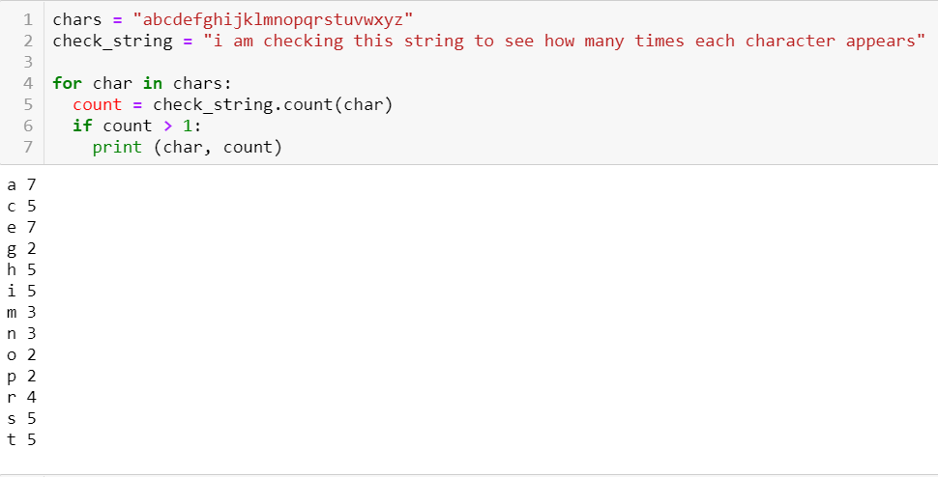

from collections import Counter
>>> Counter('qwertyqweryyyy')
Counter({'y': 5, 'e': 2, 'q': 2, 'r': 2, 'w': 2, 't': 1})

2.Counting repeated string in a given string
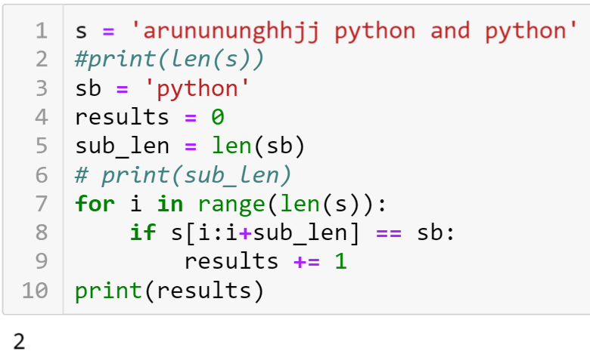

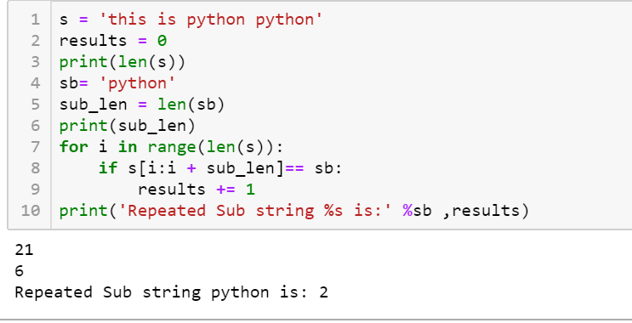

1.How to Separate the Alpha Numeric from the given string
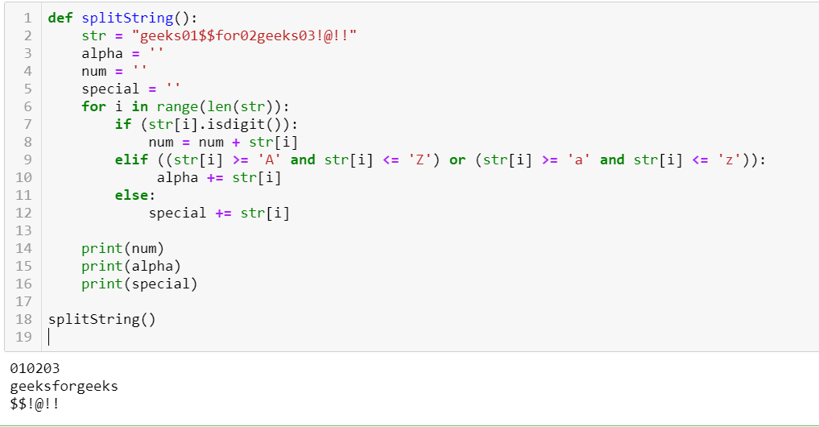
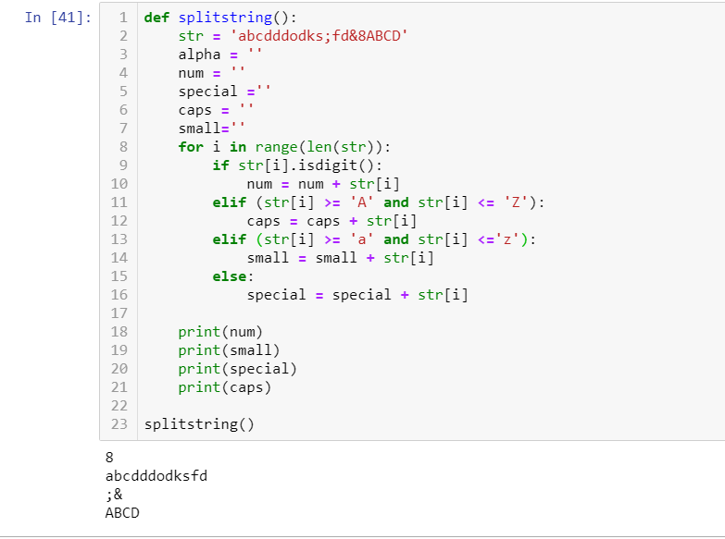

1.How to check the weather given string exist nums or not ?
My string= ‘jamesbond007’
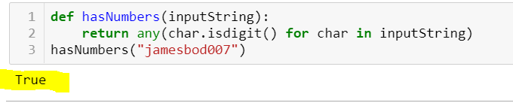
2.Max Two numbers from the given list
In Python, use heapq.nlargest. This is the most flexible approach in case you ever want to handle more than just the top two elements.
Note: Heap data structure is mainly used to represent a priority queue.
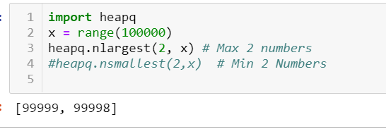
3.How to update sets using value ?
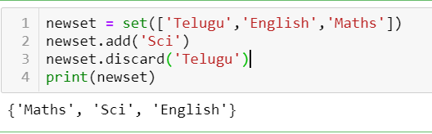

How to separate even and odd numbers from the given list ?
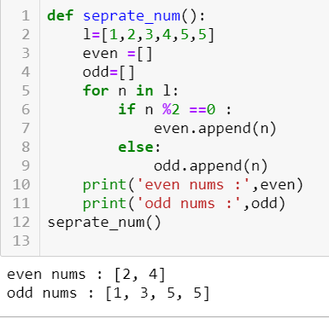

How to Split Words?
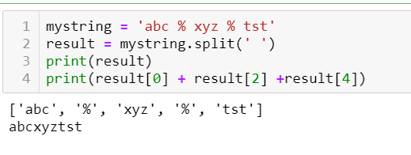

How to swap dictionary Values ?
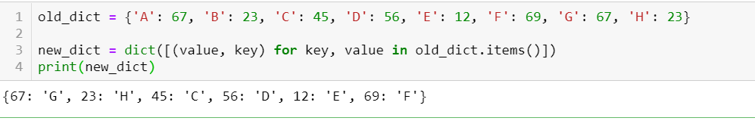

How to Print list of Numbers?
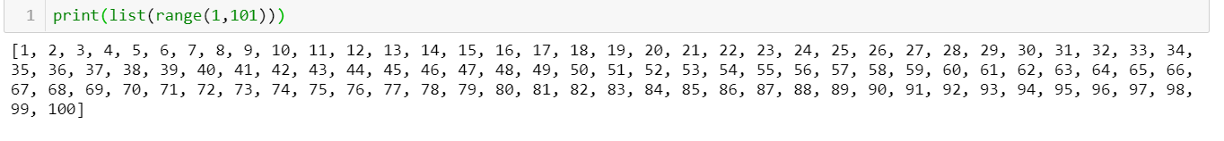
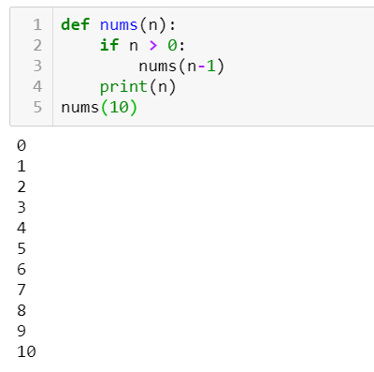

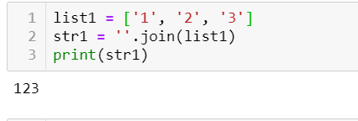
4.Convert the string to int
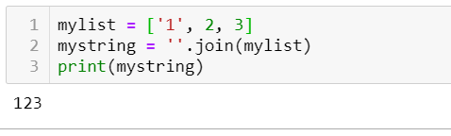
5.Convert int to string
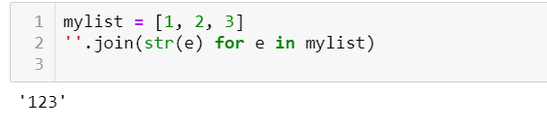
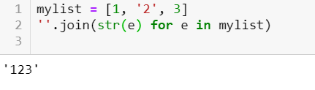
6.Tuple convert string to int
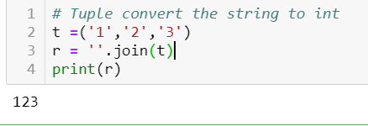
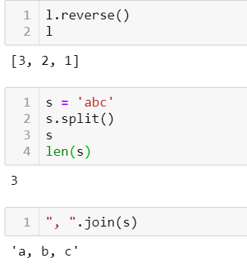

How to split the given string
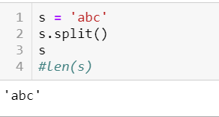
How to find the len of the given string after split
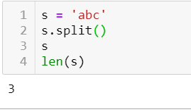

2.Can we call list in Dictionary
NO
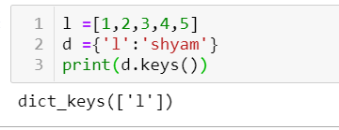

3.Print Odd numbers using filter ?

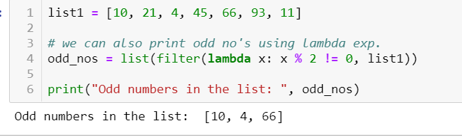

2.Print the Factorial for a given Number?
‘’’The factorial of a number is the product of all the integers from 1 to that number.
For example, the factorial of 6 (denoted as 6!) is 1*2*3*4*5*6 = 720.
Factorial is not defined for negative numbers and the factorial of zero is one, 0! = 1.
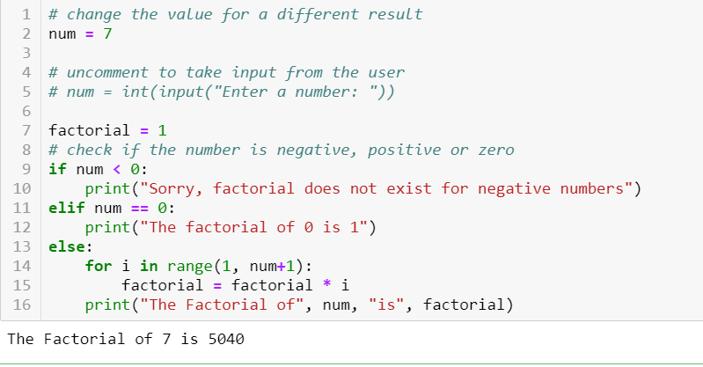

Python Number pattern to display below format :
https://pynative.com/print-pattern-python-examples/
1
1 2
2 3 4

**************************************google**************************************
1.Shift all zeros to left, but dont use conditions that if matched 0 then appends it to right. Rather compare the two adjacent numbers and if anyone the first of them is zero, replace the position.
array = [ 3, 4, 5, 0, 0, 3, 9, 0, 8]
https://stackoverflow.com/questions/33507374/how-to-move-zeros-to-the-end-of-a-list
https://www.youtube.com/watch?v=U7rxgP-fp8E
https://www.geeksforgeeks.org/given-a-string-find-its-first-non-repeating-character/
PUSH ALL ZEROS TO LEFT
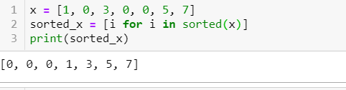

PUSH ALL ZEROS RIGHT
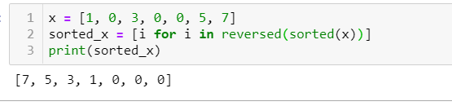
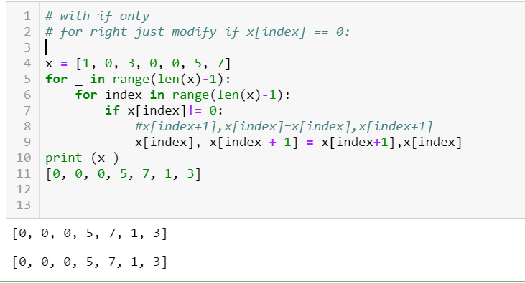

2.SWAP the Nums from the given list
list =[1,3,2,4]
temp=list[2]
list[2]=list[1]
list[1]=temp
print list
[1, 2, 3, 4]
3. Given a string as below. Write a function to do the arithmetic operation and share the result
e.g. string = "1+2+3" Result should be 6
string = "-2+4+5" Result should be 7

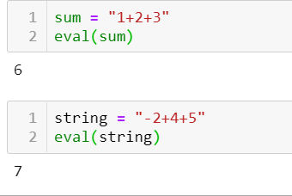
4. Given a string, write a method to return the first non repeating character. Eg: "Google" -->"l"
Good Explanation : https://www.w3resource.com/python-exercises/string/python-data-type-string-exercise-51.php
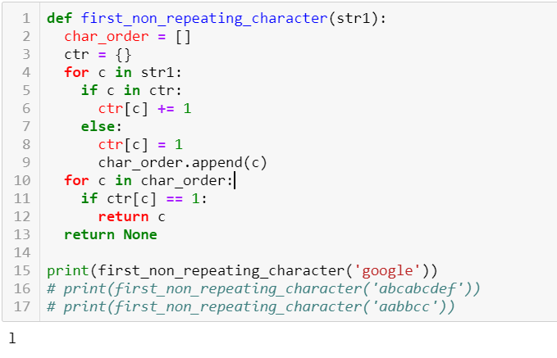
Will amend Keys in dictionary ?
There is no Direct way to Amend Keys in Dictionary
a = {1:2, 3:4}
a[5] = a.pop(1)
a
{3: 4, 5: 2}
3. Remove duplicate values in a given list
L = [1,1,2,2,4] o/p l=[1,2,4] Write a function to get the above output
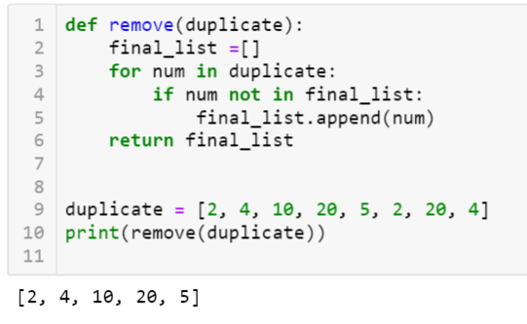
4. Write a Function to sort the Numbers
num = [1,4,2,7,6,8] o/p =[1,2,4,7,6,8] Write a function to sort the numbers
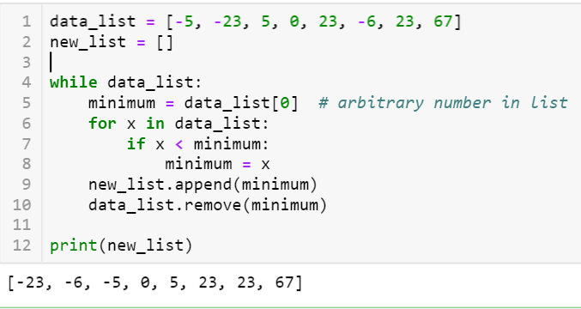
5.How to swap the Values in Python Array1.What is Lambda Function in Python?
list =[1,3,2,4] o/p -[1,2,3,4]
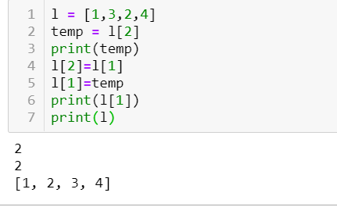

6. How to remove the white space in a given string
*** should remove space between test2 and test3 and concatenate the test2 and test3
o/p should be string = test1 test2test3 test4
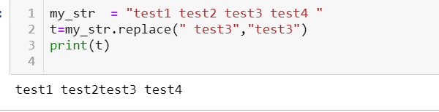

7. array = [ 3, 4, 5, 0, 0, 3, 9, 0, 8]. Shift all zeros to left, but dont use conditions that if matched 0 then appens it to right. Rather compare the two adjacnt numbers nad if anyone the first of them is zero, replace the position
???
Given two strings s1 and s2, check if both the strings are anagrams of each other.
Examples:
Input : s1 = "listen"
s2 = "silent"
Output : The strings are anagrams.

Input : s1 = "dad"
s2 = "bad"
Output : The strings aren't anagrams.
Python provides a inbuilt function sorted() which does not modify the original string, but returns sorted string.
Below is the Python implementation of the above approach:
# function to check if two strings are
# anagram or not
def check(s1, s2):

# the sorted strings are checked
if(sorted(s1)== sorted(s2)):
print("The strings are anagrams.")
else:
print("The strings aren't anagrams.")

# driver code
s1 ="listen"
s2 ="silent"
check(s1, s2)
Output:

The strings are anagrams.

A Program to check if strings are rotations of each other or not
Given a string s1 and a string s2, write a snippet to say whether s2 is a rotation of s1?
(eg given s1 = ABCD and s2 = CDAB, return true, given s1 = ABCD, and s2 = ACBD , return false)

Algorithm: are Rotations(str1, str2)
1. Create a temp string and store concatenation of str1 to
str1 in temp.
temp = str1.str1
2. If str2 is a substring of temp then str1 and str2 are
rotations of each other.

Example:
str1 = "ABACD"
str2 = "CDABA"

temp = str1.str1 = "ABACDABACD"
Since str2 is a substring of temp, str1 and str2 are
rotations of each other.

# Python program to check if strings are rotations of
# each other or not

# Function checks if passed strings (str1 and str2)
# are rotations of each other
def areRotations(string1, string2):
size1 = len(string1)
size2 = len(string2)
temp = ''

# Check if sizes of two strings are same
if size1 != size2:
return 0

# Create a temp string with value str1.str1
temp = string1 + string1

# Now check if str2 is a substring of temp
# string.count returns the number of occurences of
# the second string in temp
if (temp.count(string2)> 0):
return 1
else:
return 0

# Driver program to test the above function
string1 = "AACD"
string2 = "ACDA"

if areRotations(string1, string2):
print "Strings are rotations of each other"
else:
print "Strings are not rotations of each other"

