Python oops :
Class
Object
1.Inheritence
2.Polymorphisam
3.Encapsulation
4.Abstraction
1.What is a class ?
It is a blueprint of an object
Use of the Class:
- To Create a Class
- To Create a Instance
- Use the Instance
Note: We can’t change/access the member variable value in Instance
Note: Whenever you want the member variable just use the class Name only
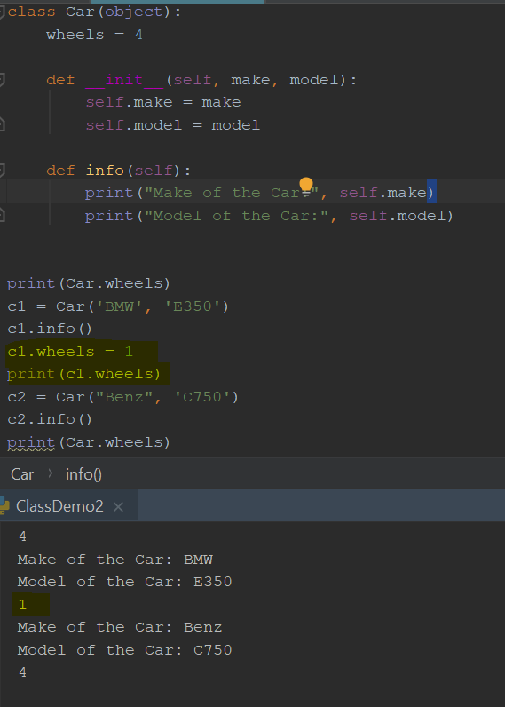

2.What is __init__() ?
It is constructor method , it is used to instantiate an Object and it is always called when the object is created .
-It takes min 1 Parameter called “Self” max it takes n num of parameters
3.What is “Self”?
It is used to refer the instance of the class, based on the self only , the method get to know for which instance to call
Can we create method without the ‘self’ Keyword under class?
No, It will throw Type Error
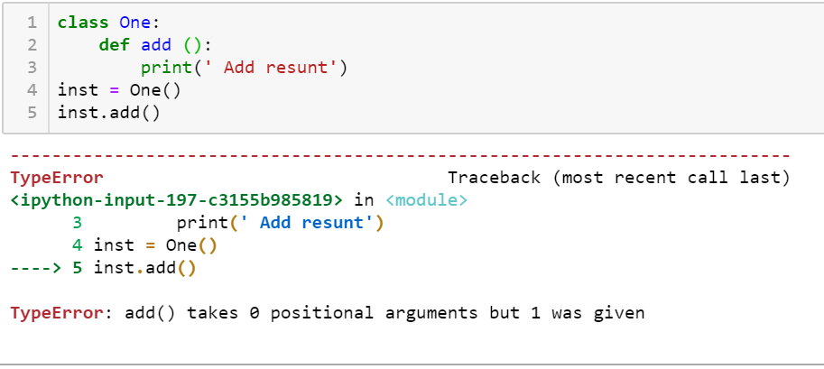
2.What is Inheritance ?
Using inheritance, we can get the parent class (base class) properties into child class properties (derived class).
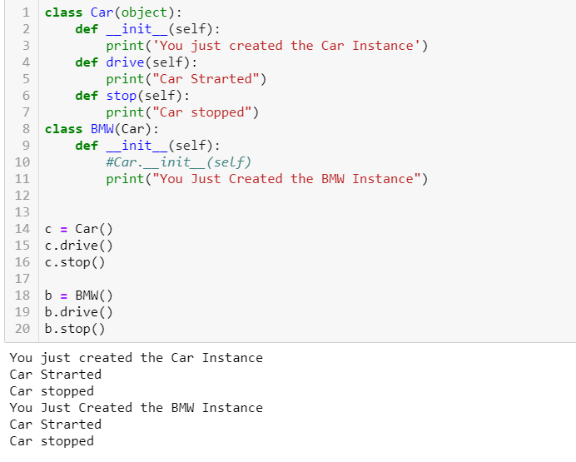
How many types of inheritances are in python?
There are 2 types
1.Multiple Inheritance
-If you Inheritance more than one class that is called Multple Inheritance
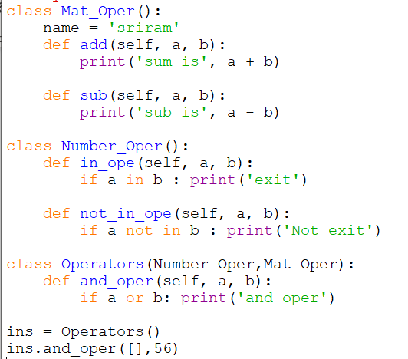
2.Multi level inheritance
- We can inherit a derived class from another derived class , this process is know as multilevel inheritance
-In Multi level Inheritance classed we can inherite at multiple separate levels
Suppose /Assume that we have 3 Classes , Class A ,Class B, Class C
- Class A is Super Class
-Class B is Sub Class (Child) of Class A
-Class C is Sub Class B

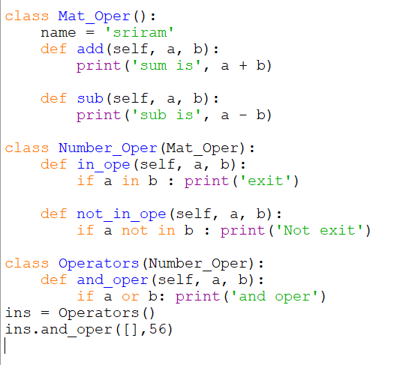

What is Overriding ?
-If you have same method names in class A and class B, then if you Inheritance class A into class B then Class A method will override with class B method.
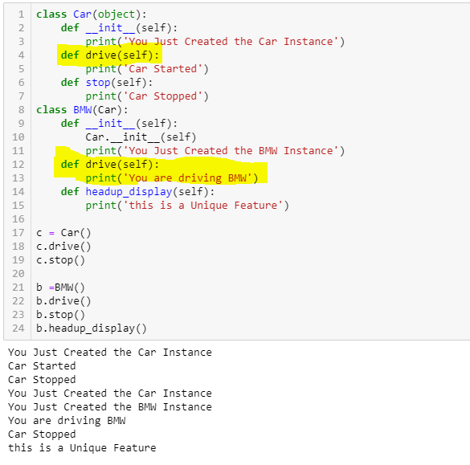

What is Super Class()?
Using super we can call parent class method
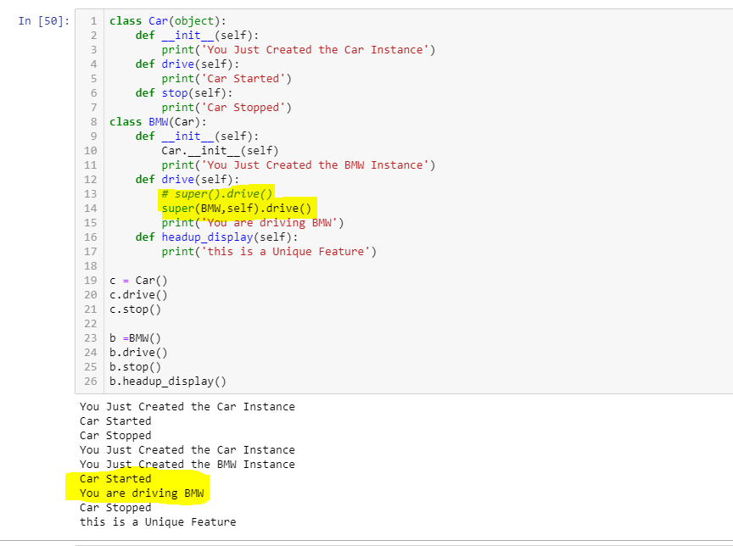

What is Overloading ?
Which lets you define the same method multiple times so that you can call them with different arguments lists
If we have different methods with same name in a class with different arguments that is called Method over loading.
2. Python doesn't support for method over loading.
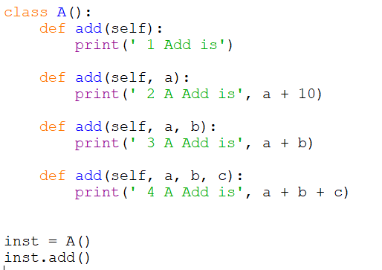

What is Encapsulation?
we can restrict access to methods and variables. This prevent data from direct modification which is called encapsulation
Encapsulation is wrapping data and functionality (methods accessing data) together into single unit.
Giving protection to the class or class members. Using access specifiers/modifiers we can achieve it

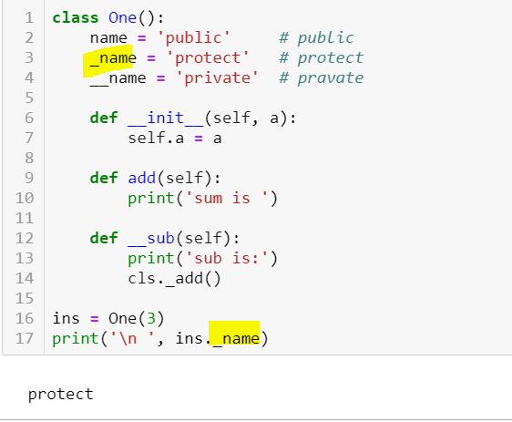

Polymorphism:
# An object behavior will get change during run time.
# By using inheritance and overloading we can achieve it.
