Versions:
→ Minimum Java Version Required = 8 +
→Python Version – v3.6
→Selenium – v3.14
→Chrome Driver – 2.45 It Supports for the Chrome v70 +
→Gecko Driver – 0.24 It supports for Fire Fox v65
→IE Driver -3.14 It supports for IE v11.31

Mention what are the capabilities of Selenium WebDriver or Selenium 2.0?

WebDriver should be used when requiring improvement support for
- Handling multiple frames, pop ups, multiple browser windows and alerts
- Page navigation and drag & drop
- Ajax based UI elements
- Multi browser testing including improved functionality for browser not well supported by Selenium 1.0
33) List the advantages of Web driver over Selenium Server?

If you are using Selenium-WebDriver, you don’t need the Selenium Server as it is using totally different technology
Selenium Server provides Selenium RC functionality which is used for Selenium 1.0 backwards compatibility
Selenium Web driver makes direct calls to browser using each browsers native support for automation, while Selenium RC requires selenium server to inject JavaScript into the browser

Scenarios that cannot be automated using Selenium.
1)Video streaming scenarios
2)Code reading scenarios - QR Code
3)Bar code scanners
4)Hardware testing
5)CAPTCHA image

***************************************Studymode*********************************
Web Application Architecture
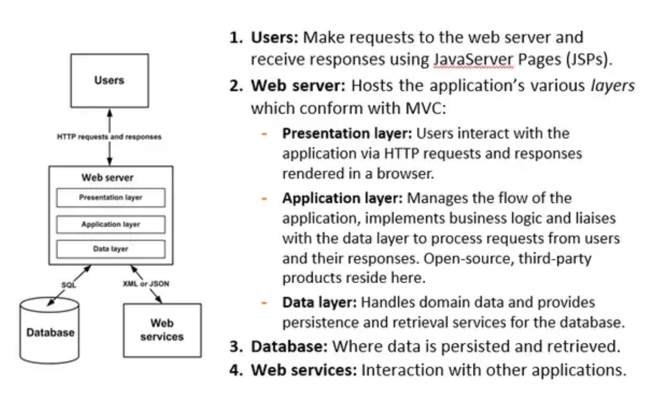
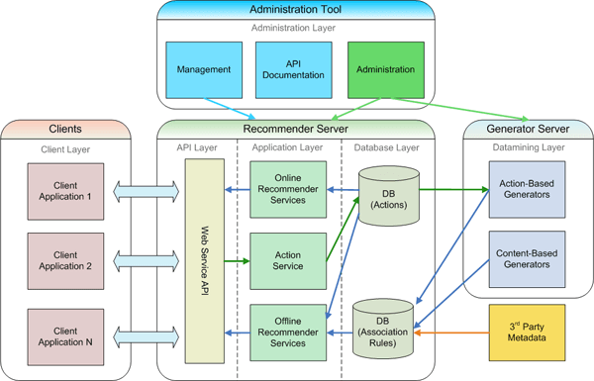

DOM – Document Object Model:
https://www.youtube.com/watch?v=BwjICm6vIEM
-It is W3C -world wide web consortium standards
-It is an Interface which is available in the form of API’s
- JavaScript Dev/ Dev with the help of w3c -CRUD API’s they can perform changes on each page
JSDEV – CRUD API- HOME PAGE- DOM
JSDEV -CRUD API’- SEETINGS PAGE -DOM
JSDEV- CRUD API-PRIVACY PAGE -DOM
There are 3 types of DOM
1.HTML DOM – Standard Model for HTML Documents
2.XML DOM – XML documents
3.CORE DOM -All different type of Documents
Architecture:
<document html>
<html>
<head> </head> ---- browser head /meta data / style sheet
<body> </body> -- All the Elements inside the Page
<header> </header> --- All the Tags / elements– div, anchor tag/ Tag - attributes
</html>

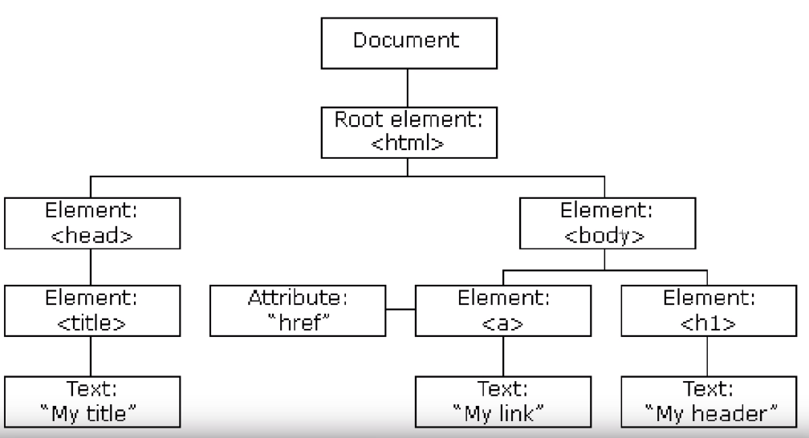
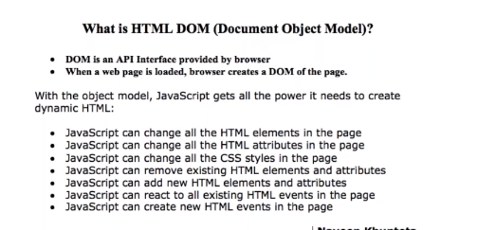
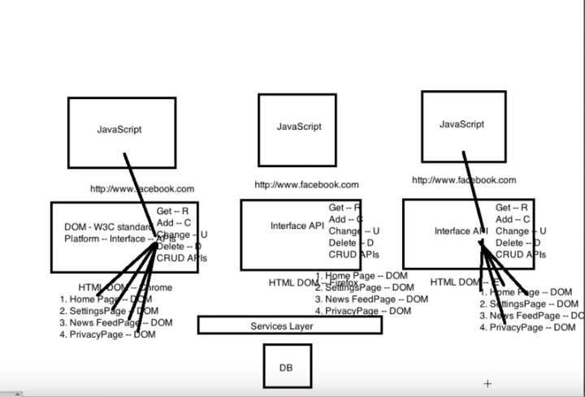
Stale Element Exception: [STALE – NOT FRESH]
Home Page
1.List = driver.find_elements_(By.xpath(“ ---“)) ------ > it has written some lists
2.Refresh the Home Page -- > It cleared all the DOM Elements
3.If You perform any action on list variable example: list.get(i).click() it will throw an Exception
“STALE ELEMENT EXCEPTION
Because once you refreshed the Home Page it will create new DOM
4.To Avoid this Exception need to find the elements again
List =driver.find_elements(By.xpath(“ –“)) -- it Will create again new DOM
5. now we can perform the list.get(i).click() action on the Variable

1.Selenium Architecture:
Refer - https://www.youtube.com/watch?v=Z6yTeEqgJ1I
Selenium is a suite of tools for automated web testing. It is composed of
Selenium IDE (Integrated Development Environment): It is a tool for recording and playing back. It is a Firefox plug-in.
Selenium Remote Control (RC) – Selenium RC is a server that allows a user to create test scripts in the desired programming language. It also allows executing test scripts within the large spectrum of browsers.
Selenium RC requires server to be started before executing the test scripts.
Selenium RC doesn't explicitly provide aids to handle alerts, navigations, and dropdowns.
Selenium RC doesn't support testing of iPhone/Android applications.
Web Driver: Web Driver is a different tool altogether that has various advantages over Selenium RC. Web Driver directly communicates with the web browser and uses its native compatibility to automate. It provides the APIs for a variety of languages like Java, .NET, PHP, etc. With most of the browsers Web driver and RC work.
Grid: With the help of Grid you can distribute tests on multiple machines so that test can be run parallel which helps in cutting down the time required for running in browser test suites.
For more info about the REST CALLS - .https://github.com/SeleniumHQ/selenium/wiki/JsonWireProtocol

-→Selenium in the form of libraries /API’s and it’s called multiple platform supported and it is platform independent
→Selenium provides multiple client libraries – java, python , c# , ruby , perl
→There 4 diff components
1.Selenium language - Java, Python, JS, Ruby, php
2.JSONWire Protocol -over HTTP
3.Browser Drivers -- chrome.exe , geckodriver.exe, safari.exe ,ie.exe
4.Real Browsers – chrome, ff, ie, safari [ window machines, mac or linux machines]

→Over the Internet/Server send the Request and we get the response
Below methods are All REST API’s
→driver = webdriver.FireFox()
→driver.get(http://goole.com)
→driver.find_element_by_id(‘names’)

It will create a JSON File (key value pair format) and sends the request to SERVERS (chrome driver,)
Each request will send to request over the Internet/Server – It will create a JSON file – then JSON file sends request to Chrome server – Over the Real Chrome browser suppose driver.get method successful it will the response to Chrome Driver – From Driver to JSON Protocol – then JSON protocol to – Your Console (Python code)

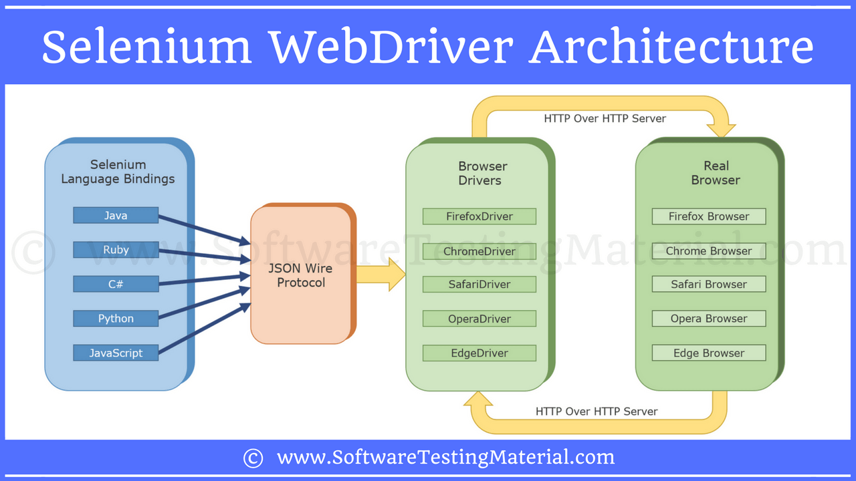

8) What are the advantages of Selenium?
It supports C#, PHP, Java, Perl, Python
It supports different OS like Windows, Linux and Mac OS
It has got powerful methods to locate elements (Xpath, DOM, and CSS)

31) Explain how Selenium Grid works?
Selenium Grid sent the tests to the hub. These tests are redirected to Selenium Web driver, which launch the browser and run the test. With entire test suite, it allows for running tests in parallel.

32) Can we use Selenium grid for performance testing?
Yes. But not as effectively as a dedicated performance testing tool like LoadRunner.
33) List the advantages of Web driver over Selenium Server?
If you are using Selenium-WebDriver, you don’t need the Selenium Server as it is using totally different technology
Selenium Server provides Selenium RC functionality which is used for Selenium 1.0 backwards compatibility
Selenium Web driver makes direct calls to browser using each browsers native support for automation, while Selenium RC requires selenium server to inject Javascript into the browser
34) Mention what are the capabilities of Selenium WebDriver or Selenium 2.0?
WebDriver should be used when requiring improvement support for Handling multiple frames, pop ups, multiple browser windows and alerts Page navigation and drag & drop Ajax based UI elements
Multi browser testing including improved functionality for browser not well supported by Selenium 1.0

1.What is Selenium Grid Architecture
Refer : https://www.youtube.com/watch?v=xO9TZNd1FGg

Commands :
1.To Run the Hub
Open command prompt and go to server path
Java -jar selenium-server-standalone-3.8.1.jar -role hub
2.To Check the Selenium up and running
Copy the ip address / http://localhost:4444
Click on Console
3. To Register the node
Open another command prompt got to server pathe
java -Dwebdriver.gecko.driver="C:\geckodriver.exe" -jar selenium-server-standalone-3.4.0.jar -role webdriver -hub http://192.168.1.3:4444/grid/register -port 5566

java <chromedriverfile>=”path of the chromedriver.exe” -jar selenium-server-standalone-3.4-0.jar
-role node -hub <http://ipaddress:portnumber(4444)/grid/register>

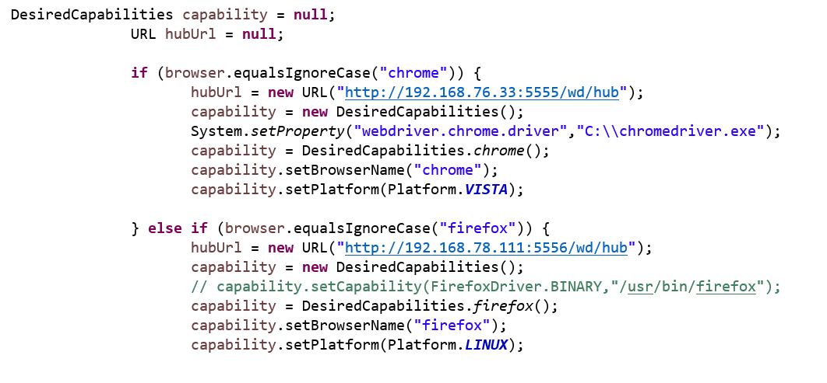
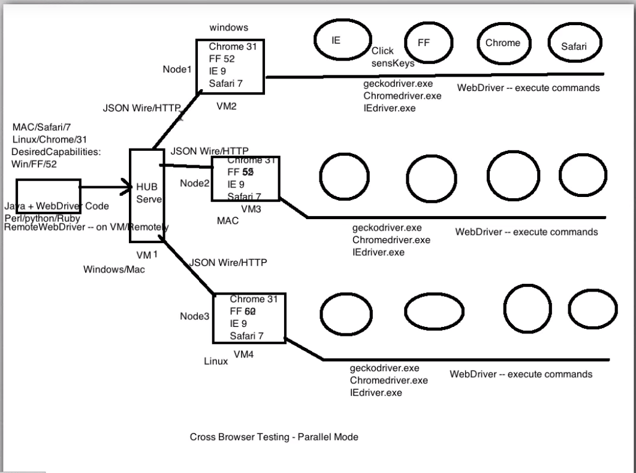
Refer : https://www.youtube.com/watch?v=P8yq37Qr4eo
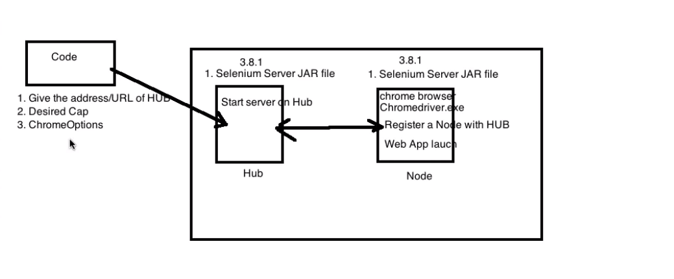

Set Up:
In this section, you will use 2 machines.
The first machine will be the system that will run the hub while the other machine will run a node.
For simplicity, let us call the machine where the hub runs as "Machine A" while the machine where the node runs will be "Machine B."
It is also important to note their IP addresses. Let us say that Machine A has an IP address of 192.168.1.3 while Machine B has an IP of 192.168.1.4.
Step1: Download the Selenium Server from seleniumhq.com
Step2: you can place the Selenium Server .jar file anywhere in your HardDrive. place it on the C drive of both Machine A and Machine B.
Step3: We are now going to launch a hub. Go to Machine A. Using the command prompt, navigate to the root of Machine A's - C drive, because that is the directory where we placed the Selenium Server.
- On the command prompt, type java -jar selenium-server-standalone-2.30.0.jar -role hub
- The hub should successfully be launched. Your command prompt should look similar to the image below
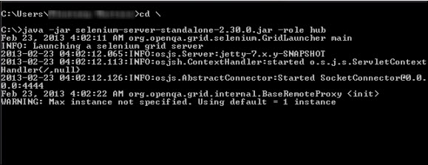

Step4:Another way to verify whether the hub is running is by using a browser. Selenium Grid, by default, uses Machine A's port 4444 for its web interface. Simply open up a browser and go to http://localhost:4444/grid/console
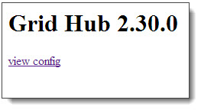
Also, you can check if Machine B can access the hub's web interface by launching a browser there and going to where "iporhostnameofmachineA" should be the IP address or the hostname of the machine where the hub is running. Since Machine A's IP address is 192.168.1.3, then on the browser on Machine B you should type http://192.168.1.3:4444/grid/console

Step5: Now that the hub is already set up, we are going to launch a node. Go to Machine B and launch a command prompt there.
- Navigate to the root of Drive C and type the code below. We used the IP address 192.168.1.3 because that is where the hub is running. We also used port 5566 though you may choose any free port number you desire.
- NOTE: You now have to give path to the Gecko driver if using Firefox. Here is updated code that needs to be used
java -Dwebdriver.gecko.driver="C:\geckodriver.exe" -jar selenium-server-standalone-3.4.0.jar -role webdriver -hub http://192.168.1.3:4444/grid/register -port 5566
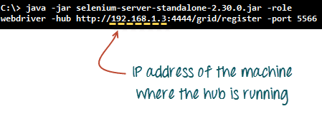
- When you press Enter, your command prompt should be similar to the image below.
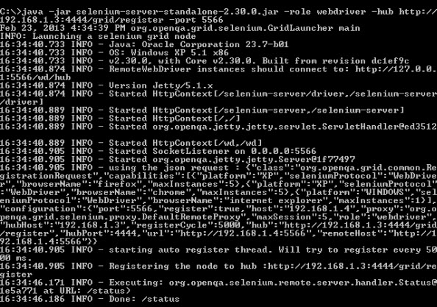
Step 6
Go to the Selenium Grid web interface and refresh the page. You should see something like this.
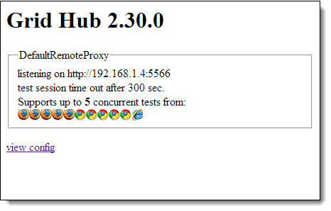
At this point, you have already configured a simple grid. You are now ready to run a test remotely on Machine B.

1.How SSL Certificate works?
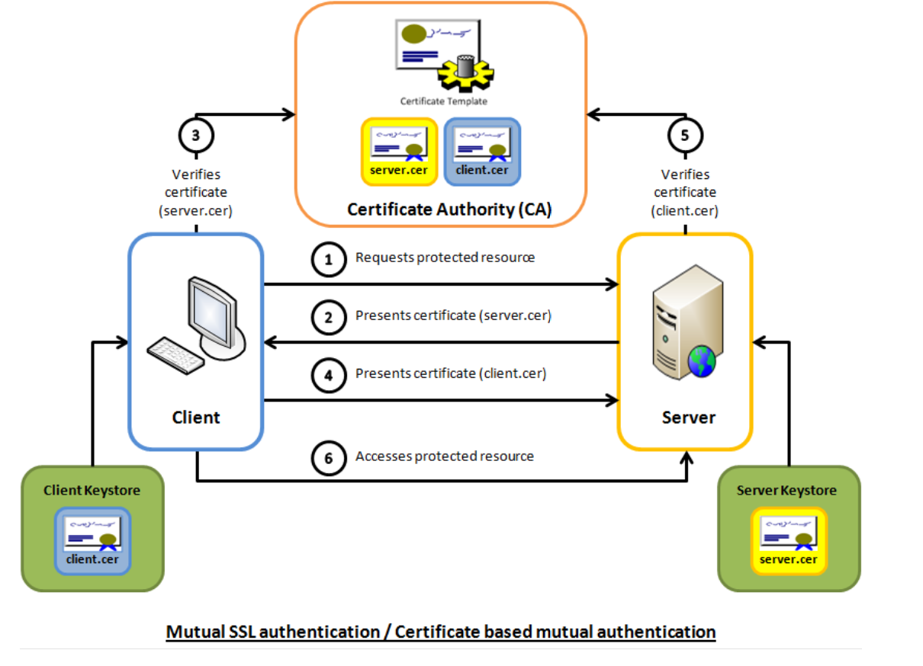

1.What is the diff between http and https
in the beginning, network administrators had to figure out how to share the information they put out on the Internet.
They agreed on a procedure for exchanging information and called it HyperText Transfer Protocol (HTTP).
Once everyone knew how to exchange information, intercepting on the Internet was not difficult. So knowledgeable administrators agreed upon a procedure to protect the information they exchanged. The protection relies on SSL Certificate to encrypt the online data. Encryption means that the sender and recipient agree upon a "code" and translate their documents into random-looking character strings.
The procedure for encrypting information and then exchanging it is called HyperText Transfer Protocol Secure (HTTPS).
With HTTPS if anyone in between the sender and the recipient could open the message, they still could not understand it. Only the sender and the recipient, who know the "code," can decipher the message.
Humans could encode their own documents, but computers do it faster and more efficiently. To do this, the computer at each end uses a document called an "SSL Certificate" containing character strings that are the keys to their secret "codes."
SSL certificates contain the computer owner's "public key."
The owner shares the public key with anyone who needs it. Other users need the public key to encrypt messages to the owner. The owner sends those users the SSL certificate, which contains the public key. The owner does not share the private key with anyone.
The security during the transfer is called the Secure Sockets Layer (SSL) and Transport Layer Security (TLS).
The procedure for exchanging public keys using SSL Certificate to enable HTTPS, SSL and TLS is called Public Key Infrastructure (PKI).

2.What is Response in web application
4.What is web driver
5.What is Selenium
7.how many layers in web application and what is response
8.What is SPA -Single Page Application
SPA applications (Angular or React JS)

9.What Debug /Dev tools used ?
Dev Tools : Eclipse, Maven,Ant,JVisual VM,JConsole,JMeter, MAT
Angular Dev Tools : VSS,Augury,gatling

***************************************SONY**************************************
1.What is Selenium Grid
2.What Web driver
3. In a Website there are Fields name, Address , Email Address ,How to get the Email address only 4. In a website how to get the all the hyperlink ?
**************************************Opetamix************************************

1.What is Selenium Hub and Node?
Plz refer link : https://www.guru99.com/introduction-to-selenium-grid.html
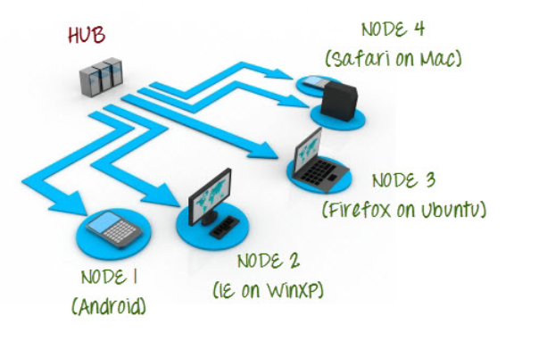

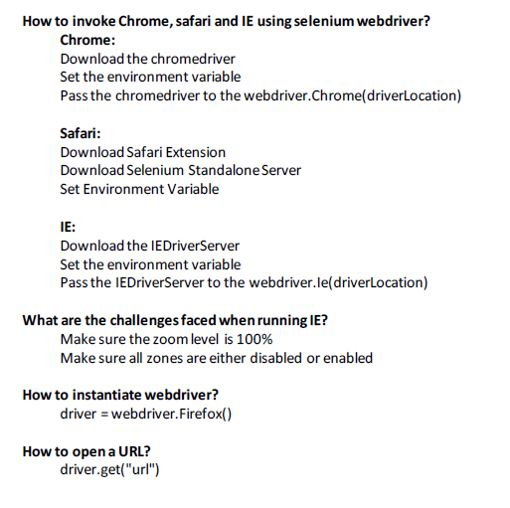
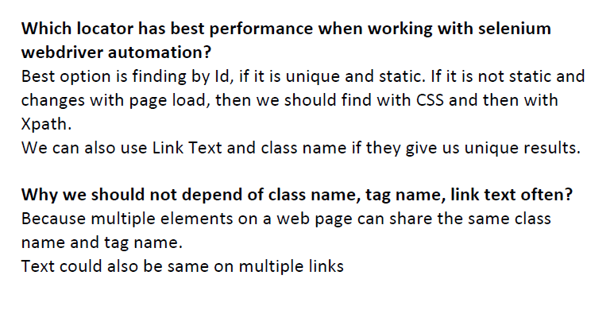
How to find the list of the Elements count?
elementByTag = driver.find_elements(By.TAG_NAME,’td’)
length = len(elementByTag)
CSS SELECTORS:
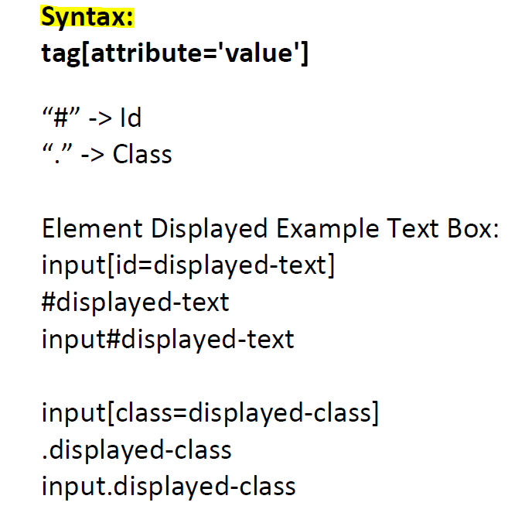

How to Append class in CSS Selector
.class1.class2.class3 -- > Until we found the unique element
CSS SELECTOR WILD CARDS
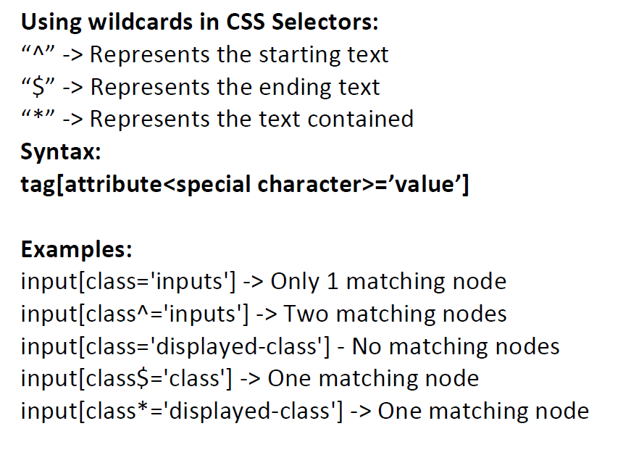

CSS SELECTOR -FINDING CHILDREN:
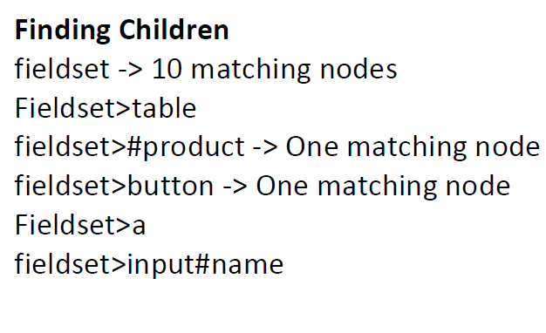
XPATH:
Syntax : //tag[@attribute = ‘value’]
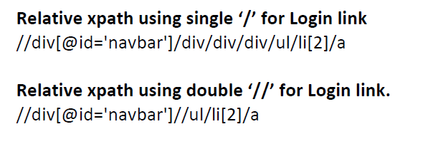

1.how many types xpaths are
There are 2 types of xpath
1.relative xpath (//)
2.absolute xpath (/)
8.Why we use Xpath?
Every Element doesn't have an ID --> Static ID ,Unique Name ,Uniques Link Text .For those elements we need to find build xpath to find and then perform actions on them
9.What are different type of Xpath and Explain absolute and relative xpath
Absolute xpath (/) – It will starts from beginning selection from the document node, It allows you to create ‘absolute’ path expressions
It will look only immediate child element
Relative xpath(//) - start selection matching anywhere in the document, It enables to create ‘relative’ path expressions
It will look Nested Child element
Note: If anything changes hierarchy in the DOM, absolute xpath will change /break it will never give a matching node
USING Text to Build an XPATH
//div[@class =’homepage-hero’]//a[text()=’Enroll now’]

XPATH finding using CONTAINS Keyword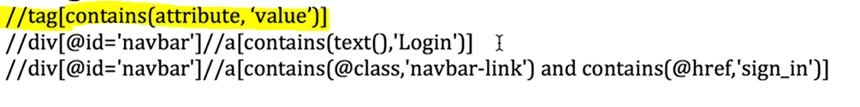
XPATH finding using STARTS-WITH keyword
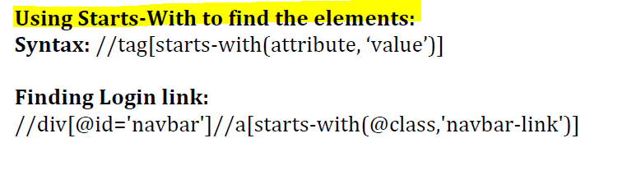
XPATH Using SIBLING
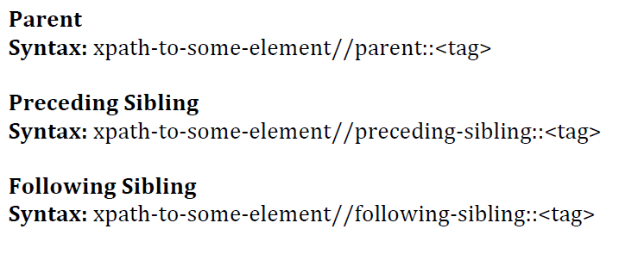
Find the Python Programing Language – 30 using Sibling
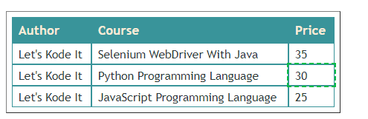
How to build Dynamic Xpath?
Problem Statement is Open web page Enter the Credentials and search for the Specific book /Invoice
1.Click on webpage
2.Enter username and password
3.Click on Submit to Login the Webpage
4.Search for the Specific Invoice

5.Select the Specific Book – Example Python Programming Book
_book = “//div[contains(@class, “book-title”) and contains(text(),{0})]
_booklocotor= _book.format(“Python Programming”)

Note :With the help of .format value we can replace {0} as below
_book = “//div[contains(@class, “book-title”) and contains(text(),Python Programming)]

What is difference between get() and Navigate ()?
driver.get() : It's used to go to the particular website , But it doesn't maintain the browser History and cookies so , we can't use forward and backward button , if we click on that , page will not get schedule

driver.navigate() : it's used to go to the particular website , but it maintains the browser history and cookies, so we can use forward and backward button to navigate between the pages during the coding of Testcase
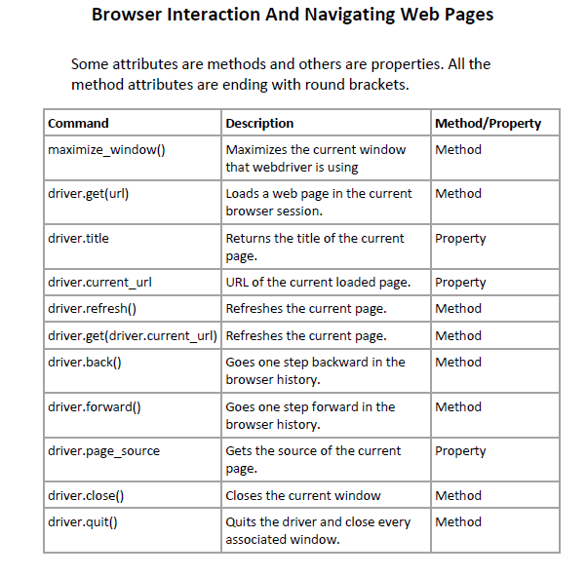
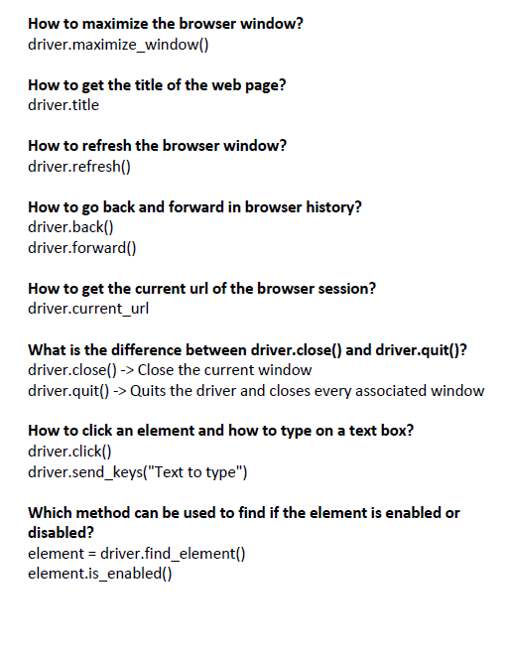
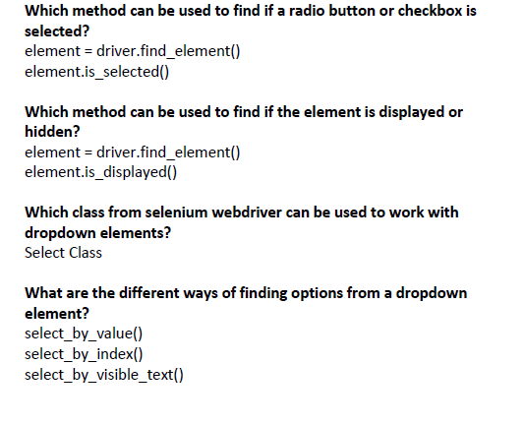
1.How to select the Radio Button and checkboxes?
First Check the DOM ,whether the element type is ‘radio’ or ‘checkbox’ then find the element
If Radiobutton is_enabled then perform the Click action
If CheckBox is_enabled then perform the Click action
2.How to get the Elements list and if the element is enabled select the element
Step1 – find the xpath for the elements using driver.find_elements(By.XPATH,’VALUE’)
Step2 – Get the length of the elements list using len()
Step3- Write a for loop to iterate all the elements
Step 4 – Check the Element is selected or not by using is_selected()
Step 5- if not selected the select that element by using click()
3.How to Select the drop down list?
By using Select Class
There are 3 type
Select_by_value()
Select_by_index()
Select_by_visible_text()

Step 1 – We need to import the Select lib
From selenium.webdriver.support.select import Select
Step 2 – Get the XPATH/ID for the Dropdown list
Step3 – Assign a variable to Select() as below
element = driver.find_element(By.CSS_SELECTOR, '#carselect')
sel = Select(element)
Step 4 –
# SELECT BY VALUE
sel.select_by_value('benz'
print('Select Benz by Value')
time.sleep(2)

# SELECT BY VISIBLE TEXT
sel.select_by_visible_text("BMW")
print('Select BMW by Visible Text')

# SELECT BY INDEX
sel.select_by_index(2)
print('Select Honda by Index')
4.How to find the Hidden Elements is Displayed or not ?
Step-1 .Find the Element
Element = driver.find_element(By.ID, ‘value’)
Step 02 .Use the is_displayed() method to check the State of the Element TRUE OR FALSE
Ele.is_displayed() # It will State of the Element TRUE OR FALSE
Example –
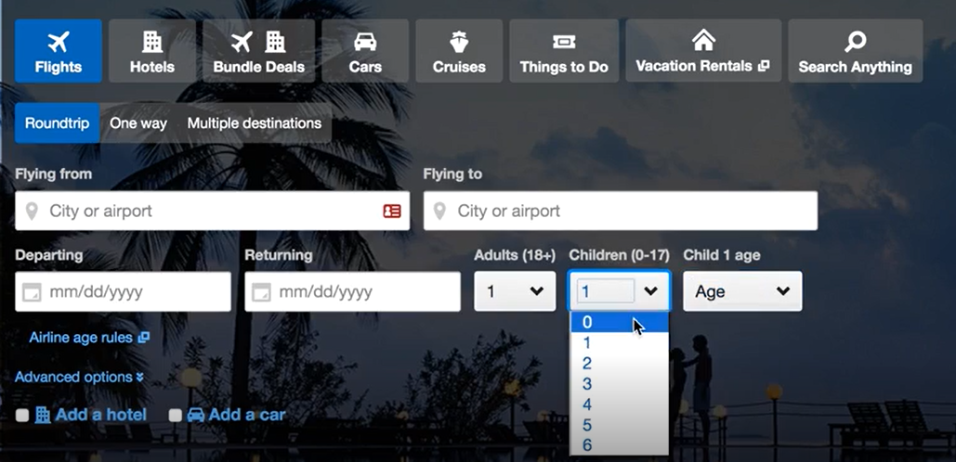
5.How to Check the whether the Element is Present or not ?
try:
element = driver.find_element(By.ID, “value”)
print(‘Element Found’
except:
print(“Element not found”)
return element

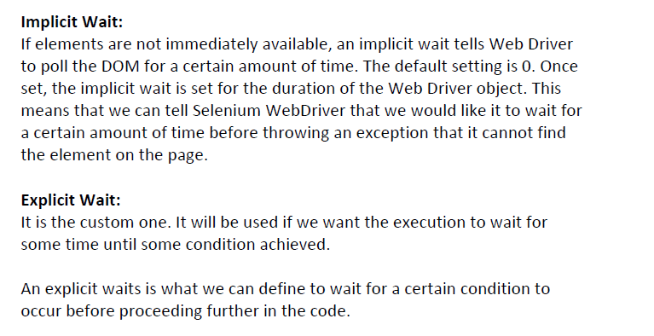
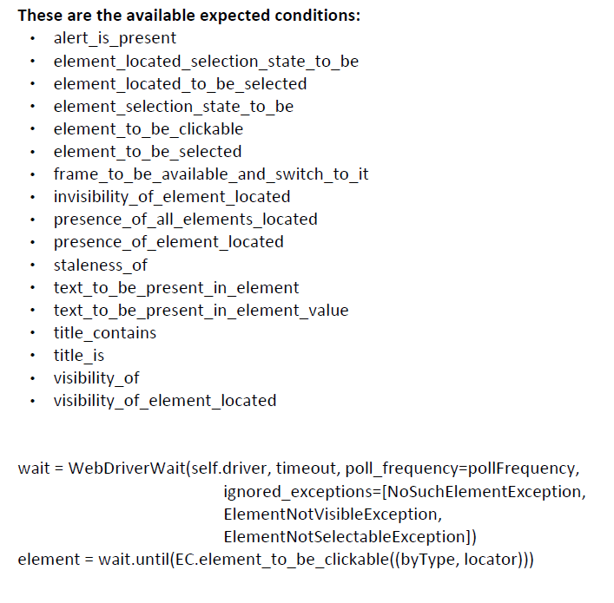
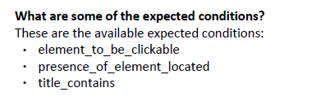

6.How to find the Size of the Window ?
height = driver.execute_script("return window.innerHeight;")
width = driver.execute_script("return window.innerWidth;")
print("Height:" + str(height))
print("Width:" + str(width))

7.How to Scroll Down and Up ?
<button onclick="scrollWin(0, 50)">Scroll down</button>
<button onclick="scrollWin(0, -50)">Scroll up</button>
<button onclick="scrollWin(100, 0)">Scroll right</button>
<button onclick="scrollWin(-100, 0)">Scroll left</button>

# Scroll Down
driver.execute_script("window.scrollBy(0,600);”)
time.sleep(5)
# Scroll Up
driver.execute_script("window.scrollBy(0,-600);")
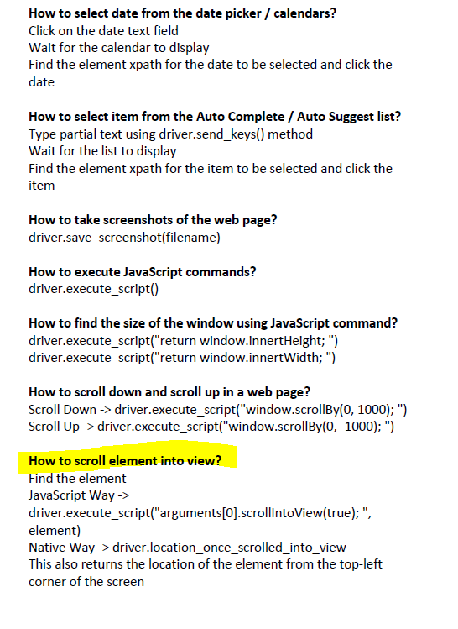

SCROLL ELEMENT INTO VIEW
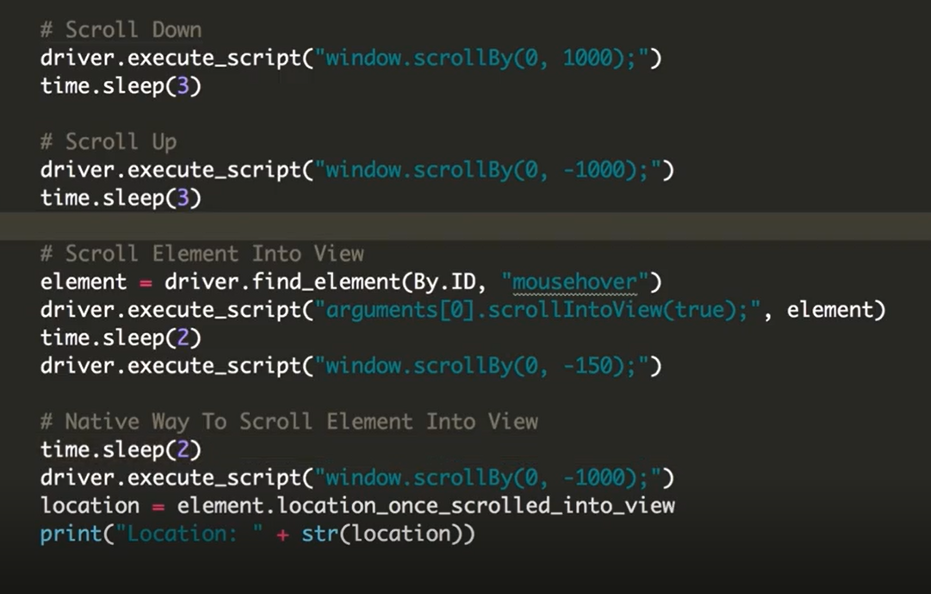
8.How to Switch Window Handle?
Step -1 Find the Parent Handle – main Window
Driver.current_window_handle()
Step -2 Find an Element to Open Window / Link – Click it
Step-3 Fina all Handles ,there should be two handles after clicking open window / Link button
Handles = driver.window_handles
Step -4 Switch to Window and Search Course
Use the for loop to iterate all the handles
For handle in handles:
Print(“handles:” + handle)
If handle not in parentHandle:
driver. switch_to_window(handle)

Step -5 Switch Back to the Parent Window
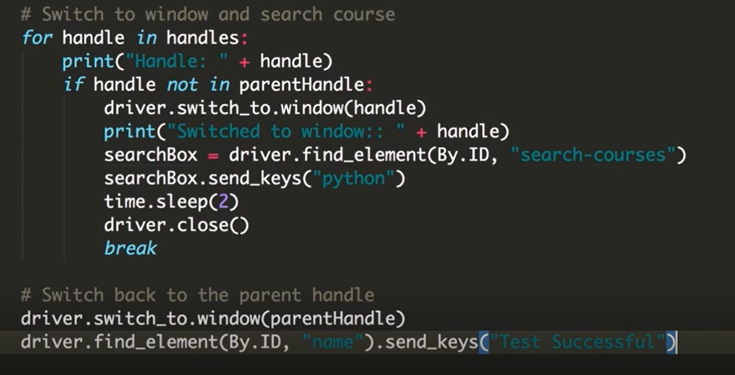

How to Work with Frames?
Switch_to_frame(0)
Switch_to_frame(“iframe_name”)
Switch_to_frame(“elementid”)
Switch_to_default_content() -→ to switch to default frame
Switch to iFrame by using Id
driver.switch_to_frame(“courses-iframe”)
Step 2 : Search for the course
Searchbox = driver.find_element_by_id(“search-courses”)
Searchbox.send_keys(‘python’)
Step 3 : Switch Back to Parent frame
driver.switch_to_default_content()
Switch to iframe Using name
driver.swtich_to_frame(“iframe-name”)
Swtich to iframe Using Numbers
Driver.switch_to_frame(0)

How to Switch to Alerts?
Step1 – To Ok the Alert
Alert1 = driver.switch_to_alert
Alert1.accept()
Step2 -- To Cancel the Alert
Alert2 = driver.switch_to_alert
Alert2.dismiss()

How to Drag and Drop in Selenium and Mouse hover Actions in Selenium ?
Mouse Hover Actions:
Assume there is a button in Application called ‘Mouse Hover’ ,if you mouse hover on that button it will display to elements “top” and “reload”

Step 1: To work on Mouse Hover Actions we need to import selenium library called Actions
from selenium.webdriver import ActionChains
Step2: find the element/object for the Mouse Hover button
Find the element object to perform an actions

Step3:declare a variable and perform actions on that
acitions = Actions(driver)
actions.move_to_element(element).perfrom()
elementtoClick = driver.find.element(By.XPATH,’xpath’)
actions.move_to_element(elementoClick).click().perform()
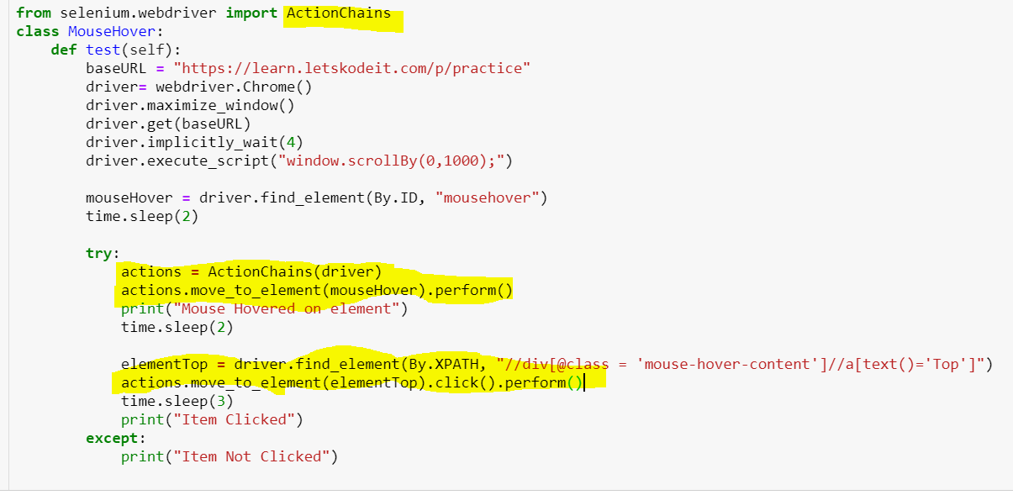
Drag and Drop
Assume there is iframe , in that we need to drag and drop the elements
Step 1: To work on drag and drop Actions we need to import selenium library called ActionChains
from selenium.webdriver import ActionChains
Step2: find the element/sobject for the drag and drop
Fromeleemnt = Find the element ID object to drag
Toelement = Find the element ID to drop
Step3:declare a variable and perform actions on that
acitions = Actions(driver)
actions.drag_and_drap(fromelement,toelement).perfrom
OR
actions.click_and_hold(fromelement).move_to_element(toelement).release().perfrom()
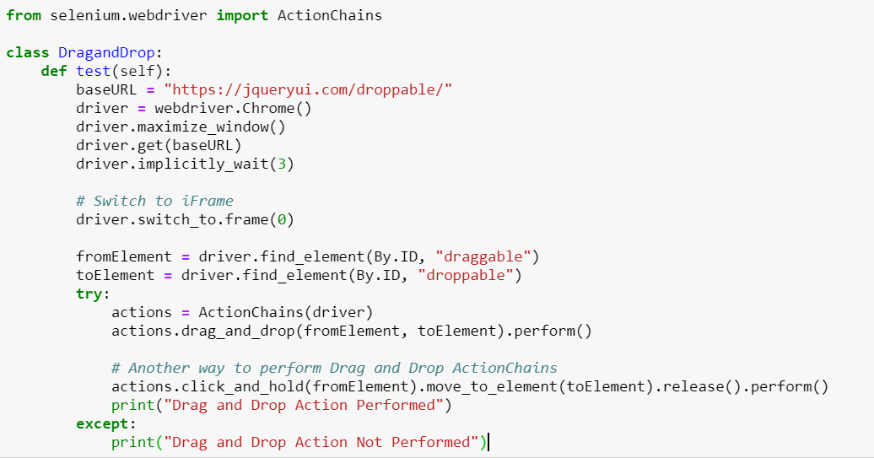

Working with Slider Operations:
Step 1: To work on drag and drop Actions we need to import selenium library called ActionChains
from selenium.webdriver import ActionChains
Step2: find the element/sobject for the slider
slidereleemnt = Find the element ID
Step3:declare a variable and perform actions on that
acitions = Actions(driver)
actions.drag_and_drap_by_offset(slidereleemnt,100,0).perfrom()

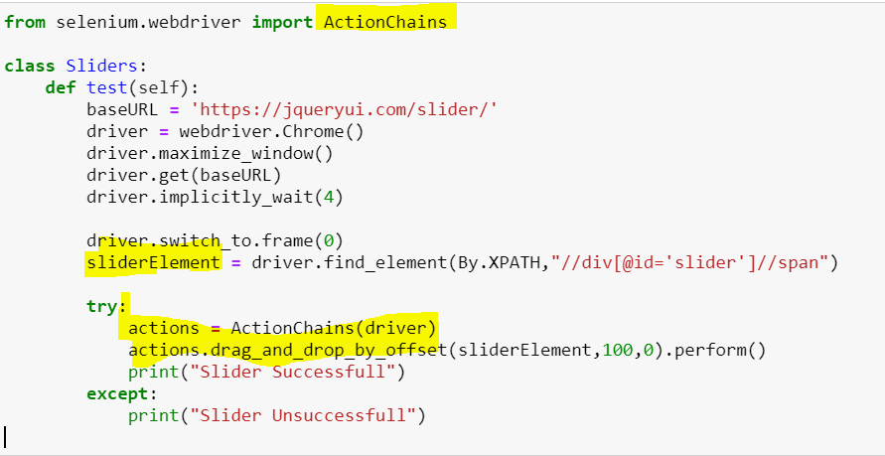

************************************QUEST**************************************
1.What are Pre-requisites to design a Framework ?
https://xbosoft.com/software-quality-blog/test-automation-framework-requirements/
https://www.infostretch.com/blog/choosing-the-right-automation-framework/
https://www.glowtouch.com/how-to-choose-the-right-test-automation-framework/
https://www.quora.com/What-are-some-of-the-points-to-be-considered-while-developing-a-test-automation-framework

1) Code must be re-usable and easy to maintain.
2) We need to design the framework in such way that, if there are any major or minor changes
in the UI or application, sometimes it may result in change in the existing process flow of
application or it may change the Object properties, those changes should be incorporated
quickly.
3) Test data should be kept distinct from the code and the code should be reusable for different
sets of input data.
3a) Object repository should be kept outside the code
4) Appropriate error handling process must be included as part of the automation framework.
5) Those error should be captured in the HTML report, so that we know exactly which line of
Code is the problem.
6) The automation framework must be written in such a way that if one test script fails should
not stop the execution process. Ideally, the framework should report the errors and move on to
execute the next test case. We have to make each test case is a separate script.
5.How to handle with Dynamic Table?
6.How to handle Frames?
IFRAME – Iframe is web page which is embedded in another web page
<iframe> tag specifies an inline iframe
How to identify the iframe ?
We cannot detect the frames by just seeing the page or by inspecting the Firebug
We can identify the frames using methods given below:
1. Right click on the element, if you find and option like “This frame” then its iframe
2.Right click on the page, click on “view page source” and search with “iframe”,if you can
Find any tag name with the name ‘iframe’ then it is meaning to say the page consisting the An iframe
3.find_element_by_tagname("iframe")
How to switch over the elements in iframes using web driver commands:
1.Id (Example : driver.switch_to.frame(“course-iframe”)
2.Name (Example:driver.switch_to.frame(“iframe-name”)
3.Numbers (Example:driver.swithc_to.frame(0)
Note: index of the iframe start with “0”
How to switch back to parent frame ?
driver.switch_to.default.content()
7.What are all locators in selenium?
Ans: There are Total 8 Locators in Selenium,they are
1.driver.find_element_by_Id
2.driver.find_element_by_name
3.driver.find_element_by_link_text
4.driver.find_element_by_partial_link_text
5.driver.find_element_by_xpath
6.driver.find_element_by_tag_name
7.driver.find_element_by_Class_name
8.driver.find_element_by_CSS_Selector

20.How do handle Tool Tips?
21.How do you handle Switch Alerts and Tabs?
22.How do you handle hidden Elements ?
23.How do you handle mouse hovers?
1) What is Selenium and what is composed of?
Selenium is a suite of tools for automated web testing. It is composed of
Selenium IDE (Integrated Development Environment): It is a tool for recording and playing back. It is a Firefox plugin.
Selenium Remote Control (RC) – Selenium RC is a server that allows a user to create test scripts in the desired programming language. It also allows executing test scripts within the large spectrum of browsers.
Selenium RC requires server to be started before executing the test scripts.
Selenium RC doesn't explicitly provide aids to handle alerts, navigations, and dropdowns.
Selenium RC doesn't support testing of iPhone/Android applications.
WebDriver: WebDriver is a different tool altogether that has various advantages over Selenium RC. WebDriver directly communicates with the web browser and uses its native compatibility to automate. It provides the APIs for a variety of languages like Java, .NET, PHP, etc. With most of the browsers Web driver and RC work.
Grid: With the help of Grid you can distribute tests on multiple machines so that test can be run parallel which helps in cutting down the time required for running in browser test suites.

2.How to scroll down to the bottom of the page?
1.SCROLL DOWN -- > driver.execute_script(“window.scrollBy(0,1000);”)
2.SCROLL UP → driver.execute_script(“window.scrolByl(0,-1000);”)
3.Find the Element
driver.execute_script(“arguments[0].scrollintoView[true];”, webelement )
browser.execute_script ("arguments[0].scrollintoview(true);",webelemet)

NativeWay -‐> driver.location_once_scrolled_into_view
time.sleep(3)
location = element.location_once_scrolled_into_view
print("Location : " + str(location))

This also returns the location of the element from the top-‐left corner of the screen
3. How will you find an element using Selenium?
In Selenium every object or control in a web page is referred as an element, there are different ways to find an element in a web page they are
Driver.find_element_by_id()
Driver.find_element_by_xpath()
Driver.find_element_by_name()
Driver.find_element_by_css_selector()
Driver.find_element_by_link_text()
Driver.find_element_by_paritl_link_text()
Driver.find_element_by_classname()
Driver.find_element_by_tagname()
4. Mention what is the use of X-path?
Single slash ( / ) start selection from the document node
It allows you to create ‘absolute’ path expressions
Double slash ( // ) start selection matching anywhere in the document
It enables to create ‘relative’ path expressions

5) List out the technical challenges with Selenium? Technical challenges with Selenium are
Selenium supports only web based applications
It does not support the Bitmap comparison
For any reporting related capabilities have to depend on third party tools
6) What is the difference between verify and assert commands?
Assert: Assert allows checking whether an element is on the page or not. The test will stop on the step failed, if the asserted element is not available. In other words, the test will terminate at the point where check fails.
Verify: Verify command will check whether the element is on the page, if it is not then the test will carry on executing. In verification, all the commands are going to run guaranteed even if any of test fails.

6. What is the difference between driver. Close() and driver.quit() methods?
driver.close(): To close current WebDriver instance
driver.quit(): To close all the opened WebDriver instances

6a) how do you 3 an option from drop down list?
From selenium.webdriver.support.ui import Select
select_by_value
select_by_index
select_by_visible_text
Example:
Select = Select (driver.find_element_by_id ('fruits01'))
# select by visible text
select.select_by_visible_text('Banana')
# Select by value
select.select_by_value ('1')
7.Actionchains in Selenium?
from selenium.webdriver.common.action_chains import ActionChains
ActionChains are a way to automate low level interactions such as
→ mouse movements,
→ mouse button actions
→ key press, and context menu interactions.
This is useful for doing more complex actions like hover over and drag and drop.
-- actions = ActionChains(driver)
-- actions.move_to_element(menu).perform()
-- actions.click(hidden_submenu)
-- actions.perform()
8.Working with Checkboxes in Selenium Web driver in Python – Example?
We can first see if the checkbox is selected using is_selected() method. Then using click method we can perform the operations such as selecting or deselecting the checkboxes as illustrated in the below example.
Is_Enabled() is the method used to verify if the web element is enabled or disabled within the webpage. Is_Enabled() is primarily used with buttons. Is_Selected() is the method used to verify if the web element is selected or not. Is_Selected() method is predominantly used with radio buttons, dropdowns and checkboxes.

Types of Asserts in unittest?
assertAlmostEquel, assertAlmostEquels, assertEquel, assertEquels, assertFalse,assertGreater, assertGreaterEquel,assertIn,assertTrue,assertNotEquel,assertRaises.

8. A) How to upload documents in Selenium? *** This is one Challenge in Selenium
Windows file uploads does not support selenium, so we have rely on AutoIT.
Download and Install AutoIT, then go to Editor, here we use ‘SciTE’.
ControlFocus(‘title’,’text’,’controlID’)- ‘Fileupload’,””,’Edit1’
ControlSetText(‘title,text’,’controlID,’newtext’’)- ‘Fileupload’,””,’Edit1’,’location of the file’
ControlClick(‘(‘title,text’,’controlID)- ‘Fileupload’,””,Button1’
Do save the file in any appropriate folder
We cannot execute .au3 files as it is, so we have to compile it first based on x32 or x64 bit.
It converts into .exe
Provide above .exe at run time in selenium (os.system (location of the executable path))
8. What type Exception except if you are uploading the file if it is more than expected size?
IO Exception
9. While File Uploading it’s allows us to upload max 5MBoly , it I want to upload a file more than 5MB file what would be your approach ?
Should be discussed with dev to increase the size
9) Why testers should opt for Selenium and not QTP? Selenium is more popular than QTP as
Selenium is an open source whereas QTP is a commercial tool
Selenium is used specially for testing web based applications while QTP can be used for testing client server application also
Selenium supports Firefox, IE, Opera, and Safari on operating systems like Windows, Mac, and Linux etc. however QTP is limited to Internet Explorer on Windows.
Selenium supports many programming languages like Ruby, Perl, and Python whereas QTP supports only VB script

22) Mention what is the difference between implicit wait and explicit wait?
Implicit Wait: Sets a timeout for all successive Web Element searches. For the specified amount of time it will try looking for element again and again before throwing a NoSuchElementException. It waits for elements to show up.
Explicit Wait: It is a one-timer, used for a particular search
Implicit wait is set for the entire duration of the web Driver object. Suppose, you want to wait for a certain duration, let's say 5 seconds before each element or a lot of elements on the webpage load.
Now, you wouldn't want to write the same code again and again. Hence, implicit wait. However, if you want to wait for only one element, use explicit.
The implicit wait will tell to the web driver to wait for certain amount of time before it throws a "No Such Element Exception". The default setting is 0. Once we set the time, web driver will wait
For that time before throwing an exception.
Explicit wait code:
from selenium import webdriver
from selenium.webdriver.common.by import By
from selenium.webdriver.support.ui import WebDriverWait
from selenium.webdriver.support import expected_conditions as EC
browser = webdriver.Chrome()
browser.get('https://google.com')
wait= WebDriverWait(browser,2)
wait.until(EC.presence_of_element_located(By.ID,'button'))

24) Explain what is the difference between find elements () and find element ()?
Find element ():
It finds the first element within the current page using the given “locating mechanism”. It returns a single Web Element
Find Elements (): Using the given “locating mechanism” find all the elements within the current page. It returns a list of web elements.
89) Mention why to choose Python over Java in Selenium?
Few points that favor Python over Java to use with Selenium is,
Java programs tend to run slower compared to Python programs.
Java uses traditional braces to start and ends blocks, while Python uses indentation.
Java employs static typing, while Python is dynamically typed.
Python is simpler and more compact compared to Java
86) To enter values onto text boxes what is the command that can be used?
To enter values onto text boxes we can use command send_keys ()
87) How do you identify an object using selenium?
To identify an object using Selenium you can use
isElementPresent(String locator)
isElementPresent takes a locator as the argument and if found returns a Boolean

88)How to handle unexpected alert in webpage?
Alert = browser.switch_to_alert ()
Alert. Accept () # Click on OK button
Alert. Dismiss () # Click on Cancel button
What are alert types in Python ?
Note : For Java Script Alert only we use below switch Alerts

- alert_obj.accept() – used to accept the Alert
- alert_obj.dismiss() – used to cancel the Alert
- alert.send_keys() – used to enter a value in the Alert text box.
- alert.text() – used to retrieve the message included in the Alert pop-up.
Note: Refer https://www.techbeamers.com/handle-alert-popup-selenium-python/

How to switch between two frames?
Frame = browser.switch_to_frame (‘frame reference’) #It will navigate to desired frame based on the frame reference.
Frame. Click ()

How to find broken links in a webpage?
Import requests
from selenium import webdriver
browser = webdriver.Chrome('C:\Selenium\chromedriver.exe')
browser.get('https://google.co.in/')
#links = browser.find_elements_by_css_selector("a")
links = browser.find_elements_by_tag_name("a")
print links
for link in links:
r = requests.head(link.get_attribute('href'))
print r
print(link.get_attribute('href'), r.status_code)

Does Selenium supports drag and drop?

Yes, it supports drag and drop. We have two functions available here

actions.drag_and_drop_by_offset(stagesreorder[2],500,308)
actions.drag_and_drop(source,target)

Common Exceptions in Selenium WebDriver
There is a complete list of Exceptions in Selenium WebDriver mentioned in the Selenium Doc which you may or may not encounter in course of your testing. Hence in this article we will focus on some most common exceptions in Selenium WebDriver,
- ElementNotVisibleException: Although an element is present in the DOM, it is not visible (cannot be interacted with). E.g. Hidden Elements – defined in HTML using type=”hidden”.
- ElementNotSelectableException: Although an element is present in the DOM, it may be disabled (cannot be clicked/selected).
- InvalidSelectorException: Selector used to find an element does not return a WebElement. Say XPath expression is used which is either syntactically invalid or does not select WebElement.
- NoSuchElementException: WebDriver is unable to identify the elements during run time, i.e. FindBy method can’t find the element.
- NoSuchFrameException: WebDriver is switching to an invalid frame, which is not available.
- NoAlertPresentException: WebDriver is switching to an invalid alert, which is not available.
- NoSuchWindowException: WebDriver is switching to an invalid window, which is not available.
- StaleElementReferenceException: The referenced element is no longer present on the DOM page (reference to an element is now Stale). E.g. The Element belongs to a different frame than the current one OR the user has navigated away to another page.
- SessionNotFoundException: The WebDriver is performing the action immediately after ‘quitting’ the browser.
- TimeoutException: The command did not complete in enough time. E.g. the element didn’t display in the specified time. Encountered when working with waits.
- WebDriverException: The WebDriver is performing the action immediately after ‘closing’ the browser.

***What are all Challenges you faced in Selenium Automation Testing ?***
1.Syncranization or Timeout Issues
Sync issue or I would say timeout issue is one of the most challenging tasks in any test automation tool.
We can avoid this by using smart wait which is present in Selenium like implicit wait,explicit wait, fluent wait or even you can write your custom method which will handle this sync issues.
After clicking on some button one alert should present and we have handled via code but due to many issues alert might come after few seconds in that case script will fail. We need to handle this kind of scenario using explicit wait.

2.Cross browser Testing - Mainly For IE
While designing we always focus on one browser and we design our script for that browser only but when it comes to real execution of the script then we have to make sure that our script should run in all browser which is known as Cross Browser Testing(Chrome, FF, IE at least). I had been struggling with this because few locators will work in one browser but not on the other. In order to avoid failure once the script is developed keep on running them on the different browser and analyze the result. If it is failing on another browser then we need to change locator strategy.
3.Windows Pop pop’s – Solution : Auto IT
4.File Uploading and Emailing
Solution : Auto IT
Windows file uploads does not support selenium, so we have rely on AutoIT.
Download and Install AutoIT, then go to Editor, here we use ‘SciTE’.
ControlFocus(‘title’,’text’,’controlID’)- ‘Fileupload’,””,’Edit1’
ControlSetText(‘title,text’,’controlID,’newtext’’)- ‘Fileupload’,””,’Edit1’,’location of the file’
ControlClick(‘(‘title,text’,’controlID)- ‘Fileupload’,””,Button1’
Do save the file in any appropriate folder
We cannot execute .au3 files as it is, so we have to compile it first based on x32 or x64 bit.
It converts into .exe
Provide above .exe at run time in selenium (os.system (location of the executable path))

5.Bitmap comparison Issue - Solution : Manually comparing / Sikuli Image based Tool
6.Integration with Different Tools
Since Selenium is an open source and we all are using many open source like Maven, Jenkins, AutoIT etc. so integration between all tools is sometimes a very challenging task.
--------------------------------------------------------------------------------------------------------------------------------------
I have faced so many challenges in my current project Test Automation using Selenium.
Ours is Enterprise Application, Insurance Domain, and Operating Environment is Windows 10 and Server side is Windows 2008 Server,
----------------------------
As per the Customer requirement we need to conduct Browser compatibility Testing also, Our selenium test scripts were executed properly in Firefox Browser, but in IE browser we faced so many issues like timeout problems/Synchronization problems...We found that IE Browser is slower than Firefox browser in Test case execution...
----------------------------
We faced some difficulties in handling Dynamic elements in our web pages...
----------------------------
And we faced some problems in Extracting data from some web tables, and Extracting data from dynamic web tables.
----------------------------------------------
In or AUT (Application Under Test) so many uploading and downloading files scenarios and There Is no any direct command to upload or download files from web page using selenium WebDriver.
----------------------------
We faced some challenges in handling multiple popup, in our AUT so many Popup windows, we can handle Popup windows using Selenium but in our application, some popup windows were not handled using regular methods
----------------------------
Bitmap comparison was not supported by Selenium, we manually did this....
----------------------------
And finally, it is not the challenge, we have spent more time than expected on Selenium Automation due to Framework implementation, no built in object repository, in selenium, and no built in result report facility...

