Astana IT University
School of Software Engineering

Diploma project
“Development of an Automated Platform for API Breaking Change Detection, Impact Analysis, and Backward Compatibility Testing”
Pre Defense 1 Report

Performed by:
Sultan Moldash, SE-2405
Sultan Yakupov, SE-2405
Tannur Talasbay, SE-2405
Supervisor:
Konstantin Latuta

Table of contents
Table of contents 2
Project definition 4
Problem Statement 4
Target Users 5
Aim 5
Objectives and expected outcomes 5
Project Scope 6
Evidence of the relevance 8
Literature review 10
Review method and source verification 10
Evidence hierarchy 11
API evolution and structural analysis 11
Consumer evidence and assurance 12
Literature synthesis and research gap 14
Existing system comparison 16
Technology comparison 18
Analysis language and OpenAPI model 18
Report delivery and frontend 19
Requirements specification 21
Functional requirements 21
Nonfunctional requirements 22
Architecture and diagrams 24
System context 24
Use case diagram 25
Components and responsibilities 26
Data contract and failure handling 27
UX and prototype 29
Overview and change exploration 29
Consumer evidence and dependencies 30
CLI prototype and acceptance scenarios 31
Verification and evaluation plan 33
Strategy and test data 33
Functional verification matrix 34
Nonfunctional and system verification 35
Correctness and consumer evidence 36
Baseline comparison and performance 37
Optional usability evaluation 38
Requirements traceability and completion 39
References 41

Project definition

Problem Statement
APIs evolve as software systems introduce new functionality, modify data models, and retire existing operations. Some changes can violate the expectations of applications that depend on these APIs, causing integration failures or requiring consumer modifications.
Comparing two API specifications can reveal contract changes, but identifying a change does not establish which consumers depend on the affected endpoint, parameter, or response field. Without explicit dependency information, developers must investigate the relevance of compatibility warnings manually. Incomplete knowledge of consumer dependencies also makes it difficult to distinguish a potentially unaffected consumer from one whose exposure has not been assessed.
The problem addressed by this project is how to combine API contract comparison with explicit consumer dependency information to produce actionable, explainable compatibility reports. The proposed solution, ApiSentinel, will detect supported changes between OpenAPI specifications, classify their compatibility implications, and identify matching consumer dependencies while clearly reporting uncertainty.

Target Users
Users | Primary need
API maintainers and backend developers | Detect incompatible contract changes before release.
Consumer application developers | Identify changes matching their declared dependencies.
QA and platform engineers | Run reproducible checks and integrate results into CI/CD.
Architects and report reviewers | Trace dependencies and coordinate changes from an offline report.
Table 1. Target users

Aim
To design, implement, and evaluate ApiSentinel, a Rust command line tool that detects breaking changes in OpenAPI contracts and analyzes their relevance to declared consumer dependencies, with explainable terminal, JSON, and standalone HTML reports.
The evaluation will assess whether declared dependencies allow correct consumer-specific prioritization while keeping uncertainty visible. Improvements in human task time will be investigated only if the optional participant study is conducted.

Objectives and expected outcomes
Objective | Expected deliverable
1 Establish the research and engineering baseline | Critical literature review, comparison of existing systems, and bounded research question.
2 Parse and normalize the supported OpenAPI subset | Rust adapter for local YAML/JSON, contextual schema model, and bounded local reference handling.
3 Detect and explain compatibility changes | Deterministic diff, documented direction-sensitive rules, and traceable change records.
4 Connect changes to consumer declarations | Versioned YAML manifest format, explicit coverage and freshness, and evidence matching.
5 Support local and CI workflows | CLI, documented exit policy, and consistent terminal and versioned JSON outputs.
6 Make results inspectable offline | Self-contained HTML report with four views, filters, and textual dependency evidence.
7 Verify correctness and evaluate costs | Rule fixtures, CLI/system checks, independent evaluation cases, baseline comparison, and timing/memory records.
Table 2. Objectives and expected outcomes.
Outcome boundaries
The deliverables include installation and usage instructions, the supported feature catalogue, limitations, and reproducible evaluation materials. A matching declaration identifies exposure to a changed element; it does not establish an observed runtime failure.
The project contribution is the combination and evaluation of explainable contract analysis with explicitly scoped consumer evidence. Rust, an HTML report, or a dependency graph alone is not a research novelty claim.

Project Scope
Included in the initial release | Excluded from the initial release
Two local OpenAPI 3.0.x contracts in YAML or JSON. | OpenAPI 3.1+, GraphQL, gRPC, and asynchronous contracts.
Operations, parameters, supported nested schemas, arrays, required properties, types, enums and nullability. | Universal compatibility proof and unsupported schema semantics.
Document-local JSON Pointer references with cycle handling. | Remote and external-file reference resolution.
Explicit consumer YAML declarations, coverage, freshness metadata, and dependency matching. | Automatic discovery from source code or traffic; executable provider verification.
CLI and CI/CD checks; terminal, JSON and offline HTML; dependency inspection. | Hosted SaaS, accounts, database, mandatory HTTP server, automatic repair and AI classification.
Table 3. Project scope
Unsupported mandatory analysis must remain visible through diagnostics and an incomplete result. No matching recorded dependency under partial coverage is not evidence that a consumer is safe.

Evidence of the relevance
Interview evidence connects the proposed tool to a practical integration problem: an API can return a successful HTTP status while its changed response structure breaks the code consuming it. The interview material concerns API integration in academic and personal projects. The analysis below paraphrases the reported experience and omits names.
The reported migration involved moving a custom API to an OpenAI-compatible format. Requests changed from fields such as prompt and model to a messages structure, while responses moved from an answer field to nested message content. The frontend continued reading the old field and displayed an undefined or empty response. A local service also submitted the previous request format and received an error. These are reported integration failures, rather than failures independently reproduced during this research.
Swagger, Postman, browser tools, and backend logs helped investigate the problem. Comparing old and new JSON examples and discussing the change with the frontend developer reportedly took about half a day. The difficult part was recognizing that a successful status code did not guarantee a compatible response. At the time described, checks were mainly manual, without automated tests that verified preservation of the previous response format.
Finding affected consumers also required manual work. Dependency tracing involved searching frontend and service code for endpoint paths or field names and consulting a colleague about API usage. There was no complete dependency inventory. Current API documentation was available through Swagger, and an earlier version might be recoverable from Git; field-level consumer declarations would need to be prepared. This supports optional consumer manifests, while also identifying their preparation and maintenance as an adoption cost.
Responses to the proposed tool indicate a preference for clear explanations showing the endpoint, old and new fields or structures, and applications declaring a dependency on them. The email-to-emailAddress example came from the interview guide and is treated as a response to a hypothetical scenario, not another observed incident. Suggested opportunities for use were before handing API changes to the frontend developer and before updating local services. Complex setup or time-consuming input preparation could discourage adoption.
These observations inform four design priorities. First, compatibility analysis should inspect supported request and response schemas rather than rely on HTTP status codes. Second, findings should show the changed location and explain the compatibility rule. Third, consumer matching should identify declared dependencies while leaving incomplete or stale coverage visible. Fourth, contract-only analysis should remain usable without a consumer inventory, with concise examples to help users add declarations later.
This qualitative evidence motivates the proposed ApiSentinel functionality; it is not a measurement of how common these problems are or proof that the proposed tool solves them. The interview guide separates experience questions from discussion of the concept; reactions to that concept are design feedback rather than observed usability results. Technical evaluation must still verify detection correctness, dependency matching, understandable output, and offline report behavior. No reduction in debugging time is claimed from this evidence.

Literature review

Review method and source verification
The preferred publication window was October 2021 through October 2026. All 9 selected scientific works fall within that window, so extending the search to ten years was unnecessary. Publication dates, rather than the collection dates of empirical datasets, determine recency.
Representative search expressions were: “REST API evolution breaking changes empirical study”; “consumer-driven contract testing microservices empirical”; “Web API evolution patterns usage-driven”; and “OpenAPI schema compatibility consumer impact”. Exact-title and DOI searches then checked candidate identity and publication details. The bibliography records the primary locations used.
The review includes nine scientific works with identifiable authors, venue, year, DOI and relevance to API evolution, usage, or interoperability. Publisher pages and institutional records establish bibliographic identity. Official standards and project documentation establish technical capabilities; discovery indexes are not treated as research evidence.
Duplicate versions were consolidated: the Lercher et al. (2024) journal paper and its earlier preprint count as one study. Unverifiable records and unrelated domains were excluded. The extraction fields were purpose, method, evidence, finding, applicability boundary, and implication for the project.
Verification distinguishes the existence of a publication from the depth of available evidence. Full article text or an author-hosted paper was consulted for Di Lauro et al. (2022a), Lercher et al. (2024), Schwarz et al. (2025), and Serbout et al. (2022). Publisher or institutional abstracts and bibliographic records support Ayas et al. (2022), Di Lauro et al. (2022b), Koçi et al. (2023), Ochoa et al. (2022), and Serbout and Pautasso (2024). Conclusions for the latter group are restricted to what those records establish. DOI links and primary source locations appear in the References section. No findings are inferred from an inaccessible full text.
This is a scoped critical review, not an exhaustive systematic literature review. No database-wide screening count, independent dual review, or comprehensive coverage claim is made. Related publications from the API-ACE research group may share collection infrastructure; their sample sizes must not be added as if they were independent populations.

Evidence hierarchy
Empirical findings support the problem analysis; the OpenAPI specification defines supported input semantics; project documentation supports tool comparisons. Design conclusions below are engineering interpretations of that evidence, not findings reported by the original authors.

API evolution and structural analysis
Lercher et al. (2024) interviewed 17 practitioners across 11 companies and identified six evolution strategies and six challenges. Their analysis connects compatibility maintenance to coordination effort and identifies automated change impact analysis as a research direction. This is direct evidence that the problem extends beyond producing a textual diff. However, practitioner accounts establish experienced problems and coping strategies, not the accuracy or efficiency of a proposed detector. ApiSentinel should therefore be evaluated on concrete change and dependency cases rather than claiming that automation alone resolves organizational coupling.
Serbout and Pautasso (2024) examined 603,293 API specifications from four sources and described more than 50 version identifier formats. This provides broad evidence of heterogeneous versioning practice. It does not establish compatibility from a label. ApiSentinel should accept explicit old and new contracts and display version metadata as context, rather than treating a major version number as a substitute for analysis.
Di Lauro et al. (2022b) studied deprecation and operation removal in 41,627 APIs. Their abstract reports 263 APIs where some operations were deprecated before removal, compared with 10,242 where operations were removed directly. The result motivates detecting removals even when no deprecation marker appears. Its boundary is equally important: operation lifecycle evidence cannot establish how a nested field change affects a particular consumer, and the reported proportions concern that dataset rather than all production APIs.
The longitudinal study by Di Lauro et al. (2022a) analyzed 395,219 commits covering 163,953 APIs and found an overall tendency toward API growth. Measuring operation count enables large-scale observation but cannot reveal a changed response property when the number of operations remains constant. The implication is to retain endpoint metrics for context while testing schema-level changes independently.
Serbout et al. (2022) analyzed 42,194 valid OpenAPI descriptions and investigated both operations and data models, including schema reuse. This supports representing references and shared schemas explicitly. The study is a structural snapshot; it neither measures subsequent consumer breakage nor establishes longitudinal compatibility. For ApiSentinel, resolving a reused schema should preserve every operation context in which it appears, because the same schema change may be relevant at several request or response locations.
Together, these studies motivate explicit before-and-after analysis with preserved operation and schema context. They do not establish the accuracy of ApiSentinel or justify inferring client failure from a contract edit alone.

Consumer evidence and assurance
Koçi et al. (2023) propose a process mining method that uses request logs to identify behavioral patterns and guide API evolution. The approach was applied to two APIs in education and health. It is particularly relevant prior work because consumer behavior already informs evolution decisions. Its purpose is to recommend changes from usage patterns, rather than to prove compatibility of a supplied pair of schemas. This review therefore positions explicit field dependencies as a different evidence source, without claiming that consumer-aware evolution is a new concept.
Ochoa et al. (2022) analyzed 119,879 Java library upgrades and 293,817 clients using bytecode-based analysis. Only 7.9% of the investigated clients were affected by breaking changes. This provides strong motivation to distinguish exposed API changes from used API elements. The numerical result cannot be transferred to REST consumers: compiled library references and remote JSON usage provide different observability. ApiSentinel should test the underlying proposition in its own dataset instead of predicting a similar percentage.
Ayas et al. (2022) examined testing artifacts in 16 microservice repositories, focusing on four projects using consumer-driven contract testing. The study helps distinguish testing levels and the role of contract artifacts. Its small qualitative sample does not establish a general detection rate. A static manifest in ApiSentinel should consequently be described as recorded dependency evidence, not as an executed consumer contract test.
Schwarz et al. (2025) combine a review of 11 articles with action research and defect seeding. They report detection of 41 of 53 seeded incompatibilities, with value-range changes prominent among missed defects. The result demonstrates the importance of test coverage and the limits of checking selected interactions. It does not prove that static schema analysis will detect every missed defect. For the proposed project, the appropriate response is to include constraint changes in test cases and distinguish contract analysis from behavioral verification.
A log records an observed call, a declaration records stated dependence, an executable contract checks selected expectations, and client analysis observes uses available to its analyzer. These evidence types are not interchangeable (Ayas et al., 2022; Koçi et al., 2023; Ochoa et al., 2022; Schwarz et al., 2025).
ApiSentinel will retain evidence scope, completeness, and available freshness rather than treating every manifest entry as verified current behavior. The planned technical evaluation will degrade evidence deliberately and check whether the output avoids unsupported confidence.

Literature synthesis and research gap
Study | Evidence boundary | Design implication
Lercher et al. (2024) | Practitioner accounts; not a detector benchmark. | Explain change and dependency context.
Serbout and Pautasso (2024) | Version labels are heterogeneous. | Do not infer compatibility from version labels.
Di Lauro et al. (2022a) | Size trends omit field-level edits. | Test schemas independently of operation counts.
Serbout et al. (2022) | Structural snapshot; not runtime outcomes. | Preserve shared-schema usage contexts.
Di Lauro et al. (2022b) | Operation lifecycle is not consumer field use. | Detect removal without prior deprecation.
Koçi et al. (2023) | Usage-driven evolution; not pairwise proof. | Distinguish observed usage from declarations.
Ayas et al. (2022) | Limited repositories and represented tests. | Do not equate manifests with executed tests.
Schwarz et al. (2025) | Seeded defects in an intervention context. | Include constraint changes and coverage gaps.
Ochoa et al. (2022) | Java bytecode evidence differs from HTTP. | Measure relevance on project-specific cases.
Table 4. Literature synthesis
The research question is how accurately an explainable OpenAPI workflow can associate changes with declared consumer dependencies under complete, partial and stale evidence. This is an integration and evaluation question, not a claim to be the first consumer-aware analyzer.
The proposed contribution comprises a bounded rule set, traceable change-to-declaration matching, and controlled evaluation of evidence quality. Contract warnings remain visible even when a particular consumer has no recorded match.
OpenAPI 3.0.4 supplies the normative reference for the initial 3.0.x subset, including request/response semantics and references. A schema description alone does not establish runtime behavior (OpenAPI Initiative, 2024).

Existing system comparison
This documentation-based comparison covers open-source tools and distinguishes Pact from its optional Broker. It is not a measured accuracy or performance ranking. Documentation was reviewed in October 2026.
System | Approach and workflow | Consumer evidence and limits
oasdiff | Two OpenAPI inputs; diff, changelog and breaking checks; CLI/CI and human/machine-readable reports. | Suitable contract baseline; manifest-based field matching is not documented in the reviewed material.
openapi-diff | OpenAPI comparison; compatible/incompatible classification; CLI, Java/Maven and multiple report formats. | Alternative comparator for overlapping rules; no claim of equivalent feature coverage.
Optic | OpenAPI comparison, linting, configured policies and browser visualization; traffic-based schema workflows. | Useful design reference; repository archived in January 2026, affecting dependency selection.
Pact and Pact Broker | Executable consumer interactions and provider verification; Broker shares verification evidence and relationships. | Consumer-specific expectations are checked for represented interactions. A running provider is needed for HTTP verification.
Table 5. Existing systems
Sources: oasdiff (n.d.-c), OpenAPITools (n.d.), Optic (n.d.), Cunniffe (2025a), and Pact Foundation (n.d.-a, n.d.-b). “Not documented” is not a claim that every product or integration lacks the capability.
Existing tools already offer compatibility checks and reporting. ApiSentinel must therefore justify its contribution through the correctness and traceability of consumer evidence, rather than CLI or HTML delivery alone. Pact provides stronger executed evidence for represented interactions; static manifests require less runtime setup but provide narrower assurance.
Policy must be controlled in evaluation: Optic documents allowing breaking changes on a major version increase (Cunniffe, 2025b). Graphs are also established functionality in Pact Broker; ApiSentinel’s graph is useful only insofar as it explains declarations and changes (Pact Foundation, n.d.-b).
oasdiff is the required experimental comparator. openapi-diff remains an optional secondary comparator; Optic and Pact provide conceptual references rather than required execution dependencies.

Technology comparison

Analysis language and OpenAPI model
Selection criteria are reliable analysis, standalone CLI distribution, CI/CD integration, offline viewing, and feasible bachelor-project scope. The following selections are confirmed project decisions; performance advantages remain unproven.
Language | Benefit | Cost or limitation
Rust | Native executable; typed domain model and ownership-based memory safety. | Borrowing and recursive structures add implementation effort.
Go | Native executable and straightforward CLI development. | A garbage-collected runtime provides a different memory model.
TypeScript (Node.js) | Shared language and types with the frontend. | Runtime/packaging dependency; types do not validate external data.
Table 6. Analysis languages
Rust’s ownership model provides memory-safety guarantees without requiring a garbage collector (Klabnik et al., n.d.). Go’s standard toolchain manages heap memory through its runtime garbage collector (The Go Authors, n.d.). Node.js supports execution of supported TypeScript syntax, but does not perform TypeScript type checking during execution (Node.js, n.d.).
Representation | Benefit | Cost or limitation
Typed adapter + owned model | Separates parsing, normalized semantics and independent rules. | Requires explicit normalization and reference handling.
Generic JSON/YAML diff | Quick prototype; preserves arbitrary values. | Must distinguish representation edits from semantic changes.
Existing diff engine integration | Reuses established rules. | Couples results and classifications to an external engine.
Table 7. OpenAPI representation
Use openapiv3 for the documented OpenAPI 3.0.x structures, followed by a project-owned normalized model and compatibility rules (glademiller, n.d.). oasdiff is a comparator, not the production analysis engine. Parser success is not full validation; unsupported constructs and unresolved references require explicit diagnostics.

Report delivery and frontend
Delivery option | Benefits | Costs
Standalone HTML | Portable CI artifact; opens offline with no backend. | All assets/data must be embedded and work under file://.
Local HTTP dashboard | Can support analysis from the browser and live updates. | Server lifecycle, ports and endpoints expand scope.
Hosted web application | Central history and collaboration. | Hosting, access control and uploaded-data management.
Table 8. Report delivery
The browser displays precomputed results. It does not invoke Rust or contact a service. Vite provides the production bundle; vite-plugin-singlefile is a candidate packaging utility, subject to offline validation (richardtallent, n.d.; Vite, n.d.).
Frontend | Fit | Tradeoff
Svelte 5 + TypeScript | Declarative components for filters, change details and evidence views. | Verify all chosen components support single-file offline delivery.
React + TypeScript | Component-based interactive views. | Changes the selected component model without a current requirement.
Vue + TypeScript | Declarative templates and reactive controls. | Adds a framework change without a current requirement.
Table 9. Frontend frameworks
Svelte compiles declarative components into JavaScript (Svelte, n.d.). React provides a component model commonly expressed through JavaScript functions and JSX (React, n.d.). Vue combines declarative templates with reactive state updates (Vue.js, n.d.).
A versioned JSON report is the boundary between Rust and Svelte. Renderers do not reinterpret classifications. The released CLI must run without Node.js; frontend tooling is used only during the build.
Technology acceptance includes preservation of supported semantics, explicit unsupported-feature diagnostics, consistent terminal/JSON/HTML records, inert rendering of input text, and direct offline opening of the final report. No database, authentication system, or server is needed.

Requirements specification

Functional requirements
“Must” defines release acceptance; “Should” is desirable and its status must be reported. The phases are 1 parsing/diff, phase 2 compatibility/JSON, phase 3 consumer analysis, and phase 4 HTML. These are target behaviors, not completed implementation claims.
Number and priority | Requirement and acceptance
1  Must, phase 1 | Read API contracts. Given equivalent supported YAML and JSON descriptions, both normalize to the same contract. An unsupported OpenAPI version returns exit code 2 with a file-specific diagnostic.
2  Must, phase 1 | Normalize structure and references. Resolve document-local references and preserve operation, request or response, status, and media-type context. Cyclic references terminate through cycle detection. Missing references fail explicitly.
3  Must, phase 1 | Detect structural changes. Fixtures cover added and removed operations, parameters, and supported nested properties. Reordering object keys or reusable definitions creates no semantic change.
4  Must, phase 2 | Classify compatibility. Each assessed change has a rule identifier, classification, explanation, location, and before or after context. Tests cover request and response directions separately.
5  Must, phase 3 | Load consumer declarations. Load YAML manifests with identities and optional endpoint or field dependencies. Use --provider to bind the comparison to a provider. Reject duplicate identities and malformed entries. Deleted targets match the baseline contract.
6  Must, phase 3 | Match impact evidence. A matching field declaration produces a confirmed dependency match; endpoint-only evidence produces potential impact for a field removal; provider-only evidence produces unknown impact. Each result identifies its supporting declaration.
7  Must, phase 3 | Represent coverage and freshness. Retain declared coverage and available freshness metadata. Known stale evidence is flagged and cannot establish a confirmed current dependency. A missing field match under partial coverage never produces a safe verdict.
8  Must, phase 2 | Export structured JSON. Output includes schema_version, analyzed API identity, changes, diagnostics, and optional consumer evidence. It parses as one JSON document and uses deterministic ordering and stable change identifiers.
9  Must, phase 1 | Provide terminal output. Show operation, change summary, compatibility when available, and an explanation. Diagnostics and progress go to stderr; --format json leaves stdout free of terminal decoration.
10  Must, phase 2 | Apply command exit rules. Check returns 1 when assessed changes include Breaking; 0 when none do; and 2 on invalid input, incomplete mandatory analysis, or execution failure. Other commands return 0 after successful output, regardless of findings.
11  Must, phase 4 | Generate standalone HTML. Report writes one HTML file containing report data and required assets. It opens directly without a server, Node.js, or network access. A failed export does not replace an existing valid output with a partial file.
12  Should, phase 4 | Explore changes. Search and compatibility or endpoint filters combine using AND. Clearing filters restores the full list. Selecting a change displays its before and after context and rule explanation.
13  Must, phase 4 | Explain consumer evidence. The consumer view shows dependency level, coverage, classification, changed element, and explanation. Confirmed matching is distinguished from observed runtime failure.
14  Should, phase 3-4 | Expose dependency graphs. Export a DOT graph from declarations and display an inspectable provider, endpoint, and consumer graph in HTML. Selecting a node exposes evidence. Graph reachability does not imply transitive failure.
15  Must, phase 1-4 | Handle errors and document commands. --help and --version succeed. Invalid options, unreadable files, unsupported versions, and invalid manifests produce actionable diagnostics and exit code 2 without claiming successful complete analysis.
16  Must, phase 3-4 | Handle absent consumer data. Analysis without --consumers still produces contract results. Reports state that consumer analysis was not supplied; they do not present zero affected consumers as proof of safety.
Table 10. Functional requirements
Policy precedence: invalid or incomplete mandatory analysis returns 2 even if Breaking changes are also found. PotentiallyBreaking alone is a warning with exit 0. Successful diff, impact, report and graph commands return 0 regardless of findings; output failure returns 2.

Nonfunctional requirements
Number and priority | Quality and acceptance
1  Must | Correctness. Every documented compatibility rule has positive, negative, and direction-sensitive fixtures where applicable. Core and CLI regression suites pass before a release.
2  Must | Determinism. Three runs on identical inputs produce identical canonical JSON and stable identifiers. Optional timestamps and path metadata are excluded from canonical comparison.
3  Must | Offline operation and privacy. Local analysis makes no outbound requests. Generated HTML has no external scripts, styles, fonts, or data fetches. Verify the final report in a browser with network access blocked.
4  Must | Safe rendering. HTML injection fixtures containing tags, script terminators, and special characters display as inert report content. No injected code executes. JSON remains parseable after embedding.
5  Must | Input robustness. Expose configurable per-file size and inline nesting limits. Initial candidate defaults are 25 MiB and 128 levels, to be reviewed after testing. Test exact configured limits and one step above; reference cycles terminate. Over-limit or invalid limits produce diagnostics.
6  Must | Modularity. apisentinel-core builds and tests without frontend assets or browser dependencies. Terminal, JSON, and HTML consume the same report contract; presentation does not reclassify compatibility.
7  Should | Portability. Build and run smoke scenarios on Linux x86_64 and Windows x86_64. A recipient can run the released CLI without a Rust compiler or frontend build tools.
8  Should | Usability and accessibility. Visible labels identify controls and classifications. All filters and node inspection are keyboard operable with visible focus. A text evidence view provides an alternative to the graph.
9  Must | Performance. Measure wall time and peak memory on three documented input scales using repeated release-mode runs. Report actual workload, environment, failures and variation. No fixed latency threshold or speed superiority is required. Measure HTML export separately.
Table 11. Nonfunctional requirements
The configurable-limit policy is selected; candidate defaults are not immutable release thresholds. Final defaults, counting conventions and override syntax will be documented and versioned before acceptance testing.

Architecture and diagrams

System context
ApiSentinel uses local batch analysis. The CLI invokes an independent Rust core, which produces one versioned report for terminal, JSON and HTML renderers. Provider and consumer services are represented by input files and are not contacted at runtime.
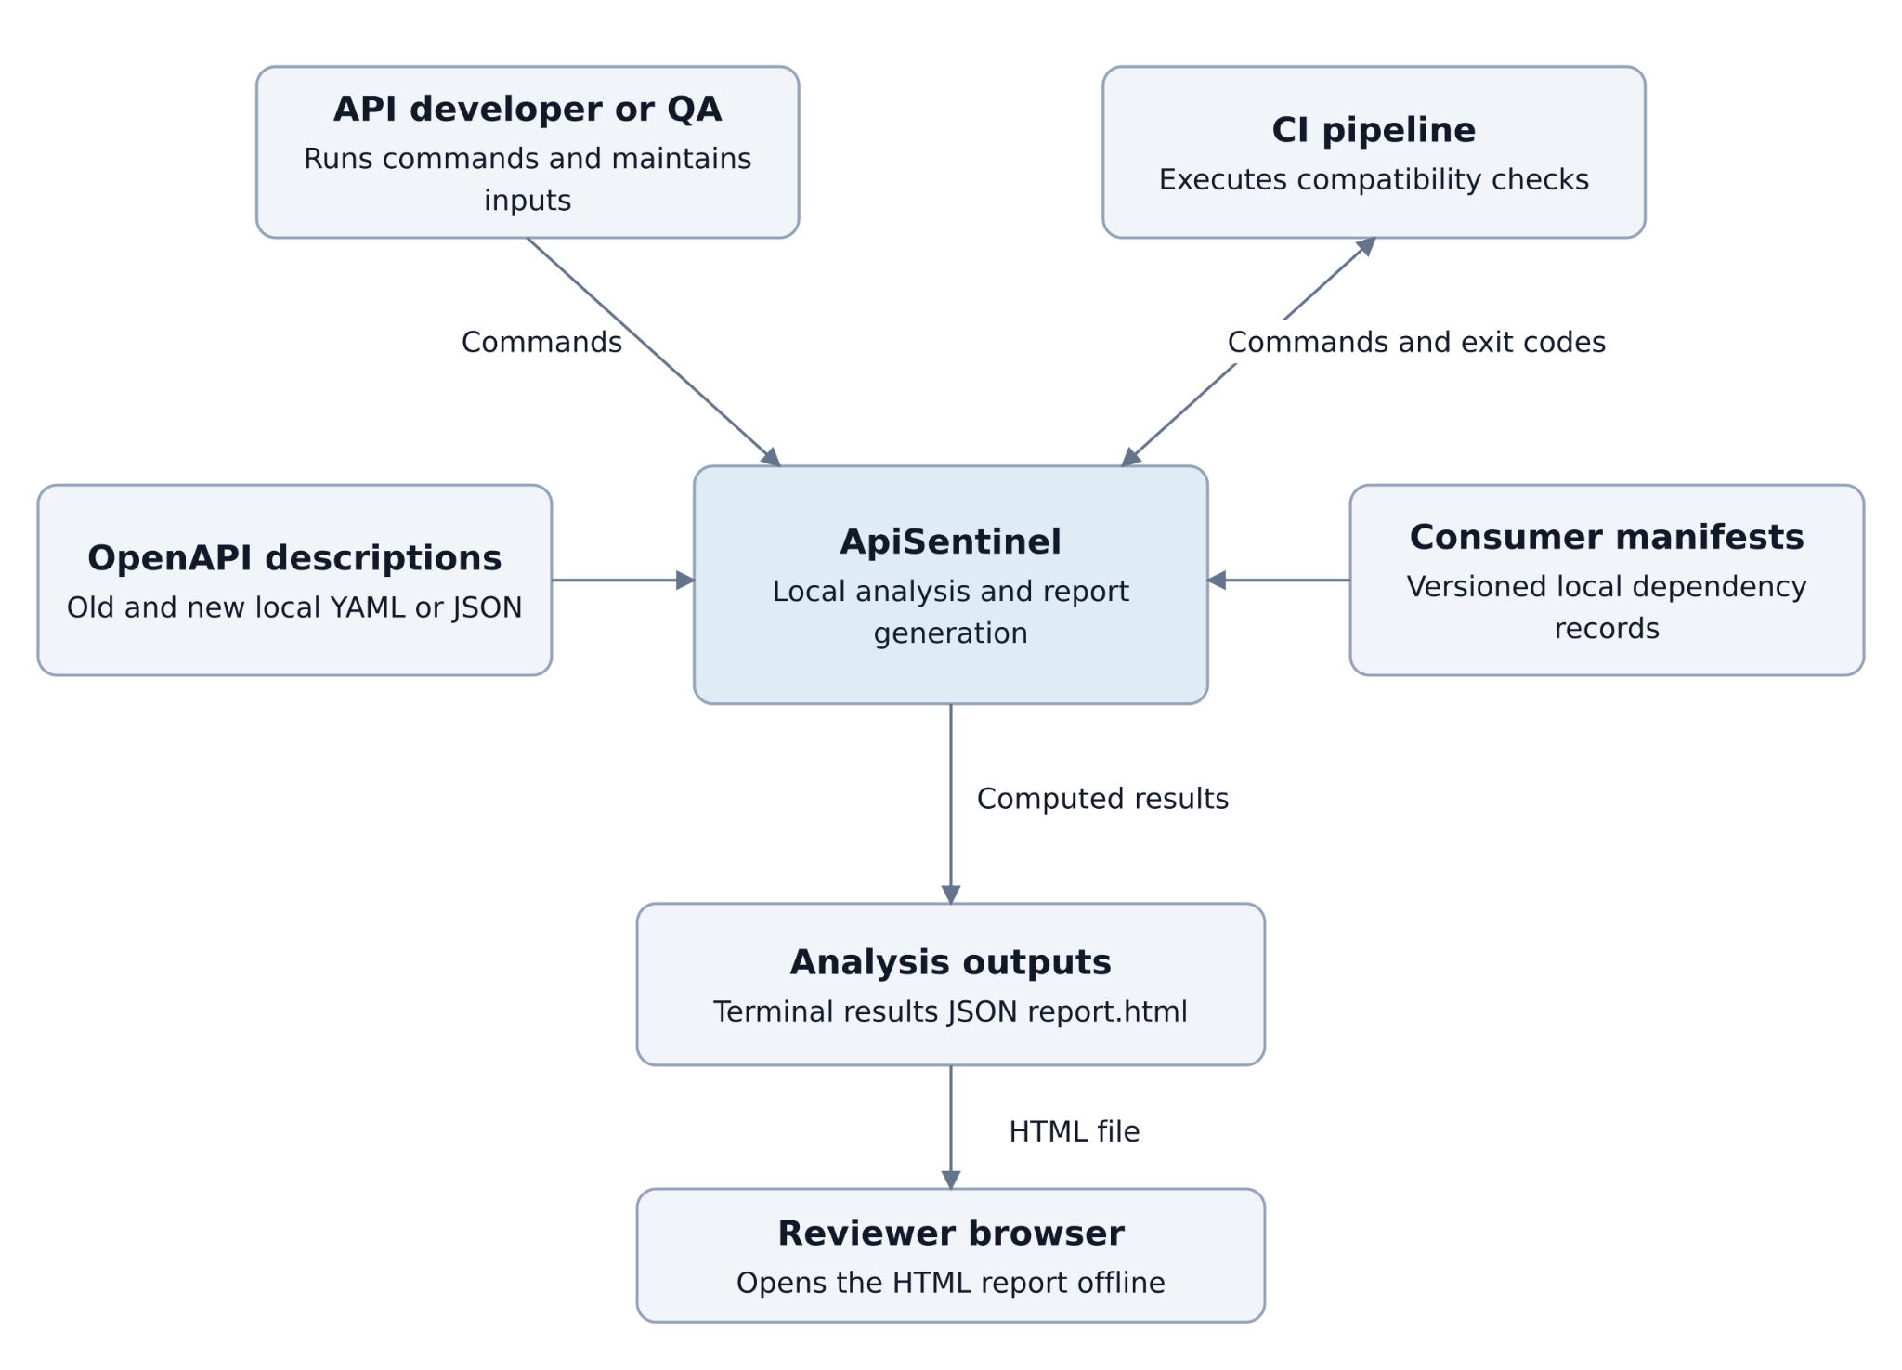
Figure 1. System context and local artifact flow
Actor | Goal
Developer / QA | Compare versions, investigate changes, maintain consumer manifests, and export reports.
CI pipeline | Run a compatibility check and interpret its exit code and structured output.
Report reviewer | Inspect an existing HTML report without installing the CLI or running a server.
Table 12. System actors
Node.js is a build-time dependency for frontend assets. A report reviewer needs only a compatible browser. CI interprets exit status and structured results; it must distinguish an assessed violation from incomplete analysis.

Use case diagram
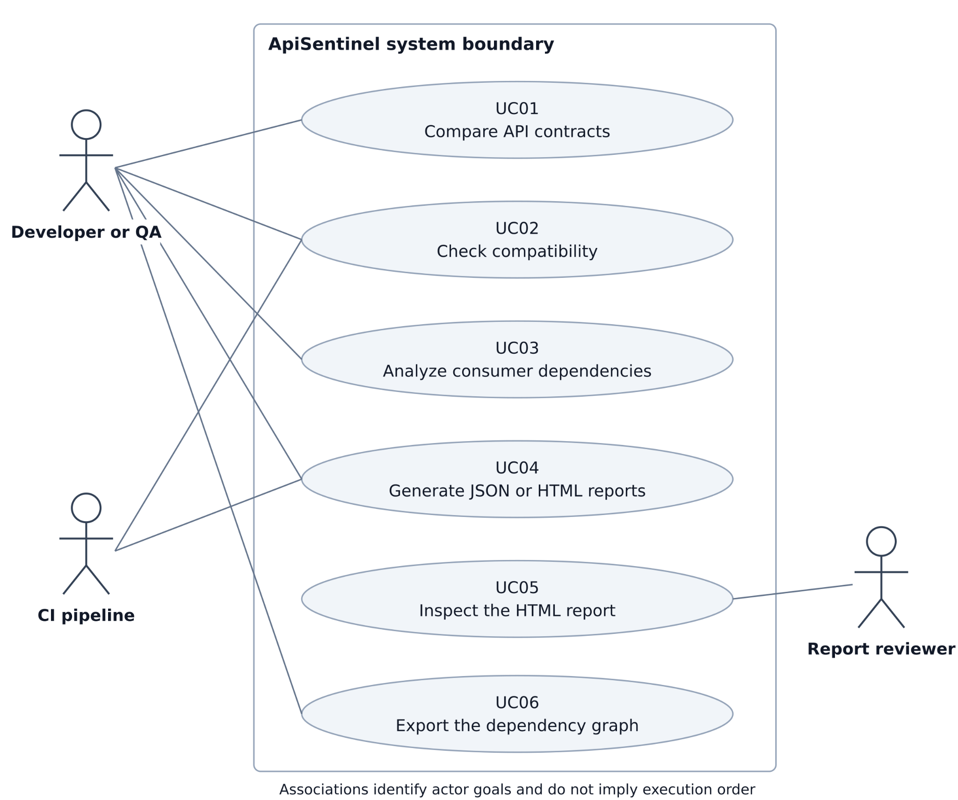
Figure 2. Actors and six use cases within the system boundary
UC01 compares contracts; UC02 applies the compatibility policy; UC03 matches consumer evidence; UC04 exports a report; UC05 inspects an existing HTML snapshot; UC06 exports dependency relationships. Actor associations express goals rather than execution order.
The developer and reviewer may be the same person. UC04 reuses the analysis pipeline when generating a new report. UC05 performs presentation interactions only. The CI actor is automated and requires stable, unambiguous exit behavior.

Components and responsibilities
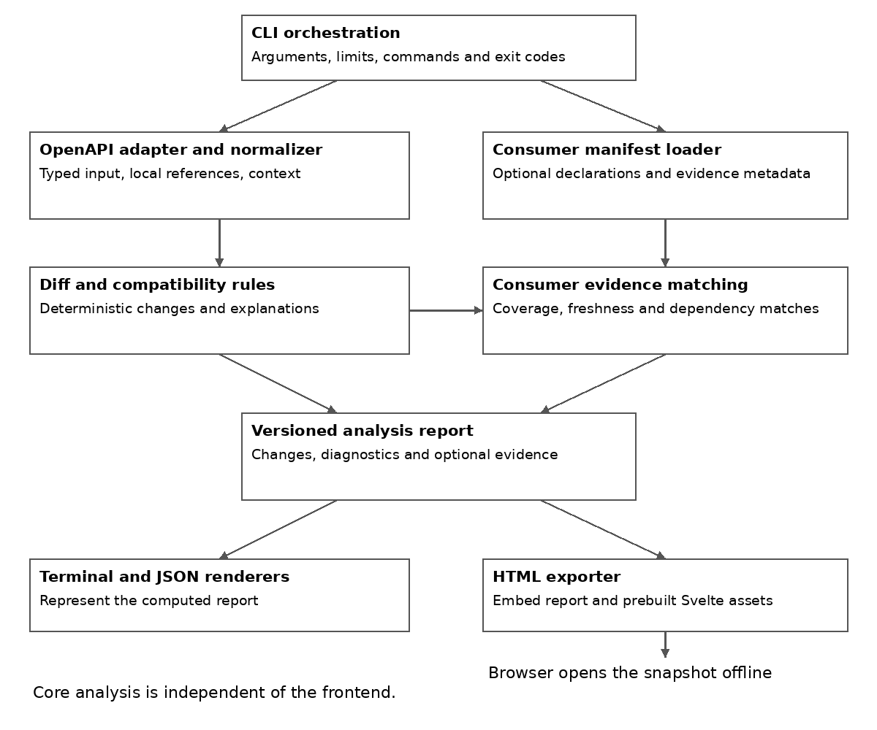
Figure 3. Components and the optional consumer evidence branch
The adapter preserves request/response, operation, status and media-type context. The diff/rule modules produce change records independently of consumer availability. The manifest loader validates identities and metadata; the matcher adds evidence without changing contract classifications.
The report builder retains completion status and diagnostics. Terminal, JSON and HTML consume the same records. Prebuilt Svelte assets enter at packaging time; the browser cannot call back into the analysis core.

Data contract and failure handling
Record | Required information
ApiContract | Provider identity, source specification version, operations, schema nodes, and reference relationships.
ApiChange | Stable ID, rule ID, method and path, request or response direction, location, old or new context, classification, and explanation.
ConsumerDeclaration | Manifest version, consumer and provider, dependency scope, endpoint and optional response fields, coverage, and optional freshness evidence.
ImpactEvidence | Consumer ID, change ID, declaration source, evidence classification, coverage, freshness status, and reasoning.
AnalysisReport | schema_version, engine and input identity, completion status, changes, diagnostics, optional consumer results, graph data, and derived counts.
Table 13. Core data contract
Nested locations use JSON Pointer. Matching retains provider identity, method/path, request or response direction, status, media type and field location. Deleted fields match declarations against the baseline contract. A display title is not a substitute for explicit provider binding.
Analysis and failure flow
Validate command and limits → load and normalize contracts → record structural changes → apply rules → validate and match optional manifests → build the report → render output. Reference cycles are represented safely rather than expanded indefinitely.
Invalid input, unresolved references, unsupported versions and failed writes stop execution with exit 2. Unsupported mandatory semantics mark the analysis incomplete. PotentiallyBreaking is an assessed rule outcome, not a label for silently omitted work.
HTML export writes a temporary file and publishes it only after successful completion. The viewer rejects incompatible report schema versions explicitly. Changing the report contract requires updated fixtures and documented compatibility handling.

UX and prototype

Overview and change exploration
These figures illustrate a prototype; its visual style may differ from the final implementation. The four views retain the provider and compared versions, use text labels, and offer evidence alongside results. They illustrate intended behavior and layout, not a completed frontend.
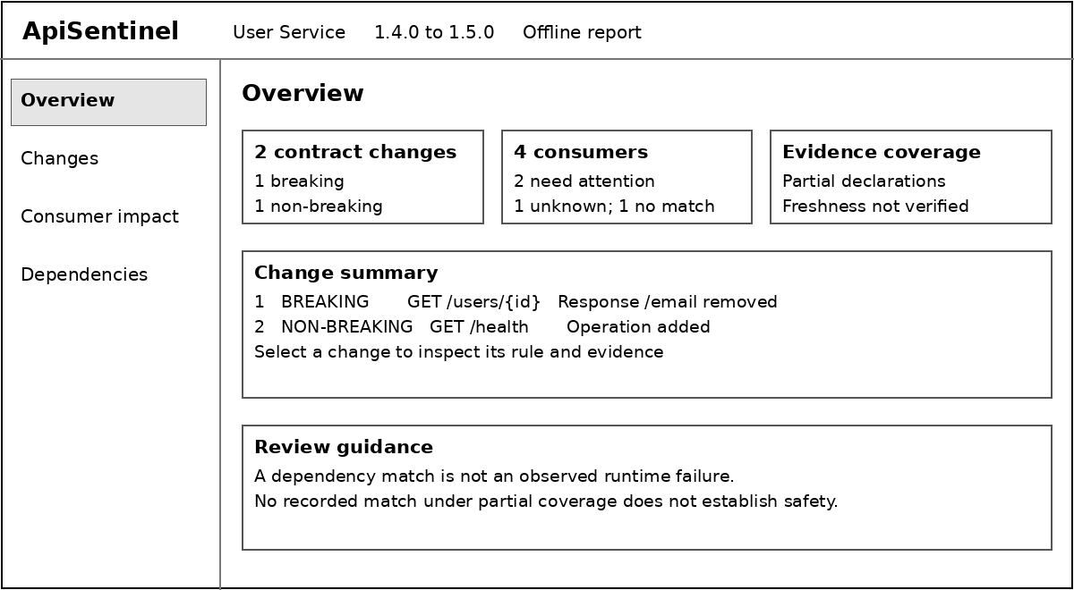
Figure 4. Overview with global totals and explicit evidence limits
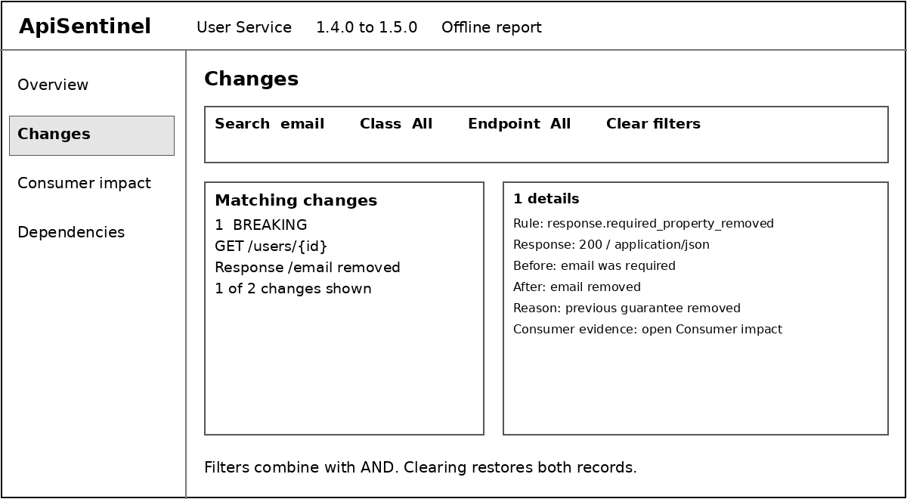
Figure 5. Change search, combined filters and rule explanation
Change 1 removes a required response email field; Change 2 adds GET /health. Search and class/endpoint filters combine with AND. Clearing them restores all records. Global overview counts remain unchanged by view-local filters.

Consumer evidence and dependencies

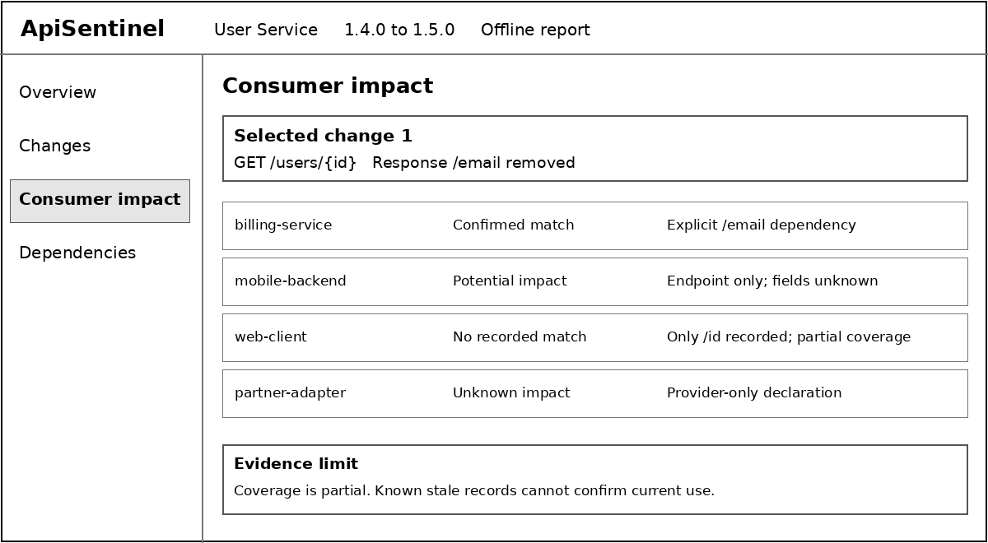
Figure 6. Consumer classifications and their supporting declarations
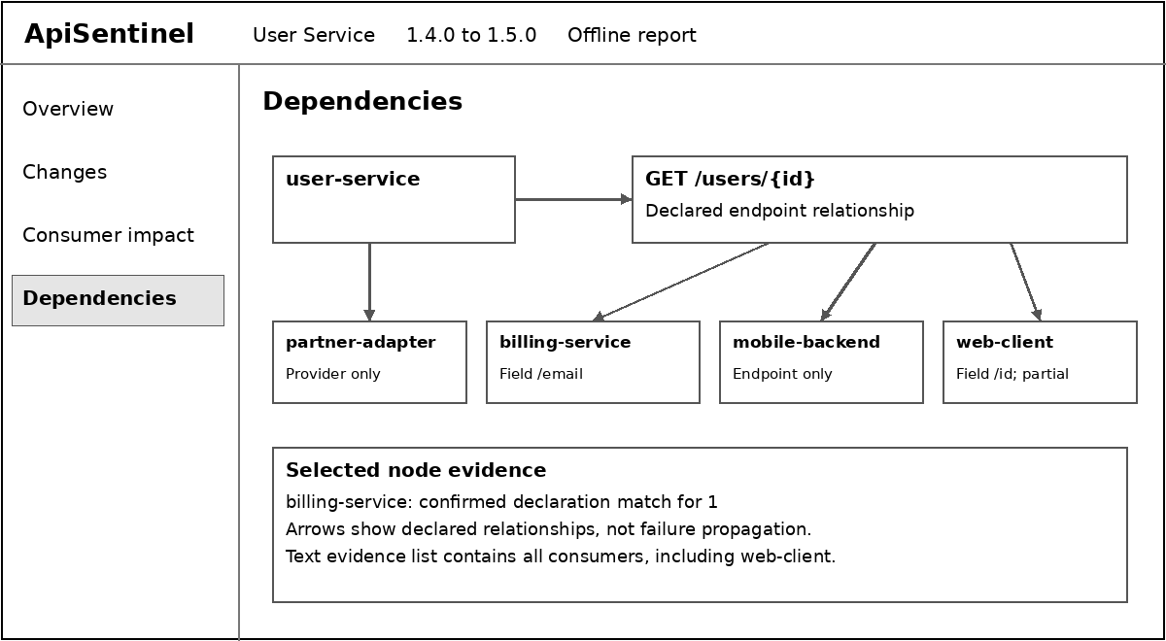
Figure 7. Dependency inspection with a textual evidence alternative
The sample has a direct field match, endpoint-only potential impact, no recorded match under partial coverage, and provider-only unknown evidence. “Confirmed” refers to the declaration match, not runtime failure. Known stale evidence cannot confirm current dependence.
Graph paths show declared relationships, not automatic failure propagation. Keyboard users must be able to select records and obtain equivalent evidence as text. Colors are not required to distinguish statuses.

CLI prototype and acceptance scenarios
The following command syntax illustrates intended behavior; it is not output from a finished Rust implementation. Long commands are shown on continued shell lines.
apisentinel diff old.json new.json
apisentinel check old.json new.json --format json
apisentinel impact old.json new.json --provider user-service \
--consumers ./consumers
apisentinel report old.json new.json --provider user-service \
--consumers ./consumers -o report.html
apisentinel graph --consumers ./consumers --format dot

Scenario | Expected observation
Inspect change 1 | Search email; inspect response 200/application/json, /email, the previous guarantee and response.required_property_removed.
Review consumer evidence | billing-service: confirmed; mobile-backend: potential; web-client: no recorded match with partial coverage; partner-adapter: unknown.
Inspect a graph node | Node selection shows its declaration and evidence; no inferred transitive failure.
Recover from empty filtering | Non-breaking plus email yields an empty result with Clear filters; clearing restores two changes.
Handle exceptional states | Distinguish no changes, no consumers, unsupported report version, invalid input and stale/partial evidence.
Verify the final report | Open under file:// without network; check every view, focus, controls and local assets.
Table 14. Prototype acceptance scenarios
The standalone interaction prototype uses fixed data and plain JavaScript. It illustrates intended interactions; its visual style may differ from the final implementation. Production Svelte conformance, browser rendering and accessibility remain verification tasks.

Verification and evaluation plan

Strategy and test data
Required evaluation covers rule correctness, consumer evidence, CLI/system behavior, the oasdiff baseline, and measured execution costs. A participant study is optional and cannot block technical completion. No test results are reported in this plan.
Level | Purpose and evidence
Unit and rule tests | Exercise normalization, reference handling, compatibility rules, and consumer matching with independently specified expected outcomes.
Integration tests | Run the CLI against files and compare exit codes, stdout, stderr, JSON records, diagnostics, and output-file behavior.
System tests | Open generated production HTML under file:// with networking blocked; test packaging, safe rendering, and platform behavior.
Outcome evaluation | Compare contract analysis with a pinned oasdiff CLI and assess declared evidence against independent labels. A manual-review participant comparison is optional.
Table 15. Verification levels
The fixture count is determined by rule coverage. Every documented rule requires positive, negative and direction-sensitive examples where applicable. Include unchanged and representation-only edits, nested and reused schemas, mixed changes, invalid inputs, unsupported constructs and consumer evidence variants.
Each fixture records identity, input hashes, supported features, expected change kind/location, classification, evidence, diagnostics and rationale. Expected labels are written before execution and reviewed independently of tool output. Retain a separate evaluation set not used to tune rules.
Add permission-cleared real API snapshots when available and record provenance and modifications. If suitable examples are unavailable, disclose the resulting synthetic-data limitation. Generate three scale tiers with recorded settings; test case volume never substitutes for semantic coverage.
Run relevant unit/integration tests during development and the full suite at release checkpoints. Record versions, configurations, inputs, results and defects. Repaired failures receive a new run record; original results remain available.

Functional verification matrix
Test group | Requirements | Required checks
1 Input and normalization | Functional 1–2 | Equivalent YAML and JSON normalize equally. Local references preserve operation, request or response, status, and media-type context. Cycles terminate; unresolved references fail explicitly.
2 Structural changes | Functional 3 | Detect operation, parameter, and nested-property additions and removals. Object-key and reusable-definition reordering produces no semantic changes. Reusing a schema retains each relevant usage context.
3 Compatibility rules | Functional 4; Nonfunctional 1 | Check each frozen rule against its expected classification, rule ID, explanation, location, and before or after context. Test request and response directions separately; unsupported semantics are diagnosed.
4 Consumer analysis | Functional 5–7, 16 | Validate manifests, provider binding, duplicate identities, deleted-target matching against the baseline, coverage, freshness, and missing declarations. Apply the evidence cases in the Correctness and consumer evidence subsection.
5 Output consistency | Functional 8–9; Nonfunctional 6 | JSON parses as one versioned document. stdout contains no progress decoration in JSON mode. Terminal, JSON, and HTML agree on change IDs, classifications, counts, diagnostics, and consumer evidence.
6 Command policy | Functional 10, 15 | check returns 1 for Breaking, 0 when none are Breaking, and 2 for invalid input, incomplete mandatory analysis, or execution failure. PotentiallyBreaking alone is a warning with exit 0. Help and version succeed.
7 HTML and exploration | Functional 11–13 | Export one complete local file. Combined filters use AND; clearing restores rows; selections show correct evidence. Failed export preserves any existing valid output. Test empty and unsupported-version states.
8 Graph and boundaries | Functional 14; Nonfunctional 6 | DOT edges and inspectable HTML nodes match declarations. Text details offer equivalent evidence. Graph reachability does not imply transitive failure. The core builds and tests independently of frontend assets.
Table 16. Functional verification
A failed Must check blocks acceptance until corrected or explicitly revised with a documented rationale. Test JSON as parsed data, not only text snapshots. Incomplete mandatory analysis takes precedence over a Breaking policy result.

Nonfunctional and system verification
Test group | Requirements | Conditions and evidence
9 Determinism | Nonfunctional 2 | Run identical inputs three times. Canonical JSON and change identifiers must match exactly. Exclude only documented optional timestamps and path metadata; keep semantic records and ordering in the comparison.
10 Offline behavior | Nonfunctional 3; Functional 11 | Block networking for CLI analysis and browser viewing. Monitor outbound attempts, not only successful requests. Open the final generated HTML directly under file://; no external scripts, styles, fonts, or data requests are permitted.
11 Injection resistance | Nonfunctional 4 | Place tags, event-handler payloads, script terminators, quotes, ampersands, and Unicode in valid input text. Check terminal and JSON integrity and every HTML surface. Content remains inert; embedded JSON parses; no unexpected execution or network attempt occurs.
12 Input boundaries | Nonfunctional 5; Functional 15 | Test the configured byte/depth limits and one step above them; test alternate valid overrides and invalid limit values. Candidate defaults are 25 MiB (26,214,400 bytes) and depth 128. Document depth counting. Over-limit input returns 2; cycles terminate without panic.
13 Portability | Nonfunctional 7 | Build release artifacts and run help, version, diff, check, and report smoke scenarios on Linux x86_64 and Windows x86_64. Use clean recipient environments without Rust or Node.js. Record OS and binary versions and any unavailable checks.
14 Viewer access | Nonfunctional 8; Functional 12–14 | Use keyboard-only navigation for filters, change selection, and node inspection; check visible focus and labels. Evidence remains available as text and classifications do not rely only on color.
15 Performance | Nonfunctional 9 | Measure time and peak memory on three input scales under the protocol in the Baseline comparison and performance subsection. Retain raw runs, failures and variation. There is no fixed latency threshold; report bottlenecks without claiming unmeasured superiority.
Table 17. Nonfunctional verification
For the production HTML, record exact Chromium-based browser and Firefox versions, clear cached assets and block network access. Verify navigation, AND filtering, details, empty states and unsupported schema handling. A prototype check does not establish production engine or viewer correctness.

Correctness and consumer evidence
Evidence case for removed response /email | Expected status
Current explicit field declaration | Confirmed dependency match, linked to its declaration.
Endpoint only | Potential impact; field dependence not established.
Provider only | Unknown impact.
Only /id recorded with partial coverage | No recorded match; no safe verdict.
Matching record known to be stale | Freshness diagnostic; no confirmed current match.
No consumers / wrong provider / invalid manifest | Explicit absence / no cross-provider match / validation error.
Table 18. Consumer evidence cases
Match Breaking findings one-to-one by normalized location and change kind. TP is a correctly matched Breaking result; FP is an unmatched Breaking report; FN is an expected Breaking result not detected. Duplicates cannot inflate success.
Measure | Definition and interpretation
Breaking precision and recall | Precision = TP/(TP+FP); recall = TP/(TP+FN). All frozen supported regression expectations must pass. Report separate independent-set scores and a severity confusion matrix.
Evidence agreement | Correct labelled change–consumer pairs / all labelled pairs; report a status confusion matrix and separate unknown/stale/partial cases.
Coverage and completion | Report tested rules, passing Must checks, incomplete analyses, unsupported cases and failures. Missing evidence is not a negative compatibility example.
Table 19. Correctness measures
Use N/A for zero denominators. Preserve abstentions rather than counting them as successful detection. Controlled complete, coarsened, partial and stale variants test sensitivity without relabelling uncertainty as safety. Any reduction in review warnings must be interpreted alongside missed matches and unknown coverage.

Baseline comparison and performance
Pin an oasdiff release, binary hash, flags, policy and documentation snapshot. Use the same frozen OpenAPI pairs and a declared common rule subset. Match findings by operation, direction, status/media type, property path and change kind. Severity mapping is defined before results are seen (oasdiff, n.d.-a, n.d.-b).
Review disagreements against independently justified expectations, not against oasdiff as an oracle. Publish full-corpus support and incomplete/failed cases as well as common-subset precision and recall. openapi-diff may provide an additional check if time permits (OpenAPITools, n.d.).
Performance control | Planned method
Environment and scales | Record CPU, RAM, OS, release build, tool versions and hashes. Use small/medium/large generated inputs; record actual operations, nodes, consumers and byte sizes.
Workload fairness | Compare contract-only stages between tools. Measure ApiSentinel consumer matching and HTML export separately; exclude compilation and frontend builds.
Repeated measurements | Proposed protocol: one warm-up and five measured runs per tier, alternating tool order. Report every time, median, range, peak memory and failures. Label warm-cache conditions.
Interpretation | No fixed latency requirement. Explain scaling and bottlenecks; do not assert a speed advantage before measurement.
Table 20. Performance protocol

Optional usability evaluation
If participants are available, compare manual review of oasdiff output plus the same manifests with ApiSentinel-assisted review. Use matched tasks for finding a change, identifying declared exposure and explaining uncertainty; counterbalance order and retain accuracy, time and assistance records.
Participant count, timeout and task sets remain a proposed protocol to finalize before recruitment. The study is exploratory and has no predetermined improvement target. If it is omitted, make no empirical claim of improved human speed or usability; technical evidence matching remains evaluable.

Requirements traceability and completion
Requirements | Use cases and phase | Verification
Functional 1–3 | Use case 1; phase 1 parsing/diff | 1–2; normalization, references and changes.
Functional 4, 10 | Use case 2; phase 2 rules | 3, 6; classification and exit policy.
Functional 5–7, 16 | Use case 3; phase 3 consumers | 4; evidence, provider binding and absence.
Functional 8–9 | Use case 4; phase 2 output | 5; consistent structured results.
Functional 11–13 | Use cases 4–5; phase 4 viewer | 7, 10–11, 14; offline, safe and inspectable output.
Functional 14 | Use cases 6 and 5; phase 3–4 | 8, 14; graph and textual evidence.
Functional 15 | Use cases 1–4; all phases | 6, 12; help, diagnostics and failure handling.
Nonfunctional 1–4 | Phases 2–4 | 3, 9–11; correctness, determinism, offline and injection.
Nonfunctional 5–9 | Phases 1–4 | 8, 12–15; limits, modularity, platforms, access and measurements.
Table 21. Requirements traceability
Completion criteria and evidence record
All Must checks and documented rule expectations must pass, with no open critical defect. Critical defects include missed required breaking rules, unsupported safe verdicts, injected code execution, data loss during export, and CI success after mandatory analysis failure. Report each Should requirement as achieved, partial or not achieved.
Phase 1 establishes parsing fixtures; phase 2 freezes rules and structured output; phase 3 validates evidence semantics; phase 4 verifies offline delivery and completes comparative measurements. Retain test IDs, requirements, commit, date, environment, versions, configuration, input hashes, expected/actual outcomes, logs and defect links.
Independent review should cover fixture expectations and disagreements. Synthetic data, imperfect labels, policy differences and incomplete declarations limit generalization. Report exclusions and failures transparently. Interview-based relevance evidence is presented separately; optional user-study results must be clearly separated from required technical evidence.

References
Ayas, H. M., Fischer, H., Leitner, P., & De Oliveira Neto, F. G. (2022). An empirical analysis of microservices systems using consumer-driven contract testing. In 2022 48th Euromicro Conference on Software Engineering and Advanced Applications (SEAA) (pp. 92–99). IEEE. https://doi.org/10.1109/SEAA56994.2022.00022
Cunniffe, A. (2025a, February 5). Diff and lint OpenAPI. GitHub. https://github.com/opticdev/optic/wiki/Diff-and-Lint-OpenAPI
Cunniffe, A. (2025b, February 5). Prevent breaking changes. GitHub. https://github.com/opticdev/optic/wiki/Prevent-Breaking-Changes
Di Lauro, F., Serbout, S., & Pautasso, C. (2022a). A large-scale empirical assessment of web API size evolution. Journal of Web Engineering, 21(6), 1937–1980. https://doi.org/10.13052/jwe1540-9589.2167
Di Lauro, F., Serbout, S., & Pautasso, C. (2022b). To deprecate or to simply drop operations? An empirical study on the evolution of a large OpenAPI collection. In I. Gerostathopoulos, G. Lewis, T. Batista, & T. Bureš (Eds.), Software architecture (pp. 38–46). Springer. https://doi.org/10.1007/978-3-031-16697-6_3
glademiller. (n.d.). openapiv3: Rust OpenAPI v3 structs and enums for easy deserialization with Serde. GitHub. https://github.com/glademiller/openapiv3
The Go Authors. (n.d.). Frequently asked questions (FAQ). Go. https://go.dev/doc/faq
Klabnik, S., Nichols, C., & Krycho, C. (n.d.). The Rust programming language. https://doc.rust-lang.org/book/
Koçi, R., Franch, X., Jovanovic, P., & Abelló, A. (2023). Web API evolution patterns: A usage-driven approach. Journal of Systems and Software, 198, Article 111609. https://doi.org/10.1016/j.jss.2023.111609
Lercher, A., Glock, J., Macho, C., & Pinzger, M. (2024). Microservice API evolution in practice: A study on strategies and challenges. Journal of Systems and Software, 215, Article 112110. https://doi.org/10.1016/j.jss.2024.112110
Node.js. (n.d.). Modules: TypeScript. https://nodejs.org/api/typescript.html
oasdiff. (n.d.-a). Breaking changes and changelog. GitHub. https://github.com/oasdiff/oasdiff/blob/main/docs/BREAKING-CHANGES.md
oasdiff. (n.d.-b). CLI quick start. https://www.oasdiff.com/docs/getting-started
oasdiff. (n.d.-c). oasdiff: OpenAPI diff and breaking changes. GitHub. https://github.com/oasdiff/oasdiff
Ochoa, L., Degueule, T., Falleri, J.-R., & Vinju, J. (2022). Breaking bad? Semantic versioning and impact of breaking changes in Maven Central: An external and differentiated replication study. Empirical Software Engineering, 27(3), Article 61. https://doi.org/10.1007/s10664-021-10052-y
OpenAPI Initiative. (2024, October 24). OpenAPI specification (Version 3.0.4). https://spec.openapis.org/oas/v3.0.4.html
OpenAPITools. (n.d.). openapi-diff: Utility for comparing two OpenAPI specifications. GitHub. https://github.com/OpenAPITools/openapi-diff
Optic. (n.d.). Optic: OpenAPI made easy. GitHub. https://github.com/opticdev/optic
Pact Foundation. (n.d.-a). How Pact works. Pact Docs. https://docs.pact.io/getting_started/how_pact_works
Pact Foundation. (n.d.-b). Pact Broker introduction. Pact Docs. https://docs.pact.io/pact_broker
React. (n.d.). Quick start. https://react.dev/learn
richardtallent. (n.d.). vite-plugin-singlefile: Vite plugin for inlining JavaScript and CSS resources. GitHub. https://github.com/richardtallent/vite-plugin-singlefile
Schwarz, G.-D., Quast, F., & Riehle, D. (2025). Ensuring syntactic interoperability using consumer-driven contract testing. Software Testing, Verification and Reliability, 35(5), Article e70006. https://doi.org/10.1002/stvr.70006
Serbout, S., Di Lauro, F., & Pautasso, C. (2022). Web APIs structures and data models analysis. In 2022 IEEE 19th International Conference on Software Architecture Companion (ICSA-C) (pp. 84–91). IEEE. https://doi.org/10.1109/ICSA-C54293.2022.00059
Serbout, S., & Pautasso, C. (2024). How are web APIs versioned in practice? A large-scale empirical study. Journal of Web Engineering, 23(4), 465–506. https://doi.org/10.13052/jwe1540-9589.2341
Svelte. (n.d.). Overview. https://svelte.dev/docs/svelte/overview
Vite. (n.d.). Building for production. https://vite.dev/guide/build
Vue.js. (n.d.). Introduction. https://vuejs.org/guide/introduction.html

