On the origin of citation

PYT

September 15, 2015

# Load the data

counts_raw <- read.delim("data/counts-raw.txt.gz")  
count_norm <- read.delim("data/counts-norm.txt.gz")

# Data exploration

What's the distribution of authors in all articles of our data set? 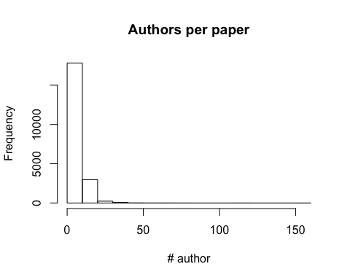

What's the distribution of facebook share in all articles of our data set? 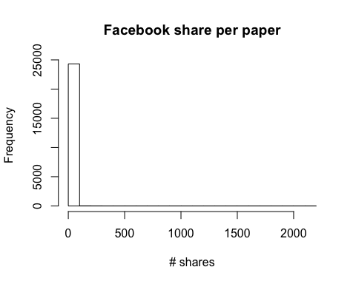

The average number of Facebook shares per paper in the data set is 0.6524187.