Title of Your Submission

Table of Contents

##### 0.0.0.0.1

# 1 Summary of Main Results

Summarize the main highlights from the Results section. This can be in bullet format. Any significant results mentioned should include p-values and references to appropriate figures and tables. There should be no information in the Summary section that is not contained in the Results section (see Results).

# 2 Background

This document should contain the study background section for HVTNGitExample.

Write project background here. Don’t use headers.

This report presents data [blinded/unblinded] to treatment arm, as of [enter date of data file creation].

Samples were collected at: [list study time points and corresponding relationship to vaccination, e.g., week 0 (1st vaccination), week 6 (2 weeks post-2nd vaccination), week 10 (2 weeks post-3rd vaccination, and week 26 (2 weeks post-4th (final) vaccination))] for [# groups; list vaccine doses or group descriptions] (reference test: Huang and Gottardo (2013)).

Table 2.1: HVTNGitExample study schema.

|  |  |  |  |
| --- | --- | --- | --- |
| Group | Sample Size | Week 10 | Week 20 |
| Group A | 10 | Dose A | Dose A |
| Group B | 10 | Dose B | Dose B |

## 2.1 Report Amendments

If previous reports were provided, note if this report supplements or supersedes the previous reports. For example, “the previous PT report (distributed on DDMonthYYYY) presented peak data. This report summarizes additional durability data.”

If this is an updated report, also briefly describe additional data included and/or analysis done since the previous report (e.g., additional visits, participants (include pubIDs), antigens, comparisons, new/changed tables, figures).

# 3 Objectives

List primary and secondary (if applicable) objectives. Objectives can be found on ATLAS, in the study protocol, or in the SAP.

# 4 Biological Endpoints

Describe the lab measures of interest and the antigens/isolates tested. The biological endpoints may be in the SAP, or you may need to contact the lab for details. This may be done at the lab review stage. Make sure to this section is written in the past tense.

# 5 Lab Methods

Describe the lab methods. The lab methods section is written by the lab. Use template language prior to lab review, and then the lab can make changes to this section during their review.

# 6 Statistical Methods

## 6.1 Statistical Endpoints

Describe the statistical measures of interest (response, response magnitude, etc.) including response call methodology and truncation, if applicable.

## 6.2 Graphical Analysis

Update the following section as appropriate for your data.

Response rates were plotted, with accompanying Wilson score confidence intervals, for each group, antigen, and study time point. Distributions of response magnitude were plotted on the log scale for each group, antigen, and study time point with box plots superimposed on the distribution of responders. The mid-line of the box denotes the median and the ends of the box denote the and percentiles. The whiskers denote the most extreme data points that were no more than 1.5 times the interquartile range (i.e., height of the box). To show response trend over time, line plots of response magnitude were plotted on the log scale by study group and antigen across time points.

## 6.3 Statistical Tests

Update the following section as appropriate for your data. If available, use language from the statistical analysis plan. Ensure that this section includes all statistical methodology used in the report.

To assess if two groups have different response rates, pairwise group comparisons were conducted using Fisher’s exact test for each time point and antigen.

For comparisons across time, McNemar’s test were used to account for paired data. Response magnitude comparisons between experimental groups were compared using the Wilcoxon rank-sum test [among responders only]. Response magnitude comparisons between time points were performed using the Wilcoxon signed-rank test to account for paired data.

# 7 Participant Cohort

The study enrolled [describe the total number enrolled to date and, if unblinded, the number in each treatment arm]. Include a table with data availability by key variables and red highlights for counts that are less than expected. Refer to the table and comment on reasons for missing data if known.

# 8 Results

The results section addresses how each endpoint supports the main objectives. Include summary statistics and significant results as applicable, including p-values and table and figure references. The results section should provide supporting evidence for all statements made in the summary section.

## 8.1 Section 1

Consider breaking up the results section by objective or by statistical endpoint.

## 8.2 Section 2

Make sure to include p-values and references to relevant tables and figures. See Figure 9.1 and Table 9.1.

##### 8.2.0.0.1

# 9 Figures and Tables

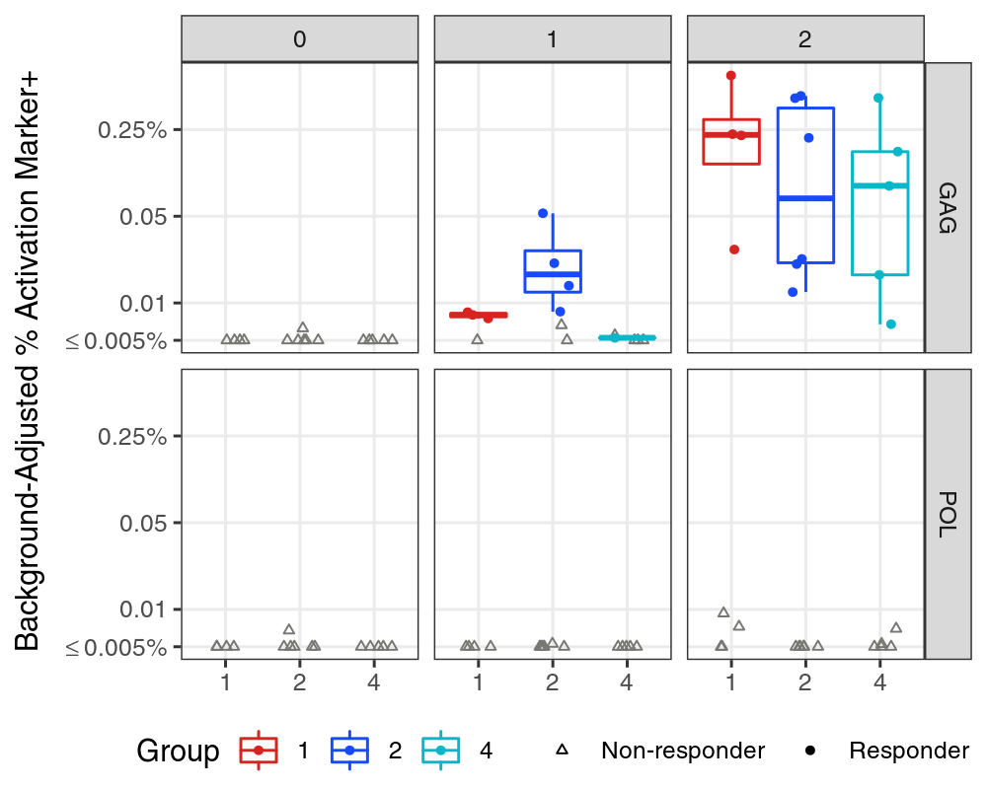

Figure 9.1: Longer caption that shows under the figure. Explain everything needed to understand the figure here.

##### 9.0.0.0.1

Table 9.1: Long caption to show above table. Explain everything needed to understand the table here.

|  |  |  |  |  |  |  |
| --- | --- | --- | --- | --- | --- | --- |
| Stim | Visit | Comparison | SampleSizes | Median (Range) | Mean (SD) | MagnitudeTest |
| GAG | 0 | 1 > 2 | 4 vs. 6 | 0.000 [0.000, 0.002] vs. 0.000 [0.000, 0.006] | 0.001 (0.001) vs. 0.001 (0.003) | 0.667 |
| GAG | 0 | 1 > 4 | 4 vs. 5 | 0.000 [0.000, 0.002] vs. 0.000 [0.000, 0.000] | 0.001 (0.001) vs. 0.000 (0.000) | 0.444 |
| GAG | 0 | 2 > 4 | 6 vs. 5 | 0.000 [0.000, 0.006] vs. 0.000 [0.000, 0.000] | 0.001 (0.003) vs. 0.000 (0.000) | 0.273 |
| GAG | 1 | 1 > 2 | 4 vs. 6 | 0.008 [0.004, 0.008] vs. 0.011 [0.003, 0.053] | 0.007 (0.002) vs. 0.018 (0.018) | 0.871 |
| GAG | 1 | 1 > 4 | 4 vs. 5 | 0.008 [0.004, 0.008] vs. 0.002 [-0.005, 0.005] | 0.007 (0.002) vs. 0.002 (0.004) | ***0.032*** |
| GAG | 1 | 2 > 4 | 6 vs. 5 | 0.011 [0.003, 0.053] vs. 0.002 [-0.005, 0.005] | 0.018 (0.018) vs. 0.002 (0.004) | ***0.009*** |
| GAG | 2 | 1 > 2 | 4 vs. 6 | 0.226 [0.027, 0.683] vs. 0.119 [0.012, 0.466] | 0.291 (0.278) vs. 0.197 (0.215) | 0.176 |
| GAG | 2 | 1 > 4 | 4 vs. 5 | 0.226 [0.027, 0.683] vs. 0.088 [0.007, 0.450] | 0.291 (0.278) vs. 0.145 (0.182) | 0.143 |
| GAG | 2 | 2 > 4 | 6 vs. 5 | 0.119 [0.012, 0.466] vs. 0.088 [0.007, 0.450] | 0.197 (0.215) vs. 0.145 (0.182) | 0.331 |
| POL | 0 | 1 > 2 | 4 vs. 6 | 0.000 [0.000, 0.003] vs. 0.000 [0.000, 0.007] | 0.001 (0.002) vs. 0.001 (0.003) | 0.667 |
| POL | 0 | 1 > 4 | 4 vs. 5 | 0.000 [0.000, 0.003] vs. 0.000 [0.000, 0.003] | 0.001 (0.002) vs. 0.001 (0.002) | 0.722 |
| POL | 0 | 2 > 4 | 6 vs. 5 | 0.000 [0.000, 0.007] vs. 0.000 [0.000, 0.003] | 0.001 (0.003) vs. 0.001 (0.002) | 0.697 |
| POL | 1 | 1 > 2 | 4 vs. 6 | 0.002 [0.000, 0.005] vs. 0.000 [0.000, 0.005] | 0.002 (0.002) vs. 0.001 (0.002) | 0.452 |
| POL | 1 | 1 > 4 | 4 vs. 5 | 0.002 [0.000, 0.005] vs. 0.000 [-0.005, 0.001] | 0.002 (0.002) vs. -0.001 (0.002) | 0.127 |
| POL | 1 | 2 > 4 | 6 vs. 5 | 0.000 [0.000, 0.005] vs. 0.000 [-0.005, 0.001] | 0.001 (0.002) vs. -0.001 (0.002) | 0.132 |
| POL | 2 | 1 > 2 | 4 vs. 6 | 0.004 [-0.001, 0.009] vs. 0.001 [-0.016, 0.004] | 0.004 (0.005) vs. -0.001 (0.007) | 0.381 |
| POL | 2 | 1 > 4 | 4 vs. 5 | 0.004 [-0.001, 0.009] vs. 0.001 [-0.002, 0.007] | 0.004 (0.005) vs. 0.002 (0.004) | 0.365 |
| POL | 2 | 2 > 4 | 6 vs. 5 | 0.001 [-0.016, 0.004] vs. 0.001 [-0.002, 0.007] | -0.001 (0.007) vs. 0.002 (0.004) | 0.686 |

##### 9.0.0.0.2

Table 9.2: Reproducibility software session information

|  |  |
| --- | --- |
| name | value |
| version | R version 4.0.4 (2021-02-15) |
| os | openSUSE Leap 42.2 |
| system | x86_64, linux-gnu |
| ui | X11 |
| language | (EN) |
| collate | en_US.UTF-8 |
| ctype | en_US.UTF-8 |
| tz | America/Los_Angeles |
| date | 2022-10-25 |
| pandoc | 2.11.4 @ /usr/lib/rstudio-server/bin/pandoc/ (via rmarkdown) |
| repo | <https://github.com/pyu2101/HVTNGitExample.git> |
| file name | HVTN_Workshop_Example.Rmd |
| location | HVTN_Workshop_Example |
| user | Pei-Chun Yu |

Table 9.3: Reproducibility software package version information

|  |  |  |  |
| --- | --- | --- | --- |
| package | version | date | source |
| conflicted | 1.1.0 | 2021-11-26 | CRAN (R 4.0.4) |
| dplyr | 1.0.9 | 2022-04-28 | CRAN (R 4.0.4) |
| forcats | 0.5.1 | 2021-01-27 | CRAN (R 4.0.4) |
| ggplot2 | 3.3.6 | 2022-05-03 | CRAN (R 4.0.4) |
| here | 1.0.1 | 2020-12-13 | CRAN (R 4.0.4) |
| kableExtra | 1.3.4 | 2021-02-20 | CRAN (R 4.0.4) |
| knitr | 1.40 | 2022-08-24 | CRAN (R 4.0.4) |
| purrr | 0.3.4 | 2020-04-17 | CRAN (R 4.0.4) |
| readr | 2.1.2 | 2022-01-30 | CRAN (R 4.0.4) |
| rmarkdown | 2.16 | 2022-08-24 | CRAN (R 4.0.4) |
| stringr | 1.4.0 | 2019-02-10 | CRAN (R 4.0.4) |
| tibble | 3.1.7 | 2022-05-03 | CRAN (R 4.0.4) |
| tidyr | 1.2.0 | 2022-02-01 | CRAN (R 4.0.4) |
| tidyverse | 1.3.1 | 2021-04-15 | CRAN (R 4.0.4) |
| VISCfunctions | 1.2.2 | 2022-02-24 | git2r (<https://github.com/FredHutch/VISCfunctions.git@28be2826df1c09cf2cac919ae2db82e05dde8dd9>) |
| VISCtemplates | 1.1.0 | 2022-10-19 | Github ([FredHutch/VISCtemplates@5c2da0e37c313fc59a3e01caa44777843b810c12](mailto:FredHutch/VISCtemplates@5c2da0e37c313fc59a3e01caa44777843b810c12)) |

##### 9.0.0.0.3

# References

Huang, Yunda, and Raphaël Gottardo. 2013. “Comparability and Reproducibility of Biomedical Data.” *Briefings in Bioinformatics* 14 (4): 391–401.