Rounding corners of 3D flat figure with trapezoid edge

Trapezoid edge of plane figure of height $h$. At each point edge has middle point $M$ and normal vector $N$ of length w. Local coordinates relative to middle point $M$: $z$– vertical (bottom plane $z=0$, top plane $z=h$). Top and bottom smoothing with radius $r$ and $n$ additional points in smoothing arc. $r$ can be the same for all edge or be a fraction of $w$.

$tg\left(α\right)=h/{w, }dc=r*tg\left(α/2\right)=rh/{\left(w+\sqrt{h^{2}+w^{2}}\right)}, max\left(dc\right)={\sqrt{h^{2}+w^{2}}}/2$,

Position of top center: $cTop=-\left(0.5+dc/w\right)N+\left(h-r\right)e_{z}$

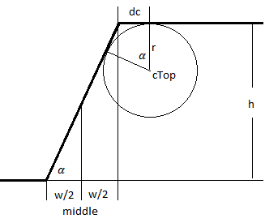

Smoothing points are evenly distributed on the smoothing arc. There are $n+2$ points on each arc including arc start and end. Positions of smoothing points, ${pTop}_{i}$, and normal at each point, $V_{i}$, defined as

${pTop}_{i}=cTop+r V_{i}, V_{i}=-sin\left(φ_{i}\right)N+w cos\left(φ_{i}\right)e_{z}, φ_{i}=i dφ, i=\left[0:n+2\right], dφ=α/{\left(n+1\right)}$

Bottom smoothing is defined as follows:

$cBottom=\left(0.5+dc/w\right)N+re_{z}$, ${pBottom}_{i}=cBottom-r V_{i}$.

Bottom normal, $V_{i}$, for each edge point is the same as top. Smoothed edge and normals look like left polygon ($n=1$).

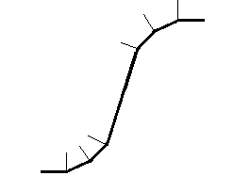 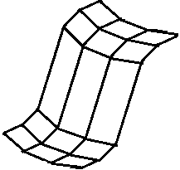

**Useful choice: $dc=k w$, $max\left(k\right)={\sqrt{{h^{2}}/{w^{2}}+1}}/2$**