Example Document

Table of Contents

Chapter 1. 1

Part 1. Introduction. 1

Part 2. Action. 2

Part 3. The End 3

Chapter 2. 4

# Chapter 1.

## Part 1. Introduction.

Once upon a time, long long long time ago, there was a document. It was bad. You can see it.

## Part 2. Action.

The document lacked any images, so the Author added one on the right.

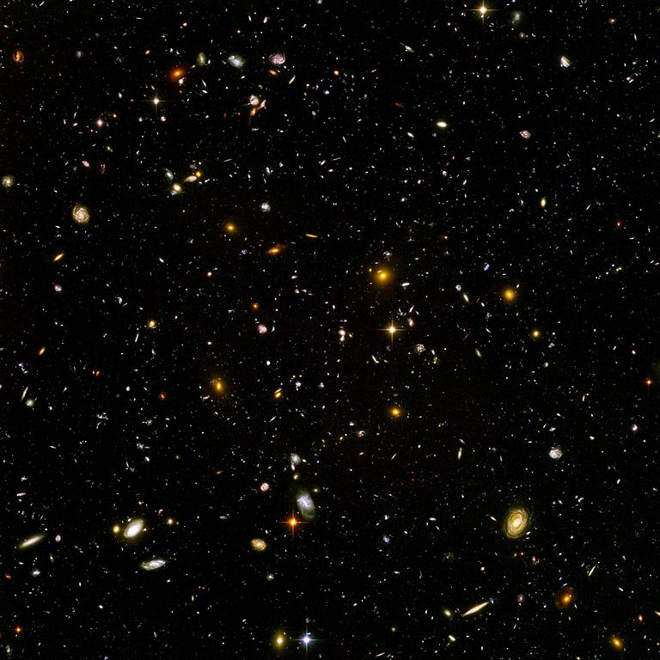  
Illustration 1: Hubble Extreme Deep Field

## Part 3. The End

And that was it.

The Document was still bad, but it had a great image in it.

The end.

# Chapter 2.

And there was no chapter 2 because the end was in Chapter 1.