**Pyxel Printer Test**

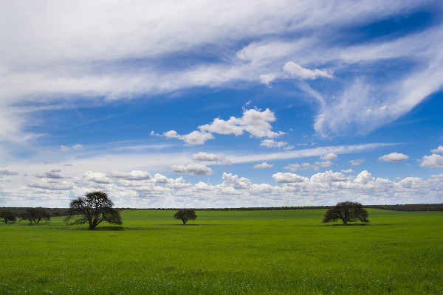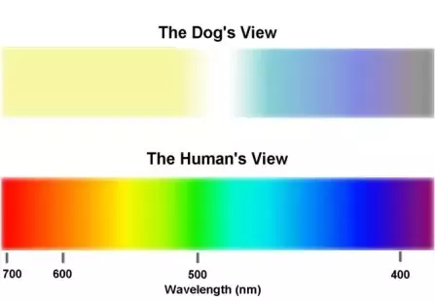

Thank you for using Pyxel. Print this in a paper you won’t use to test your printer’s colors and black and white text.

Version 2