Optical Character Recognition on Pulse Volume Recording Image

Presenting Author’s Name (underlined), Other author’s names.

Authors’ affiliated institution(s).

**Introduction:** A Pulse Volume Recording (PVR) is an ultrasound study on the status of blood circulation to legs. Reports will be written based on evaluating the data(numbers) contained in a graphical image sent by the Doppler machine. Though the process of evaluation on PVR is simple, writing the report could be tedious. The objective of this study is to develop an Optical Character Recognition (OCR) method to extract the numbers from images provided by Doppler machine, so that an automatic report generator can be build upon it. Due to the low resolution and quality of the graphical image, an OCR method was developed specifically for recognizing numbers in such cases.

**Materials and Methods:** Sixteen PVR images containing ninety-three sets of numbers were provided to develop the OCR method (sudokuOCR). MatLab was used to be the development and test environment of sudokuOCR. The basic idea of this method was a special template matching technique. Every digit from the ninety-three sets of numbers were categorized into ten clusters (from digit “0” to digit “9”). By averaging and normalizing each cluster, ten of “digit image” was generated. The resolution of these “digit image” were increased, and the mass center of the digits were reallocated to the center of the image frame. Then, each “digit image” was split into nine parts, mass and the position of each part’s mass center were calculated. Weighted mass center range of each part was generated by taking the product of the mass of each part(*m*) and the length from the center of the “digit image” to each mass center(*r*). Each digit template was created by putting these nine weighted mass center location in a nine elements (floating numbers) array. Similar method was used to generate the nine elements array for sample, and by matching the sample array to template arrays, the sample digit can be determined by finding the highest correlation.

**Results and Discussion:** The sudokuOCR method was tested on all sixteen PVR images, ninety-three set of numbers. All number images were correctly matched, and a string matrix containing these numbers were generated by MatLab(Figure 1.). In the sudokuOCR method, each “digit image” can be represented by a nine numbers array using the weighted mass center range algorithm. This representation greatly enhanced the efficiency of the matching process, but also possess a major limitation. Weighted mass center range was a product of two variables(*m* and *r*), same value can be draw from at least two scenarios-high *m* short *r* and low *m* long *r*. The concise representation was sufficient for this study because the templates were only ten digits. This limitation brought difficulties in alphabet letter recognition, since more numbers of templates were involved.

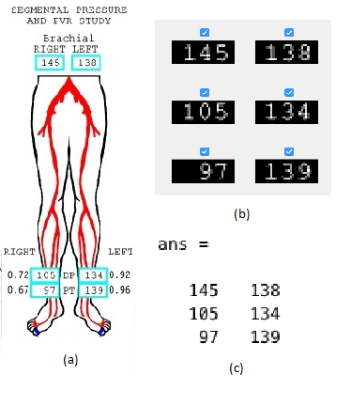

**Figure 1.** A sample of the result of sudokuOCR. (a) The image from Doppler machine needs to be processed. (b) The program crops out parts of the image that contain number of interest. (c) A matrix containing the recognized numbers is output by MatLab.

**Conclusions:** The sudokuOCR method reached 100% match rate, and was proven sufficient for PVR study. The next step is to develop algorithm to analyze the blood pressure, so that a report on PVR can be automatically generated for radiologist/physician. Another direction is to refine the sudokuOCR method to recognize alphabet letters, so that it can be utilized in a wider range of applications.

**Acknowledgements: (Optional)** Please I would like to thank Dr. Uygar Teomete for suggesting this project, and providing sample PVR images. Thanks to Dr. Zhao for giving me advice on reallocating the mass center of the “digit image” for template matching.