1. Install Python and a Neural Network library:

Python is a popular programming language for machine learning and artificial intelligence tasks, including neural networks. In this lab, we will be using Python to implement and train neural networks. You will need to have Python installed on your computer, along with a neural network library such as TensorFlow, Keras, or PyTorch. These libraries contain pre-built functions that we can use to create and optimize neural networks.

But please pay attention to the separate file, where I will write a few words about working environments

2. Introduce the concept of neural networks:

A neural network is a type of machine learning algorithm that is inspired by the structure and function of the human brain. It is made up of layers of interconnected nodes or "neurons", where each neuron receives input from other neurons and produces an output that is sent to other neurons. Neural networks are used for a wide range of tasks, including image and speech recognition, natural language processing, and predictive modeling.

3. Implement a simple neural network:

We will start by implementing a simple neural network using Python and the chosen library. This neural network will be used for a classification problem.

During the lab, we will train the neural network to make predictions on the testing set, calculate the accuracy score of the neural network, and experiment with different neural network architectures, such as adding or removing layers and changing the number of neurons in each layer. Of course we can use others examples.

**I think it's a good idea** to explore the topic of neural networks in general, based on one of several tutorials, to begin with:

* <https://realpython.com/python-ai-neural-network/>
* <https://towardsdatascience.com/deep-learning-with-python-neural-networks-complete-tutorial-6b53c0b06af0> (unfortunately requires login )
* <https://www.activestate.com/resources/quick-reads/how-to-create-a-neural-network-in-python-with-and-without-keras/>
* <https://www.educative.io/answers/how-to-build-a-simple-neural-network-using-keras>

Before you start, I think it's worth showing some examples:

1. Implement a neural network for predicting whether a person has diabetes based on their age, BMI, blood pressure, and glucose levels. Train the network using the Pima Indians Diabetes dataset.

2. Implement a neural network for predicting whether a customer will purchase a product based on their age, income, and previous purchases. Train the network using a dataset of customer behaviors and purchase histories.

3. Implement a neural network for predicting whether a credit card transaction is fraudulent based on the transaction amount, location, and time. Train the network using a dataset of credit card transactions.

4. Implement a neural network for predicting the median house value in a given neighborhood based on features such as the number of rooms, median income, and proximity to schools and stores. Train the network using the California Housing Prices dataset.

5. Implement a neural network for identifying the species of a flower based on features such as the petal length, petal width, sepal length, and sepal width. Train the network using the Iris dataset.

Each exercise can be implemented using Python and a neural network library such as TensorFlow, Keras, or PyTorch. The datasets used in these exercises are publicly available and can be easily imported into your Python environment.

In a separate file you will find sample solutions to these cases (lab01.py)

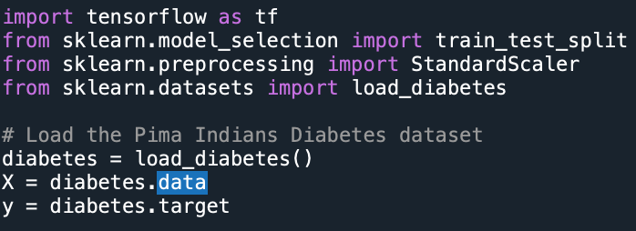

And exercises for you:

1. Implement a neural network for predicting the price of a used car based on its age, mileage, and condition. Train the network using a dataset of used car sales.

2. Implement a neural network for predicting the next day's weather based on the previous day's weather conditions. Train the network using a dataset of weather reports.

3. Implement a neural network for predicting the outcome of a sports game based on the performance of each team's players. Train the network using a dataset of game statistics.

4. Implement a neural network for classifying images of cats and dogs. Train the network using a dataset of labeled images.

5. Implement a neural network for predicting the sentiment of movie reviews. Train the network using a dataset of movie reviews and their corresponding sentiments (positive or negative).