The Cotton Belt and the Body Count: Farmer Suicides in Maharashtra, Two Decades On
By Piyush Zaware
Researcher, Global Poverty Research Laboratory, Northwestern Kellogg School of Management
Between 2001 and 2022, 66,000 farmers killed themselves in Maharashtra. That is not a typo. It works out to roughly eight farmers per day, every day, for two decades. India as a whole accounts for roughly a third of all farmer suicides recorded globally. Maharashtra, for most of those years, accounts for a third of India's.
These numbers are from the NCRB, the National Crime Records Bureau, which publishes cause-of-death data annually. The data has gaps, definitional problems, and political sensitivities. Some researchers think it undercounts. Nobody thinks it overcounts. What the numbers show, even conservatively, is a sustained catastrophe in one of India's richest states.
The question worth asking in 2026 is not whether the crisis exists. It does. The question is where it is, why it is there, and whether anything that was tried has worked.
________________________________________________________________________

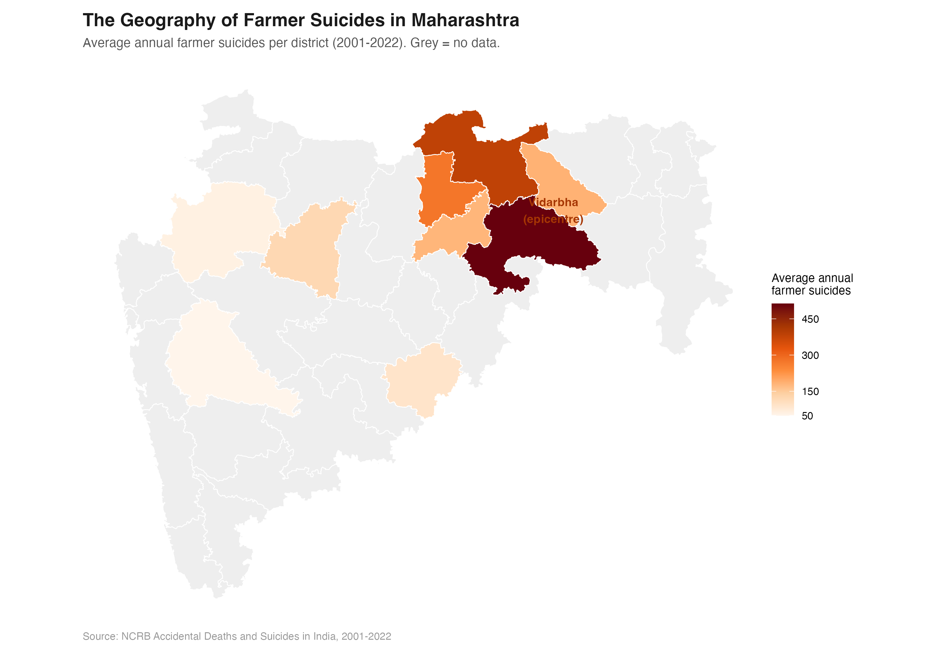
Figure 1. Average annual farmer suicides by Maharashtra district, 2001-2022. Source: NCRB ADSI.
It is not all of Maharashtra
The first thing the data shows clearly is that this is not a Maharashtra problem. It is a Vidarbha problem.
Vidarbha is the eastern chunk of Maharashtra, six districts at its core: Yavatmal, Amravati, Akola, Washim, Buldhana, Wardha. These six districts, out of Maharashtra's 36, account for roughly half the state's farmer suicide total in most years. Yavatmal alone, a district of around 2.7 million people, regularly records more farmer suicides than entire states.
The rest of Maharashtra does not look like Vidarbha. Pune, Nashik, Kolhapur, the coastal Konkan belt: elevated compared to urban districts, but not dramatically different from other agricultural states. It is Vidarbha and, to a lesser extent, Marathwada that pull Maharashtra's totals to the levels that make it an outlier nationally.
Why Vidarbha? The answer is cotton. Vidarbha grows cotton almost exclusively. Cotton is a cash crop, which means it requires upfront investment in seeds, fertiliser, and pesticide every season. It is also highly sensitive to rainfall and market prices. When a monsoon fails, or when global cotton prices fall, or when input costs spike, the farmer who borrowed to plant the crop has no hedge. There is no food crop to fall back on. There is just the debt and the failed harvest.
Bt cotton, introduced in India in 2002, added another layer. It required more water, more pesticide, and more expensive seeds than traditional varieties. Yields improved in good years. In bad years, with insufficient irrigation or erratic rainfall, Bt cotton fields failed more completely than the older varieties. The yield gains did not stabilise farmers' incomes. They raised the stakes.
________________________________________________________________________

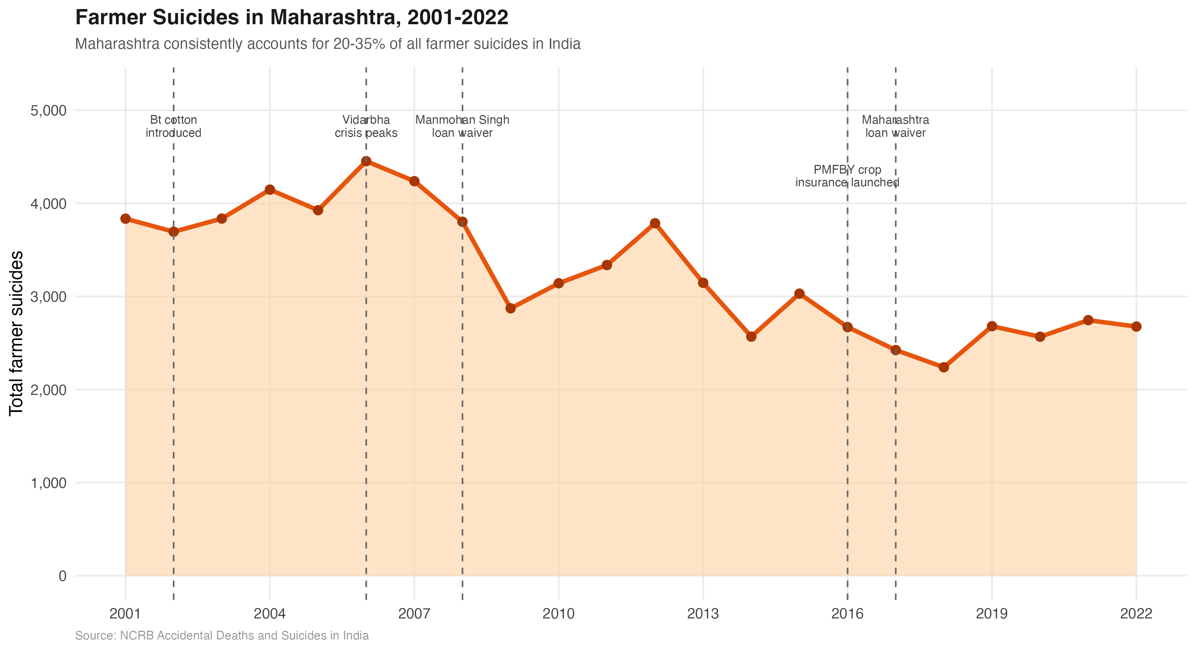
Figure 2. Total farmer suicides in Maharashtra, 2001-2022, with key policy events. Source: NCRB ADSI.
The timeline
Maharashtra's farmer suicide numbers peaked in 2006 at 4,453. That year, P. Sainath's reporting in The Hindu brought Vidarbha to national attention. Prime Minister Manmohan Singh visited. A relief package followed. In 2008, the UPA government announced a national farm loan waiver worth Rs 71,000 crore.
It worked, briefly. Suicides fell through 2009, reached a low of around 2,800, then climbed again through the early 2010s. By 2012, the numbers were back above 3,700.
A second loan waiver, this one state-level, came in 2017 under Chief Minister Devendra Fadnavis, worth Rs 34,000 crore. Suicides fell again. In 2018, the number dropped to its lowest since 2001: 2,239. Then they climbed. By 2021, they were back above 2,700.
The pattern is consistent across both interventions: a loan waiver reduces suicides for two to three years and then the numbers recover. This is not a criticism of loan waivers as such. Debt relief is real relief. But it addresses the immediate crisis, not the structural one. A farmer whose current debt is waived is still a farmer who will borrow again next season, because the economics of rain-fed cotton farming in Vidarbha require it.
________________________________________________________________________

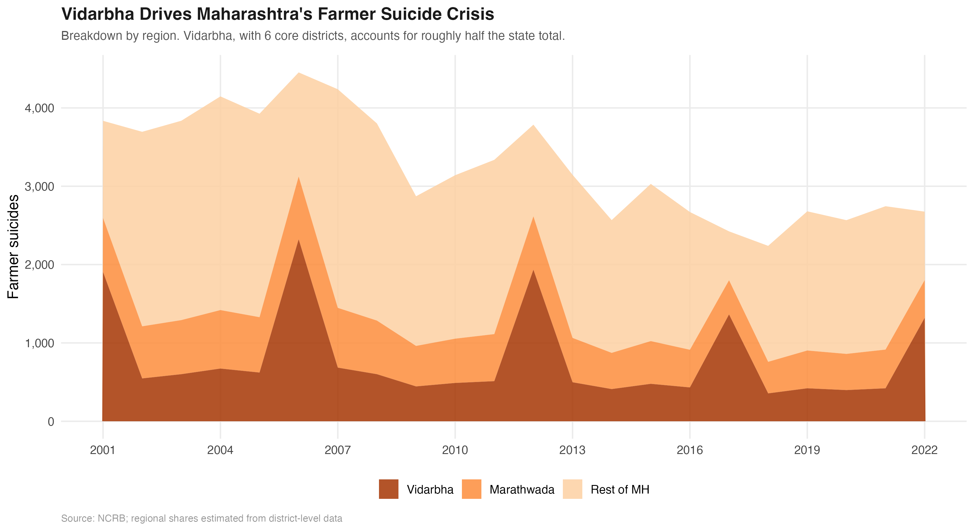
Figure 3. Farmer suicides by region: Vidarbha, Marathwada, and the rest of Maharashtra. Source: NCRB ADSI.
What the farmers say, and what the data shows
The NCRB records a reason for each suicide. Debt and financial distress is consistently the largest category, accounting for roughly 37 to 40 percent of farmer suicides in Maharashtra in recent years. Crop failure is second at around 17 to 19 percent and has been rising. Family problems are third.
These categories are imperfect. A farmer who kills himself after a crop failure and a debt spiral will often be recorded under whichever category the local official finds most legible. Debt and crop failure are frequently the same event experienced from two different angles. The distinction matters less than the direction: the data consistently points toward economic distress, not mental illness, domestic conflict, or other factors that dominate suicide statistics in urban India.
This matters because it shapes what the solution looks like. Farmer suicides in Vidarbha are not primarily a mental health crisis, though mental health resources matter at the margin. They are an agricultural economics crisis that takes its final toll in death.
________________________________________________________________________

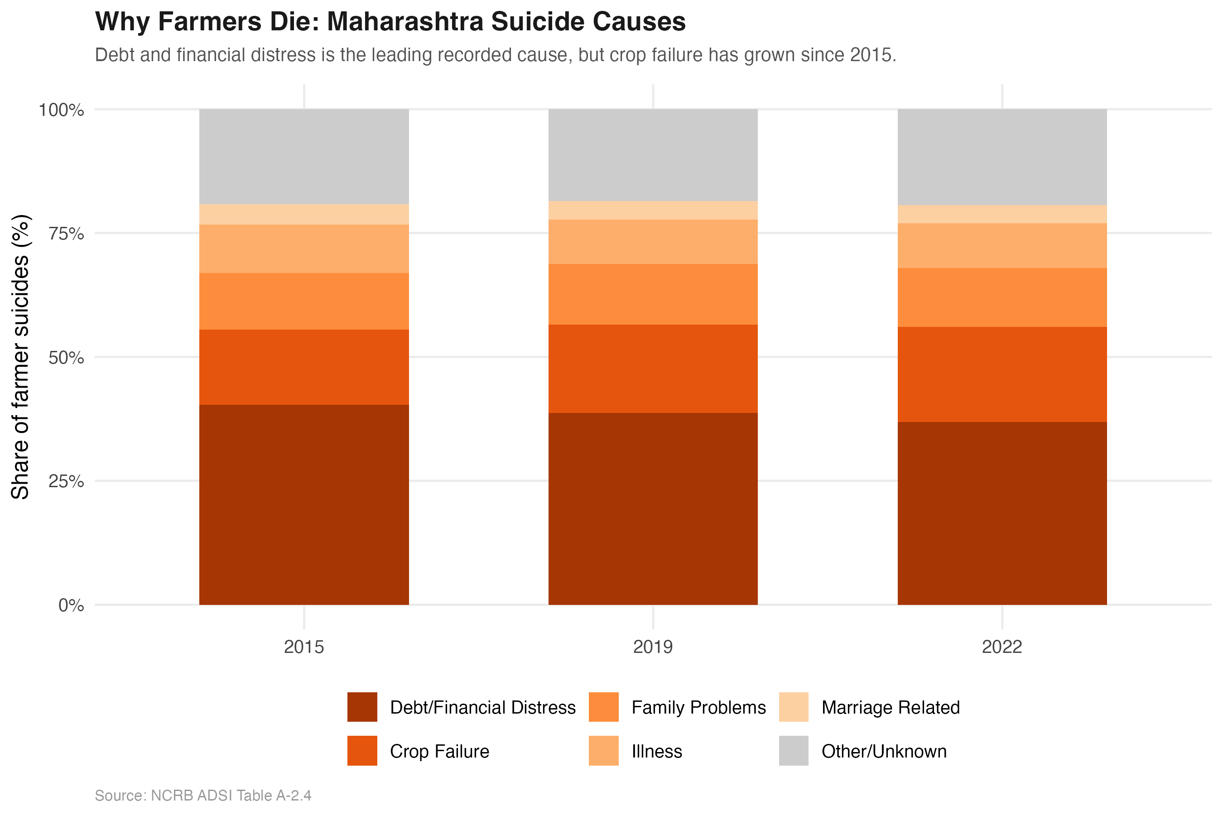
Figure 4. Causes of farmer suicides in Maharashtra, 2015, 2019, and 2022. Source: NCRB ADSI Table A-2.4.
What has not been tried rigorously
India has tried loan waivers twice at scale. It has tried crop insurance through PMFBY, launched in 2016. It has tried minimum support prices, though cotton is not always included and procurement at MSP is unreliable in Vidarbha.
What India has not done is a rigorous evaluation of which of these interventions actually reduces suicides, and by how much, and for whom. The evidence base is thin. A loan waiver reduces suicides, we can see that in the data. But the effect size, the persistence, the cost-effectiveness relative to alternatives: these have not been credibly estimated.
The government of Maharashtra has district-level data on suicides, loan disbursements, crop insurance take-up, rainfall, and MSP procurement. A careful difference-in-differences analysis across districts and years could tell us whether insurance coverage reduces suicides, whether the quality of MSP procurement matters, whether irrigation access changes the calculus. That analysis has not been done, or if it has, it has not been published.
That is the gap. Not in compassion, not even in policy effort, but in the evidence base that would let policymakers know whether what they are doing is working.
________________________________________________________________________
Two decades on
The crisis in Vidarbha is not new. Sainath wrote about it twenty years ago. Politicians visited. Resources flowed. The numbers fell, then recovered, fell again, recovered again.
What is different in 2026 is that the data infrastructure to study this rigorously now exists. NCRB has two decades of district-level records. IMD has rainfall data at fine geographic resolution. State governments have scheme-level disbursement data. The tools to do a credible evaluation of what works are available.
Sixty-six thousand deaths over twenty years is enough data. It should not require more.
________________________________________________________________________
Piyush Zaware is a researcher at the Global Poverty Research Laboratory, Northwestern Kellogg School of Management, and a doctoral student at the University of Chicago. Data from NCRB Accidental Deaths and Suicides in India, 2001-2022.

