**Exercise 5**

*Simple data processing with Python and Pandas*

**Prior Knowledge**

Unix Command Line Shell

Simple Python

**Learning Objectives**

First steps with Pandas

Understand the Jupyter Notebook model

**Software Requirements**

(see separate document for installation of these)

* Python 3.9.x
* Jupyter notebooks

*Downloading our sample data*

1. Let’s make a directory to store our code.

mkdir ~/hyg

cd ~/hyg

1. Now let’s download some star data.  
   This data is found at:  
   <http://www.astronexus.com/hyg>

You can either download the data by going to that website and finding HYG3.0 and downloading into the newly created directory, or you can use a command line and type:  
  
wget https://www.astronexus.com/downloads/catalogs/hygdata_v3.csv.gz

1. Either way that you downloaded it, you now need to uncompress it:   
     
   gunzip hygdata_v3.csv.gz
2. Check it’s the right size:  
   ls -l ~/hyg  
     
   You should see:  
   -rw-rw-r-- 1 oxclo oxclo 33449663 Sep 7 2016 hygdata_v3.csv
3. The VM has a “notebook” system called Jupyter configured by default. The result is that instead of starting a command line repl[1], there is a web based editor/evaluator launched instead.
4. To start this, type (from the same command line that is in the hyg directory):  
     
   jupyter notebook
5. In the command-line you will see  
   
6. And then a browser window will pop up.  
   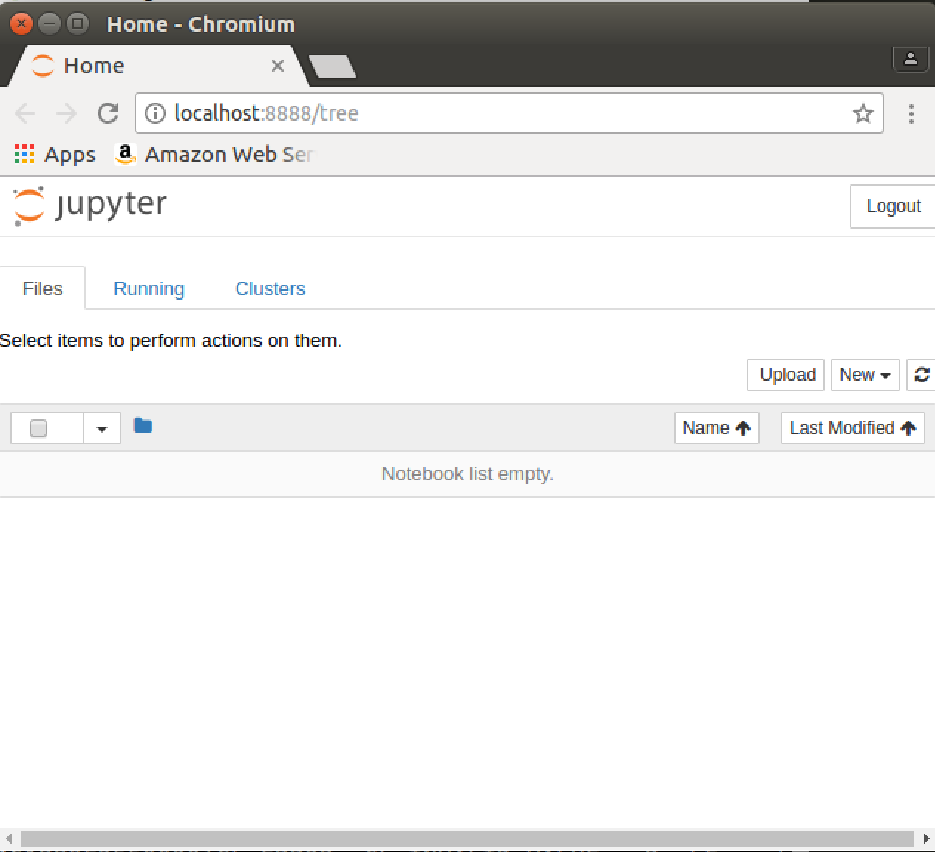
7. Use the **New** button to create a new Python3 notebook:  
   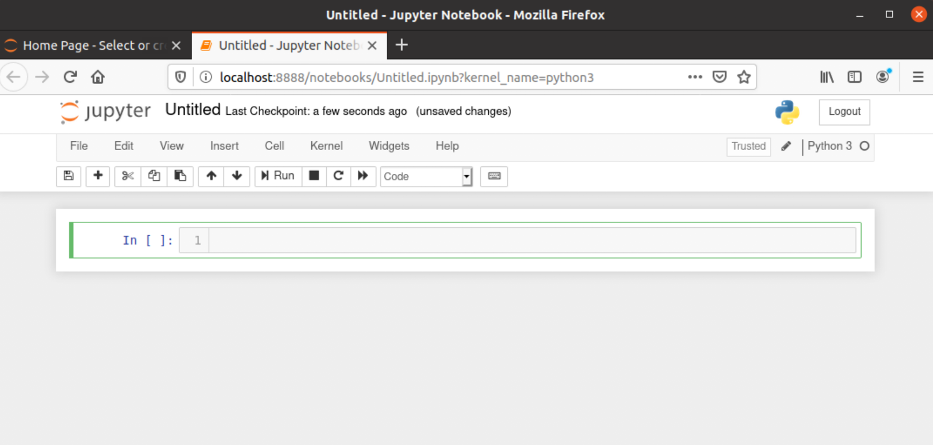
8. Click on the name of the notebook (currently “Untitled”) and rename it to **hyg**
9. Now type the following into the **Cell** (next to the words **In [ ]:**)  
   You don’t need to type in the comments!  
     
   import numpy as np # numpy is a library of numerical routines  
   import pandas as pd # pandas is the data handling library  
   dffull = pd.read_csv('file:///home/oxclo/hyg/hygdata_v3.csv')   
   dffull # show   
     
   This is creating a DataFrame. This is an object offered by the pandas library that helps deal with tabular data. It is very good at dealing with data that naturally falls into rows and columns and also that has missing elements.
10. Now click on the Run icon 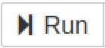
11. You should see:  
    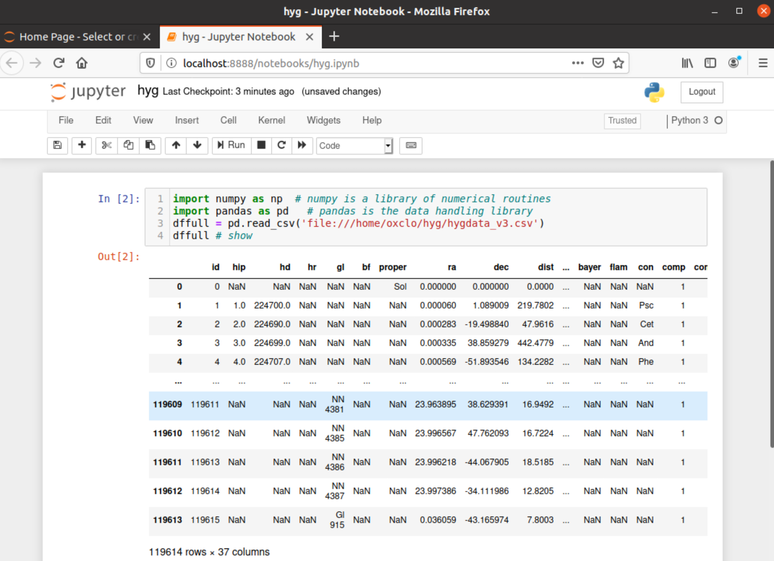
12. Scroll down to the bottom of the table and you should see how many rows (stars) are in the catalogue. Note how the notebook automatically knows how to display pandas dataframes in an intelligent manner. Also note that you are not seeing all the rows or columns because there is too much data to display.  
      
    You can see the description of the columns here:  
    <https://github.com/astronexus/HYG-Database/blob/master/README.md>
13. Before we do any more data processing, let’s configure Jupyter to do nice *tab completion*. In a new cell enter:

%config IPCompleter.greedy=True

Anything starting with % is a hint that this is for Jupyter not for Python.

Make sure you **Run** this cell.

1. Another handy hint is to paste this into a new cell and run it:  
   from IPython.core.display import display, HTML  
   display(HTML("<style>.container { width:100% !important; }</style>"))  
     
   This expands the cells to take the full width available.
2. You can also just get that information (number of rows and columns) by using the dataframe df.shape. In the next cell type:  
     
   dffull.

Before typing anything else, hit the Tab key. You should see all possible options for syntax now appear in a little box like this:  
  
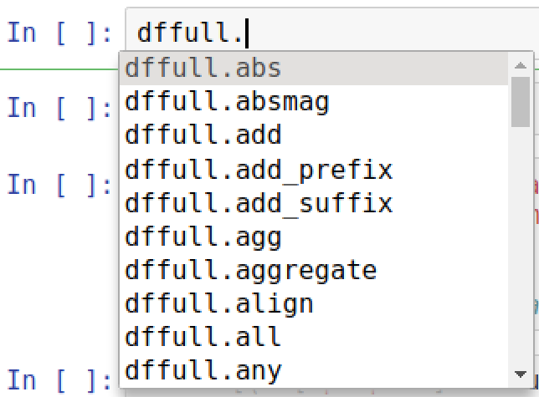

Now type ‘s’, and you should see just the operations starting with ‘s’ appear:

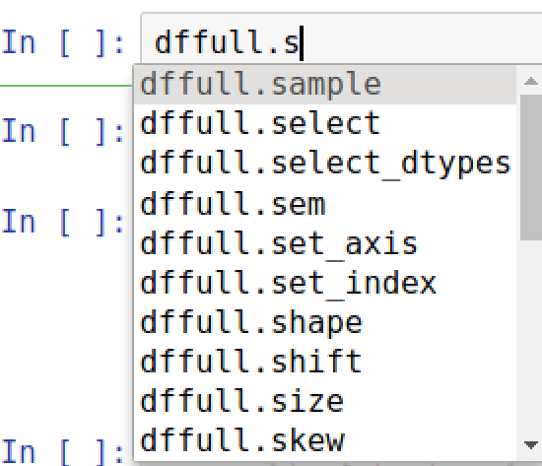

Now move down using the down arrow and select ‘shape’ by hitting Enter.

Now hit **Ctrl-Enter** (same as Run icon)  
  
You should see:  
  
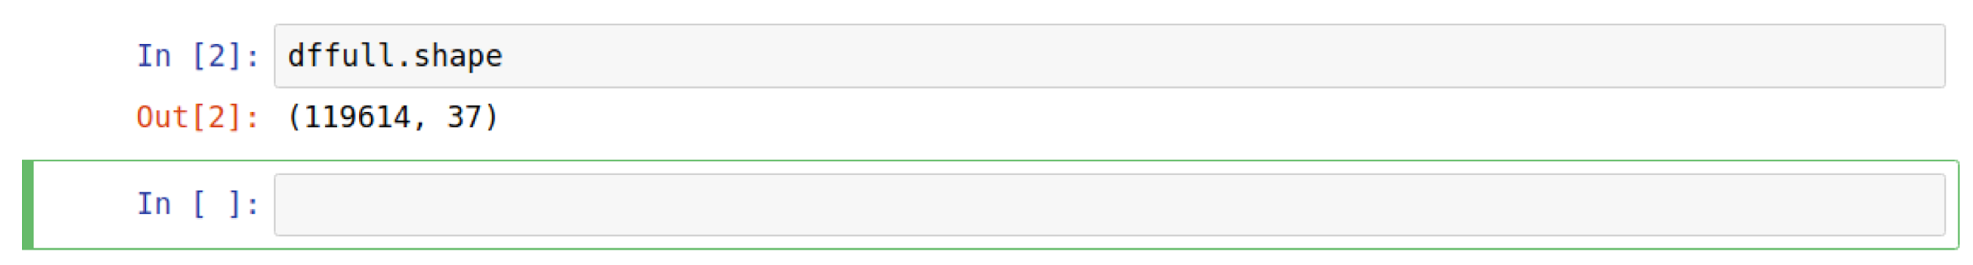  
Not all the columns are of interest to us. One simple approach is to create a new dataframe that only uses some of the columns from the old dataframe.   
  
To do that, we can use the following syntax:  
  
columns = ['id', 'gl', 'mag', 'absmag', 'proper', 'ra', 'dec',   
 'dist','con', 'ci','lum']

df = pd.DataFrame(dffull, columns=columns)

df # show the resulting dataframe

1. Paste or type that into a new cell and execute it.
2. Now, let’s identify the stars that have a ‘proper’ name.
3. There are a couple of ways we could do this. The first, simple one, is to just select that column, and then drop all NaN entries:  
     
   Execute:  
     
   df['proper'].dropna()
4. You should see something like:  
   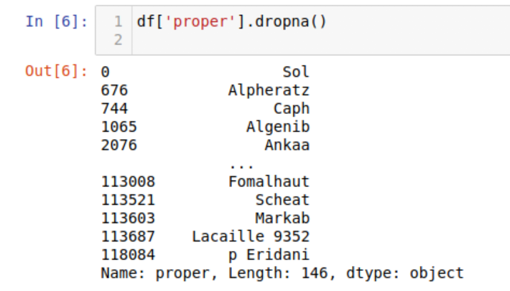
5. Notice that this no longer looks quite the same. This is because this has created a Series object instead of a DataFrame (Each column is effectively a Series, and we’ve extracted one column).
6. Suppose we want the whole DataFrame (all the columns), but only those with a ‘proper’ name. We can use a selection function to *locate* the right rows:  
     
   df.loc[df['proper'].notnull()]
7. You should see:  
   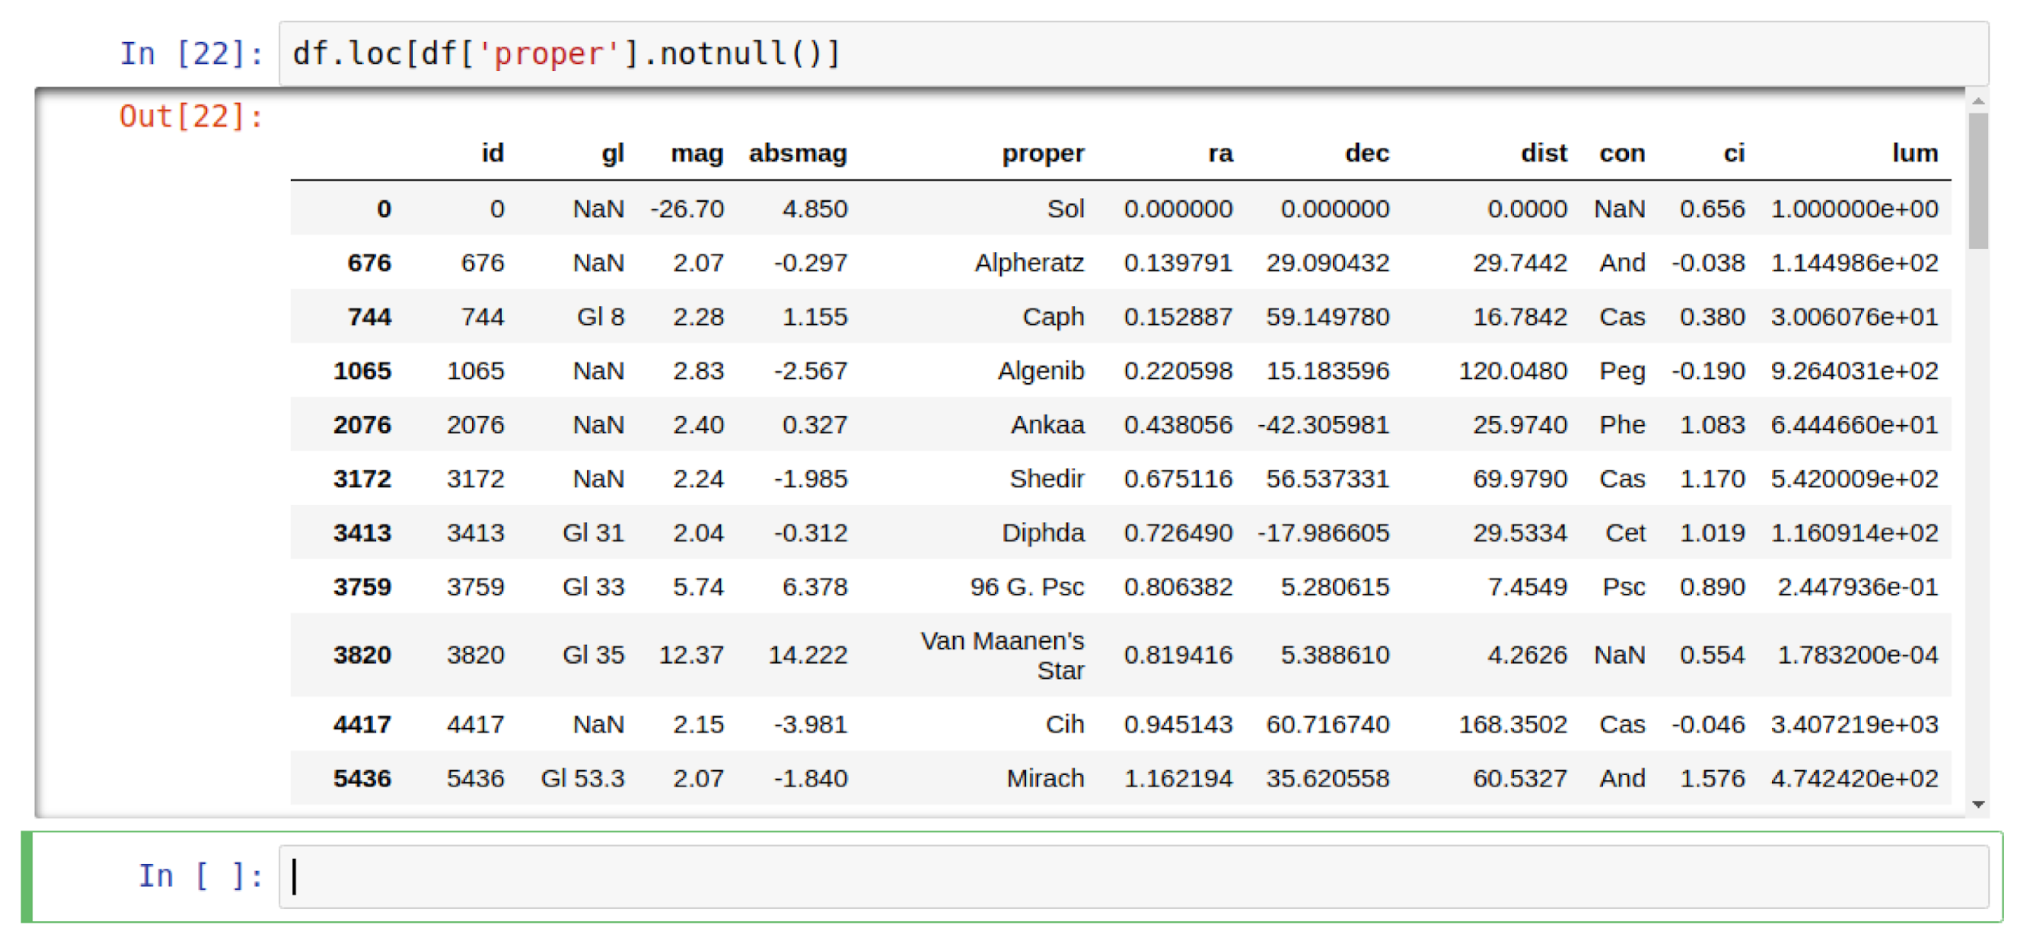
8. This has selected every row which meets the criteria (i.e. that the column *proper* is not null).
9. You can sort the data based on a column using the following syntax, e.g. to identify the stars by distance.  
     
   df.sort_values('dist', ascending=False)
10. If you just want to see the first 10 rows of a DataFrame you can use:  
      
    df.head(n=10)
11. Use those to identify the five furthest “proper named” stars. What do you think of the data?
12. You can select on multiple criteria at once, e.g.:  
    df.loc[(df['proper'].notnull()) & (df['dist']<100000)].sort_values(

'dist', ascending=False)

(extension exercise: Looking at the data, why did I choose to select data with distance < 100000 ?)

1. Identify the Gliese catalog identifier of the three least luminescent stars.

**Visualisation**

1. We can do some simple graphing of the data in Jupyter very easily.   
     
   In a new cell, we can set this up with the following commands:  
     
   %matplotlib notebook  
   import matplotlib.pyplot as plt
2. MatPlotlib is a simple graphing package for Python. The second line imports it for use in your code. The first line tells Jupyter to automatically plot diagrams made by matplotlib.
3. Any pandas dataframe or series is automatically plottable by matplotlib (although you may not get anything useful!).
4. Try it:  
   df.plot()
5. For something more useful, let’s plot a scatter graph of luminosity vs distance:

df.plot.scatter(x='dist', y='lum')

1. You should see:  
   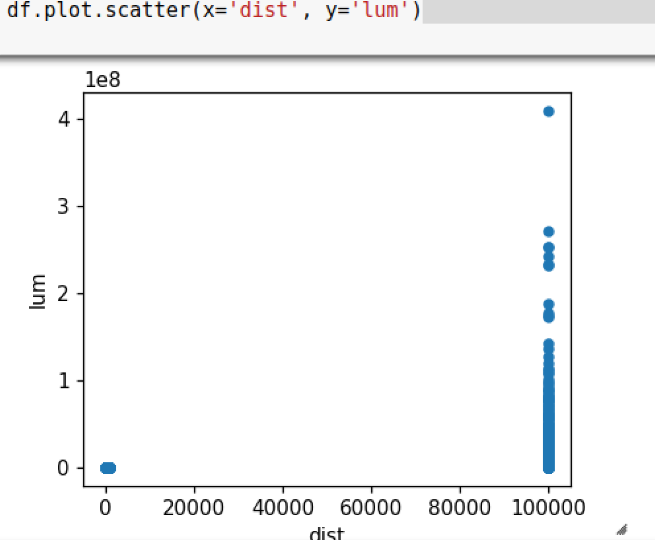
2. Once again, it looks like the data is incorrect and therefore not useful (see the comment in the documentation under the distance attribute).
3. Redo the graph this time filtering out any distance >= 100,000.
4. This still isn’t much use. Now try making the scales logarithmic by adding the parameters logx=True, logy=True to the plot. Is there anything meaningful about the resulting graph?
5. **Extension:**  
     
   Explore the data further using the matplotlib to identify any interesting correlations between the data.
6. Before finishing, close the Jupyter browser windows and then stop the Jupyter server by using Ctrl-C on the window, and then **y**.

1. Read Eval Print Loop