**Exercise “Free Stuff”**

*Create a Kubernetes Cluster in DigitalOcean and Deploy an app*

**Overview**

In this exercise we are going to sign up to Digital Ocean to get some free credit.

1. First sign up with Github Education (if you haven’t already).  
   [https://education.github.com/](https://education.github.com/pack/offers#digitalocean)  
   This gives you $50 credit for DigitalOcean and credit for many other systems as well.

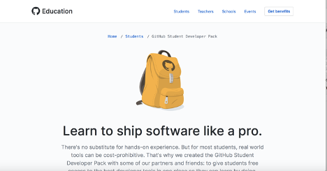

* 1. After signing in using your GitHub education account, you can get the promo here: <https://education.github.com/pack/offers#digitalocean>   
       
     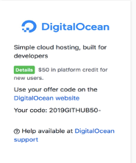
  2. Sign up and get a free Digital Ocean account.
  3. Enter your billing details
  4. You should see something like:  
     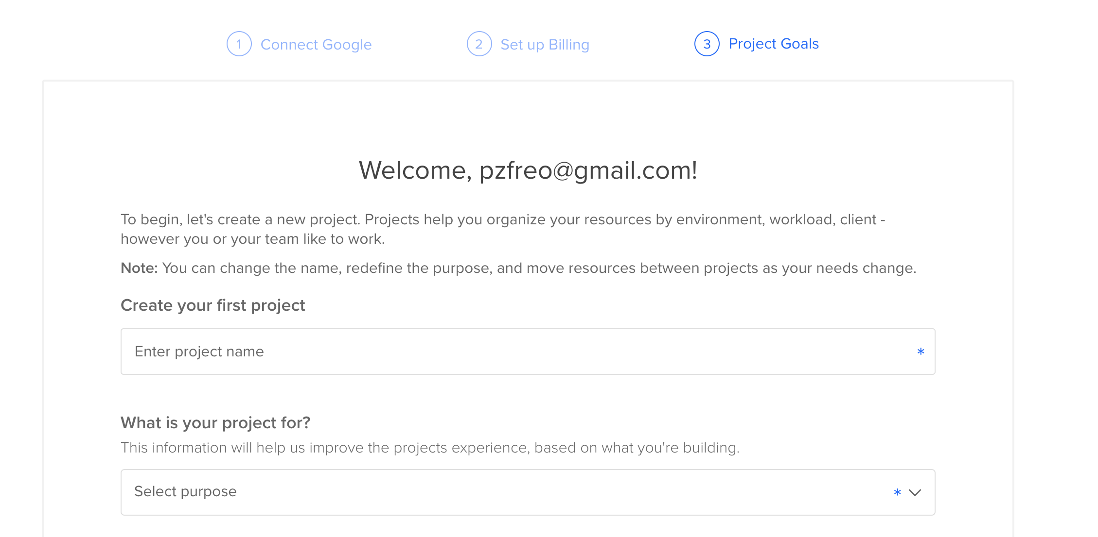
  5. Give your project the name “cassandra”:

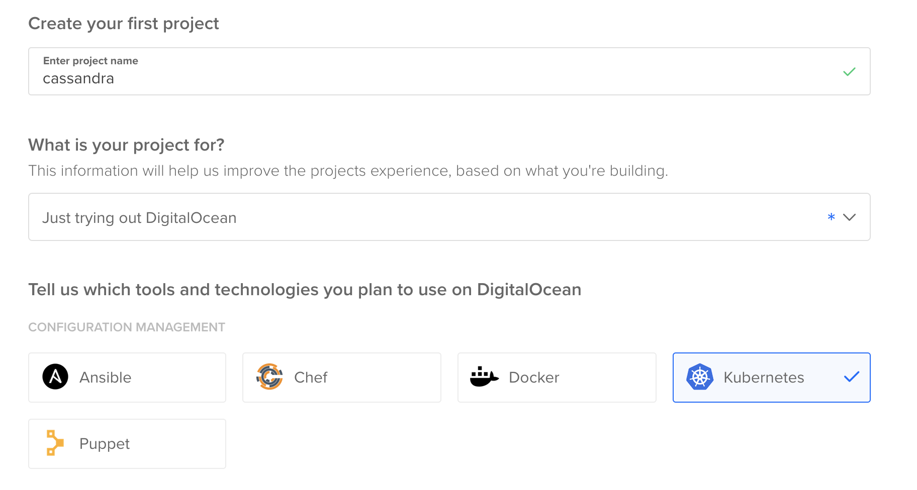

* 1. Select “Just trying out DigitalOcean” and tick Kubernetes
  2. Click “Start” at the bottom of the page
  3. You should see something like:  
     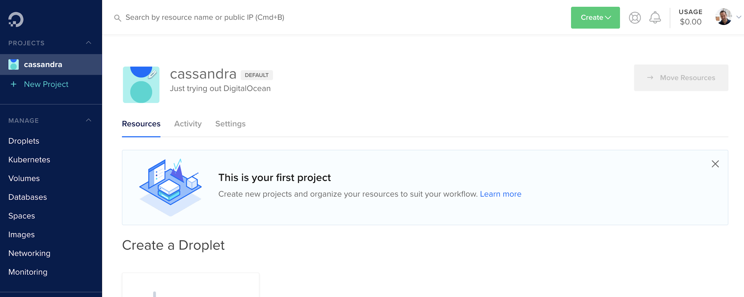
  4. Go to Billing and enter your Github Education Promo code.
  5. You are done!