**Exercise 9**

*Deploy a more complex ESB flow that implements the Jim Webber Starbucks REST model*

**Prior Knowledge**

Exercise 8 on ESB

**Objectives**

See basic ESB operations. Look at the mapping of REST to SOAP

**Software Requirements**

(see separate document for installation of these)

* Java Development Kit 7
* WSO2 Application Server 5.2.1
* WSO2 ESB 4.8.1

1. Remember that Starbucks SOAP service we installed? We are now going to look at how to map that into REST based on this article: <http://wso2.org/library/articles/2012/09/get-cup-coffee-wso2-way/>   
     
   Please take a reasonably good look at this. Also, make sure your Application Server and ESB are running.
2. Check you have the Starbucks ESB config downloaded. It should be in ~/Downloads/starbuck-synapse-configs.zip
3. Unzip the ESB configs into the right place:  
     
   On the command line:  
   cd ~/servers/wso2esb-4.8.1  
   cd repository/deployment/server  
   unzip ~/Downloads/starbucks-synapse-configs.zip  
     
   When prompted:  
   replace synapse-configs/default/synapse.xml? [y]es, [n]o, [A]ll, [N]one, [r]ename:  
   **Type A and hit Enter**
4. Look at the ESB command line window and see how the progress is going. You should see hot deployment messages.
5. Start the Java App that uses the REST API:

cd ~/Downloads  
java –jar starbucks-rest-sample.jar

1. You should see a window pop-up:  
   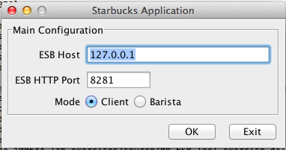
2. Choose Client mode and click OK
3. Create some orders ☺  
   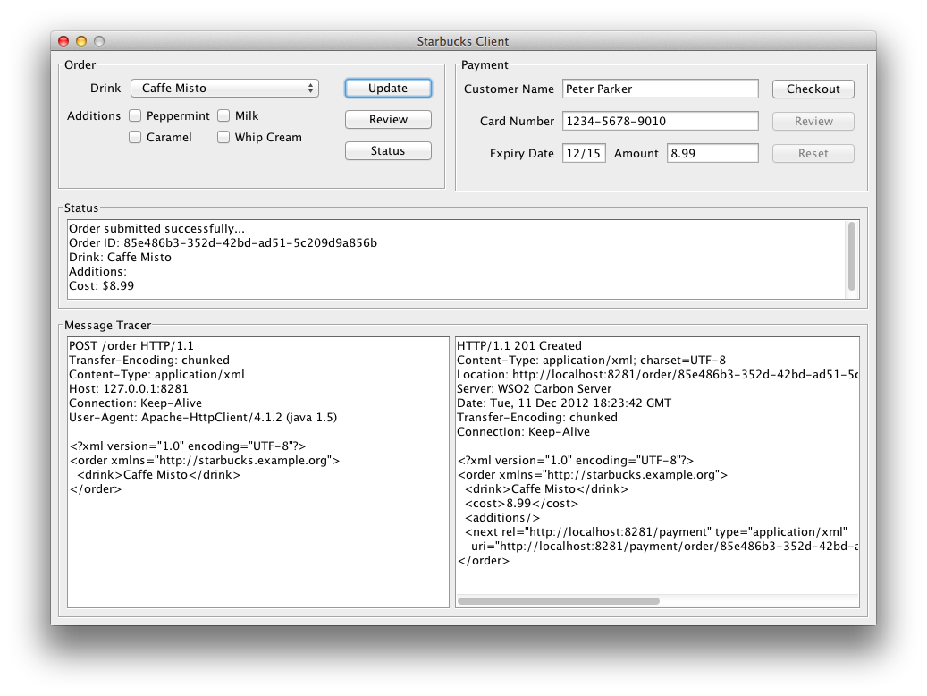
4. Read the article to understand how this is working. You can also view the API configuration and definitions from the ESB Console. And you can take a run at being a Barista as well.