**Exercise 8**

*Simple Benchmarking with wrk*

**Prior Knowledge**

Previous exercises

**Objectives**

Benchmarking runtimes

**Software Requirements**

* docker-compose
* wrk - a simple benchmarking tool

**Overview**

We will look at using a benchmarking tool to call our APIs very fast and see how they react.

Steps

1. Start your service using “docker-compose up”

(If you don’t have a working service but want to try this anyway then do this:  
  
cd ~   
git clone <https://github.com/pzfreo/purchase-complete.git>

cd purchase-complete

yarn install  
docker-compose up --build

)

1. wrk should already be installed.  
     
   Test that the binary is there. Start a new terminal window and type:  
   wrk --help  
     
   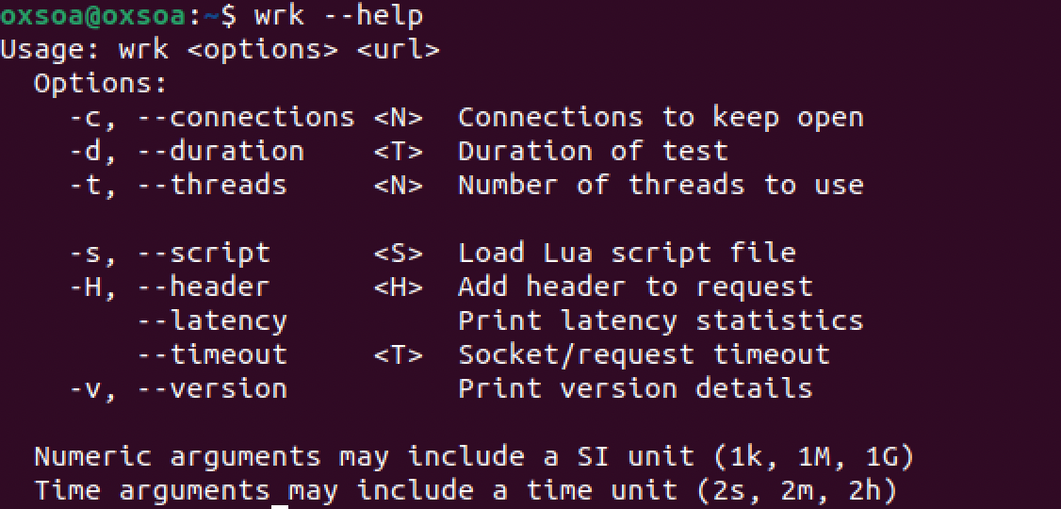
2. Now we can run a test:  
   wrk -c 100 -d 1m -t 10 http://localhost:8000/purchase
3. This will constantly hit our server with 100 concurrent clients calling over 1 minute (using 10 threads).
4. typeorm and postgres are meant to implement connection pooling automatically. However, the first time I run this I get connection pooling issues in both the postgres container and the purchase container:  
     
   2021-03-28 14:46:36.503 UTC [3003] FATAL: sorry, too many clients already

purchase_1 | error: sorry, too many clients already

1. This shows up in the wrk output  
   wrk -c 100 -d 2m -t 10 http://localhost:8000/purchase

Running 1m test @ http://localhost:8000/purchase

10 threads and 100 connections

Thread Stats Avg Stdev Max +/- Stdev

Latency 59.67ms 89.02ms 1.98s 95.32%

Req/Sec 208.74 60.48 300.00 84.82%

123949 requests in 1.00m, 80.22MB read

Socket errors: connect 0, read 0, write 0, timeout 21

Non-2xx or 3xx responses: 1357

Requests/sec: 2056.85

Transfer/sec: 1.33MB

1. Notice the 1357 error responses I got back.
2. If you rerun this however, everything seems warmed up and ready to work reliably:  
     
   wrk -c 100 -d 1m -t 10 http://localhost:8000/purchase

Running 1m test @ http://localhost:8000/purchase

10 threads and 100 connections

Thread Stats Avg Stdev Max +/- Stdev

Latency 49.31ms 9.97ms 183.09ms 92.12%

Req/Sec 204.88 41.52 303.00 73.40%

122170 requests in 1.00m, 78.06MB read

Requests/sec: 2034.45

Transfer/sec: 1.30MB

1. I think 2000+ requests per second accessing a database is reasonable. You may get different results on your setup of course.
2. While it is running you can monitor the CPU.   
   Extend the time to run longer (e.g. 5m) and rerun  
     
   Open up a new terminal window and type:  
   top
3. You will see a memory/cpu/process monitor.   
   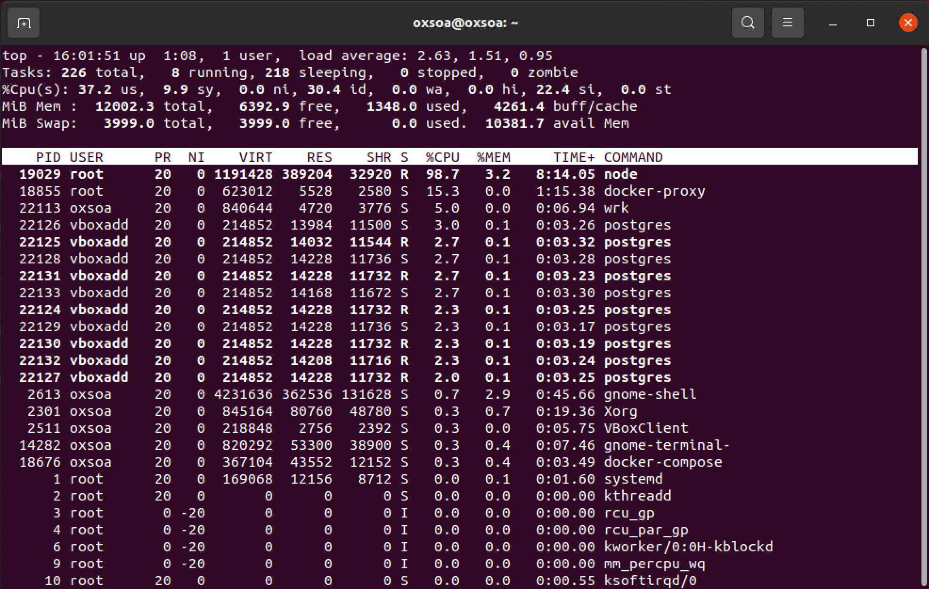  
   If you want to read more about load averages, this is a good read: <http://www.brendangregg.com/blog/2017-08-08/linux-load-averages.html>

1. You will see that there is only one node process here. Node is single-threaded, so on a multi-core system you might want to run more. In a Kubernetes environment you would run multiple replicas behind a load-balancer. In other systems you can use tools like pm2 to automatically scale up node instances:  
    <https://github.com/Unitech/pm2>
2. Note that this is not a real performance analysis. Ideally the servers would be on a separate machine from the client load drivers (siege engines!). Also, microservices are designed to be run in parallel in multiple containers with load balancing across them, so this model is not the recommended way of running either deployment.
3. That’s all for this lab!