Requirements
Part of a draft, written by the group, is due during Weeks 13 through 15 on the following schedule. Drafts must be submitted to the appropriate myCourses DropBox before Thursday workshop. Each draft is worth 1% of your final grade, for a total of 3%. No late drafts will be accepted for a grade. For drafts, color your individual text in a color unique to you among your group. You must use MS Word, LibreOffice, or OpenOffice. Word is available from the COS computer labs and the others are free. Be sure to include one comment at the start of the draft with your full name so that your revision color can be identified.
Week 13 - Outline of the paper.
Week 14 - Draft of half of the text.
Week 15 - Draft of the rest of the paper.
Expectations of the paper are as follows.
30-50 pages
- Minimum of 15 primary sources.
- No more than half figures/tables. The rest must be prose.
- 8.5” x 11” paper-size
- double-spaced
- Citations do not count for or against the page requirements.
- MS Word 2016 or later, LibreOffice, or OpenOffice. Do not use Google Docs which creates formatting issues.
- 10 or 12 point Calibri or Times New Roman font.
- Exactly 1” margins.
- No more than one page of direct quotes in total.
- Proper spelling, grammar, and style.
- Standard scientific sections (Introduction, Materials and Methods, Results, Discussion, References).
Notes (draft1 formatting)
- One clear header per section.
- Use consistent bullet styles.
- Use numbered lists only when order matters.
- Leave white space for quick scanning and edits.

Outline
Introduction
- Brief intro about high-throughput sequencing
- What our goal was: utilizing NGS
- Introduce paper/dataset
  - Discussing methods
    - Experimental design
  - Goals of the paper
    - Why did they analyze DRG with cKO
      - Ipsilateral vs contralateral
  - Citations (LINK)
- How we wanted to use the paper
- Claim
  - “Next Gen. Seq. helps us understand what actual genes are at play beyond the ones the paper discussed”
Materials and Methods
- Figure of the pipeline
  - Compared to a general NGS pipeline
- Pipeline Steps
  - Aggregation/Collection
    - Download SRR (file type gz)
      - Tool:
  - Processing/Cleaning
    - Raw FASTQC/MultiQC
    - FASTP (trimming)
    - Trimmed FASTQC/MultiQC
  - Alignment
    - Selection of the Genome
      - (mm39)
    - Building STAR Genome
    - Align one paired-end
  - Analysis/Interpretation
    - MultiQC
    - Differential Expression Analysis
      - DESeq2
        - Volcano Plot
        - Heatmap of Top DEGs (Regeneration-Enhancing)
        - MA plot
        - Target Validation (Gene Expression Boxplots)
    - GO Analysis
    - Extra analysis?
Results
- Quality control
- Alignment stats
- Differential Expression Plots (Discuss biological interpretation)
  - PCA (VERY IMPORTANT)
  - Volcano Plot (Important Genes)
    - Cumulative Distribution Plot (2nd derivative is 0)
    - Do a secondary Volcano Plot
  - Heatmap
  - MA Plot
- GO Analysis
  - Pathway level analysis
- *Extra analysis once determined*

Two-hybrid screening
Discussion ~ Discuss the biological interpretation more
- What does the data show
  - Gene expression
  - Injury vs control
  - Pathways being affected
    - proteostasis (AhR activation),
    - translation (suppression/upregulation of genes)
    - metabolism (energy output)
- Things that were weird about the dataset to consider
  - Reference Odd volcano plots
  - The genotype is weaker / secondary
  - collisions in PCA
  - interpretation vs causation
- Global Discovery
  - External Application
- Discussion about NGS in the context of this paper
  - Reproducibilty
  - Global Discovery
- External Applications/Biological Relevance
  - How does our Global discovery (new genes connect to the gene found in the paper)

Two-hybrid screening
  - What this adds beyond the paper
  - What it suggests for future validation
References
- Main Paper
- NGSTech overview (paper for my courses)
- ADD papers that use/review NGS
- More papers referencing the background of the mouse study
Code Availability
Attach git, notebook
Source Data
Data supporting the graphs/ plots (actual csv)
Dataframes…
Supplemental Material
All figures

Outline draft1

Draft1 outline

Claim
- [1 sentence] Our central point for SRP618841/mouse_new (kept plain + precise)

Strongest evidence (draft1)
- DE contrasts run: ipsi_vs_contra_in_ff, ipsi_vs_contra_in_cre
- Table: filters + full gene lists
- What we show (draft1 figures):
  - QC/alignment summary
  - PCA of samples (use sample codes to avoid clutter)
  - Volcano/top genes for each contrast

Supporting/secondary evidence
- Sample QC: read depth + alignment (only key metrics)
- PCA: interpret what separates samples (cohort/condition)
- DE table: effect sizes + multiple testing (state thresholds)

Project-specific checklist (SRP618841)
- Read in files
- QC
- Alignment
- Filtering
- PCA
- DE
- One list of genes

Key TODOs before draft2
- Replace placeholders with the exact claim + key genes
- Add code refs to mouse_group_project_work/docs
- Decide which figures become Figure
Draft 1 mind map (ASCII)Draft 1 mind map (ASCII)
Claim
├─ Strongest evidence
│ ├─ contrast ipsi_vs_contra_in_ff
│ │ ├─ QC + alignment (only key metrics)
│ │ ├─ PCA: cohort/condition separation (what separates)
│ │ └─ DE: effect sizes + multiple testing (state thresholds)
│ └─ contrast ipsi_vs_contra_in_cre
│ ├─ QC/PCA/DE (same key metrics)
│ └─ replicate pattern from ff
├─ Supporting/secondary evidence
│ ├─ sample QC summary
│ ├─ PCA interpretation
│ └─ DE table (effect sizes)
└─ Project-specific checklist (SRP618841)
├─ read in files
├─ QC / alignment / filtering
├─ PCA / DE
└─ one list of genes
References
- Strategy doc (public): https://github.com/pzg8794/mouse_group_project_work/blob/main/docs/PAPER_DRAFTING_STRATEGY_SRP618841.md
Draft 1 mind map (bullet version)
- Claim
  - Strongest evidence
    - contrast ipsi_vs_contra_in_ff
      - QC + alignment
      - PCA separation
      - DE: effect sizes + thresholds
    - contrast ipsi_vs_contra_in_cre
      - QC/PCA/DE replication
  - Supporting/secondary evidence
    - sample QC summary
    - PCA interpretation
    - DE table
  - Project-specific checklist (SRP618841)
    - read in files
    - QC / alignment / filtering
    - PCA / DE
    - one list of genes
Results
- Quality control
- Alignment stats
- Differential Expression Plots (Discuss biological interpretation)
  - PCA (VERY IMPORTANT)
  - Volcano Plot (Important Genes)
    - Elbow (2nd derivative is 0)
  - Heatmap
  - MA Plot
- GO Analysis
  - Pathway level analysis
- *Extra analysis once determined*
Best discussion structure
- What the data show
  - PCA: injury-side vs contralateral separation
  - DE: side-specific contrasts are strongest
  - key genes driving the split
  - pathway themes supported by GO
- What it may mean biologically
  - injury response
  - stress / proteostasis / translation / metabolism
  - relation to source paper biology
- Caveats / weird features
  - odd volcano bias
  - genotype is weaker / secondary
  - collisions in PCA
  - interpretation vs causation
- Broader significance
  - what this adds beyond the paper
  - what it suggests for future validation

Paper
Nikhi Boggavarapu
Sam Kopelev
Piter Garcia

Introduction
(Draft owner: Nikhi/Sam — placeholder for now.)

Materials and Methods (Piter Garcia)
Draft owner: Piter Garcia. Canonical formatting lives in materials_methods_piter_draft.tex (this Markdown mirrors the same subsections, figures, and tables).
This project reanalyzed mouse DRG bulk RNA-seq after spinal cord injury using four stages: Data Collection, Data Cleaning, Data Preparation, and Data Analysis and Interpretation. The working subset comprised 20 NovaSeq X paired-end libraries from SRP618841 (BioProject PRJNA1017789; GEO GSE243308) organized into a balanced side-by-genotype design before QC, alignment, and DE modeling began.
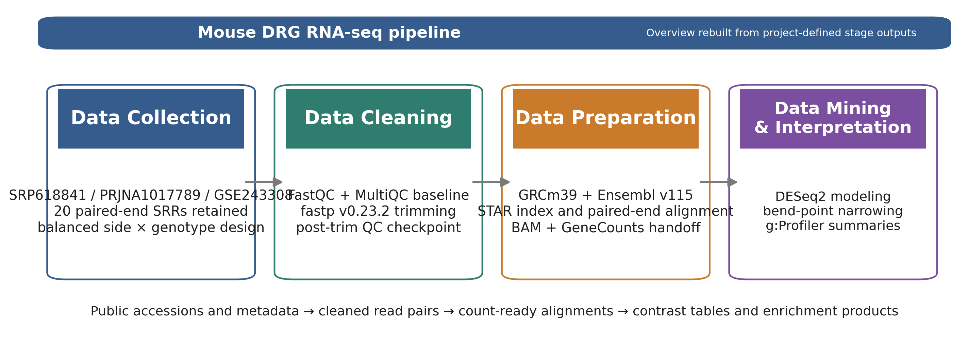
Overview ribbon summarizing the four computational stages and their stage-owned handoffs in the mouse_new workflow.
Table: Pipeline checkpoint table used to anchor the Methods section to stage-specific evidence.
Stage
Primary artifacts
Core tools
Checkpoint metric
Handoff
Collection
sample table; family sheet
prefetch + fasterq-dump
20 SRRs retained; 4 balanced subgroups (n=5 each)
FASTQ.gz pairs + manifest
Cleaning
QC heatmap; severity delta
FastQC + MultiQC + fastp
raw adapter-content failures resolved after trimming
trimmed read pairs plus per-sample QC reports
Preparation
unique-mapping plot; STAR median summary
STAR + GeneCounts
93.23% median unique mapping; 3.82% median noFeature
sorted BAMs, STAR logs, count tables, and family matrix
Analysis
filtering summaryanalysis summaryg:Profiler source tables
DESeq2 + bend-point + g:Profiler
78,334 → 21,481 genes after filtering; 5 modeled contrasts
DE tables, bend-point follow-up sets, and enrichment summaries

Data Collection: SRA Acquisition and Sample Organization
The project started from the published DRG RNA-seq study SRP618841, which is linked to BioProject PRJNA1017789 and GEO series GSE243308. Public runs were retrieved through the project’s acquisition wrappers around prefetch and fasterq-dump, and the local workflow retained 20 paired-end NovaSeq X libraries from the 1-day-post-injury DRG subset. The accession lineage matters here because the downstream paper draft needs a precise record of what was reanalyzed, not just a verbal reference to “the mouse dataset.”
Once the runs were local, metadata were consolidated into a design-aware sample table rather than being left as file-name strings. Each retained sample was tagged with side_class (ipsi or contra), geno_class (ff or cre), and the derived condition_family. That step established the balanced 2×2 design that later drove both the DESeq2 model and the interpretation strategy emphasized in class discussions.
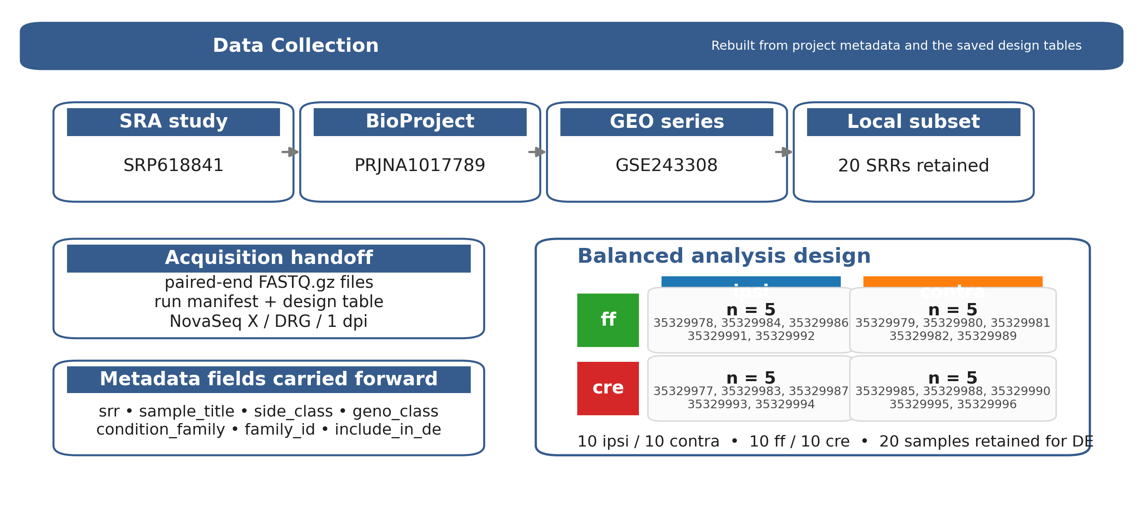
Rebuilt Data Collection stage figure derived from the saved project metadata and design tables.
Table: Data Collection stage table.
Substage
Input
Tool
Checkpoint artifact / evidence
Why it mattered
Study provenance
public accession records
SRA / GEO review
accession lineage shown in the stage figure: SRP618841 → PRJNA1017789 → GSE243308
anchors the Methods section to the exact source study
Run acquisition
public SRA runs
prefetchfasterq-dump
paired-end FASTQ.gz files plus the local run manifest; 20 retained SRRs from the DRG / NovaSeq X subset
creates the fixed read set used throughout the pipeline
Design mapping
run manifest + sample titles
local manifest assembly
design table and family sample sheet; 5 samples in each subgroup
makes the side/genotype structure explicit before PCA and DE modeling

Data Cleaning: Quality Control and Read Trimming
Raw read quality was reviewed with FastQC, and the cohort-level summaries were consolidated with MultiQC. This stage was not treated as a one-line preprocessing checkbox; instead, the project preserved before/after QC artifacts so that any improvement introduced by trimming could be demonstrated and not merely asserted. The local workflow retained fastp v0.23.2 as the canonical cleanup tool because it handled paired-end adapter detection, tail trimming, and general read cleanup more cleanly than the legacy baseline while keeping the pipeline reproducible.
The retained fastp configuration used paired-end adapter detection, poly-G cleanup, a mean-quality cutoff of 20, a minimum retained length of 30 bases, and per-sample HTML/JSON reporting. In the stage figure, the left panel is the saved module-status heatmap and the right panel is the saved SRR-level severity-change plot; together they show that the trimming stage changed the QC state of the libraries in a consistent cohort-level direction before alignment began.
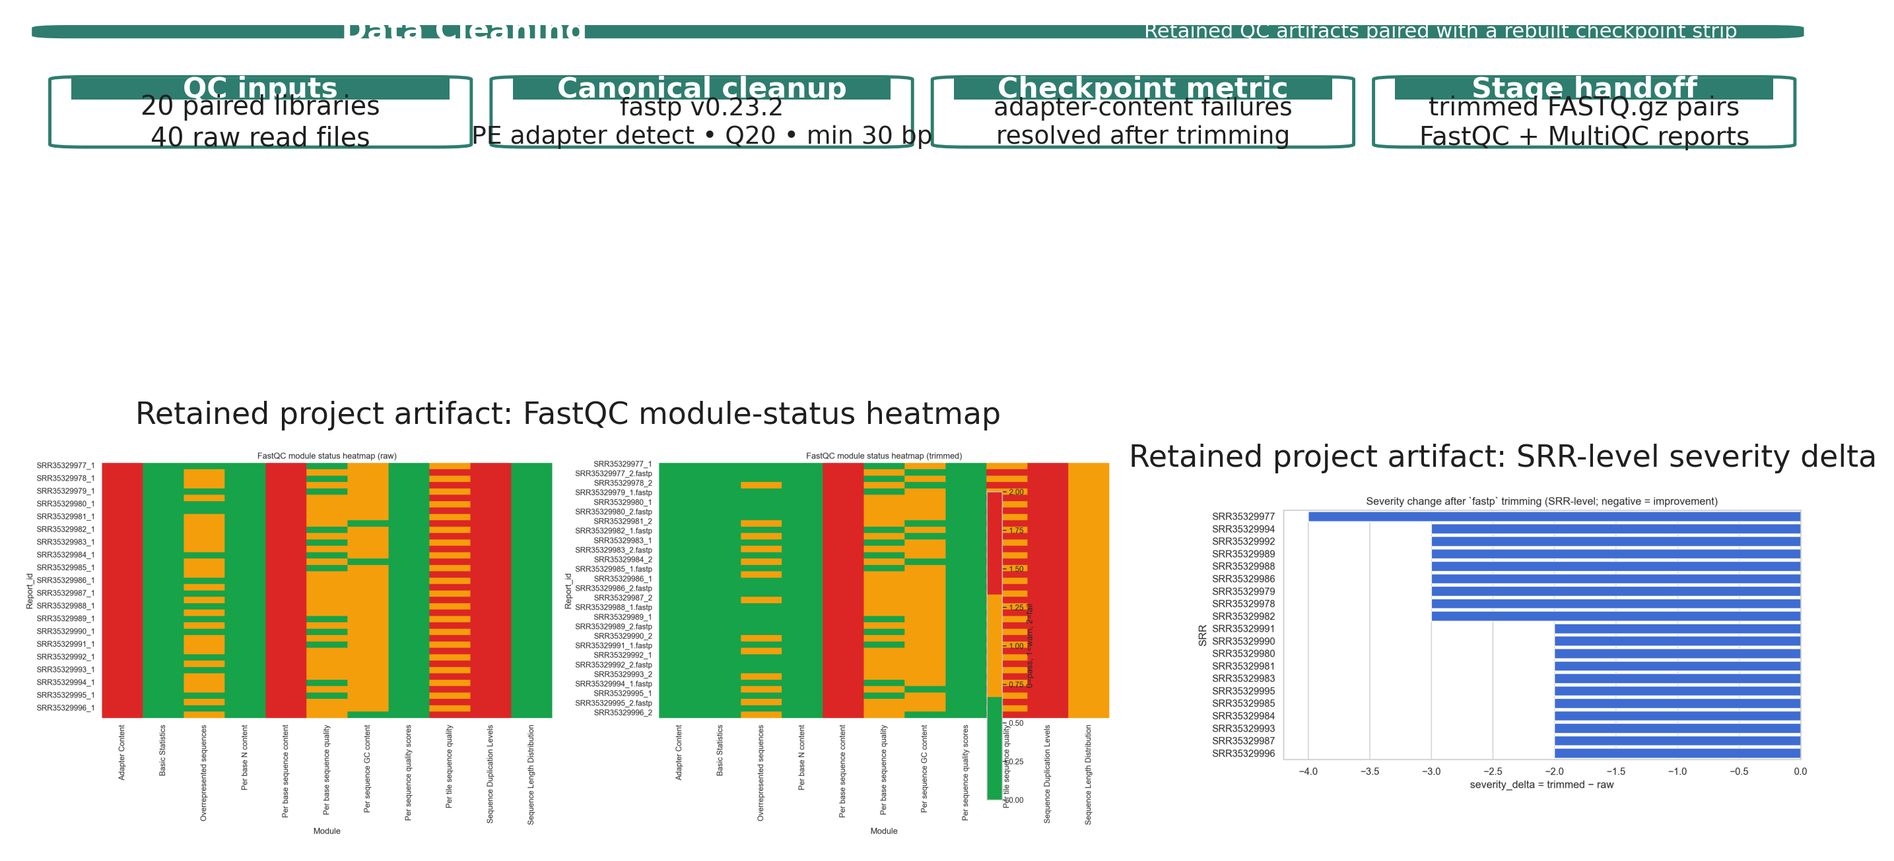
Data Cleaning stage figure using retained QC artifacts and a rebuilt checkpoint strip.
Table: Data Cleaning stage table.
Substage
Input
Tool
Checkpoint artifact / evidence
Why it mattered
Raw QC
raw paired-end reads
FastQC + MultiQC
raw module-status heatmap and cohort QC summary; adapter-content failures across all 40 raw read files
establishes the baseline quality state before trimming
Read trimming
raw FASTQ.gz pairs
fastp v0.23.2
trimmed read pairsper-sample HTML/JSON reports; PE adapter detect, Q20 cutoff, min length 30 bp, poly-G trimming
standardizes cleanup across all retained libraries
Post-trim checkpoint
trimmed read pairs
FastQC + MultiQC
saved SRR-level severity summary; all retained severity deltas shifted negative after trimming
justifies using the cleaned reads, not the raw reads, for alignment

Data Preparation: Reference Selection and Alignment
The cleaned read pairs were aligned against the Mus musculus GRCm39 primary assembly with the matching Ensembl release 115 annotation. The reference pair used in the local workflow was Mus_musculus.GRCm39.dna.primary_assembly.fa plus Mus_musculus.GRCm39.115.gtf, and a STAR genome index was built with sjdbOverhang = 150 to match the 151-bp paired-end reads. STAR was run with gzip-aware input handling, coordinate-sorted BAM output, and GeneCounts enabled so that the same alignment pass also generated per-sample count tables.
This stage functions as the bridge between cleaned reads and inferential modeling. Each sample produced three checkpoint artifacts that mattered downstream: a sorted BAM, a STAR Log.final.out summary, and a ReadsPerGene.out.tab file. The figure below keeps one retained alignment plot—unique mapping by sample—and pairs it with rebuilt metric cards from the STAR summary tables so the stage is represented by actual alignment evidence rather than by a generic alignment cartoon.
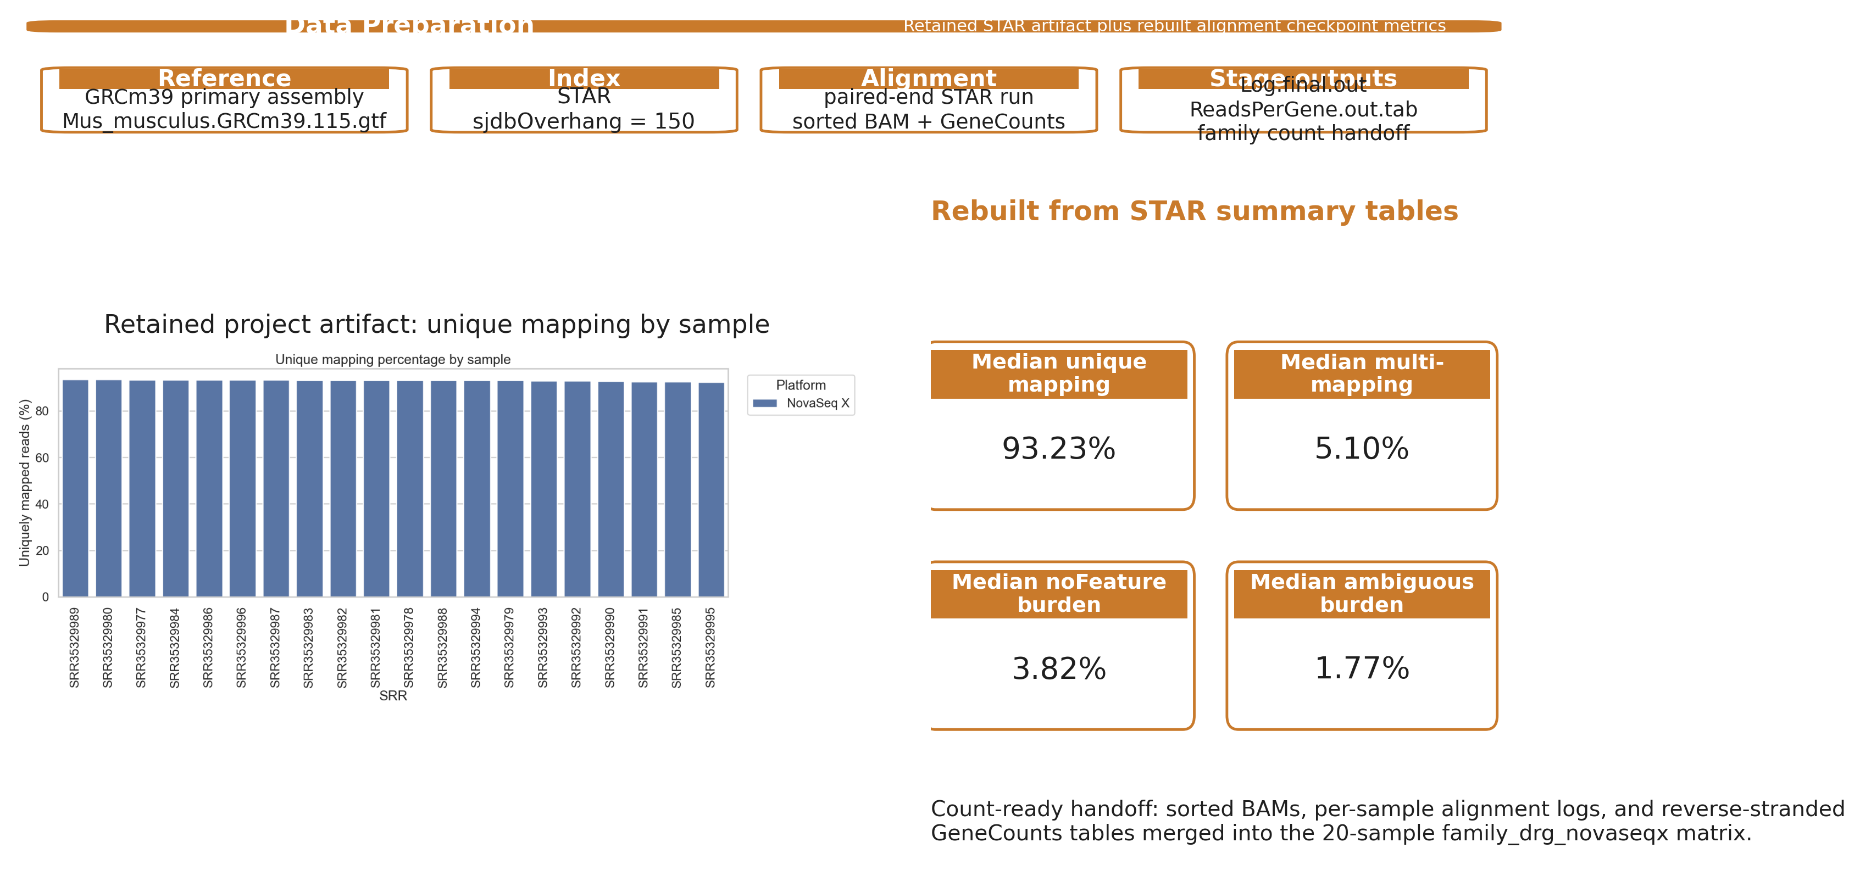
Data Preparation stage figure built from retained STAR outputs and rebuilt alignment checkpoint metrics.
Table: Data Preparation stage table.
Substage
Input
Tool
Checkpoint artifact / evidence
Why it mattered
Reference choice
mouse genome + annotation
Ensembl reference selection
reference FASTA/GTF pair for GRCm39 primary assembly + Ensembl v115 annotation
locks the coordinate system used by STAR and downstream counts
STAR index & run
trimmed read pairs + reference
STAR
sorted BAM, Log.final.out, and ReadsPerGene.out.tab; sjdbOverhang = 150 and paired-end alignment/counting in one run
produces the alignment checkpoint and the count-ready artifacts in one run
Alignment checkpoint
saved STAR summaries
local alignment review
retained unique-mapping plot plus the STAR median summary table; unique 93.23%, multi 5.10%, noFeature 3.82%, ambiguous 1.77%
confirms the cleaned reads mapped well enough to move into DESeq2
Count handoff
per-sample count outputs
local merge scripts / notebooks
family-level count matrix for family_drg_novaseqx; 20 samples retained in the final family matrix
converts per-sample STAR outputs into the DE-ready family matrix

Data Analysis and Interpretation: Differential Expression and Functional Analysis
The merged family count matrix was modeled with DESeq2 using the explicit side/genotype design carried forward from the sample manifest. Prior to modeling, low-support genes were filtered, reducing the tested set from 78,334 genes to 21,481 while retaining all 20 DRG samples. The workflow then evaluated five contrasts: ipsi_vs_contra_in_ff, ipsi_vs_contra_in_cre, geno_in_contra, geno_in_ipsi, and interaction. PCA, MA plots, volcano plots, and heatmaps were generated at this stage, but they are reserved for the Results section.
To keep very large DE lists from becoming unstructured gene dumps, the workflow added a bend-point rule on the ordered adjusted-p-value curve for each contrast. The resulting follow-up sets are therefore reported alongside the padj < 0.05 counts rather than treated as guaranteed subsets of them. In practice, this retained 709 and 870 genes for the two primary side-specific contrasts. Those bend-point-selected sets were then submitted to g:Profiler using GO Biological Process, KEGG, and Reactome layers. The stage figure below summarizes the filtered modeling inputs, contrast-level output counts, and enrichment-source layers without reusing the Results figures.
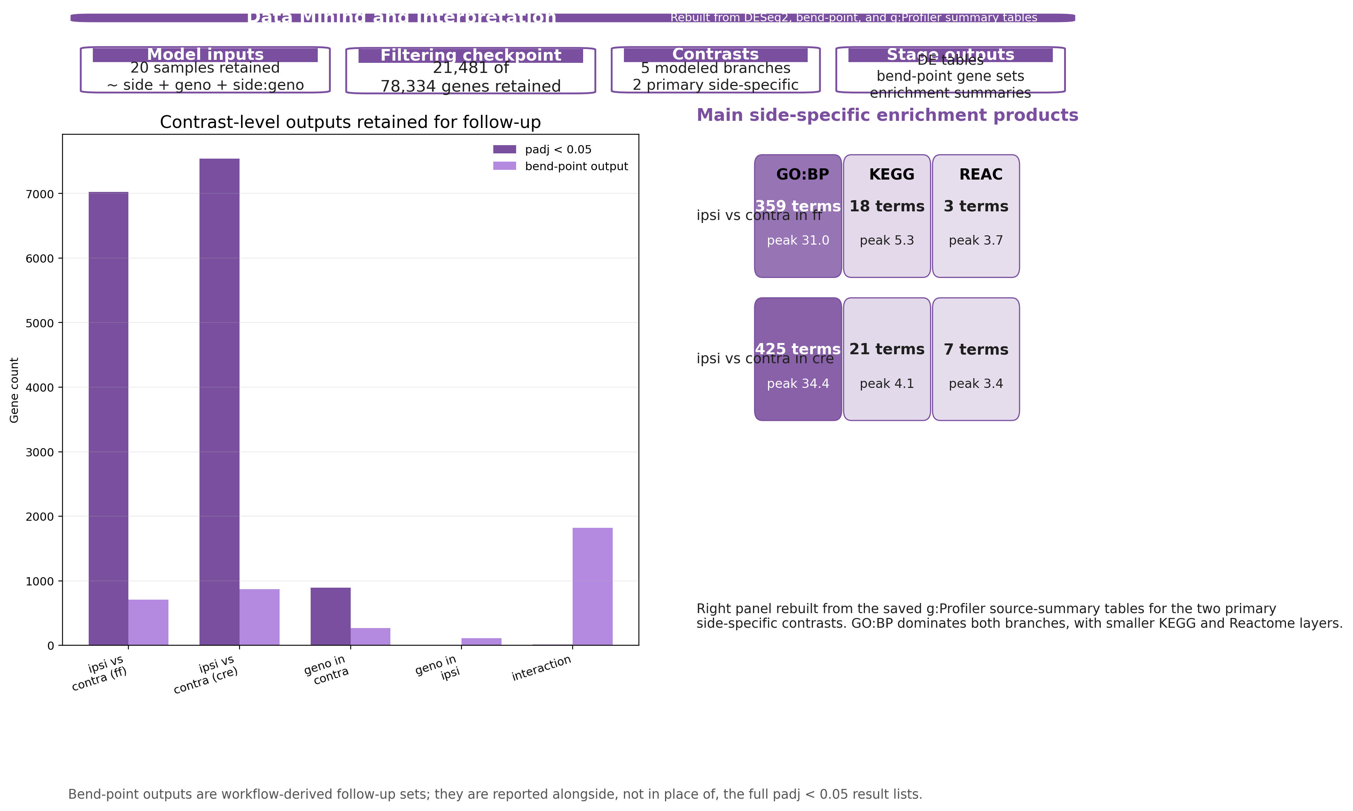
Rebuilt Data Analysis and Interpretation stage figure derived from saved DESeq2, bend-point, and g:Profiler summary tables.
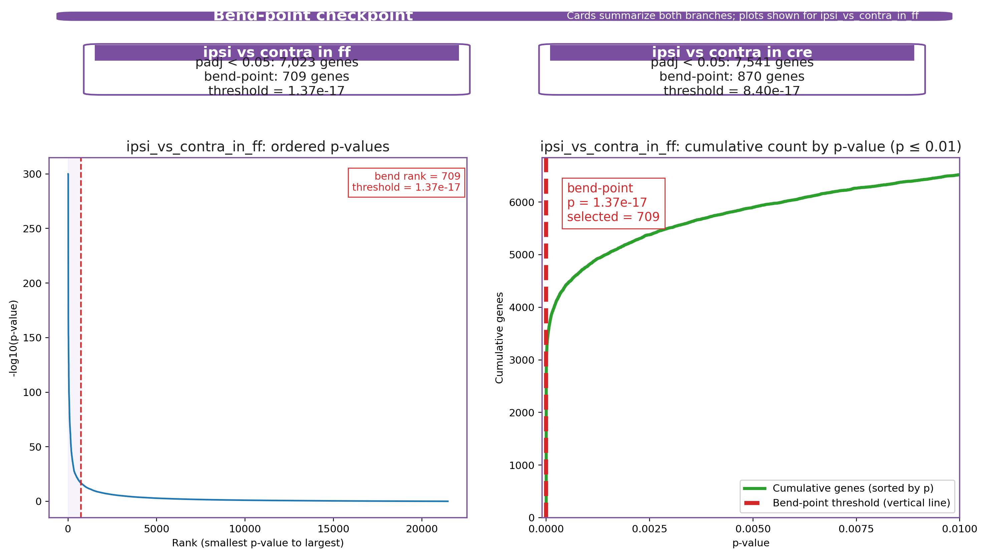
Retained bend-point checkpoint summary for the two primary side-specific branches (cards). The ordered p-value and cumulative-count plots are shown for the ipsi_vs_contra_in_ff example, with the right panel zoomed to p ≤ 0.01.
Table: Data Analysis and Interpretation workflow table.
Substage
Input
Tool
Checkpoint artifact / evidence
Why it mattered
Model setup
family count matrix + design table
DESeq2
normalized counts, VST matrix, and contrast-level result tables; 20 samples retained and 78,334 → 21,481 genes after filtering
defines the inferential base for every contrast and downstream plot
Contrast production
filtered model outputs
DESeq2contrast manifest
five saved contrast branches; two primary side-specific and three supporting genotype / interaction branches
keeps the main and supporting stories explicit before list narrowing
Bend-point selection
ordered adjusted-p tables
local bend-point scripts
analysis-summary and per-contrast bend-point summary tables; primary side-specific follow-up sets of 709 genes in ff and 870 genes in cre
turns very large DE lists into smaller reproducible follow-up sets
Enrichment layer
bend-point-selected gene sets
g:Profiler
g:Profiler source-summary and enrichment tables; the main ff branch retained 359 GO:BP, 18 KEGG, and 3 Reactome terms
captures the terminal functional-summary products without replacing the gene-level story
Table: Primary side-specific follow-up summary carried out during the Data Analysis stage.
Branch
padj < 0.05 genes
Bend-point genes
Threshold
GO:BP
KEGG
REAC
ff side branch
7,023
709
1.37e-17
359
18
3
cre side branch
7,541
870
8.40e-17
425
21
7

Results
(Placeholder for now.)

Discussion
(Placeholder for now.)

References
(Placeholder for now.)

Paper draft1
Paper draft1
Claim
- The main effect to test is ipsilateral vs. contralateral DRG after injury.
- This axis should be visible across pipelines and across datasets (ff vs. cre).
Strongest evidence (Results)
- Differential expression: ipsi vs. contra in the family_drg_novaseqx dataset shows the strongest signal.
- Replication: the same genes shift in the same direction in the mouse_new dataset.
- Highlight a small set of top genes that carry the effect (use the overlap across datasets).
Supporting evidence
- QC/alignment: keep alignment and sequencing QC consistent across samples; add a short table in final draft.
- PCA: the largest principal component should separate ipsi vs. contra; show that replicates cluster and groups separate.
- DE list handling: combine multiple contrasts carefully; avoid double counting the same gene in different comparisons.
Secondary results
- Consider additional contrasts that help the story (only if they strengthen the claim). The focus stays on ipsi vs. contra.
Methods
- Sequencing: outline sample prep, sequencing platform, and counts alignment.
- Differential expression: specify normalization, model terms, and statistics.
Discussion
- Summarize what the evidence means biologically and why the replication across datasets matters.
- State limitations and the next analyses needed to turn this into a full manuscript.
References
- Start a numbered list of the key papers you will cite. Keep it short for draft1.
Appendix (internal)
Project-specific checklist (SRP618841)
- read in files
- QC / alignment / filtering
- PCA / DE
- one list of genes
Key TODOs before draft2
- replace placeholders with actual gene lists + key metrics
- add code references / link to the exact scripts/outputs used
- decide which figures/tables/summary stats fit the claim

