Materials and Methods Draft
Mouse DRG RNA-seq Follow-up Project
Piter Garcia
Draft prepared for BIOL550

Materials and Methods
This section describes the mouse_new analysis workflow as a reproducible bioinformatics pipeline organized around four computational stages: Data Collection, Data Cleaning, Data Preparation, and Data Analysis and Interpretation. That structure makes both the biological context and the computational handoffs explicit, from raw sequence acquisition through differential expression and enrichment analysis. Each stage is documented by a pipeline summary table and a matching figure; figures explain how each stage works, while tables capture the concrete inputs, tools, outputs, and key metrics produced. Color coding within each table reflects stage identity at the row level, with additional within-stage shading used in the Data Analysis section to distinguish primary, supporting, and contextual contrasts from one another.
%% ── Overall pipeline figure ──────────────────────────────────────────────────
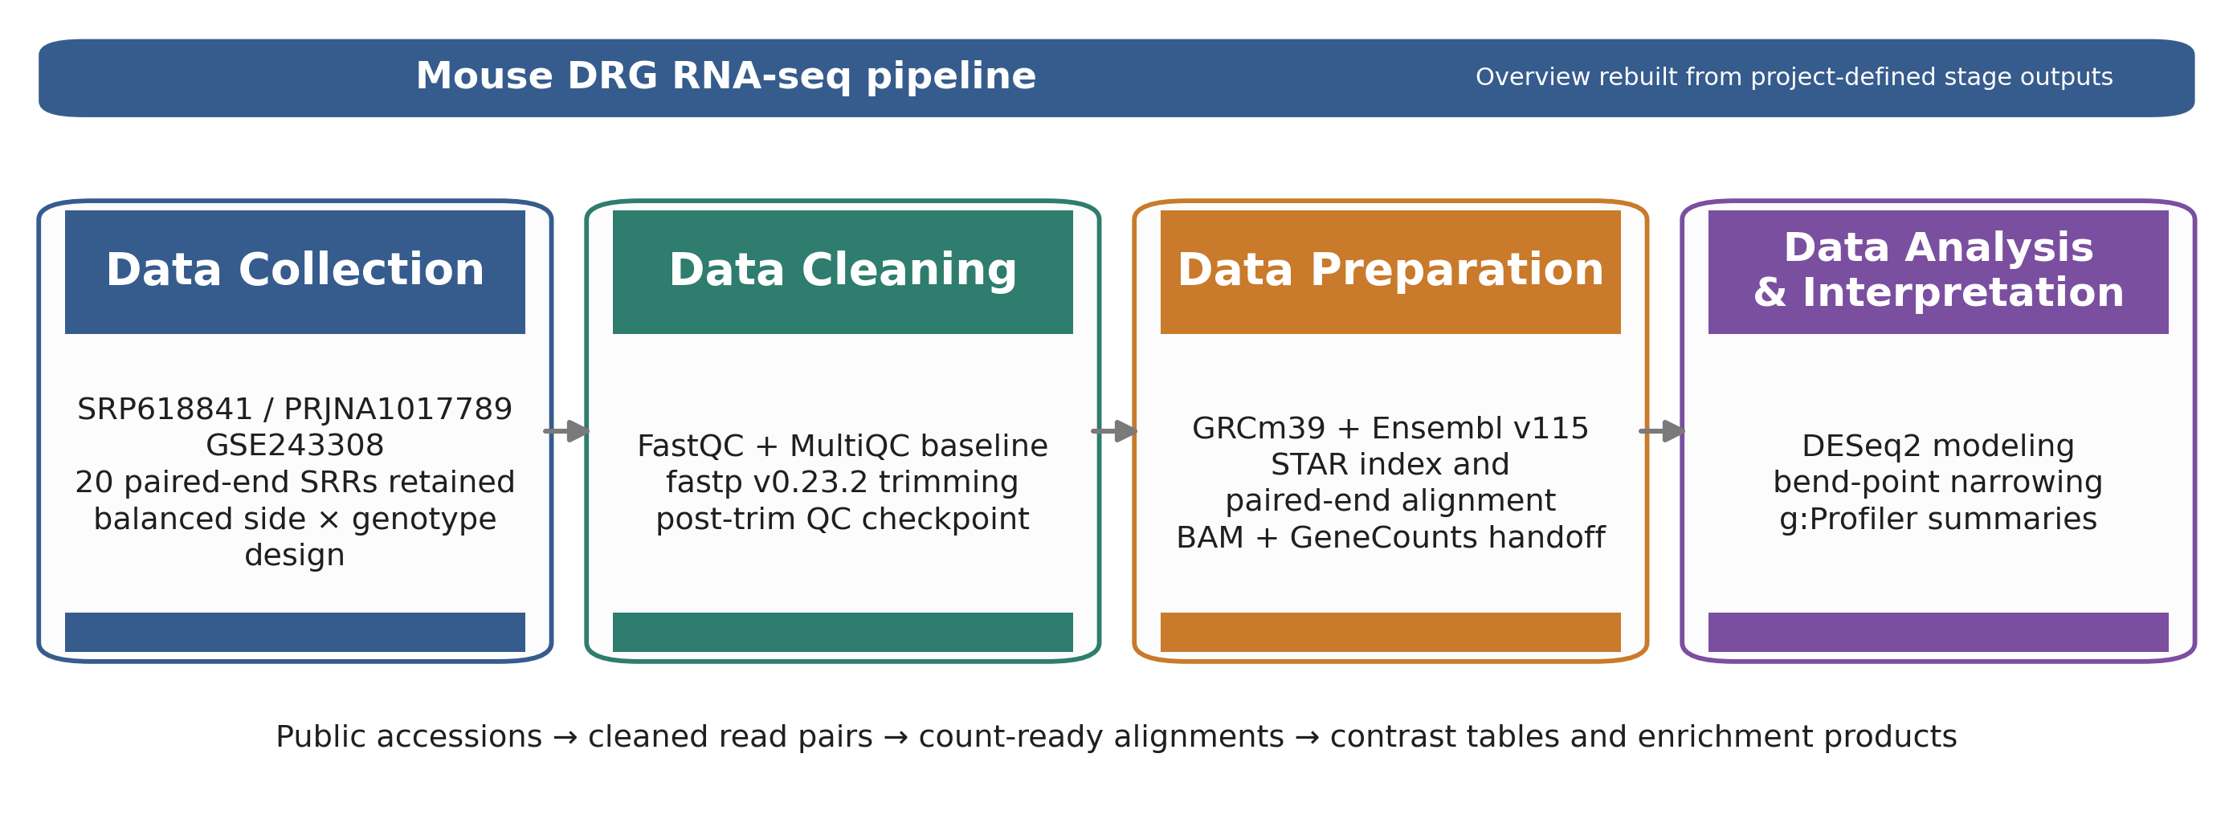
Figure 1. End-to-end structure of the mouse_new
%% ═══════════════════════════════════════════════════════════════════════════════

Data Collection: SRA Acquisition and Sample Organization
The study analyzed the mouse dorsal root ganglion (DRG) bulk RNA-seq dataset associated with SRP618841 (BioProject PRJNA1322439; GEO GSE243308). Sequence runs were obtained from the NCBI Sequence Read Archive using local acquisition wrappers around prefetch and fasterq-dump, and the paired-end outputs were stored as compressed FASTQ.gz files so the same inputs could be reused across QC, alignment, and notebook-based downstream analysis without modification. The working subset consisted of 20 DRG samples generated on a NovaSeq X platform under a sciatic nerve injury (SNI) design, all sampled at 1 day post-injury (1 dpi).
Sample metadata were structured as a design table rather than as loose file names, with each run labeled by side class (ipsi or contra) and genotype class (ff or cre). The 20 samples split into four balanced groups of five replicates each: ipsi_ff, ipsi_cre, contra_ff, and contra_cre, all belonging to the family family_drg_novaseqx. the corresponding table shows the full per-sample design used in all downstream contrasts. Making the biological groupings explicit before any exploratory or inferential analysis was a deliberate design choice: sample structure had to be confirmed before gene-level and pathway-level claims could be trusted.
%% ── Design table ─────────────────────────────────────────────────────────────
Table 1. Per-sample design table for the family_drg_novaseqx
l l >p1.6cm >p1.6cm >p2.2cm Y SRR | Replicate | Side | Geno | Condition group | Genotype label SRR35329978 | H65 | ipsi | ff | ipsi_ff | Wildtype SRR35329984 | H62 | ipsi | ff | ipsi_ff | Wildtype SRR35329986 | H63 | ipsi | ff | ipsi_ff | Wildtype SRR35329991 | H96 | ipsi | ff | ipsi_ff | Wildtype SRR35329992 | H97 | ipsi | ff | ipsi_ff | Wildtype SRR35329977 | H64 | ipsi | cre | ipsi_cre | CRE SRR35329983 | H61 | ipsi | cre | ipsi_cre | CRE SRR35329987 | H95 | ipsi | cre | ipsi_cre | CRE SRR35329993 | H99 | ipsi | cre | ipsi_cre | CRE SRR35329994 | H100 | ipsi | cre | ipsi_cre | CRE SRR35329979 | H96 | contra | ff | contra_ff | Wildtype SRR35329980 | H97 | contra | ff | contra_ff | Wildtype SRR35329981 | H65 | contra | ff | contra_ff | Wildtype SRR35329982 | H62 | contra | ff | contra_ff | Wildtype SRR35329989 | H63 | contra | ff | contra_ff | Wildtype SRR35329985 | H64 | contra | cre | contra_cre | CRE SRR35329988 | H99 | contra | cre | contra_cre | CRE SRR35329990 | H100 | contra | cre | contra_cre | CRE SRR35329995 | H95 | contra | cre | contra_cre | CRE SRR35329996 | H6 | contra | cre | contra_cre | CRE 6l ipsiFFX ipsi / FF ipsiCREX ipsi / CRE contraFFX contra / FF contraCREX contra / CRE

%% ── Stage summary table ───────────────────────────────────────────────────────
Table 2. Data Collection stage summary.
>tableheaderp2.25cm Y Y Y Y Input | Tool or source | Output | Purpose | Key stage metrics or artifacts Public study accession (SRP618841) | SRA Toolkit and local acquisition wrappers | 20 paired-end FASTQ.gz runs and run manifest | Reconstruct the working DRG subset locally from public data | BioProject PRJNA1322439; GEO GSE243308; all 20 samples retained in the active DRG subset Run metadata and sample annotations | Project design table assembly | Structured per-sample manifest (the corresponding table) used by all downstream scripts and notebooks | Preserve the biological labels (side_class, geno_class) attached to each sequencing run | 10 ipsi (5 ff + 5 cre), 10 contra (5 ff + 5 cre); family = family_drg_novaseqx; design formula = side_class + geno_class + side_class:geno_class

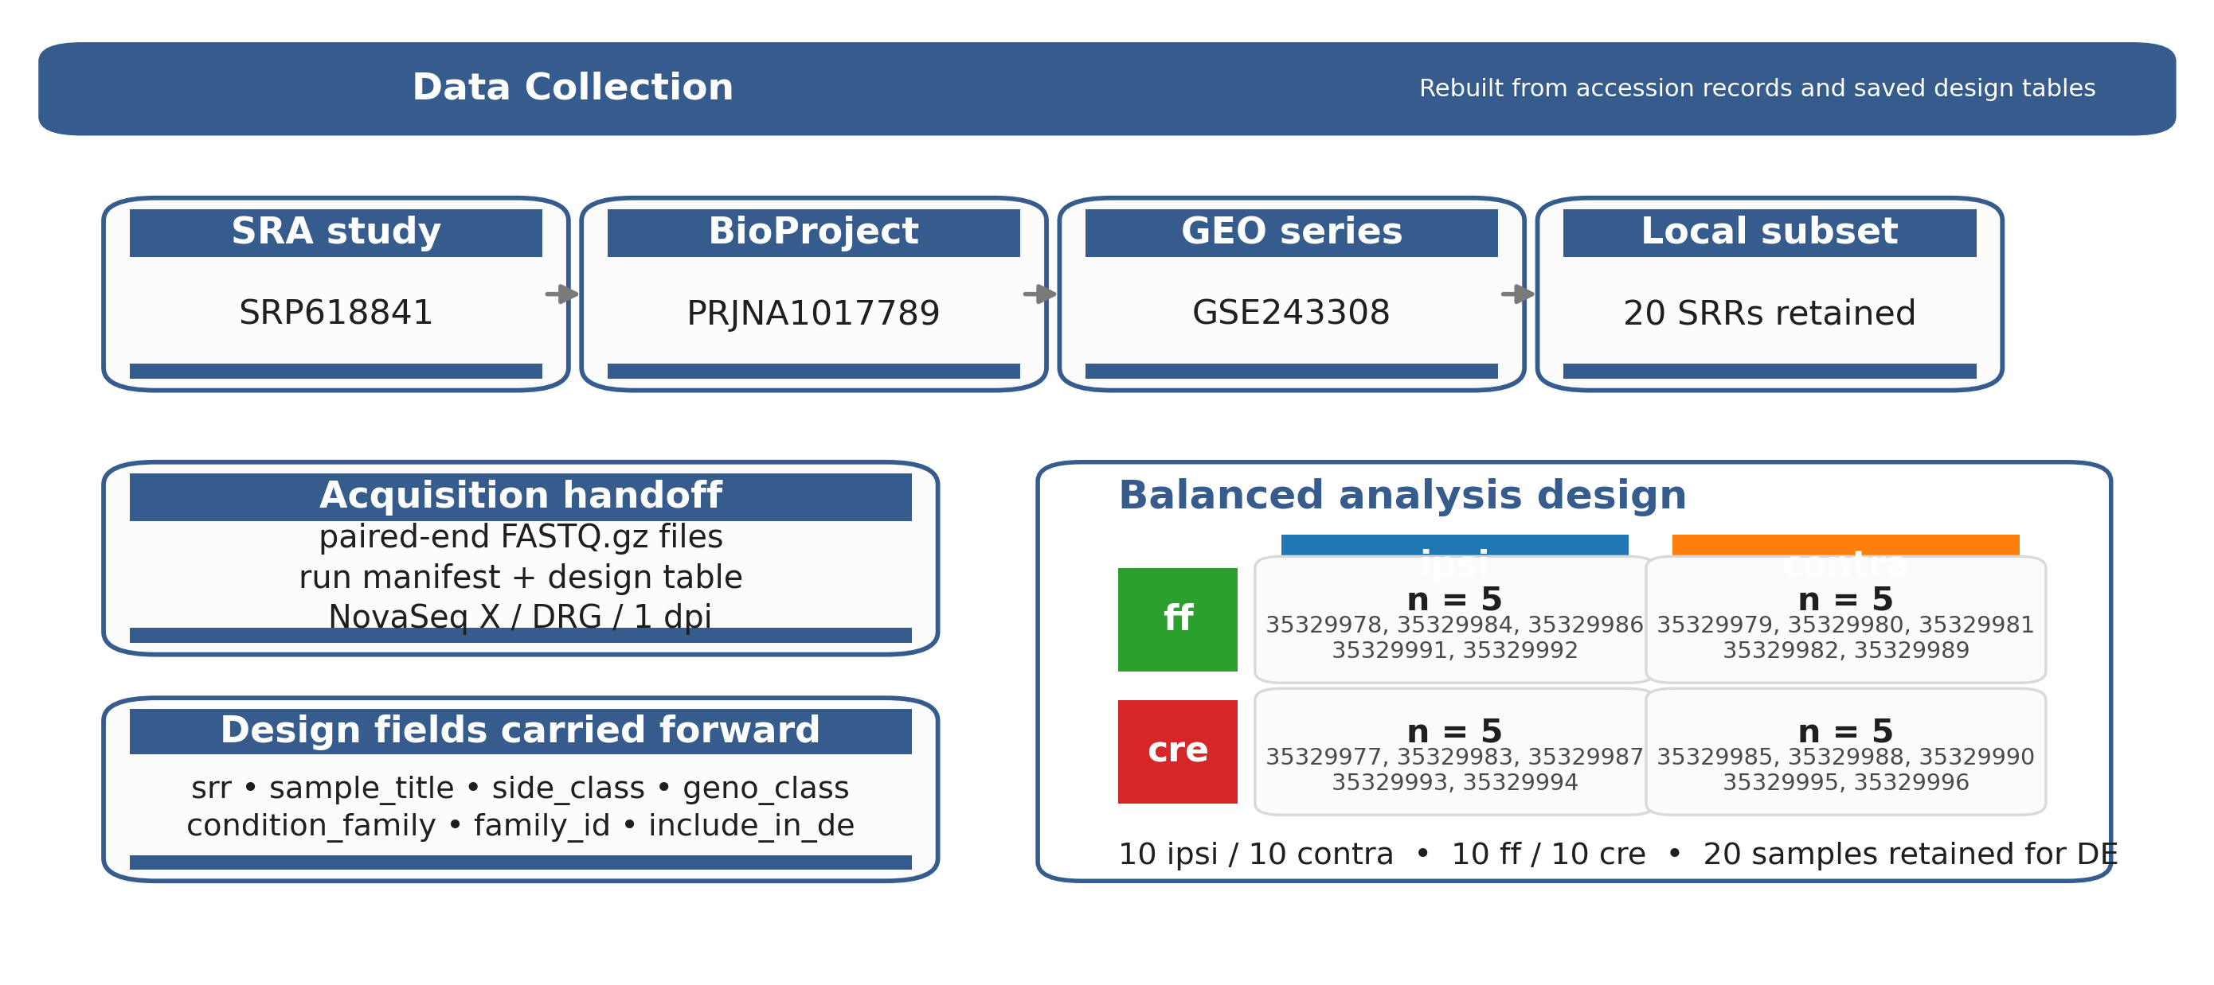
Figure 2. Data Collection stage summary figure. The panel shows the public accession lineage (SRP618841
%% ═══════════════════════════════════════════════════════════════════════════════

Data Cleaning: Quality Control and Read Trimming
sec:cleaning
Raw sequence quality was assessed with FastQC, and consolidated summaries were reviewed with MultiQC to evaluate adapter contamination, sequence-content anomalies, read-length behavior, and per-sample warning patterns across all 40 raw read files (20 samples, two mates each). fastp v0.23.2 was retained as the canonical trimming step following earlier remediation work on the mouse project; it resolved adapter-related signal more effectively than the earlier FASTX-based baseline while preserving a fully reproducible paired-end workflow. The trimming configuration applied paired-end adapter detection (--detect_adapter_for_pe), tail trimming (--cut_tail), a mean-quality cutoff of 20, a minimum retained length of 30 bases, poly-G trimming, and per-sample HTML/JSON reporting.
Post-trimming FastQC runs confirmed that Adapter Content improved from 40/40 raw-file failures to 80/80 post-trim passes. One pattern persisted after trimming and required explicit documentation: all 20 DRG samples carried a Per Sequence GC Content WARN flag in the corrected trimmed-only shared MultiQC report. The GC WARN subset did not map to a single biological condition (it was not confined to injury vs.\ control, nor to FF vs.\ CRE), which made targeted removal unjustified at this stage (see also Section sec:preparation). The working decision, documented in the project remediation notes, was to treat the GC WARN status as a monitored flag, proceed to alignment, and use per-sample STAR metrics to determine whether the WARN samples showed any downstream penalty relative to a hypothetical PASS cohort. As confirmed in the alignment summary (Section sec:preparation), the lowest uniquely mapped rate in the cohort was 92.50%, with the cohort median at 93.24%, so the GC WARN pattern did not translate into a meaningful alignment quality penalty.
Table 3. Data Cleaning stage summary. Three sub-steps are shown: raw QC baseline, fastp
>tableheaderp2.25cm Y Y Y Y Input | Tool or source | Output | Purpose | Key stage metrics or artifacts Raw paired-end FASTQ.gz files (20 samples, 40 read files) | FastQC + MultiQC (raw-only report) | Raw QC bundle; module-level warning table | Establish baseline sequencing quality before cleanup | Adapter Content: 40/40 raw files FAIL; Per Sequence GC Content: pattern noted; raw-only MultiQC retained as authoritative pre-trim reference Raw paired-end reads + QC feedback | fastp v0.23.2 | Trimmed paired-end reads; per-sample HTML/JSON reports | Remove adapter-related and low-quality trailing sequence while preserving paired reads | Adapter detection (--detect_adapter_for_pe), tail trim (--cut_tail), mean-Q cutoff 20, min-length 30, poly-G trim; 20 samples 2 mate files trimmed Trimmed read pairs | FastQC + MultiQC (trimmed-only report) | Post-trim QC bundle; before/after module comparison | Verify that cleanup improved the read set before alignment | Adapter Content: 40/40 fail -> 80/80 pass; Per Sequence GC Content: 0 FAIL, all 20 samples = WARN (monitored; GC WARN subset does not correspond to one biological condition; alignment metrics evaluated in Section sec:preparation)

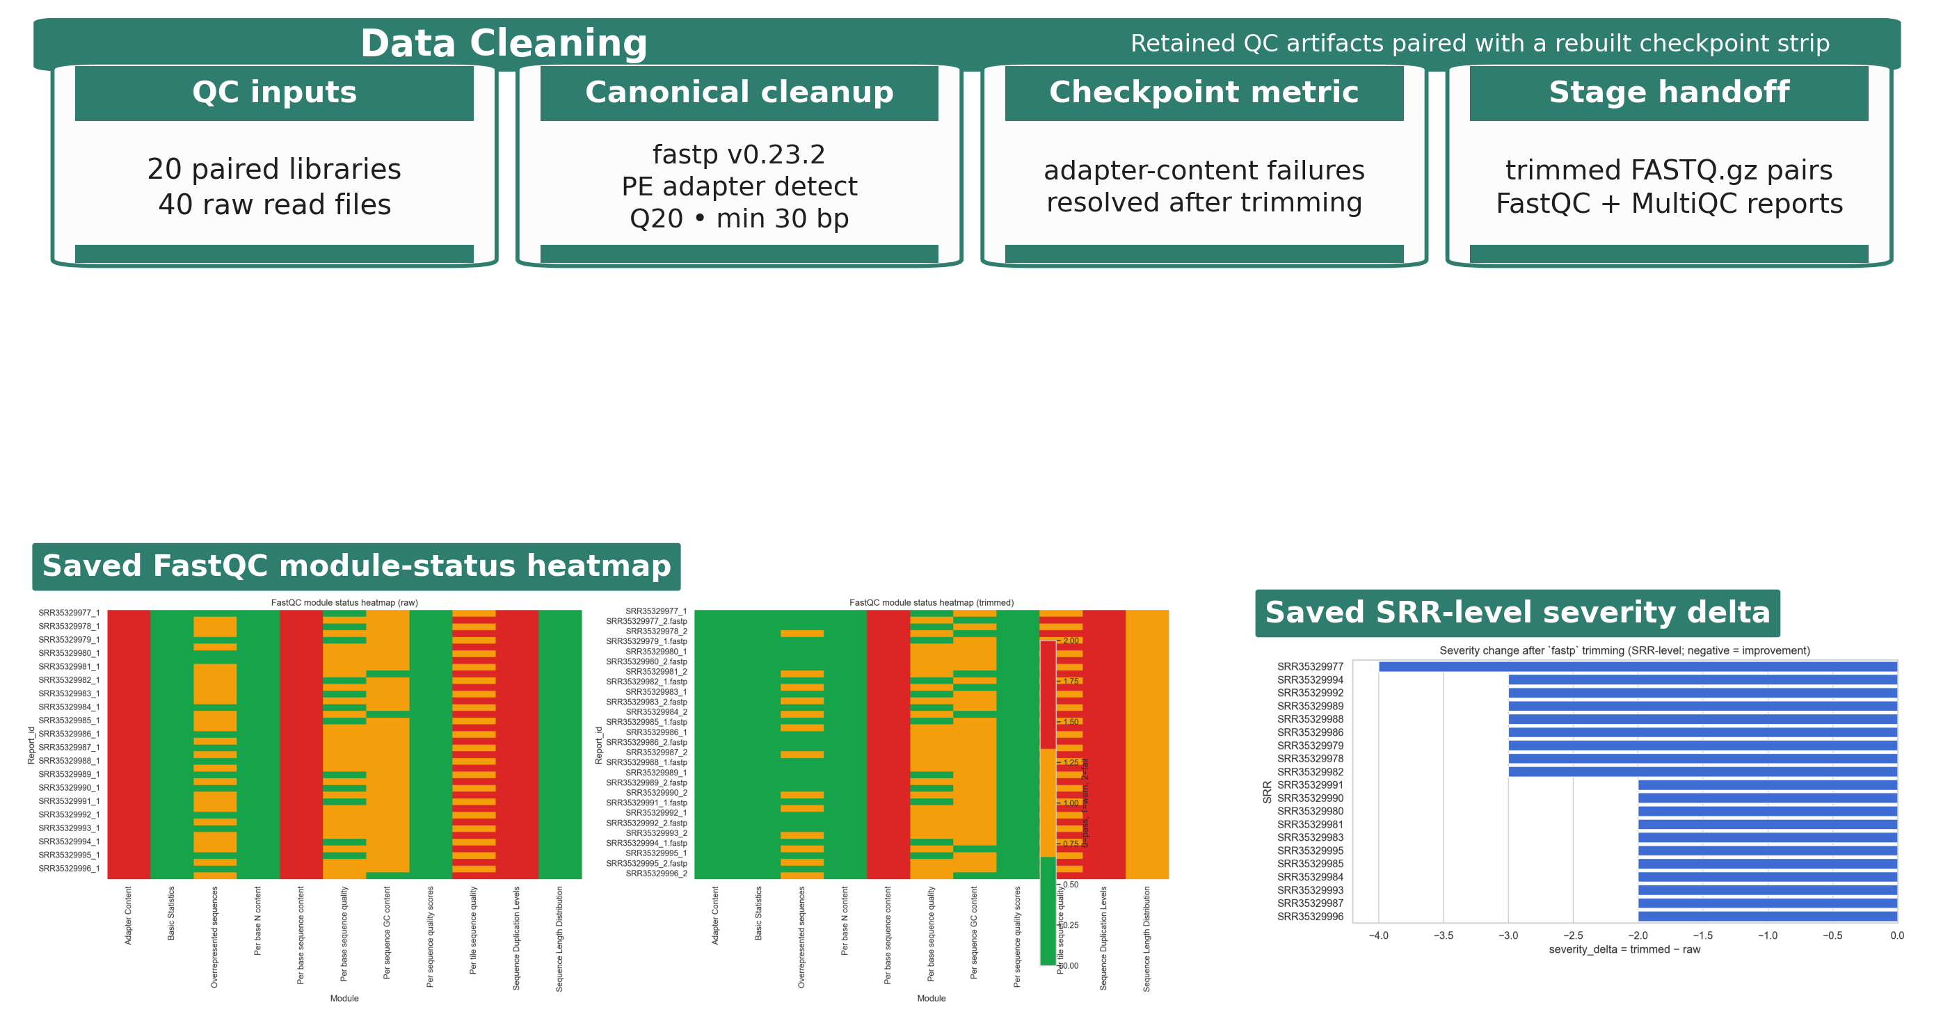
Figure 3. Data Cleaning stage artifacts from the stage-specific QC review. Panel (a): module-level FastQC transition from raw to trimmed reads showing the Adapter Content
%% ═══════════════════════════════════════════════════════════════════════════════

Data Preparation: Reference Selection and Alignment
sec:preparation
The cleaned reads were aligned against the Mus musculus GRCm39 primary assembly (Mus_musculus.GRCm39.dna.primary_assembly.fa) with the matching Ensembl release 115 annotation (Mus_musculus.GRCm39.115.gtf). A STAR genome index was built with sjdbOverhang = 150 to match the 151-bp paired-end read length of the NovaSeq X runs in the DRG subset. Alignment was performed with STAR using gzip-aware input reading, coordinate-sorted BAM output, and GeneCounts quantification, so the same alignment step produced both the sorted BAM and the count-ready gene summary for each sample.
Each sample produced three output files used in downstream analysis: a sorted BAM, a Log.final.out alignment report, and a ReadsPerGene.out.tab count table. The per-sample STAR metrics were aggregated into a cohort-level alignment summary (the corresponding table), which served as the explicit quality checkpoint before differential expression modeling. Across all 20 NovaSeq X DRG samples, the median unique mapping rate was 93.24% and the median multi-mapping rate was 5.10%; the five lowest individual unique-mapping rates were 92.50%, 92.67%, 92.70%, 92.74%, and 93.08%, confirming that the GC WARN cohort (Section sec:cleaning) did not carry a meaningful alignment penalty. Reverse-stranded assignment burden remained low across the cohort (median noFeature 3.82%; median ambiguous 1.77%), consistent with the expected behavior for a well-annotated mouse primary assembly. The per-sample count outputs were then merged into a family-level gene-by-sample count matrix using local merging scripts.
Table 4. Data Preparation stage summary. Three sub-steps are shown: reference and index preparation, alignment and per-sample output generation, and count-matrix assembly. All metrics are derived from the saved mouse_alignment_sample_summary.tsv
>tableheaderp2.25cm Y Y Y Y Input | Tool or source | Output | Purpose | Key stage metrics or artifacts Trimmed paired-end reads | Ensembl mouse primary assembly + GTF | Reference FASTA/GTF pair and STAR genome index | Build a coordinate system matched to the current mouse annotation | GRCm39 primary assembly; Ensembl v115; sjdbOverhang = 150 (matched to 151-bp read length) Trimmed reads + STAR index | STAR with --quantMode GeneCounts | Sorted BAMs, Log.final.out, and ReadsPerGene.out.tab per sample | Generate alignment and count outputs in one reproducible step; evaluate mapping quality before differential expression | Cohort median (NovaSeq X, n=20): unique mapping = 93.24%; multi-mapping = 5.10%; lowest individual unique mapping = 92.50% (SRR35329995; CRE / contra); GC-WARN cohort alignment metrics indistinguishable from GC-PASS reference range Per-sample count outputs | Local merging scripts and notebooks | Family-level gene-by-sample count matrix; cohort alignment summary table | Convert per-sample outputs into a matrix suitable for DESeq2 modeling | Reverse-stranded assignment burden: median noFeature 3.82%; median ambiguous 1.77%; final count matrix passed to DESeq2

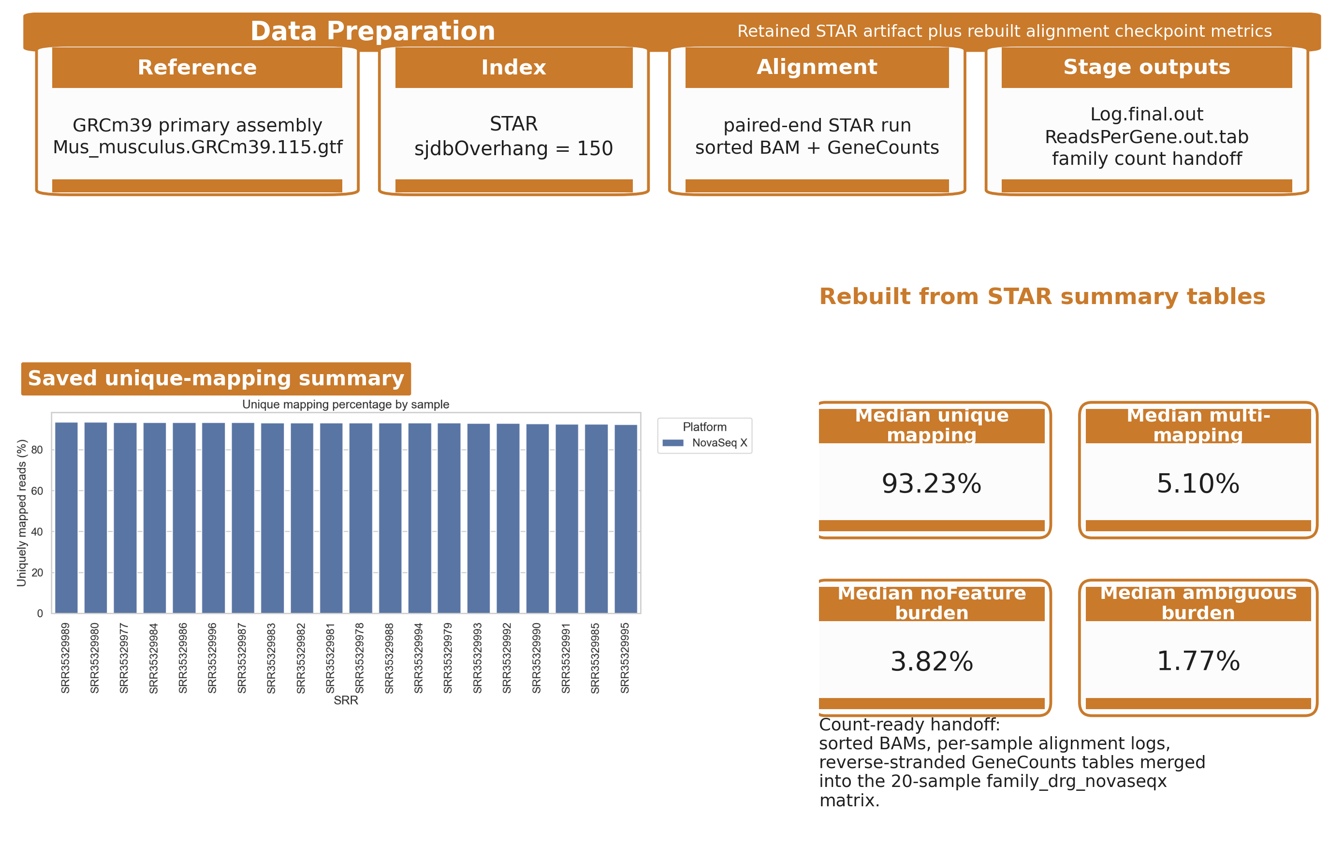
Figure 4. Data Preparation stage artifacts from the saved STAR alignment outputs. Panel (a): unique mapping rates by sample and by platform, with the five lowest-mapped samples annotated (range 92.50–93.08%; all NovaSeq X / GC WARN, consistent with the rest of the cohort). Panel (b): reverse-stranded assignment burden showing noFeature
%% ═══════════════════════════════════════════════════════════════════════════════

Data Analysis and Interpretation: Differential Expression and Functional Analysis
The STAR count outputs were merged into a gene-by-sample count matrix for the family_drg_novaseqx subset and modeled with DESeq2. Before modeling, genes with insufficient support across the family were filtered out, reducing the tested set from 78,334 genes to 21,481 genes while retaining all 20 samples. The full interaction model applied was: \[ \ side_class + geno_class + side_class:geno_class \] which estimates both main effects and the genotype-by-side interaction term in a single model, making all five contrasts extractable from the same fitted object without refitting.
The first interpretive checkpoint after fitting was principal component analysis (PCA) on the variance-stabilized count matrix (VST). The PCA confirmed that side_class (ipsilateral vs.\ contralateral) drives the dominant variance axis in the DRG cohort, with ipsi and contra samples separating clearly on PC1. Genotype effects were visible as secondary structure: within the ipsilateral group, FF/CRE pairs showed PCA distances as small as 0.27 (SRR35329986/SRR35329987), while across the contralateral group the maximum FF/CRE pair distance was 32.9 (SRR35329982/SRR35329990), reflecting a broader genotype-dependent variance component on the contra side. This PCA interpretation was locked before gene-level claims were made.
Five contrasts were extracted from the DESeq2 model and are summarized in the corresponding table. The two primary side-specific contrasts---ipsi_vs_contra_in_ff and ipsi_vs_contra_in_cre---produced the largest significant gene sets (7,023 and 7,541 genes at p_adj < 0.05, respectively) and are the central analytical results of the paper. The two genotype-focused contrasts (geno_in_contra and geno_in_ipsi) and the interaction contrast are retained as supporting and contextual results.
Because the primary side-specific contrasts yielded very large significant-gene sets unsuitable for direct follow-up, the workflow applied a custom bend-point rule based on ranked p-value distributions to derive a smaller, data-driven gene subset from each contrast. The bend-point threshold for ipsi_vs_contra_in_ff was 1.37 10^-17, yielding 709 selected genes from 7,023 significant; for ipsi_vs_contra_in_cre the threshold was 8.40 10^-17, yielding 870 from 7,541. Functional enrichment was then run on the bend-point-selected gene sets using g:Profiler with GO Biological Process, KEGG, and Reactome sources. For the main ff side-specific contrast, the retained enrichment outputs included 359 GO:BP terms, 18 KEGG terms, and 3 Reactome terms. MA plots, volcano plots, and heatmaps were generated as downstream analytical products for all five contrasts and are reserved for the Results section.
Table 5. Data Analysis and Interpretation stage summary. Rows are ordered by contrast priority (primary -> supporting -> contextual) and shaded accordingly. Bend-point thresholds and selected gene counts are derived directly from the saved per-contrast bendpoint_summary.tsv
>tableheaderp2.0cm Y Y Y Y Step / contrast | Tool or source | Output | Purpose | Key metrics or artifacts %% -- Modeling row 5lstagemineModeling and sample-structure check Family count matrix + design table | DESeq2 | Normalized counts, VST matrix, and fitted model object | Model expression differences under the full interaction design; confirm sample structure via PCA before gene-level claims | 20 samples retained; genes filtered 78,334 -> 21,481; VST PCA: PC1 separates side_class; minimum FF/CRE PCA pair distance = 0.27 (ipsi group); maximum = 32.9 (contra group) [0.3em] %% -- Primary contrasts header 5lstageminePrimary side-specific contrasts () %% -- ipsi_vs_contra_in_ff ipsi_vs_ contra_in_ff | DESeq2 coef side_class_ ipsi_vs_contra; bend-point narrowing; g:Profiler | Ordered p-value table; bend-point gene set; GO/KEGG/Reactome enrichment table and plots | Capture the injury-side DRG expression signal in the FF (wildtype) background | 21,466 genes tested; 7,023 significant (p_adj < 0.05); bend-point threshold = 1.37 10^-17; 709 selected; enrichment: 359 GO:BP, 18 KEGG, 3 Reactome %% -- ipsi_vs_contra_in_cre ipsi_vs_ contra_in_cre | DESeq2 list side_class_ipsi_vs_contra + interaction term; bend-point narrowing; g:Profiler | Ordered p-value table; bend-point gene set; enrichment table and plots | Capture the injury-side DRG expression signal in the CRE background; compare signal breadth and pathway overlap with the FF contrast | 21,466 genes tested; 7,541 significant; bend-point threshold = 8.40 10^-17; 870 selected [0.3em] %% -- Supporting contrasts header 5lstagemineGenotype-focused contrasts () %% -- geno_in_contra geno_in_ contra | DESeq2 coef geno_class_ cre_vs_ff; bend-point narrowing; g:Profiler | Ordered p-value table; bend-point gene set; enrichment table and plots | Assess genotype-driven expression differences in contralateral DRG (uninjured reference side) | 21,466 genes tested; 891 significant; bend-point threshold = 2.13 10^-4; 267 selected geno_in_ ipsi | DESeq2 list (geno_class + interaction term); bend-point narrowing | Ordered p-value table; bend-point gene set | Assess genotype-driven differences on the injured ipsilateral side | 21,466 genes tested; 2 significant (p_adj < 0.05); bend-point threshold = 0.0143; 113 selected below threshold [0.3em] %% -- Contextual contrast header 5lgrayInteraction contrast () %% -- interaction interaction | DESeq2 coef side_class_ ipsi.geno_class_ cre; bend-point narrowing | Ordered p-value table; bend-point gene set | Identify genes whose ipsilateral vs.\ contralateral difference is specifically larger or smaller in CRE animals | 21,466 genes tested; 14 significant; bend-point threshold = 0.046; 1,823 selected below a permissive bend-point 5l deepmineX Primary midmineX Supporting palmineX Contextual

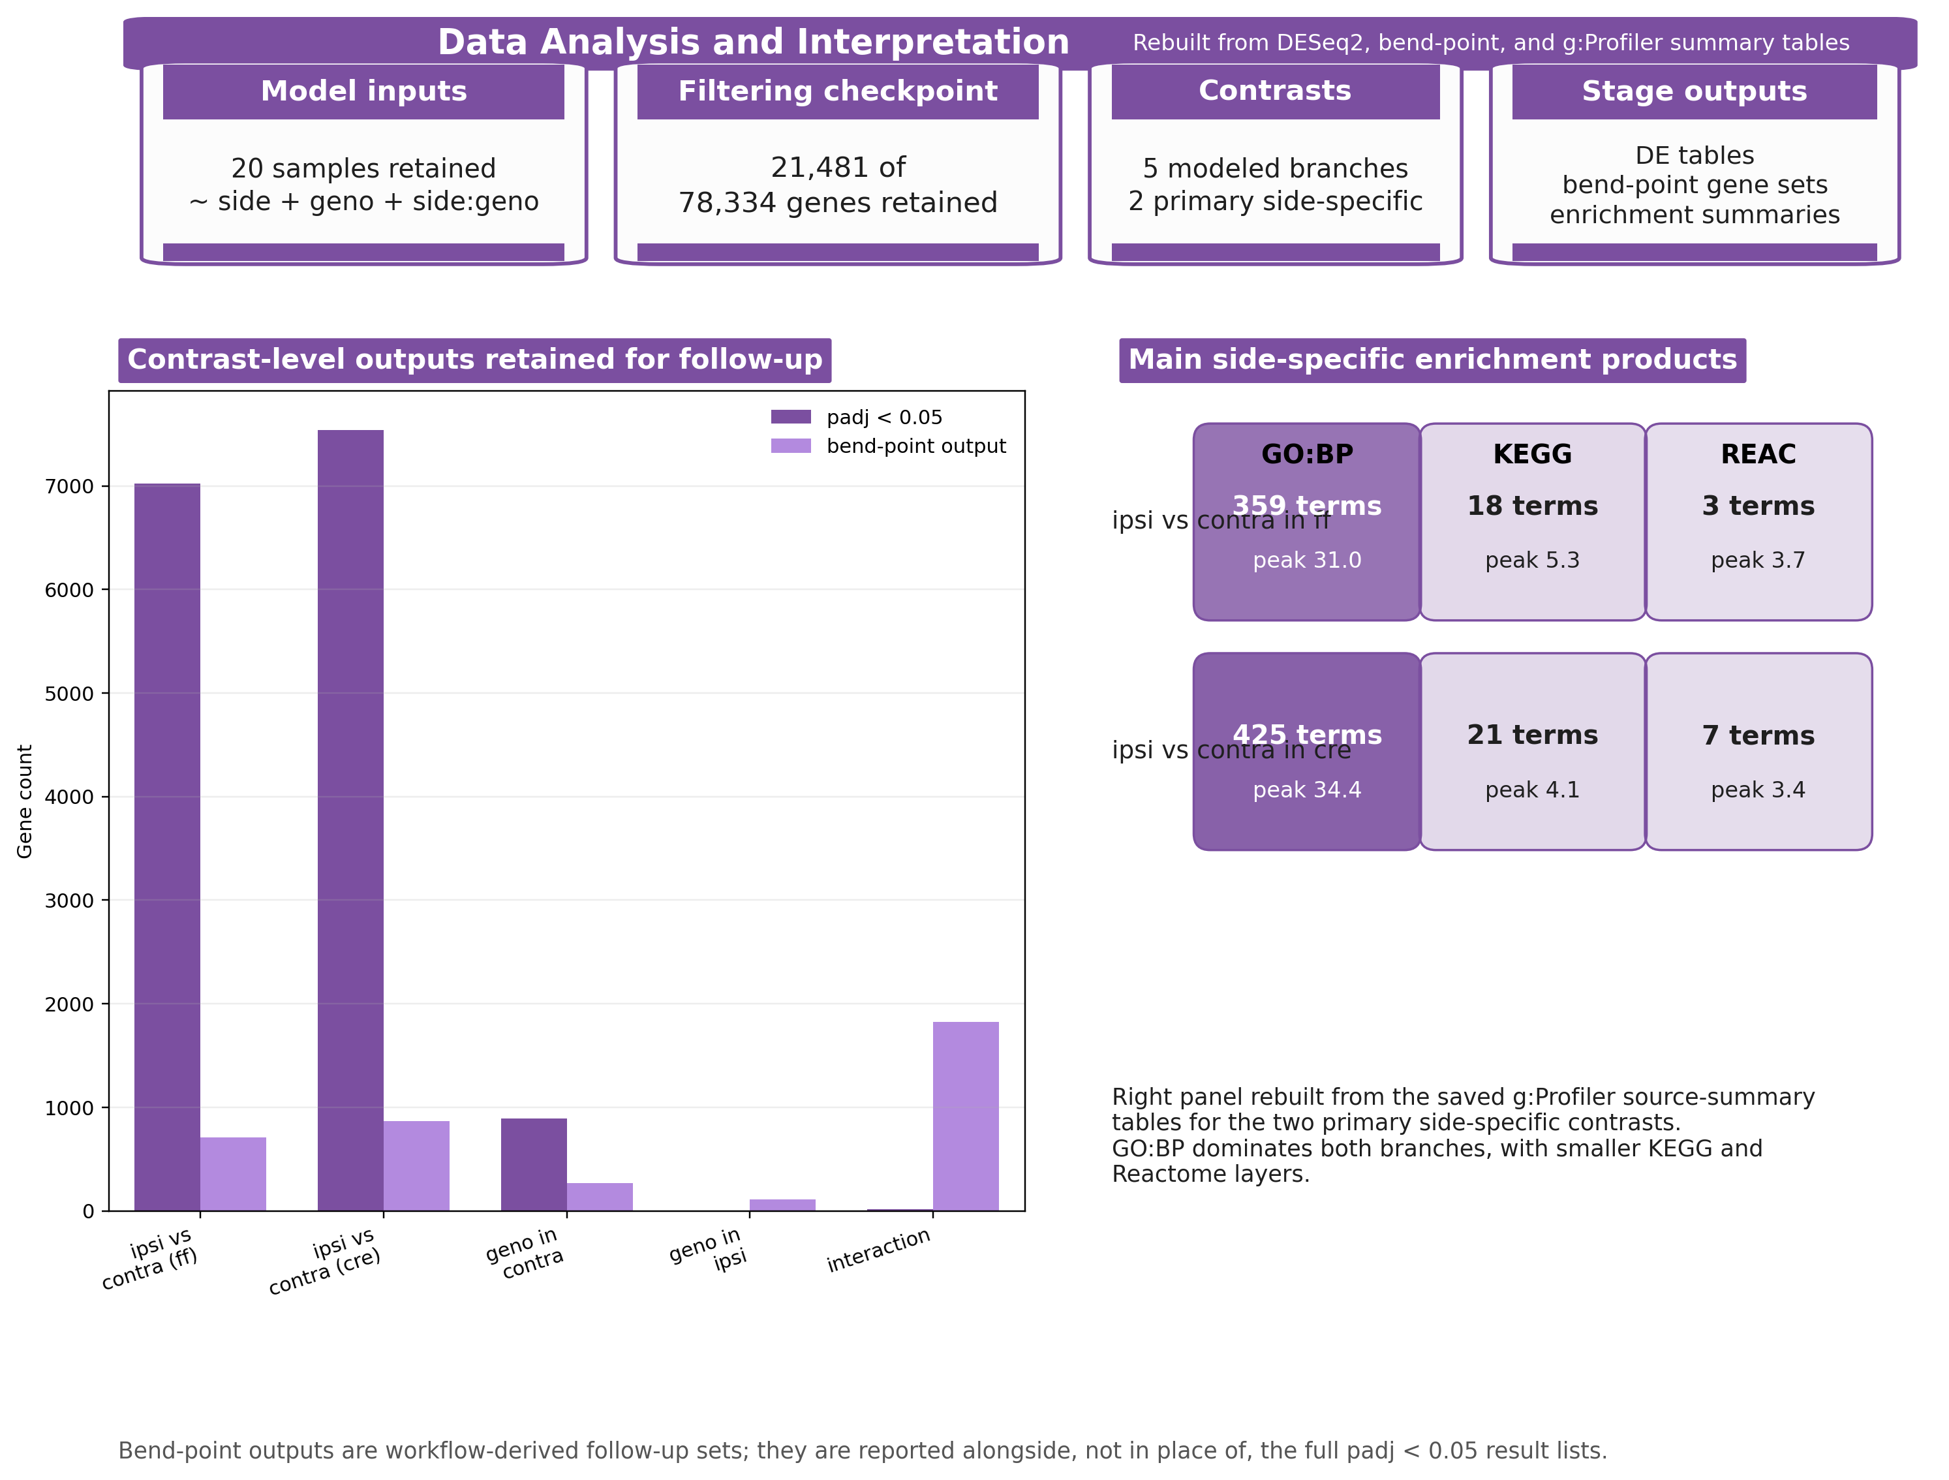
Figure 5. Data Analysis and Interpretation stage summary derived from the saved DESeq2
Across the section, the design principle was to let figures explain how each pipeline stage was executed and let tables capture what each stage produced. Color coding is applied at two levels: stage identity (blue / teal / amber / purple for Collection, Cleaning, Preparation, and Mining) and, within the Mining stage, contrast priority (deeper purple for primary contrasts, mid-purple for supporting genotype contrasts, and pale purple for the contextual interaction contrast). This layered coding makes the status of each analytical product visible at a glance without requiring additional legend text in the narrative.

