Materials and Methods Draft
Mouse DRG RNA-seq Follow-up Project
Piter Garcia
Draft prepared for BIOL550

Materials and Methods
This project reanalyzed mouse DRG bulk RNA-seq after spinal cord injury using four computational stages: Data Collection, Data Cleaning, Data Preparation, and Data Analysis and Interpretation. The working subset comprised 20 NovaSeq X paired-end libraries from SRP618841 (BioProject PRJNA1017789; GEO GSE243308), organized as a balanced side-by-genotype design before quality control, alignment, and differential expression modeling.
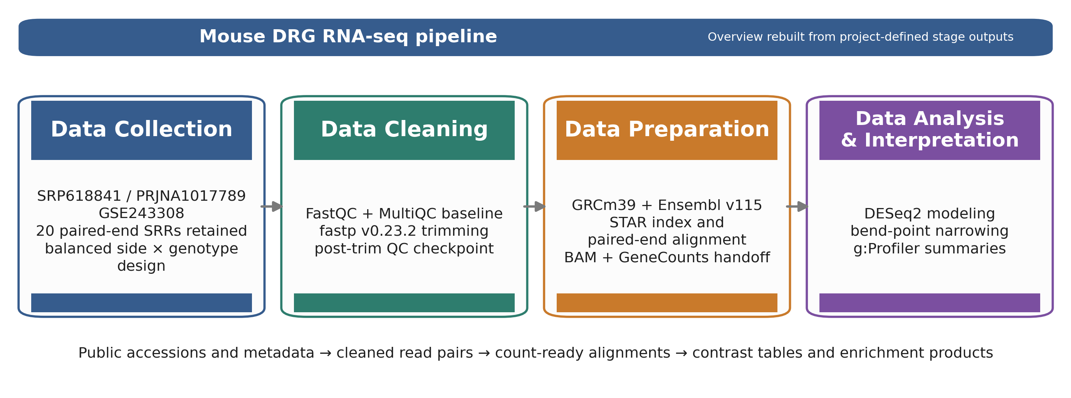
Figure 1. Overview ribbon summarizing the four computational stages and their stage-owned handoffs in the mouse_new
Table 1. Pipeline checkpoint table used to anchor the Methods section to stage-specific evidence.
Stage | Primary artifacts | Core tools | Checkpoint metric | Handoff
Collection | sample table; family sheet | prefetch + fasterq-dump | 20 SRRs retained; 4 balanced subgroups (n=5 each) | FASTQ.gz pairs + manifest
Cleaning | QC heatmap; severity delta | FastQC + MultiQC + fastp | raw adapter-content failures resolved after trimming | trimmed read pairs plus per-sample QC reports
Preparation | unique-mapping plot; STAR median summary | STAR + GeneCounts | 93.23% median unique mapping; 3.82% median noFeature | sorted BAMs, STAR logs, count tables, and family matrix
Analysis | filtering summary analysis summary g:Profiler source tables | DESeq2 + bend-point + g:Profiler | 78,334 -> 21,481 genes after filtering; 5 modeled contrasts | DE tables, bend-point follow-up sets, and enrichment summaries

Data Collection: SRA Acquisition and Sample Organization
The analysis began with the published DRG RNA-seq study SRP618841, linked to BioProject PRJNA1017789 and GEO series GSE243308. Public runs were retrieved using the project wrappers around prefetch and fasterq-dump, and the local workflow retained 20 paired-end NovaSeq X libraries from the 1-day-post-injury DRG subset. Recording this accession lineage was important because the downstream paper draft required a precise description of the reanalyzed dataset rather than a generic reference to ``the mouse dataset.''
After download, metadata were consolidated into a design-aware sample table rather than being left as file-name strings. Each retained sample was annotated by side_class (ipsi or contra), geno_class (ff or cre), and the derived condition_family. This step established the balanced 22 design used in the DESeq2 model and in subsequent interpretation.
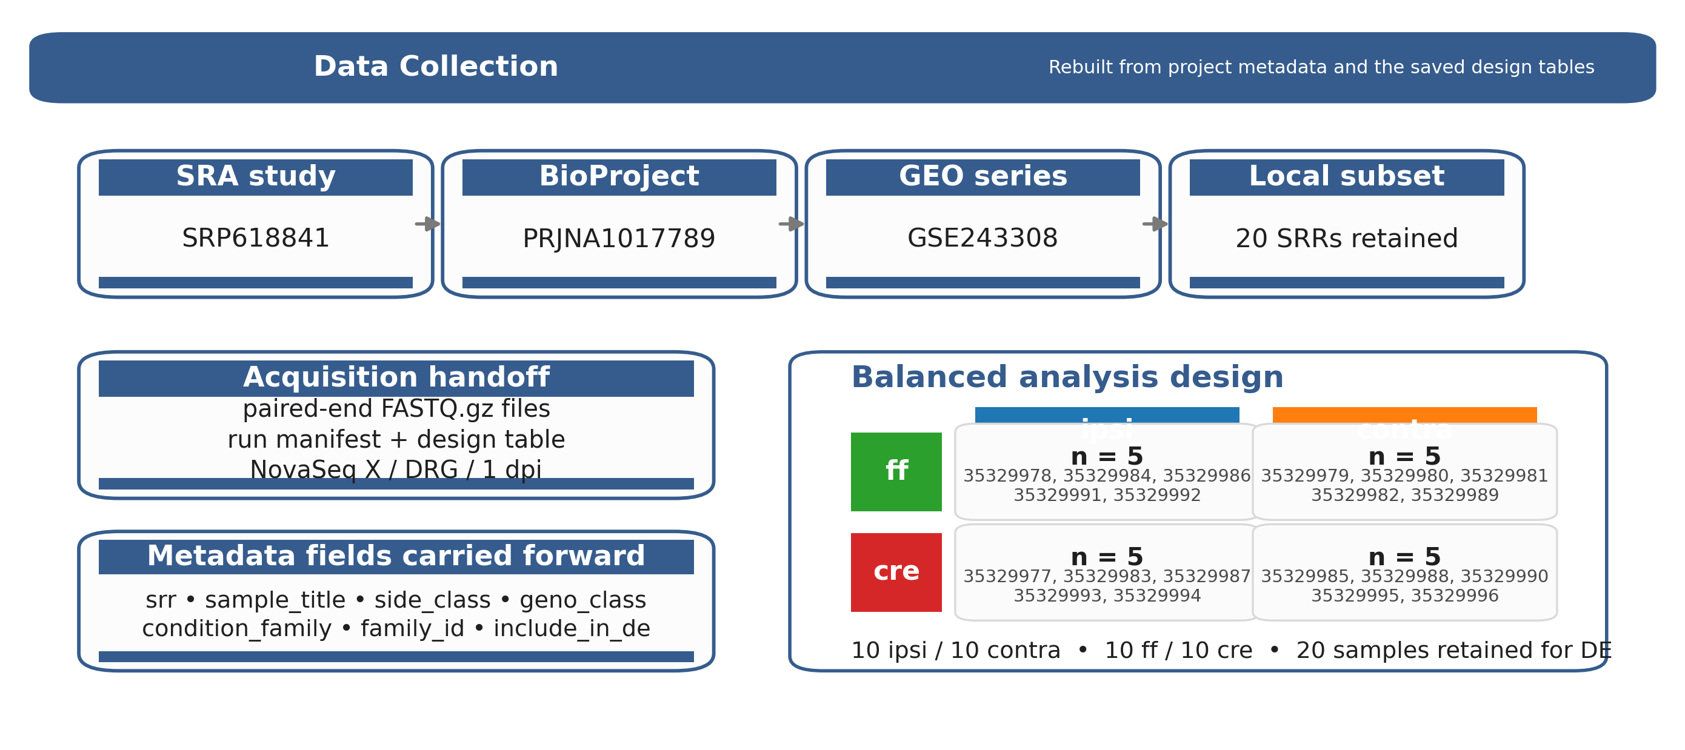
Figure 2. Rebuilt Data Collection stage figure derived from the saved project metadata and design tables.
Table 2. Data Collection stage table.
Substage | Input | Tool | Checkpoint artifact / evidence | Why it mattered
Study provenance | public accession records | SRA / GEO review | accession lineage shown in the corresponding figure: SRP618841 -> PRJNA1017789 -> GSE243308 | anchors the Methods section to the exact source study
Run acquisition | public SRA runs | prefetch fasterq-dump | paired-end FASTQ.gz files plus the local run manifest; 20 retained SRRs from the DRG / NovaSeq X subset | creates the fixed read set used throughout the pipeline
Design mapping | run manifest + sample titles | local manifest assembly | design table and family sample sheet; 5 samples in each subgroup | makes the side/genotype structure explicit before PCA and DE modeling

Data Cleaning: Quality Control and Read Trimming
Raw read quality was evaluated with FastQC, and cohort-level summaries were consolidated with MultiQC. This stage was treated as a documented checkpoint rather than a minimal preprocessing step, so before-and-after QC artifacts were retained to show the effect of trimming explicitly. The local workflow used fastp v0.23.2 as the canonical cleanup tool because it provided a reproducible paired-end workflow and resolved adapter-related signal more effectively than the earlier baseline.
The retained fastp configuration used paired-end adapter detection, poly-G trimming, a mean-quality cutoff of 20, a minimum retained length of 30 bases, and per-sample HTML/JSON reporting. In the corresponding figure, the left panel shows the module-status heatmap and the right panel shows the SRR-level severity-change plot. Together, these artifacts document a consistent improvement in read quality across the cohort before alignment.
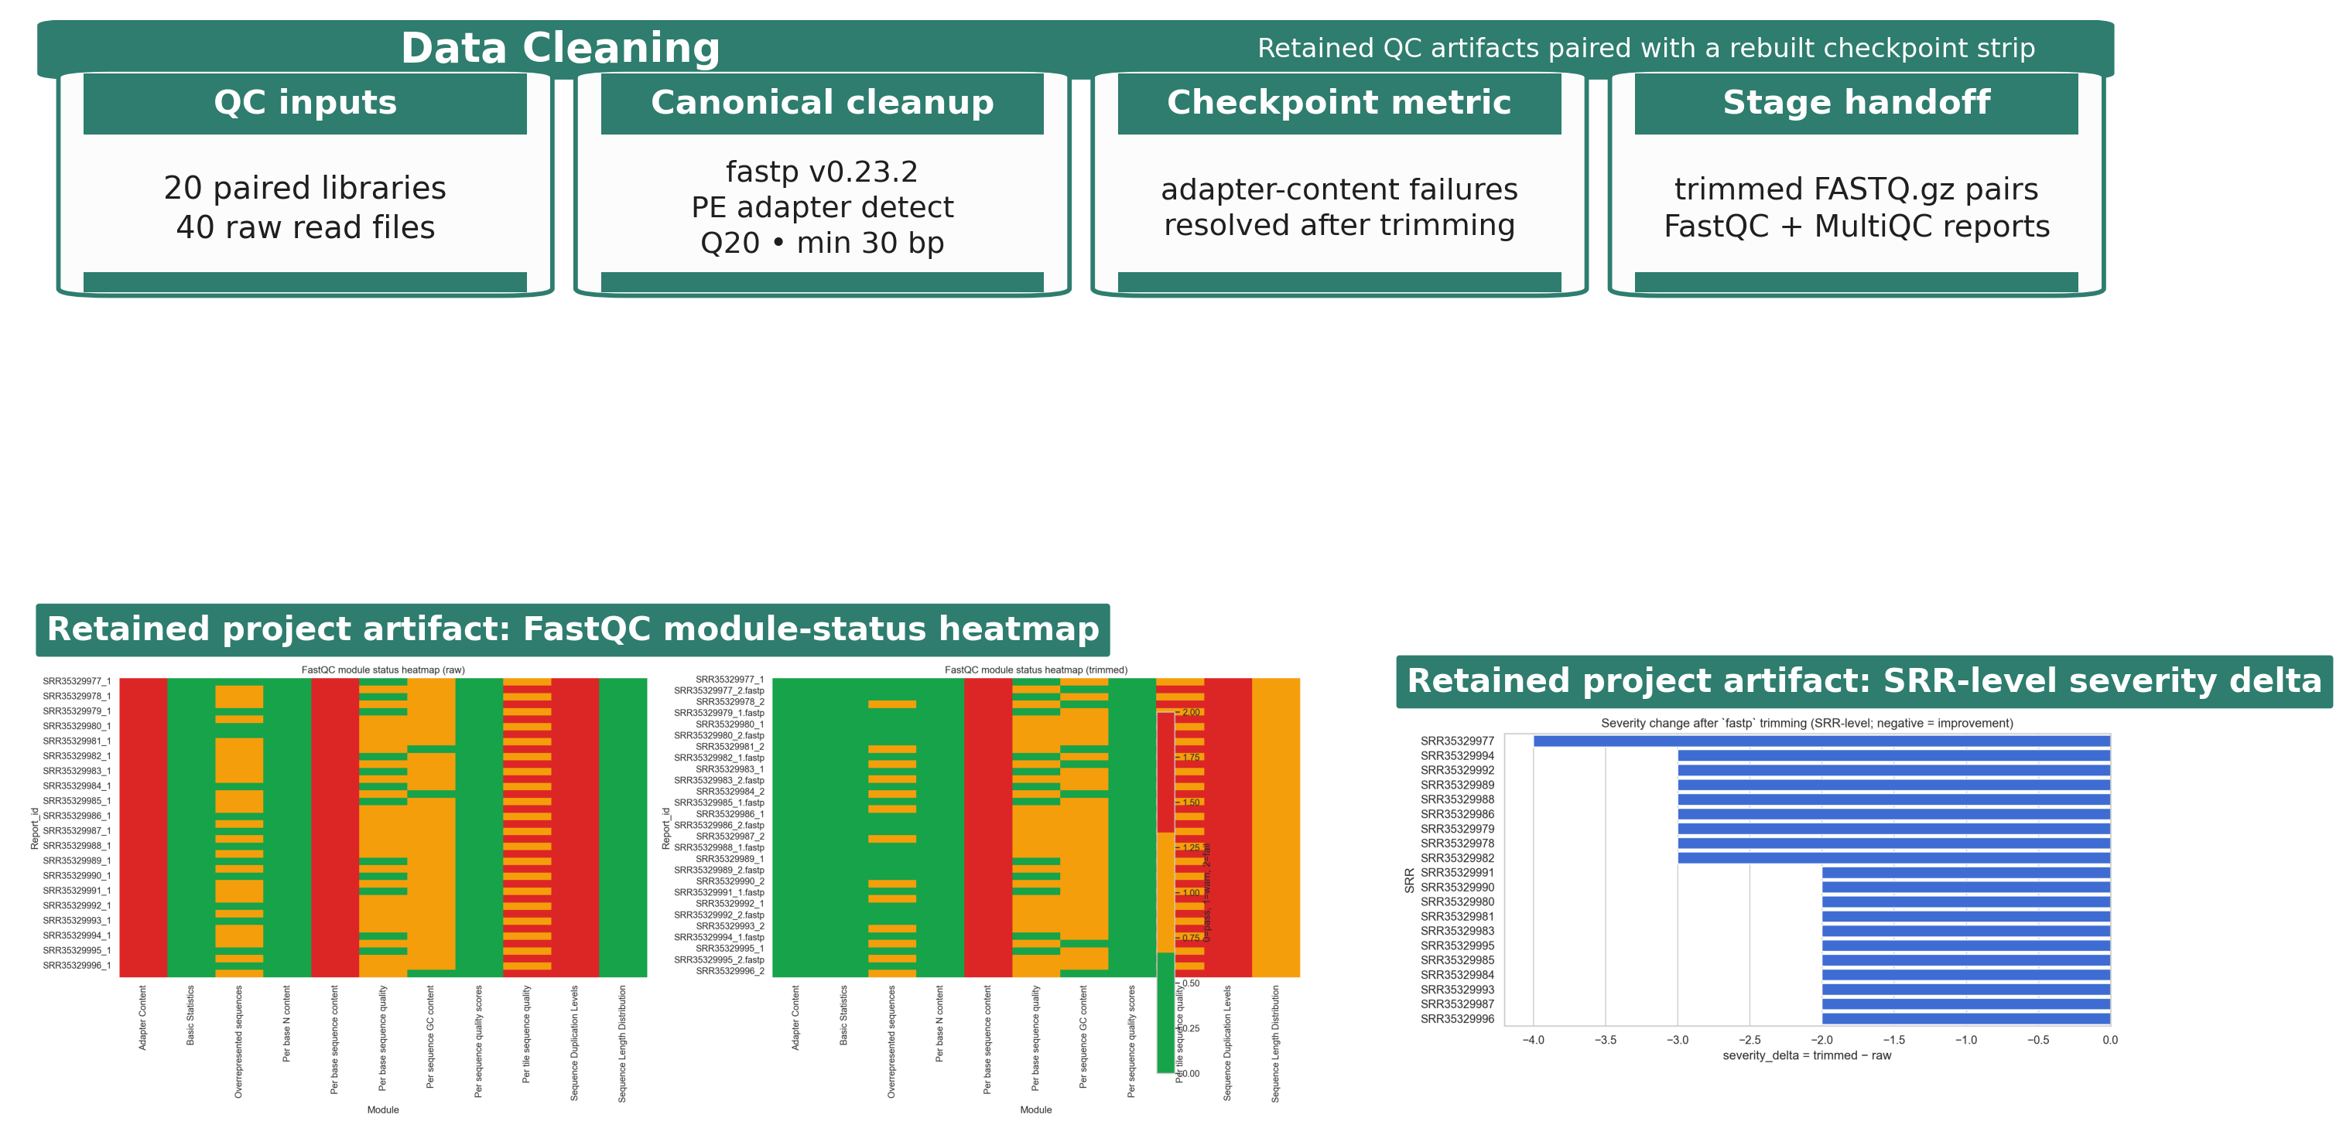
Figure 3. Data Cleaning stage figure using retained QC artifacts and a rebuilt checkpoint strip.
Table 3. Data Cleaning stage table.
Substage | Input | Tool | Checkpoint artifact / evidence | Why it mattered
Raw QC | raw paired-end reads | FastQC + MultiQC | raw module-status heatmap and cohort QC summary; adapter-content failures across all 40 raw read files | establishes the baseline quality state before trimming
Read trimming | raw FASTQ.gz pairs | fastp v0.23.2 | trimmed read pairs per-sample HTML/JSON reports; PE adapter detect, Q20 cutoff, min length 30 bp, poly-G trimming | standardizes cleanup across all retained libraries
Post-trim checkpoint | trimmed read pairs | FastQC + MultiQC | saved SRR-level severity summary; all retained severity deltas shifted negative after trimming | justifies using the cleaned reads, not the raw reads, for alignment

Data Preparation: Reference Selection and Alignment
Trimmed read pairs were aligned to the Mus musculus GRCm39 primary assembly with the matching Ensembl release 115 annotation. The reference pair used in the local workflow consisted of Mus_musculus.GRCm39.dna.primary_assembly.fa and Mus_musculus.GRCm39.115.gtf. A STAR genome index was generated with sjdbOverhang = 150 to match the 151-bp paired-end reads. Alignment was performed with STAR using gzip-aware input handling, coordinate-sorted BAM output, and GeneCounts so that the same run also produced per-sample count tables.
This stage linked cleaned reads to downstream modeling. For each sample, the workflow retained three key outputs: a coordinate-sorted BAM file, a STAR Log.final.out summary, and a ReadsPerGene.out.tab count table. These outputs provided both the alignment checkpoint and the count-level handoff used to assemble the final family matrix for the DRG subset.
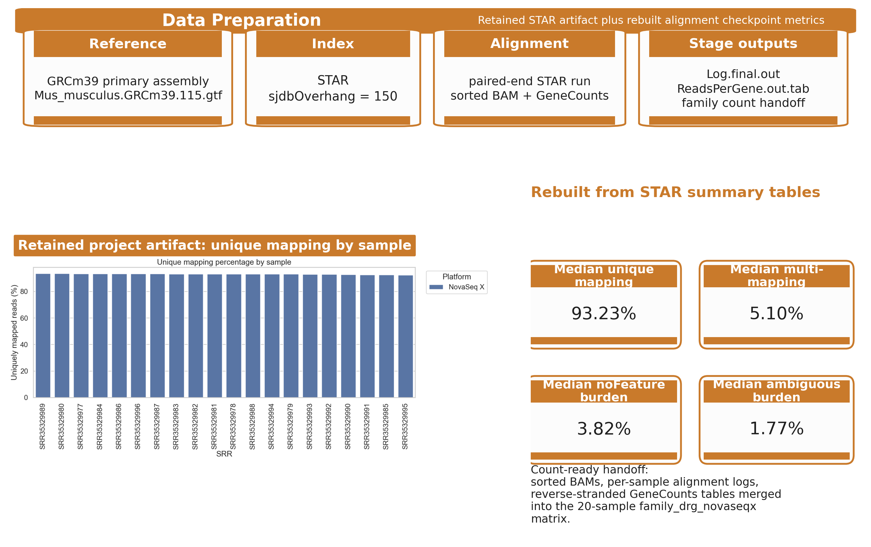
Figure 4. Data Preparation stage figure built from retained STAR outputs and rebuilt alignment checkpoint metrics.
Table 4. Data Preparation stage table.
Substage | Input | Tool | Checkpoint artifact / evidence | Why it mattered
Reference choice | mouse genome + annotation | Ensembl reference selection | reference FASTA/GTF pair for GRCm39 primary assembly + Ensembl v115 annotation | locks the coordinate system used by STAR and downstream counts
stageprepSTAR index \ | run | trimmed read pairs + reference | STAR | sorted BAM, Log.final.out, and ReadsPerGene.out.tab; sjdbOverhang = 150 and paired-end alignment/counting in one run | produces the alignment checkpoint and the count-ready artifacts in one run
Alignment checkpoint | saved STAR summaries | local alignment review | retained unique-mapping plot plus the STAR median summary table; unique 93.23%, multi 5.10%, noFeature 3.82%, ambiguous 1.77% | confirms the cleaned reads mapped well enough to move into DESeq2
Count handoff | per-sample count outputs | local merge scripts / notebooks | family-level count matrix for family_drg_novaseqx; 20 samples retained in the final family matrix | converts per-sample STAR outputs into the DE-ready family matrix

Data Analysis and Interpretation: Differential Expression and Functional Analysis
The merged family count matrix was analyzed with DESeq2 using the explicit side-by-genotype design carried forward from the sample manifest. Before modeling, low-support genes were filtered, reducing the tested set from 78,334 genes to 21,481 while retaining all 20 DRG samples. Five contrasts were then evaluated: ipsi_vs_contra_in_ff, ipsi_vs_contra_in_cre, geno_in_contra, geno_in_ipsi, and interaction. PCA, MA plots, volcano plots, and heatmaps were generated at this stage, but those figures are reserved for the Results section.
To avoid reducing very large DE outputs to unstructured gene lists, the workflow applied a bend-point rule to the ordered adjusted-p-value curve for each contrast. These bend-point-derived follow-up sets were therefore reported alongside the padj < 0.05 results rather than treated as interchangeable with them. For the two primary side-specific contrasts, this step retained 709 and 870 genes, respectively. The resulting follow-up sets were then submitted to g:Profiler using GO Biological Process, KEGG, and Reactome layers. In this Methods framing, the enrichment outputs are treated as downstream products of the analysis workflow rather than as final biological claims.
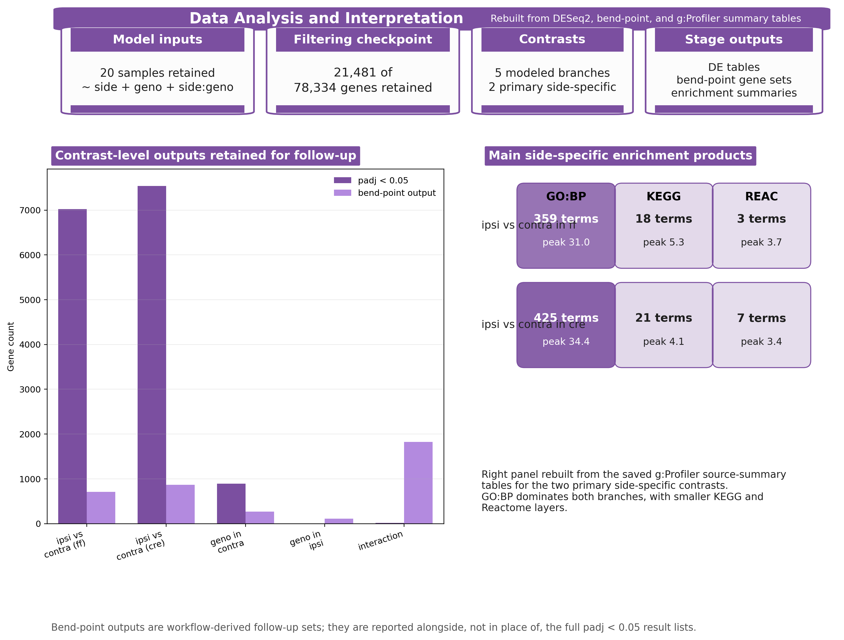
Figure 5. Rebuilt Data Analysis and Interpretation stage figure derived from saved DESeq2
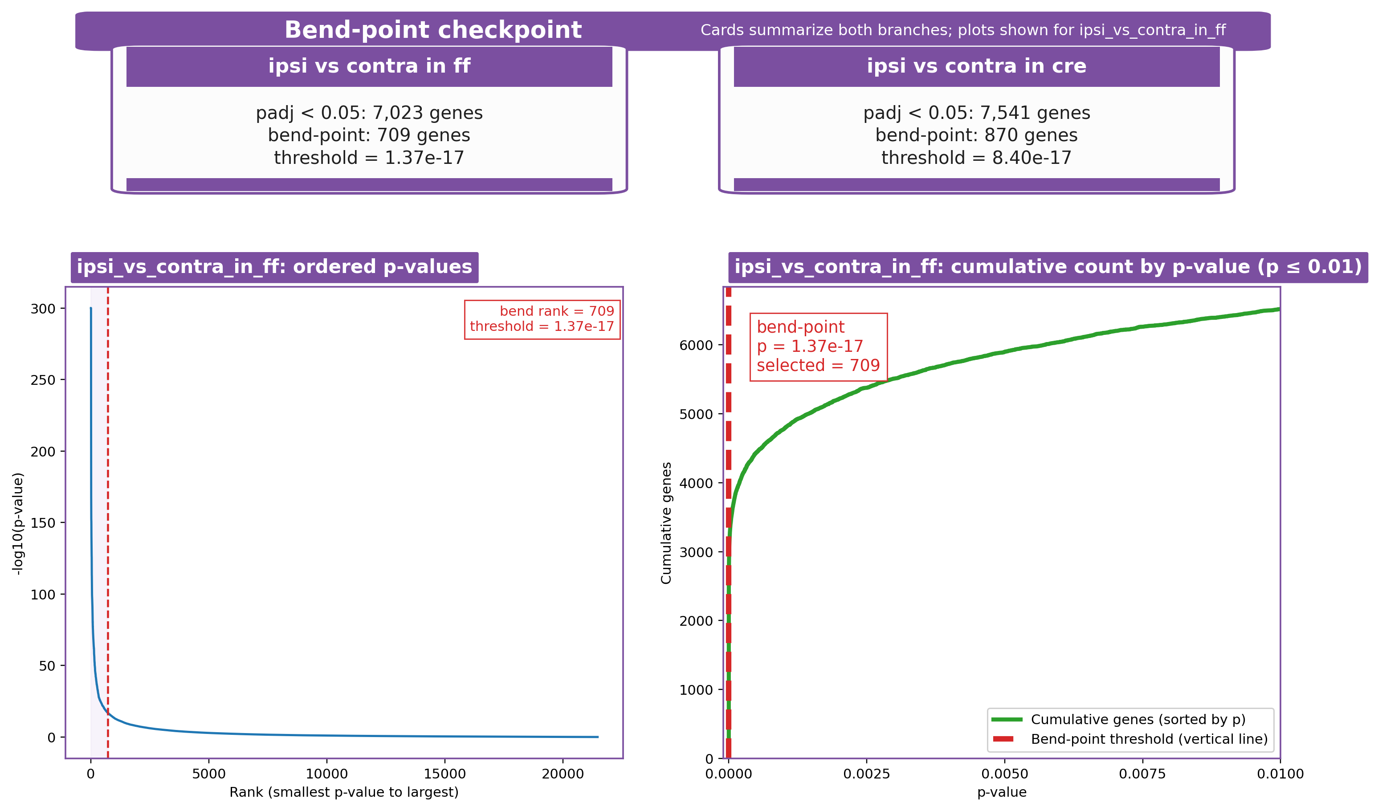
Figure 6. Retained bend-point checkpoint summary for the two primary side-specific branches (cards). The ordered p-value and cumulative-count plots are shown for the ipsi_vs_contra_in_ff
Table 5. Data Analysis and Interpretation workflow table.
Substage | Input | Tool | Checkpoint artifact / evidence | Why it mattered
Model setup | family count matrix + design table | DESeq2 | normalized counts, VST matrix, and contrast-level result tables; 20 samples retained and 78,334 -> 21,481 genes after filtering | defines the inferential base for every contrast and downstream plot
Contrast production | filtered model outputs | DESeq2 contrast manifest | five saved contrast branches; two primary side-specific and three supporting genotype / interaction branches | keeps the main and supporting stories explicit before list narrowing
Bend-point selection | ordered adjusted-p tables | local bend-point scripts | analysis-summary and per-contrast bend-point summary tables; primary side-specific follow-up sets of 709 genes in ff and 870 genes in cre | turns very large DE lists into smaller reproducible follow-up sets
Enrichment layer | bend-point-selected gene sets | g:Profiler | g:Profiler source-summary and enrichment tables; the main ff branch retained 359 GO:BP, 18 KEGG, and 3 Reactome terms | captures the terminal functional-summary products without replacing the gene-level story

Table 6. Primary side-specific follow-up summary carried out during the Data Analysis stage.
Branch | padj < 0.05 genes | Bend-point genes | Threshold | GO:BP | KEGG | REAC
ff side branch | 7,023 | 709 | 1.37e-17 | 359 | 18 | 3
cre side branch | 7,541 | 870 | 8.40e-17 | 425 | 21 | 7

