Invisible Invaders: July 15 Meeting Commitment Pack
Team: Piter Garcia and Aastha
Immediate purpose: Give us a clean, reviewable starting point for the opening experience, revised phenomenon, gapless explanation, four agreed checklist ideas, and youth advocacy choices.
Editable team document: 02 - Invisible Invaders July 15 Meeting Commitment Pack
What we agreed on: We replaced the tire-based phenomenon with “Humans aren’t trash cans, but we have plastics in our bodies.” This is now the focus of our lesson. The earlier tire discussion belongs to the old brainstorm; it is not our anchoring phenomenon or a required activity. We will give campers enough evidence, structure, and accessible choices to explain how plastics can reach human bodies and propose an action they can defend.
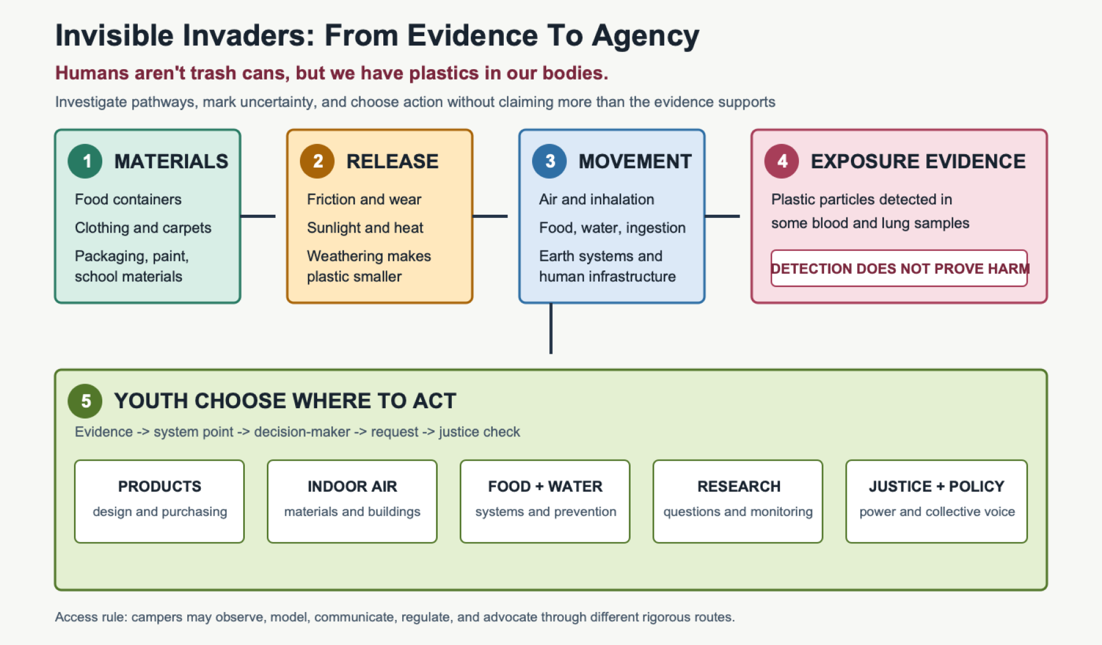
A five-step pathway from everyday plastic through release, movement, and exposure evidence to several youth-selected action routes
Open the full-size editable visual. Color is paired with numbered steps, labels, arrows, and shapes so it is never the only source of meaning.

1. What I Committed To Prepare
My commitment | Completed here | Team decision still needed
Clean up the old plan and create a less busy template | This document begins with the decisions, then moves through moment, checklist, explanation, and advocacy | Confirm what is ready to paste into the team’s official plan
Brainstorm feasible opening moments | Four choices are below, with one recommended launch written in detail | Choose one moment and assign facilitator roles
Use the four checklist ideas selected together | Each idea now has a precise Invisible Invaders meaning and lesson evidence | Confirm the wording with April if the course examples must remain verbatim
Revise the gapless explanation for the new phenomenon | A complete five-part causal explanation and 60-second version are below | Review how the evidence will be introduced without creating fear or overstating health effects
Make advocacy inclusive rather than limiting campers to water cleanup | Five evidence-based action pathways are provided | Campers choose, adapt, combine, or challenge the options
Keep the work empowering and accessible | Multiple ways to observe, model, communicate, regulate, and act are built into the routine | Confirm camper needs, site constraints, and available staff

2. Revised Phenomenon And Driving Question

Headline
Humans aren’t trash cans, but we have plastics in our bodies.

Anchoring phenomenon
Humans aren’t trash cans, but we have plastics in our bodies.
This is the phenomenon Piter and Aastha selected during the meeting. The science explanation underneath it must stay precise: the blood study examined 22 volunteers, and the lung study examined 13 tissue samples. These studies show plastic-particle detection in sampled human blood and lung tissue; they do not establish that every person has the same particles, identify every pathway into the body, or prove a particular health outcome.

Driving question
How can plastic from everyday materials become small enough to move through connected systems and reach living bodies, and what changes could reduce those pathways fairly?

Evidence boundary displayed beside the question
Detected does not mean proven harmful. The FDA reports that microplastics have been found in human samples, but major questions about health effects and measurement remain. Our campers can investigate sources, pathways, evidence, systems, and possible prevention without being told that a particular disease has been proven. FDA: evidence and remaining uncertainty

3. Recommended Opening Moment

The Evidence Pathway Mystery: 40-45 Minutes
This keeps the mystery structure from the team’s Friday - Anchoring Phenomenon Routine, but it does not stage litter, identify untested particles as plastic, use fear about bodies, or require anyone to touch an unknown sample.

Before campers arrive
- Post a five-part visual agenda: Notice -> Connect -> Model -> Question -> Choose.
- Prepare one image-and-object evidence set per group: synthetic clothing label, food or drink packaging, classroom plastic, paint or household-material photograph, indoor-dust photograph, water or food-pathway photograph, and a human silhouette.
- Prepare two short research cards: plastic detected in a small blood study and plastic detected in a small lung-tissue study. Put the evidence-limit card beside them.
- Provide movable arrows and pathway words: friction, weathering, air, water, food, shoes/clothing, runoff, infrastructure, inhale, ingest, uncertain.
- Offer paper, magnetic, digital, spoken, audio, partner-supported, and home-language modeling routes.

Step 1 - Notice without a forced performance: 6 minutes
Each camper chooses an evidence card or object they are willing to examine. They can write, draw, point, dictate, speak, or quietly place a notice and a question beside it. We do not hide the purpose from students or tell them a sample is confirmed plastic when it is not.

Step 2 - Reveal the research evidence and its limit: 7 minutes
Place the blood and lung evidence cards on the human silhouette. Say: “These studies detected plastic particles in some human samples. They do not tell us that every person has the same exposure, where each particle came from, or what health effect it caused.” Campers mark what the evidence supports, what it does not support, and what they now wonder.

Step 3 - Build a first pathway model: 12 minutes
Campers choose one everyday plastic-containing material and make a before -> during -> after model showing how a larger material might release particles, how particles might move through connected systems, and how inhalation or ingestion could lead to exposure. The model may include more than one route and may end with unknown where the evidence does not establish a connection.

Step 4 - Build the question board: 8 minutes
Sort questions under five image-and-text headings: sources, becoming small, movement, living bodies, systems and action. Keep camper wording visible. Questions about health are recorded honestly and marked for trusted-source research rather than answered through speculation.

Step 5 - End with agency, not fear: 7-10 minutes
Show the five advocacy pathways without asking campers to choose yet. Ask: “Which part of this system would you want the power to investigate or change, and what evidence would you need?” Campers place a removable marker or private response; they may change it as the week develops.

Other Feasible Moments
Moment | Shared experience | Strength | Boundary
What did researchers find? | Reveal a human silhouette with blood- and lung-study evidence cards, then separate what the studies show from what remains unknown | Begins directly with the selected human-body phenomenon | Preview body content and provide an equivalent environment-only evidence route
Invisible but detectable | Use an image-led size ladder from visible plastic to micro- and nanoscale particles, followed by the human-sample evidence | Makes scale and invisibility concrete without claiming campers can see body particles themselves | Distinguish a scale model from actual laboratory detection
One material, many routes | Give groups clothing, packaging, paint, food-container, or school-material cards and let them build competing routes toward air, food, water, and possible exposure | Invites several experiences and identities instead of prescribing one source | Do not imply all materials or routes create equal exposure
Evidence pathway mystery | Connect everyday materials to movement routes and carefully limited human-sample evidence | Best match for the selected phenomenon and youth advocacy choice | Use calm language, content preview, evidence limits, and a non-body-focused route

4. The Four Checklist Ideas We Selected
These are the four course ideas selected in the team document after the meeting. Each one is translated into a causal idea campers can actually place on their model.
Course checklist idea | Invisible Invaders meaning | Evidence or activity that develops it
Earth systems are interconnected. | Plastic moves among products, buildings, roads, air, water, soil, organisms, and waste systems. A pathway may cross several systems before anyone detects a particle. | Life-cycle/pathway card model; indoor/outdoor comparison; before/during/after model
Water transports materials. | Rain, runoff, wastewater, rivers, and distribution systems can move plastic fragments and fibers away from their sources. Water is one possible environmental and exposure pathway, but it is not the only route into human bodies. | Water-pathway model; watershed tracing; food-and-water evidence cards; WHO drinking-water evidence review
Living organisms respond to environmental conditions. | Organisms interact with materials in their surroundings through processes such as ingestion and inhalation. Detecting a particle documents interaction or possible exposure; it does not automatically establish harm. | Human-sample evidence cards; wildlife-source cards; evidence-limit sort
Human infrastructure influences natural systems. | Product design, purchasing, roads, traffic, buildings, ventilation, drains, wastewater, waste collection, and green infrastructure can increase, redirect, capture, or prevent particle movement. | School and neighborhood system map; stormwater model; decision-maker and power map

How the checklist operates
After every activity, campers answer five short prompts:
- What did we do or examine?
- What did we observe?
- Why might it have happened?
- Which checklist idea does this evidence support, complicate, or leave unanswered?
- What do we add, change, question, or remove from our model?

5. Revised Gapless Explanation

1. Everyday materials can release persistent particles
Plastics are used in clothing, packaging, paint, furniture, food and drink containers, school materials, and many other products. Friction, washing, sunlight, heat, oxygen, and weathering can weaken these materials and separate small fragments or fibers. Becoming smaller is not the same as disappearing; particles under 5 millimeters are commonly called microplastics. NOAA: plastic fragmentation and persistence

2. Connected Earth systems move particles away from their sources
Once released, particles may enter dust, air, soil, runoff, wastewater, rivers, lakes, or food webs. Wind, ventilation, human movement, rain, and flowing water can transport particles, while gravity and contact can deposit them elsewhere. This is why the product, the place where a particle is released, and the place where it is eventually detected may be different.

3. People can encounter particles through more than one pathway
Particles present in air may be inhaled, while particles present in food or water may be ingested. These routes connect the four checklist ideas: Earth systems move materials, water transports some of them, living organisms encounter their environments, and human infrastructure changes where particles travel. The evidence does not support choosing one universal pathway for every particle found in a body, so campers should model several possible routes and mark uncertainty. WHO: microplastics in drinking water and FDA: microplastics in foods

4. Living organisms can encounter particles through environmental pathways
People and other organisms may encounter small particles through air, food, water, and contact with environments and materials. Researchers have chemically identified plastic particles in some human blood and lung-tissue samples, which supports the claim that particles can reach internal human samples. Those detections do not reveal one universal route and do not, by themselves, prove a particular health effect. Blood study, lung study, and WHO evidence review

5. Infrastructure and collective decisions can change the pathway
The amount and movement of microplastic pollution are shaped by choices made in product design, manufacturing, food and water systems, purchasing, buildings, waste systems, environmental monitoring, and public policy. Cleanup can help with larger debris, but very small particles are difficult to remove after release, so prevention and system redesign both matter. No single camper or family controls the whole system; meaningful action can target decision-makers who control products, school materials, food and water systems, research, monitoring, or policy. NOAA prevention and removal overview

60-second version
Plastic in everyday products can become smaller through friction and weathering without disappearing. Because Earth systems are connected, particles can move through air, water, soil, buildings, infrastructure, food webs, and human activity before settling or being encountered by living organisms. Researchers have detected plastic particles in some human samples, but detection does not prove a particular health effect or identify one universal source. Product design, purchasing, transportation, stormwater, buildings, waste systems, monitoring, and policy can all change parts of the pathway, so campers need evidence and several possible routes for action.

6. Inclusive Advocacy Choice Studio
Campers do not receive a predetermined solution. We teach how to match evidence -> system point -> decision-maker -> request -> justice check, then let youth choose or create the direction.
Possible pathway | Question campers can investigate | Possible real audience | Feasible advocacy product
Products and purchasing | Which school or camp purchases create avoidable plastic release or waste, and what accessible alternative would work? | School administrator, purchasing office, cafeteria, camp director | Illustrated purchasing recommendation, comparison chart, or short meeting request
Indoor air and school materials | Which materials or practices may contribute particles indoors, and what evidence would be needed before recommending change? | Principal, facilities team, custodial team, purchasing office | Material audit, cleaning or ventilation questions, purchasing recommendation, or monitoring plan
Food and water systems | Where could plastic enter food or water pathways, and which institutions have the power to prevent or monitor it? | Cafeteria, water authority, public-health office, food supplier | Evidence request, container comparison, monitoring question, or prevention proposal
Community research and monitoring | What evidence is missing, whose environments and bodies are studied, and whose questions guide the research? | Community organization, local scientist, university lab, public-health department | Youth-designed research question, interview, monitoring request, or community data story
Policy and environmental justice | Who experiences more exposure or less protection, and what system-level change would be fair? | School board, elected official, agency, public audience | Public comment, illustrated policy request, audio message, exhibit, or advocacy art

Justice check before youth finalize an action
- Does our evidence support the request?
- Who has the authority and resources to act?
- Who benefits, who bears exposure or cleanup labor, and whose knowledge counts?
- Would the proposal create cost, time, health, language, mobility, or sensory barriers for people with fewer choices?
- Does the action preserve more than one way to participate and communicate?
- Are we promising more than the science can establish?

Bioplastics caution
Learning about new materials is appropriate; presenting biodegradable as an automatic solution is not. NOAA explains that many bio-based, biodegradable, or compostable plastics require industrial conditions and may persist in soil or marine environments. Campers can evaluate a material claim by asking where, under what conditions, how quickly, into what products, and who controls the disposal system? NOAA: biodegradable-plastic evidence limit

7. Access Is Part Of The Lesson Mechanism
- Body-topic choice: Preview the human-sample evidence and provide an equivalent environment-only route for campers who do not want to engage with body imagery.
- Observation choice: Printed image, sealed object, shared camera, magnified still, or partner description.
- Modeling choice: Movable cards, drawing, writing, speech, audio, digital diagram, home language, or co-authored model.
- Energy and movement choice: Mobile investigator, seated mapper, evidence checker, timekeeper, question organizer, or quiet researcher.
- Communication choice: Live speech, partner-supported explanation, annotated image, writing, audio, video, art, or private contribution to a shared product.
- Regulation: Visible agenda, one instruction at a time, processing time, predictable transitions, sensory break, and no forced touching, tasting, smelling, or public disclosure.
Every route still asks campers to build a causal pathway, use evidence, identify uncertainty, revise a model, and justify an action.

8. Team Review Queue

Prepared by Piter for review
- Revised phenomenon and driving question
- Four feasible opening moments
- Detailed recommended opening experience
- Four selected checklist ideas connected to lesson evidence
- Revised gapless explanation
- Five advocacy pathways with real audiences
- Human-health and particle-identification evidence limits
- Neurodivergent, chronic-illness, disability, language, sensory, energy, and multiple-identity access routes
- Human-body phenomenon confirmed as the replacement for the earlier tire-based phenomenon

Piter and Aastha decide together
- Which opening moment will we use?
- Which materials and images will be prepared for each group?
- Who facilitates each step and who monitors time, access, and evidence language?
- Which advocacy audiences are realistically reachable during camp?
- What question do we want April to answer before we finalize the plan?

9. Evidence From Our Meeting
This packet responds directly to the July 15 planning conversation:
- 00:05:51-00:06:12: We changed the wording from the tire-based idea to “Humans aren’t trash cans, but we have plastics in our bodies.”
- 00:18:19-00:18:34: We recognized that the new phenomenon opens the investigation to indoor pollution and many possible plastic sources.
- 00:29:27-00:30:26: Aastha confirmed that the phenomenon was settled; I acknowledged that we could leave the tire idea and use the human-body phenomenon.
- 00:36:51-00:39:15: I agreed to move the old phenomenon aside and create a cleaner template focused on “Humans aren’t trash cans, but we have plastics in our bodies,” the checklist, class notes, and inclusion goals.
- 00:41:53-00:47:18: We selected four course checklist ideas for the lesson.
- 00:47:38-00:48:08: We named the opening moment and gapless explanation as the two immediate deliverables.
- 00:49:48-00:53:31: I committed to preserve more than one advocacy possibility so youth are not steered toward one answer, while keeping the options feasible for a short middle-school camp.
- 00:54:13-00:54:56: I agreed to brainstorm feasible moments and prepare a less busy template for us to review and clean up together.
The automatic transcript remains a protected local source because speaker labels and wording are not fully verified and the conversation includes informal team discussion.

AI Use Disclosure
I used OpenAI Codex on July 16, 2026 under my supervision and guidance to organize the commitments I made during our July 15 meeting, connect them to our course documents and transcripts, validate scientific claims with direct sources, and make the planning packet more accessible and inclusive. I, Piter Garcia, provided the team context, priorities, inclusion requirements, questions, and decisions that shaped this work. I reviewed and remain responsible for the final science, language, representation of Aastha’s contributions, and what we use or submit.

