Invisible Invaders: Current Opening Routine
Team: Piter Garcia and Aastha
Anchoring phenomenon: Humans aren’t trash cans, but we have plastics in our bodies.
Driving question: How can plastics from everyday materials become small enough to move through connected systems and reach human bodies, and what changes could reduce those pathways fairly?
This 40-45 minute Evidence Pathway Mystery replaces the earlier beach crime-scene routine. It begins with the phenomenon the team selected, protects scientific uncertainty, and ends with agency rather than fear. Campers are never asked to touch an unknown sample, disclose health information, view body imagery, or perform publicly in order to participate.
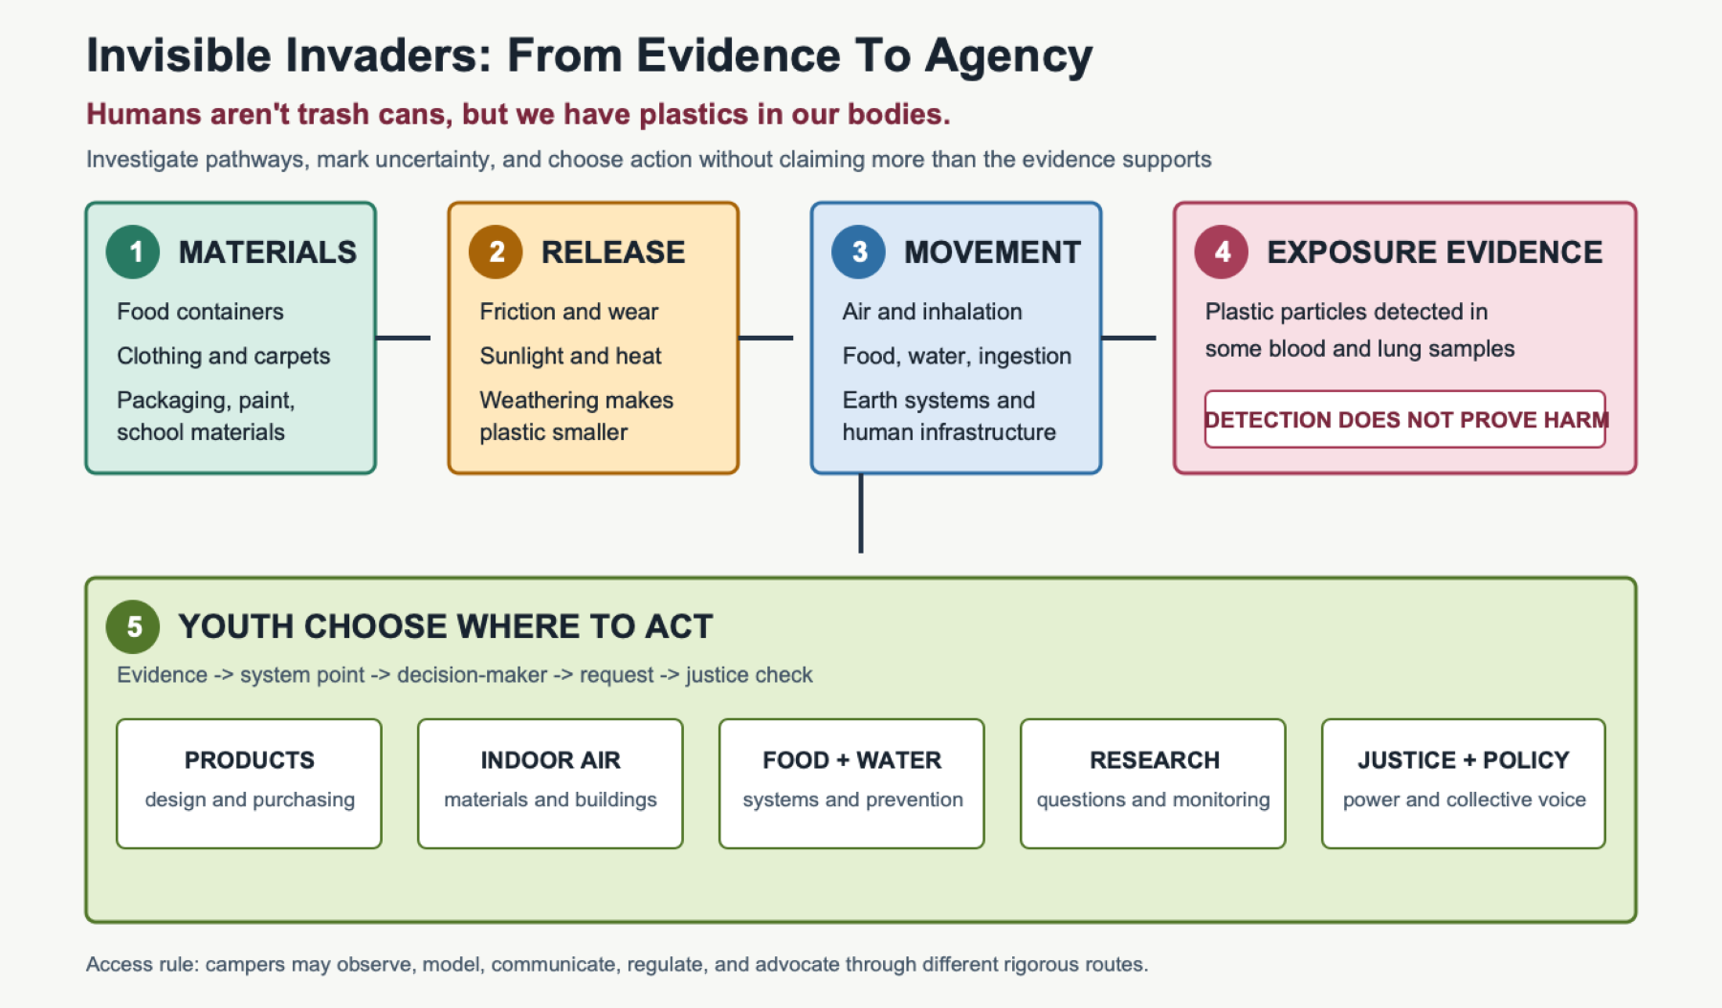
Five-step pathway from everyday materials to release, movement, limited human-sample evidence, and several youth-selected action routes
Open the full-size visual | Open the gapless explanation | Open the July 15 commitment pack

Learning Goal
By the end of the opening, campers will create an initial model that connects an everyday plastic-containing material to release, movement through connected systems, and a possible exposure route. They will distinguish what limited human-sample studies show from what those studies do not prove, record questions, and identify a part of the system they may want to investigate or change.

Evidence Boundary
Researchers detected plastic particles in blood from a study of 22 volunteers and in lung tissue from 13 surgical samples. These detections support the limited claim that plastic particles reached those sampled human fluids or tissues. They do not prove that every person has the same exposure, reveal the source or path of every particle, or establish a particular health effect. Blood study | Lung-tissue study | FDA evidence limits

Before Campers Arrive
- Post the visual agenda: Notice -> Connect -> Model -> Question -> Choose.
- Prepare one evidence set per group: synthetic-clothing label, food or drink packaging, classroom-plastic image, paint or household-material image, indoor-dust image, food/water pathway image, and a neutral human silhouette.
- Prepare two short research cards: detected in a small blood study and detected in a small lung-tissue study. Place an evidence limit card beside them.
- Prepare movable arrows and word/image cards: friction, washing, weathering, air, water, food, runoff, wastewater, infrastructure, inhale, ingest, uncertain.
- Provide paper, movable-card, drawing, digital, spoken, audio, partner-supported, and home-language modeling routes.
- Keep all physical materials clean and sealed. Do not generate particles by sanding, cutting, burning, or abrading plastic.

Step 1: Notice Without Forced Performance - 6 Minutes
Show the phenomenon and read it calmly: “Humans aren’t trash cans, but we have plastics in our bodies.” Give a content preview before displaying the human-sample cards.
Each camper chooses an evidence card or object they are willing to examine. They may write, draw, point, dictate, speak, use a partner, or quietly place one notice and one question. Do not require eye contact, rapid responses, standing, or whole-group speech.
Facilitator prompt: “What do you notice, what do you wonder, and what would we need to know before making a claim?”

Step 2: Examine The Research Evidence And Its Limits - 7 Minutes
Place the blood and lung evidence cards beside the silhouette.
Say: “Researchers detected plastic particles in some blood and lung-tissue samples. These studies do not tell us that every person has the same exposure, where each particle came from, or what health effect it caused.”
Campers sort statements under three headings:
- The evidence supports this.
- The evidence does not prove this.
- We still need to investigate this.
The equivalent non-body route uses the same source, pathway, and uncertainty cards but stops at possible encounter by a living organism. It asks for the same causal reasoning without body imagery or personal health discussion.

Step 3: Build A First Pathway Model - 12 Minutes
Campers choose one everyday plastic-containing material and create a before -> during -> after model:
- Before: What larger material or product contains plastic?
- During: What process could release a fragment or fiber, and how might air, water, food systems, buildings, or infrastructure move it?
- After: How might inhalation or ingestion create a possible exposure route, and where must the model say uncertain?
Models may contain more than one route. Campers should not be pushed to name one source as the answer when the evidence does not establish one universal source.

Step 4: Build The Question Board - 8 Minutes
Keep camper wording visible and sort questions under five image-and-text headings:
- Sources
- Becoming small
- Movement
- Living bodies and organisms
- Systems and action
Health questions are recorded for trusted-source research. Facilitators do not answer them through speculation or dramatic claims.

Step 5: End With Agency, Not Fear - 7 To 10 Minutes
Show five possible action pathways without assigning a solution:
- products and purchasing;
- indoor air and school materials;
- food and water systems;
- community research and monitoring; and
- policy and environmental justice.
Ask: “Which part of this system would you want the power to investigate or change, and what evidence would you need?”
Campers may answer publicly, privately, visually, orally, in writing, through audio, in a home language, or through a partner. They may change their choice as the investigation develops.

Use The Four Gotta-Haves
Before ending, ask groups which ideas their first model already includes and which are still missing:
- Water transports materials.
- Living organisms respond to environmental conditions.
- Earth systems are interconnected.
- Human infrastructure influences natural systems.
These statements are tools for revising the model, not vocabulary to memorize before campers can participate.

Access And Safety Check
- Body-content choice: preview the topic and provide the equivalent organism/environment route.
- Communication choice: drawing, writing, pointing, speech, audio, partner support, or home language.
- Energy and mobility choice: seated or mobile roles, breaks, and no penalty for pacing or stamina.
- Sensory choice: sealed materials, no generated dust or fumes, quiet route, and predictable transitions.
- Technology choice: printed evidence and movable cards remain available when screens, cameras, or devices do not help.
- Privacy: no diagnosis, identity, body, family, or health disclosure is required.
- Shared rigor: every route builds a causal model, uses evidence, marks uncertainty, and identifies a defensible action question.

What We Retired
The earlier collaborative routine remains linked only as a superseded source. It used crime-scene framing, deliberately unresolved anxiety, unverified particle identification, unrelated body and cloud claims, and a single-source beach prediction. The current routine uses limited direct evidence, calm language, multiple routes, and meaningful access choices.

AI Use Disclosure
I used OpenAI Codex on July 16, 2026 under my supervision to structure and format content I provided, strengthen accessibility, align it with our agreed phenomenon and checklist, and validate direct sources. I, Piter Garcia, provided, reviewed, and guided the content, inclusion priorities, team decisions, and final direction. AI supported organization, accessible formatting, source validation, and causal-gap checking. I remain responsible for the final science, language, Aastha’s contributions, and camp use.

