Invisible Invaders: A Closed Room Is Not An Empty Room
Team: Piter Garcia and Aastha
Shared working document: Invisible Invaders' Gapless Explanation
Our question: How can microplastics appear in samples from a parking lot and inside a closed classroom when we cannot see them with our eyes?
Color key: SCIENCE = what happens | EVIDENCE = how we know | ACCESS = multiple ways into the work | JUSTICE/ACTION = power and change
The labels repeat throughout the page so color is never the only cue.

The 60-Second Explanation
1. MATERIAL AND PERSISTENCE [SCIENCE]: Most everyday plastics are long chains of molecules designed to resist quick breakdown. Sunlight, oxygen, heat, and repeated friction can weaken an object and split it into smaller pieces, but becoming too small to see is not the same as disappearing. A plastic piece smaller than 5 millimeters is commonly called a microplastic. NOAA: what microplastics are and NOAA: how larger plastic fragments.
2. PARKING-LOT SOURCES [SCIENCE]: Tires grip pavement through friction, and that contact wears material from both the tire and road surface. The resulting tire-road-wear particles can collect on or near pavement, become part of road dust, move in stormwater, or be lifted with airborne dust. Litter, paint, and older plastic objects can add other fragments to the same outdoor sample. EPA: tire-wear particles and their pathways.
3. CLASSROOM SOURCES [SCIENCE]: A classroom creates particles even when its doors are closed: clothing, carpets, curtains, furniture, paint, and plastic supplies experience rubbing and wear. People and objects also carry dust through the room, while doors, windows, and ventilation have connected indoor and outdoor air over time. A closed room is therefore not a sealed or source-free room. Peer-reviewed indoor/outdoor fiber study and EPA: outdoor air enters schools.
4. AIR MOVEMENT AND SETTLING [SCIENCE]: Very small or light fibers and fragments can remain suspended for a time, travel with moving air, and be lifted again when people walk, clean, or use a fan. Gravity eventually deposits many particles onto floors, desks, dust, or an open collection surface. USGS found plastic, mostly fibers, on more than 90 percent of atmospheric-deposition filters in one study, including remote sites. USGS: It Is Raining Plastic.
5. WATER AND RETURN PATHS [SCIENCE]: Outdoors, rain can remove particles from the air and wash pavement dust toward soil, drains, streams, and lakes. Indoors, particles may settle, be vacuumed, move through ventilation, or leave on clothing and shoes; outdoor particles can enter by those same routes. The pathway is a loop with several branches, not a one-way trip from one source to one sample. EPA: tire-wear particles in air and stormwater.
6. DETECTION AND UNCERTAINTY [EVIDENCE]: Filters, clear tape, and microscopes can help campers count and describe suspected fibers or fragments by size, color, and shape. Visual evidence alone cannot prove that every particle is plastic because hair, cellulose, and other natural materials can look similar; spectroscopy is normally used to confirm polymer type. Field blanks, covered samples, clean tools, and repeated procedures help reveal contamination and uncertainty. EPA: limits of visual microscopy and NOAA laboratory methods.
7. JUSTICE AND SYSTEM CHANGE [JUSTICE/ACTION]: Traffic, school location, building condition, ventilation, work, housing, and access to monitoring shape who encounters airborne pollution and who has power to respond. A national study found school proximity to major roads was associated with race/ethnicity and socioeconomic indicators, although that study examined traffic pollution broadly rather than microplastics alone. Fair responses include safer product and tire design, less unnecessary plastic, better building and stormwater systems, transparent monitoring, and community authority over decisions. Peer-reviewed U.S. school-roadway study.

See The Whole Path
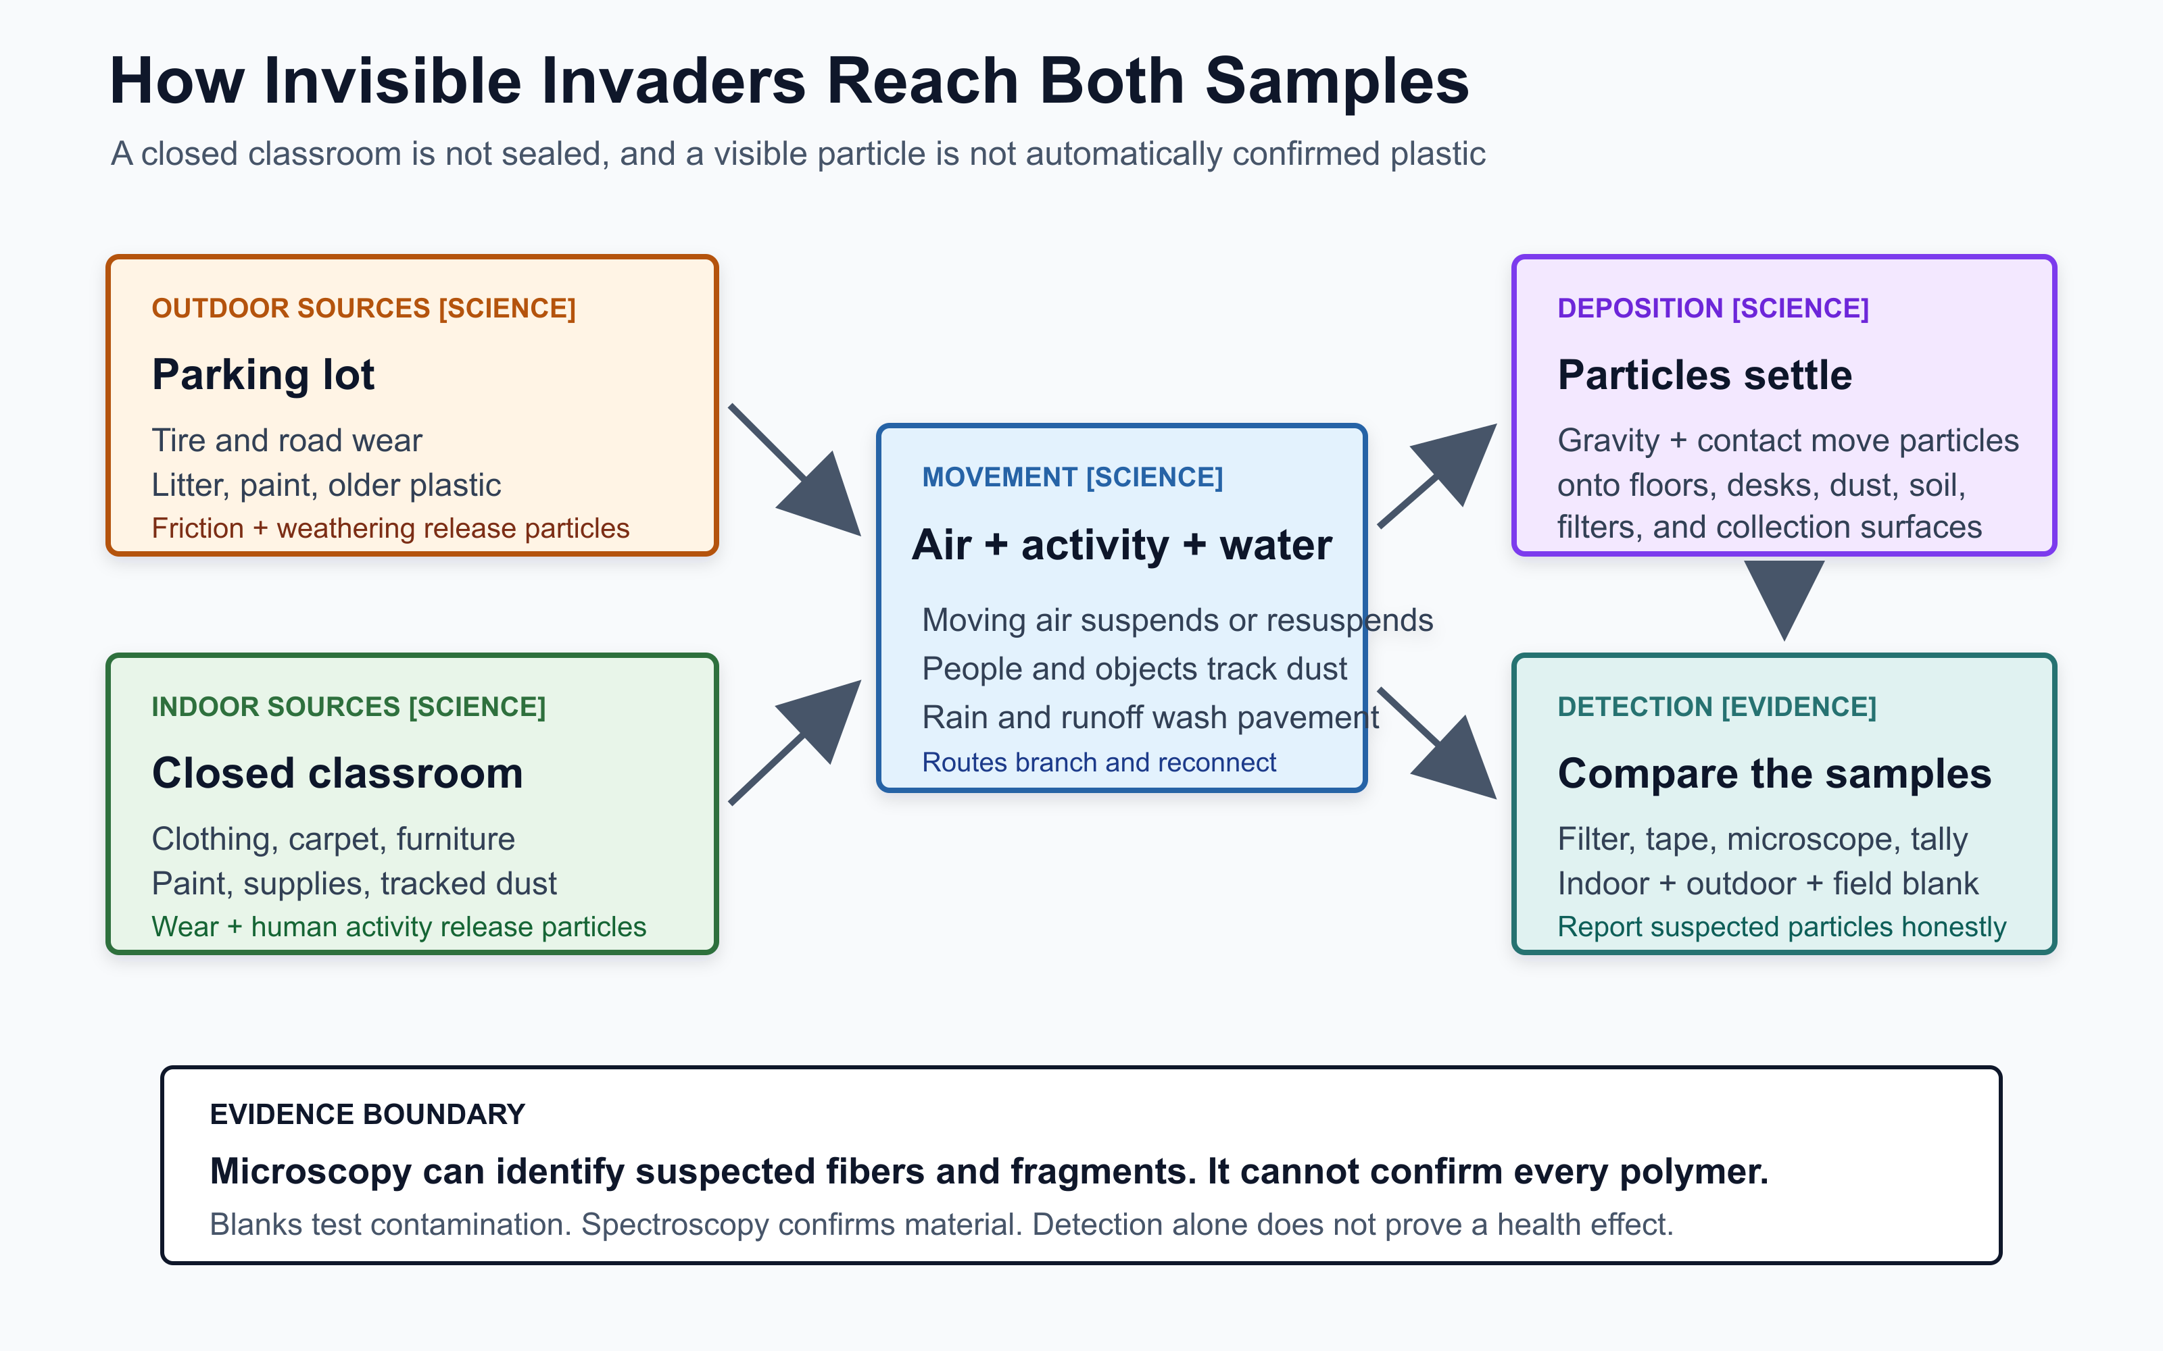
Open full-size accessible SVG
Click the image for the full-size model. Evidence base: NOAA, EPA tire research, USGS atmospheric deposition, and the indoor/outdoor fiber study.

Our Gapless Claim
Plastic does not have to be visible to remain present. Friction and weathering release small particles from outdoor and indoor materials. Air movement, human activity, rain, and runoff transport them; gravity and contact deposit them. Sampling can reveal suspected microplastics in both places, but careful controls and chemical confirmation are needed before we claim what each particle is.

What we will not claim
- Closed is not sealed: finding particles indoors does not prove they were created only inside the room.
- Visible under a microscope is not chemically confirmed: campers should report suspected microplastics unless polymer testing confirms them.
- Detected is not proven harmful: finding a particle documents possible presence or exposure, not a specific health effect. WHO reviews the remaining health uncertainties.
- Individual choice is not system change: families and young people cannot redesign tires, buildings, products, or public infrastructure by themselves.

Inclusion Changes The Design
Neurodivergent, chronically ill, disabled, multilingual, culturally diverse, and multiply identified campers should not have to tolerate pain, sensory overload, chemical exposure, public speaking, or one rigid technology in order to count as scientists. CAST UDL Guidelines 3.0 emphasizes multiple and intersecting identities, multiple media, flexible communication, accessible tools, learner choice, interdependence, and challenging exclusionary practices.
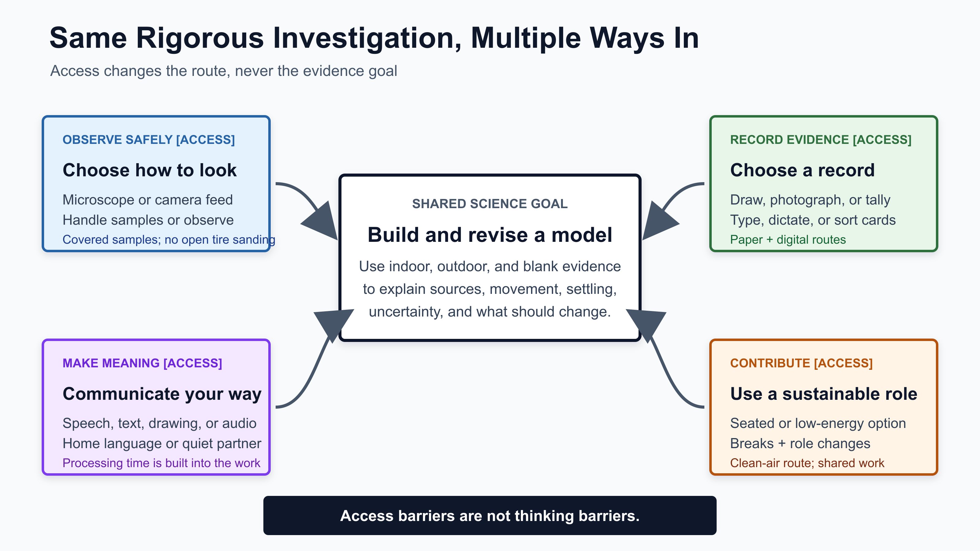
Open full-size accessible SVG
Click the image for the full-size access model. Design basis: CAST UDL Guidelines 3.0.
A barrier might hide thinking when... | We design... | The science stays rigorous because campers still...
speech, English dominance, or processing speed controls participation | speech, text, drawing, audio, home-language discussion, quiet partners, and wait time | explain a causal link, use evidence, and revise a model
pain, fatigue, mobility, asthma, or chemical sensitivity controls access | seated and low-energy roles, breaks, remote microscope viewing, covered samples, clean air, and no open tire sanding | control contamination, tally, compare, interpret, or document evidence
sensory load or working-memory demand hides the investigation sequence | a visible agenda, one-step cards, repeated vocabulary, predictable transitions, and a quiet route | follow the procedure and explain what changed in their thinking
one device becomes the gatekeeper | direct microscope viewing and a camera feed; paper tally and digital record; visual model and spoken explanation | observe, document uncertainty, compare results, and make a defensible claim

Camp Investigation Moves
1. NOTICE [EVIDENCE]: Compare the parking lot and classroom. Photograph or map possible sources before collecting anything.
2. MODEL [ACCESS]: Build a first explanation with cards, objects, drawing, speech, text, audio, or home language.
3. INVESTIGATE [EVIDENCE]: Collect paired indoor/outdoor deposition or surface samples plus a blank; label, cover, filter, observe, classify, and tally.
4. REVISE [SCIENCE]: Use source evidence to repair missing links and mark where the data support, complicate, or fail to answer the model.
5. ADVOCATE [JUSTICE/ACTION]: Create an image-led poster or plastic-art message for a real audience about a product, building, traffic, monitoring, or policy change.
This follows a gapless explanation in Ambitious Science Teaching: campers connect observable evidence to an unobservable mechanism without a "magic" jump.

Strengthening Aastha's Activity Ideas
- Banana and plastic comparison: Use the jars as a multi-day observation that raises questions about biological decomposition and plastic persistence. It does not prove that plastic never changes; it shows that the two materials visibly change at different rates under the camp conditions.
- Scale ladder: Start at 5 millimeters, then move to micrometers and nanometers with a printed scale or zoom sequence. Keep the conversion accurate: 1 millimeter = 1,000 micrometers = 1,000,000 nanometers.
- Tire-wear evidence: Do not have campers sand or aerosolize an open tire sample. Use images, an instructor-prepared sealed sample, or a fully enclosed demonstration so learners with asthma, chemical sensitivity, or other health concerns are not asked to trade safety for participation.
- Indoor/outdoor comparison: Pair each environmental sample with a blank opened only during the collection window. Keep containers covered, record location and time, and treat microscope observations as suspected particles.
- Process of science: Let the poster show the initial model, evidence, contamination controls, revised model, uncertainty, and next question, not only a polished conclusion.

Trusted Evidence Library

Science and methods
- NOAA Marine Debris Program: What Are Microplastics?
- NOAA: How Plastic Fragments
- U.S. EPA: Tire-Wear Research
- U.S. EPA: Tire-Wear Particles in Waterways
- USGS: It Is Raining Plastic
- Dris et al.: Indoor and Outdoor Fibers
- U.S. EPA: Limits of Visual Microscopy
- NOAA: Laboratory Methods for Microplastics
- WHO: Dietary and Inhalation Exposure to Microplastics

Justice, access, and learning design
- U.S. Schools Near Major Roadways: Nationwide Assessment
- U.S. EPA: Why Indoor Air Quality Matters in Schools
- CAST UDL Guidelines 3.0
- Ambitious Science Teaching: Getting Started

AI Use Disclosure
OpenAI Codex was used on July 14, 2026 under my supervision and guidance to help make this material more inclusive and accessible. I, Piter Garcia, provided, reviewed, and guided the AI-assisted additions; AI supported structuring, formatting, visual presentation, accessibility enhancements, causal-gap checks, and links to direct sources. Aastha's original phenomenon and activity ideas were preserved, strengthened, and credited rather than replaced. I reviewed the final language, evidence, safety guidance, representation of Aastha's contributions, and design, and I remain responsible for the additions I approve and for what I submit.

