Task 1 - Teacher as Learning Scientist

Requirement
Construct a prompt for AI to produce an image and characteristics as a learning scientist. After reading the syllabus, reflect on how this description aligns and presses against the role expected in EDU486. Email the picture to Zen by June 29.
Email target from announcement: zborys@warner.rochester.edu
Public image file:
- teacher-learning-scientist-evidence-map.png
- teacher-learning-scientist-evidence-map.svg
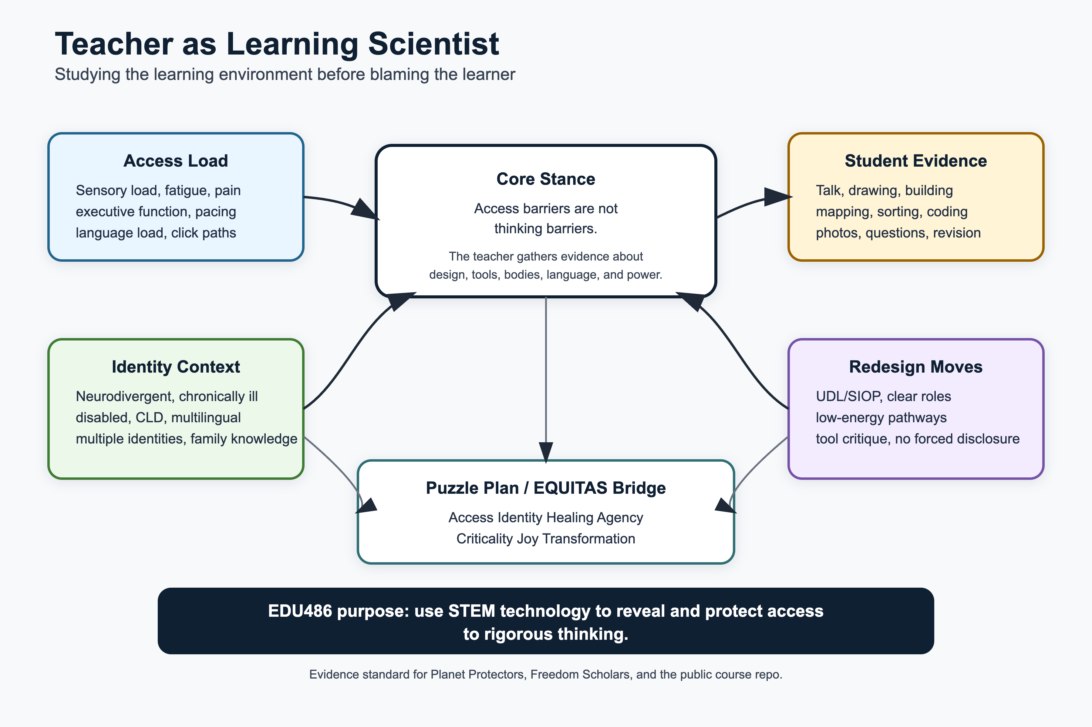
Teacher as learning scientist evidence map
Public DOCX export:
- task1-learning-scientist-prompt-reflection.docx

AI Image Prompt Used
Create a clean evidence-map visual, not a cartoon portrait. The image should represent a teacher as a learning scientist who studies the learning environment before blaming the learner. Center the claim “access barriers are not thinking barriers.” Surround it with four evidence domains: access load, identity context, student evidence, and redesign moves. Include neurodivergent, chronically ill, disabled, CLD, multilingual, and multiply marginalized learners; bodymind access; language load; sensory load; fatigue; click-path friction; multimodal evidence; UDL/SIOP; and no forced disclosure. Connect the map to Puzzle Plan / EQUITAS dimensions: Access, Identity, Healing, Agency, Criticality, Joy, and Transformation. Visual style should be rigorous, readable, public-facing, and portfolio-ready.

Learning Scientist Characteristics
- Observes before interpreting behavior as ability, motivation, or attitude.
- Treats youth questions, community knowledge, disability culture, bodymind experience, and multilingual practices as evidence.
- Designs with technology, but does not assume technology is always the best answer.
- Documents learning, participation, access, energy, sensory load, language load, and motivation.
- Separates access barriers from thinking barriers.
- Revises plans based on what students actually do, say, build, avoid, mask, ask for, and need.
- Notices whose knowledge is centered, whose is missing, whose body is assumed, and who has access to participate.
- Uses science and technology for agency, action, and repair, not only for classroom performance.

Reflection
This evidence-map image aligns with the role I expect in EDU486 because the syllabus frames teachers as people who study the impact of their choices on student learning, participation, and motivation. The course is not just about using tools in STEM. It asks us to work with Freedom Scholars, learn from community and place, design camp experiences, revise based on youth feedback, and communicate what we learned as learning scientists.
The image also presses against a simpler version of teaching where the teacher is mainly a deliverer of content. In this class, the teacher has to be a listener, designer, observer, facilitator, access researcher, and critic of technology. That matters because my course throughline is not generic STEM engagement. It is EQUITAS Access-to-Agency STEM for neurodivergent, chronically ill, disabled, CLD, multilingual, and multiply marginalized learners. A learning scientist has to notice when a student is blocked by a click-path, a noisy station, a language demand, a fatigue pattern, a social expectation, or an assessment format, and then ask what the environment is revealing.
This connects directly to my Puzzle Plan and PhD goals around diagnostic justice, inclusive AI, and equitable learning systems. A learning scientist cannot hide behind a polished lesson plan. If the tool adds barriers, if the activity requires students to perform identity or disclose private needs, if the pacing assumes one energy level, or if the data misses what matters, I have to notice that and change the design.
My commitment for this course is to treat technology as a design material, not a default solution. I want to document what students are able to notice, build, explain, question, and revise when the learning environment gives them real agency, access, bodymind safety, and multiple ways to show rigorous thinking.

Email Draft
Subject: EDU486 Learning Scientist Image - Piter Garcia
Hi Zen,
I am sending my image for the “teacher as learning scientist” prompt. I represented the teacher as an evidence-map thinker: someone who studies access load, identity context, student evidence, and redesign moves before interpreting student difficulty as inability.
My main characteristics for a learning scientist are: observing before interpreting, treating youth/community knowledge and disability/identity knowledge as evidence, using technology critically, documenting access and participation, separating access barriers from thinking barriers, and revising instruction based on what students actually do and say.
Best, Piter

AI Use Disclosure
OpenAI Codex was used on July 1, 2026 to rebuild the image prompt, create the evidence-map SVG/PNG, and revise the reflection around the Puzzle Plan / EQUITAS foundation.

