Class 4: The Cultural ___________ Pedegogies
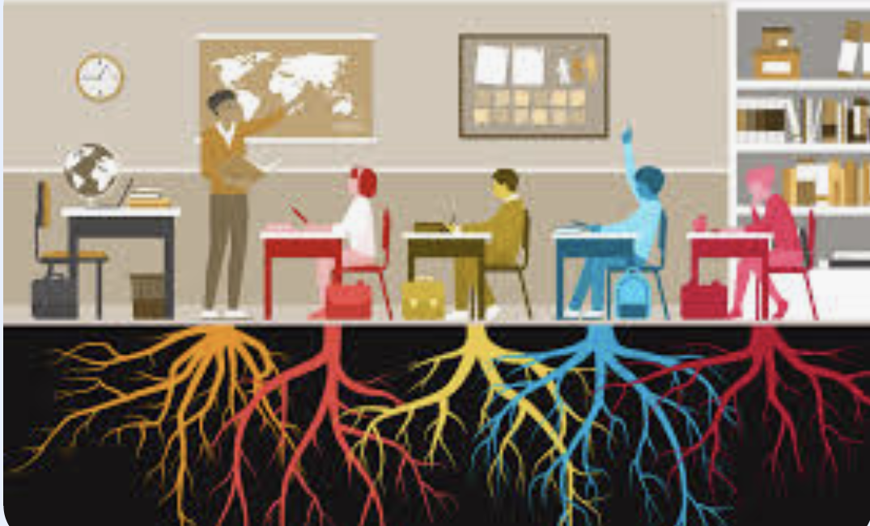
Tuesday Recap
&
A note about AI usage

498 Non-Negotiables: Our Collective Agreement for Online Etiquette
For detailed description of each agreements click here
- Remember that everyone has been through their own challenges, and that emotion/passion is not the same as weakness/irrationality. Be considerate of others and understand that they are trying to engage with you and your culture, so you should respectfully attempt to do the same. *Staying committed to shared understanding
- Engage constructively with others online as you would with people in person; with respect, kindness, and empathy.
- Use technology meaningfully and responsibly, ensuring that you are aware of the strengths and limitations of your digital resources.
- Value the other person's contributions online by considering time and be as respectful as you would in real life interactions.
- Ensure your face is in full frame and that you do not have any distracting backgrounds or visual effects enabled. Be present to the fullest extent possible, as though you were in an in-person setting.
- Make contributions with informed foundations from depth of practice and research and participate with critical thinking. It’s okay to be unfamiliar with a topic; that’s the point of learning, continue leverage cultural resources in the community
- Accept that disagreements and discomfort will occur, and advocate for open and respectful communication. Experiencing discomfort and conflict helps us to grow as learners.
- Respect other people's privacy and do not share personal information that others shared during the class. Focus on the lesson, not the story
- Be mindful of your own privilege and power; do not weaponize it but use it to uplift others by listening, respecting differences of opinion (as they TOO can be right) and make space for everyone to contribute.
- Approach the mistakes, yours and your peers, with empathy and openness; to be human is to make mistakes. Recognize in these moments opportunities for growth, deeper understanding of ourselves, our community and the topics we are tackling.

Class Objectives:
Explore and Reflect on Culturally-Historically Responsive Literacies (CHRL): We will collectively engage with readings on culturally responsive pedagogy, critically reflect on our own linguistic and literacy histories, and explore how these histories shape our teaching practices and perspectives on literacy.
Design and Create Disruptive Literacy Practices: In groups we will collaboratively design and present a digital slogan, call to action, or pedagogy that challenges traditional literacy instruction, incorporating concepts from the readings.
Analyze Science and Mathematics Through Social, Cultural, Historical, and Power Lenses: We will analyze how science and mathematical literacy are shaped by social, cultural, historical, and power dynamics by synthesizing key ideas from a text or video, identifying contextual influences on knowledge and learning, and explaining why attending to learners’ lived experiences is essential for meaningful participation in science and mathematics.

Healing-Centered Wellness Check-in
What part of yourself has been growing, healing, or changing recently, even if others cannot yet see it?

Freewrite & Group Discussion
(Take 5 to freewrite)
How was literacy and language cultivated historically with your family/ancestors? (see Muhammad, 2020, p. 51) How do you want to simulate this for students in your classroom?
What thoughts are circulating in terms of what counts as literacy?

Class Activity 2: Redefining Norms by Leveraging our Readings
- Create a group name. Be creative!
  - Your group name should reflect your ideas or goals related to literacy disruption.
- Select three quotes from this week’s texts that resonate with your views on literacy (feel free to go back to your posts on Harmonize too)
- Use these quotes to design a digital slogan, call to action, demand, or pedagogy that challenges the status quo of traditional literacy learning in schools.
- Reflect on why this literacy practice matters and how it can transform current educational approaches based on at least one of the discussion board prompts below:

Discussion Board prompts:

How can culturally Sustaining Pedagogy be a “sustainable” practice in light of funding cuts across the nation and bills like Arizona House Bill 2281 (HB2281) among others?

How can we leverage the concepts found in Perspectives of Children From Refugee Backgrounds on Their Family Storytelling as a Culturally Sustaining Practice, how can teachers realistically do this work even if their classroom is not very diverse or when they don’t have direct access to families from the cultural backgrounds they are trying to represent

Drawing from Paris and alim (2014) foundational writing on CSP, how do we value all students’ languages rather than choosing some over others?

Group Name and members: | Quote | Digital slogan, call to action, demand, or pedagogy | How can it transform current educational approaches?
EXAMPLE  (The Joy Seekers) | “I have decided to live a life of excavation.” - Yolanda Sealey-Ruiz, Truth, Love, and Racial Literacy  “I have never encountered any children in any group who are not geniuses. There is no mystery on how to teach them. The first thing you do is treat them as human beings and the second thing you do is love them”  “Culturally sustaining pedagogy (CSP) seeks to perpetuate and foster and sustain… as a needed response to demographic and social change” (Paris, 2014) | Excavate, self-reflect, and put joy at the center, to keep the change in motion. | Being the model for transformation, fueled by honest reflection and joy, cultivates instruction that produces a cycle of powerful learning experiences between students and their teachers.
Group 1
Group 2
Group 3

Asynchronous Activity 1
Journal : Unearthing What We've Learned: A Reflective Excavation of Racial Belief
Resources: Truth, Love, & Racial Literacy | Yolanda Sealey-Ruiz ( refresh your memory if needed)
Racial Literacy Model: 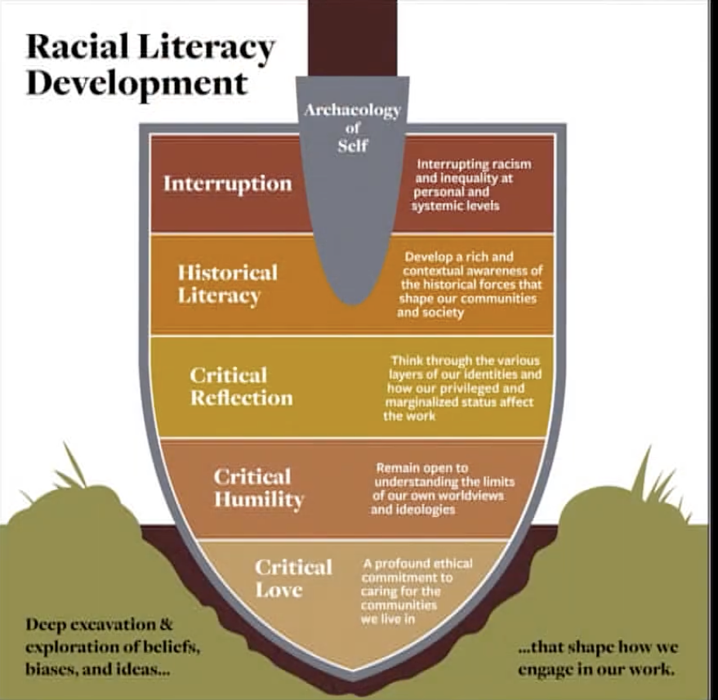

Click to Listen to Directions here: Asynch. directions .m4a

Or

Read Directions: Dr. Yolanda Sealey-Ruiz describes racial literacy as a commitment to deep self-reflection and critical love, what she calls the archaeology of the self. This work involves facing beliefs we've inherited or absorbed, even when doing so makes us uncomfortable. She reminds us:
“What we believe becomes our practices. Practices become policies. If harmful beliefs are not examined, excavated, and interrupted, they just rage on.”
To engage in this work, this journal invites you to reflect on a racial trope or stereotype you’ve encountered, through lived experience, your upbringing, media, or education.
- Describe the moment. What happened? Where were you? Who was involved?
- Excavate it. What belief or narrative was being reinforced? Where might that belief come from? What were its historical or cultural roots?
- Reflect on impact. How did it affect you or others at that moment? What emotions did it stir up? What emotions is that event stirring up now?
- Do the work of interruption. What have you come to understand about this trope now? What would it look like to interrupt that belief in yourself, your circles, or your practice moving forward?

Name
Describe the moment:
Excavate the moment:
Reflect on the impact of the moment:
Interrupt the moment:
Name
Describe the moment:
Excavate the moment:
Reflect on the impact of the moment:
Interrupt the moment:
Name
Describe the moment:
Excavate the moment:
Reflect on the impact of the moment:
Interrupt the moment:
Name
Describe the moment:
Excavate the moment:
Reflect on the impact of the moment:
Interrupt the moment:
Name
Describe the moment:
Excavate the moment:
Reflect on the impact of the moment:
Interrupt the moment:
Name
Describe the moment:
Excavate the moment:
Reflect on the impact of the moment:
Interrupt the moment:
Name
Describe the moment:
Excavate the moment:
Reflect on the impact of the moment:
Interrupt the moment:
Name
Describe the moment:
Excavate the moment:
Reflect on the impact of the moment:
Interrupt the moment:
Name
Describe the moment:
Excavate the moment:
Reflect on the impact of the moment:
Interrupt the moment:
Name
Describe the moment:
Excavate the moment:
Reflect on the impact of the moment:
Interrupt the moment:

Asynchronous Activity 2 : Commitment to Culturally and Historically Responsive Education

1. Reflect on Your Learning 🤔
- Think about what you've learned in class thus far
2. Make a Commitment ✅
- If you're currently teaching or in a placement, set a specific action for how you’ll use CHRE in your classroom soon.
- If you're not teaching yet, make a plan for how you’ll use CHRE in your future teaching or plan to use it in your final project

3. Write ✍️✍🏼✍🏾✍🏿 or Present 🖼️ Your Commitment
- Submit a written reflection (1-2 paragraphs):
- What CHRE means to you.
- Why you're committed to it.
- Your plan to implement CHRL(literacy) in your teaching or future work.
Name | Commitment

Looking Forward:

Class 5: Digital & Media Literacy
Choose 3 of 6 Readings
1.) Knobel, M., & Lankshear, C. (2014). Studying new literacies. Journal of Adolescent & Adult Literacy, 58(2), 97-101
2.) Price-Dennis, D., Holmes, K. A., & Smith, E. (2015). Exploring digital literacy practices in an inclusive classroom. The Reading Teacher, 69(2), 195-205.
3.) Stornaiuolo, A., & Thomas, E. E. (2017). Disrupting educational inequalities through youth digital activism. Review of Research in Education, 41(1), 337-357.
4.) Brooks, M. D., & Frankel, K. K. (2020). Pathways for Educators to Challenge Deficit Perspectives: Adolescents’ Transnational Digital Literacy Practices in the Classroom. Journal of Adolescent & Adult Literacy, 63(6), 711–714.
5.) Serpagli LP, Mensah FM. Keeping up with the digital natives: Using social media in an all-girls science classroom. School Science and Mathematics. 2021; 121: 288–298.
6.) Melo-Pfeifer, S., & Gertz, H. (2022). Transforming Disinformation on Minorities Into a Pedagogical Resource: Towards a Critical Intercultural News Literacy. Media and Communication, 10(4), 338-346
Explore:
Digital citizenship lessons. (Explore lesson plans for the grade level of your choice).
Watch:
Dr. Nichole Pinkard on Digital Literacy: Big Thinkers

Discussion Board Group B 11:59 am 6/2
Upcoming assignment: Assignment: Joy Oriented Literacy Pursuit Due June 7th 11:59 pm

