Class 6: AI & (Critical) Media Literacy
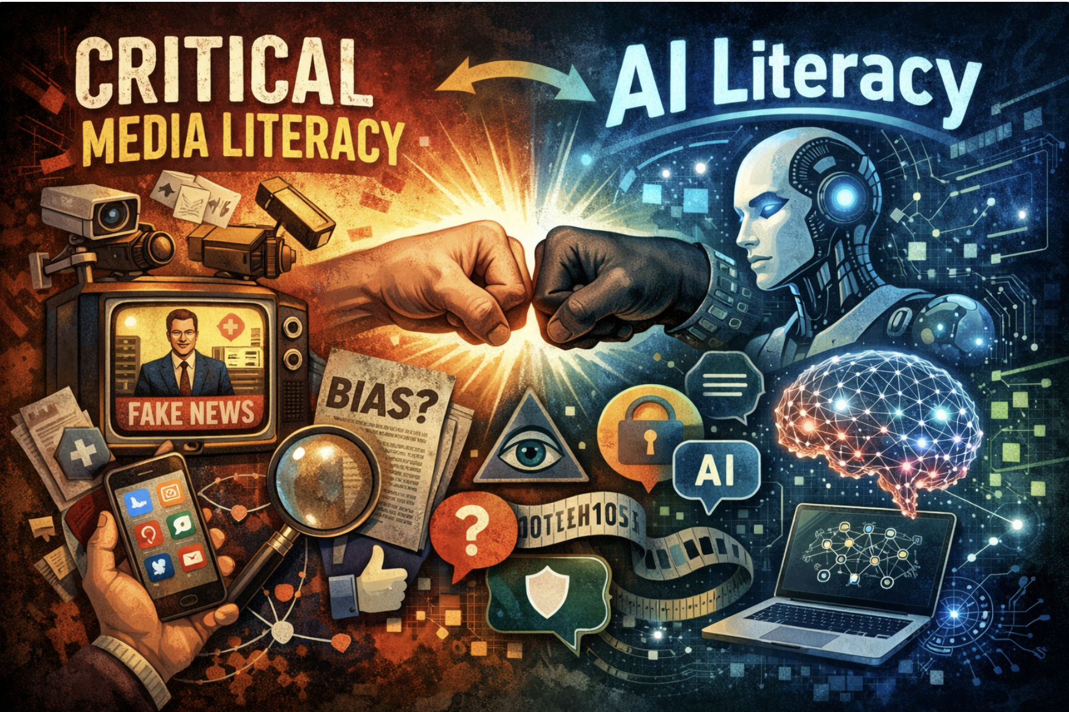
* AI was used to generate this Image

498 Non-Negotiables: Our Collective Agreement for Online Etiquette
For detailed description of each agreements click here
- Remember that everyone has been through their own challenges, and that emotion/passion is not the same as weakness/irrationality. Be considerate of others and understand that they are trying to engage with you and your culture, so you should respectfully attempt to do the same. *Staying committed to shared understanding
- Engage constructively with others online as you would with people in person; with respect, kindness, and empathy.
- Use technology meaningfully and responsibly, ensuring that you are aware of the strengths and limitations of your digital resources.
- Value the other person's contributions online by considering time and be as respectful as you would in real life interactions.
- Ensure your face is in full frame and that you do not have any distracting backgrounds or visual effects enabled. Be present to the fullest extent possible, as though you were in an in-person setting.
- Make contributions with informed foundations from depth of practice and research and participate with critical thinking. It’s okay to be unfamiliar with a topic; that’s the point of learning, continue leverage cultural resources in the community
- Accept that disagreements and discomfort will occur, and advocate for open and respectful communication. Experiencing discomfort and conflict helps us to grow as learners.
- Respect other people's privacy and do not share personal information that others shared during the class. Focus on the lesson, not the story
- Be mindful of your own privilege and power; do not weaponize it but use it to uplift others by listening, respecting differences of opinion (as they TOO can be right) and make space for everyone to contribute.
- Approach the mistakes, yours and your peers, with empathy and openness; to be human is to make mistakes. Recognize in these moments opportunities for growth, deeper understanding of ourselves, our community and the topics we are tackling.

Wellness Check: Twisted Twitter and TikTok Truths 

Ever read someone's status update and not know left from right? For today’s wellness check post a status update that sounds misleading or outlandish, but has a kernel of truth. Be prepared to answer what is actually true about it if someone is curious.

Name: | Twisted Twitter,TikTok Truths

Objectives:
- Analyze AI Literacy in Education: We will explore how AI technologies are transforming education, identifying both the opportunities and challenges they present for teachers and learners, and developing strategies for incorporating AI literacy into our teaching practices and our learning practices.
- Evaluate the bias and reliability of Media and AI tools: Using the Ad Fontes Media framework, we will assess factual accuracy, ideological neutrality. We will synthesize key insights and their implications for education.
- Collect feed forward to inform the second half of semester: Ensuring that your voices are heard and responded to is integral to my practice. Each of you will share your perspective on what is and is not working this semester, via a mid-semester survey, and I will do my best to be responsive to the collective needs of our learning community.

Media & Critical Media Literacy Slides
Activity 1: Digging In: Reading Reflections & Connections (20 min)
Directions:
- Choose at least two questions to discuss as a group and pose practice based solutions
- Elect a speaker and share in main room

Changing Role of the Teacher
- What specific skills and outlooks can we develop now in order to be more useful in our changing role alongside developments in AI? (based on Sămărescu et al.)
- If students begin to heavily rely on AI tools to answer questions, what could be the impact on communication and relationships between students and teachers and how does reliance impact the social practice of learning?
Human vs. AI Capabilities in Education
- What types of assistance in the classroom cannot be replaced or supported by AI? For example: Using AI to generate student feedback seems counterintuitive; How does this lead to a good teacher-student relationship if we aren’t the ones giving students personalized feedback based on our own opinions?
- Is grading fundamentally administrative should we expect AI can do it as well as a human teacher if so what if any are the ethical concerns? (based on Zhang & Zhang)
- How can AI platforms be able to understand the "why" behind students' mistakes? Especially in non-text-based subjects like math?

Skepticism and Concerns
- How do we make AI accessible without making students trade privacy for participation?
- Based on most college academic policies on the use of AI, should K-12 teachers encourage students to use AI for homework assignments and classwork?
- How can schools and governments make sure that AI improves educational opportunities for all students rather than exacerbating existing inequalities between wealthy and developing regions?

Group 1:
Question:
Proposed Solutions:
Question:
Proposed Solutions:

Group 2:
Question:
Proposed Solutions:
Question:
Proposed Solutions:

Group 3:
Question:
Proposed Solutions:
Question:
Proposed Solutions:

(10 min)

mis/disinformation in social media
Amy Stell and Luke Hands
Amy Stell astell@u.rochester.edu
Luke Hands lhands@u.rochester.edu

Presentation for EDU 498

Class Activity 2: Deconstructing Headlines (30 min)

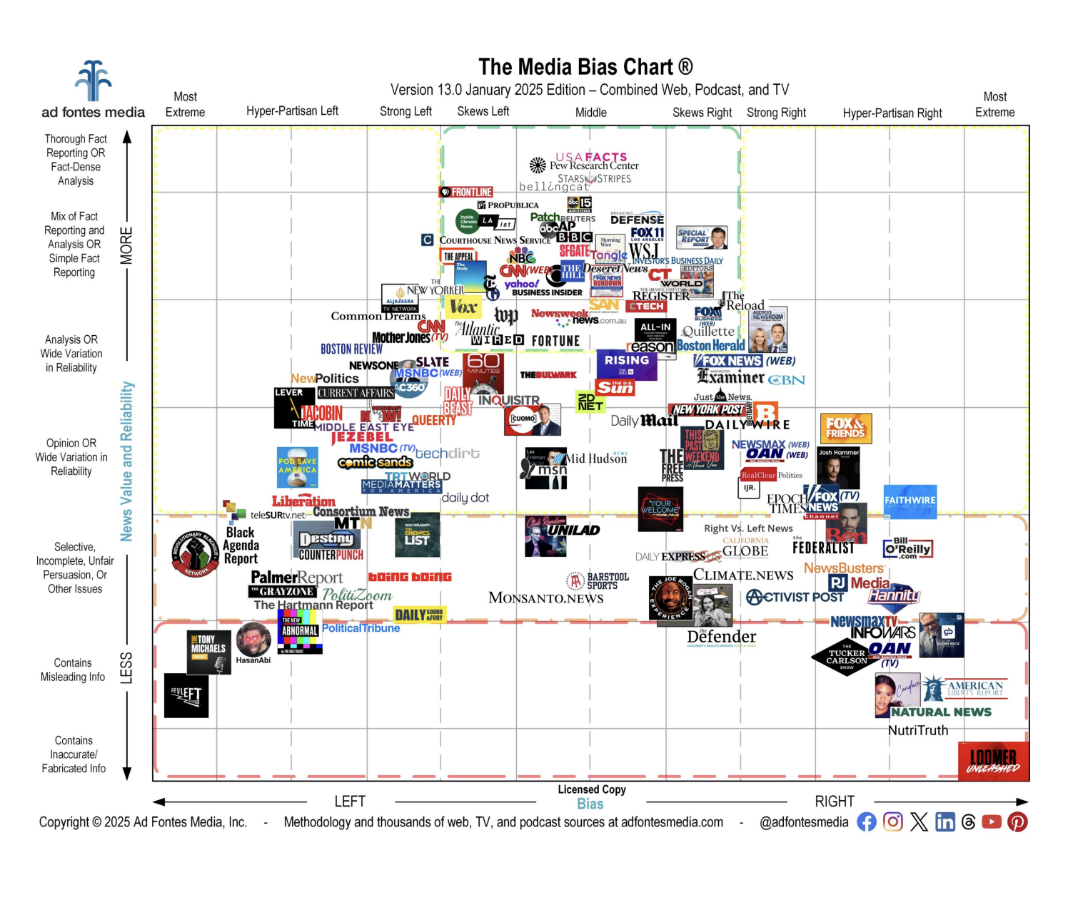

Media-Bias-Chart-13.0_Jan-2025-Licensed-scaled.jpg (JPEG Image, 2560 × 2024 pixels) — Scaled (39_).pdf

Five Minute Methodology Overview

*We won't look at this source but
https://ground.news/ uses ad fontes media bias charts to engage in meaningful discourse on media bias
Directions:
Examine the headlines from a variety of perspectives (Right Leaning, Left Leaning, Centrist, etc.).
- Break down each headline structure, looking for biased language, emotional appeals, and framing techniques.
- Skim the articles. Does it confirm your initial thoughts?
- Look where this article falls on the Media BIas Chart-were you surprised? * only 5 free searches can be done per day, per person so take turns
- Capture key takeaways to share out
- Time permitting, select an article of your choosing and follow same steps

How to use the chart:
Go to : Daily Beast Bias and Reliability | Ad Fontes Media
Select: Media Bias Chart drop down menu in Upper left toolbar and click the interactive chart option
Find: Use the search bar on the left hand side of the screen to first locate the news source. See if you can find the article plotted on the chart ( its okay to just get a general idea where the article falls)
Headline | Biased language, emotional appeals, and framing techniques.

The real victims in the “Libs of TikTok” discourse are the teachers and LGBTQ people harassed because of the account ( Media Matters)

China calls for calm amid growing row with US over suspected spy balloons (The Guardian)

Time permitting, Select an article of your choosing and follow same steps

Federal Officials Trade Stock in Companies Their Agencies Oversee
(Wall Street Journal)

Michael Knowles Says Transgenderism Must Be ‘Eradicated’ at CPAC ”THIS IS GENOCIDAL” (Daily Beast)
Time permitting, Select an article of your choosing and follow same steps

Inside Donald Trump's execution spree - with 12 dead so far and another to go ( Mirror)

Gun recovered in Charlie Kirk assassination revealed — and ammo bore pro-trans, anti-fascist messages: sources ( New York Post)
Time permitting, Select an article of your choosing and follow same steps

Looking Ahead:

- Begin Module 4 * Note that this is the most labor intensive module of the semester
- Assignment: Joy Oriented Literacy Pursuit Questions? Concerns?

- Invitation to complete either or both of the final two assignments in the course in pairs. Keep in mind of you pair up for mini-unit you both need to agree to a ‘creative commons” approach where either of you could use the unit in future practice

Asynchronous Work :
Mid-Semester Check-in

Joyful Literacy Pursuit Workshop


