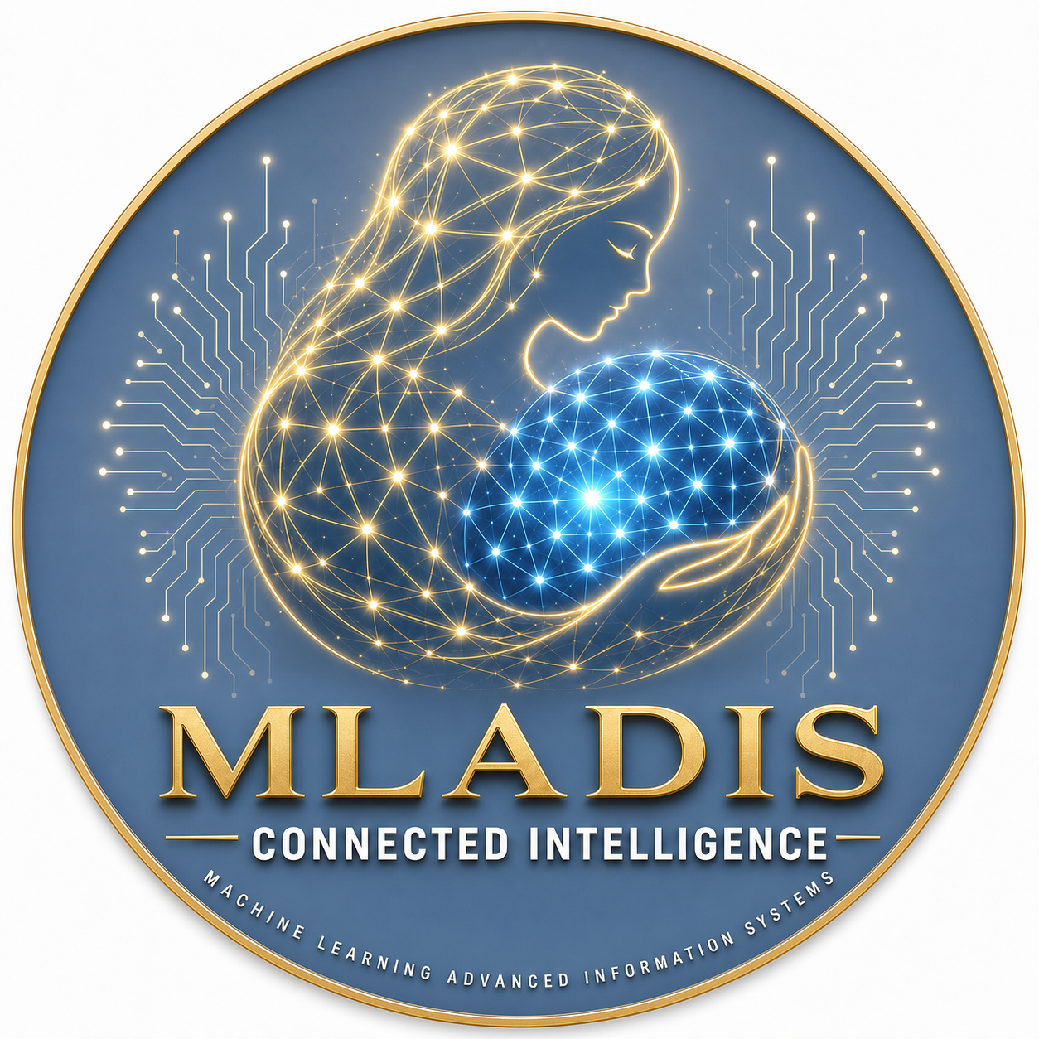
MLADIS LLC
Initial Written Consent
Sole Member Resolutions
DOCUMENT CODE | MLADIS-GOV-002
PREPARED FOR | Formation, operating authority, EIN, banking, systems, publication, and records
PARTIES / SIGNER CONTEXT | Piter Zacari Garcia Bautista, sole member

Prepared for execution through the approved MLADIS e-signature workflow.

The undersigned, being the sole member of MLADIS LLC, a New York limited liability company, adopts the following resolutions as of June 3, 2026.

1. Formation Acknowledged
The member acknowledges that MLADIS LLC was formed as a New York domestic limited liability company and that New York Business Express shows application `DOS1336-2026-029778` as `Approved/Issued` on 2026-06-03.

2. Operating Agreement Approved
The member approves and adopts the Operating Agreement of MLADIS LLC dated June 3, 2026.

3. Management Authority
Piter Zacari Garcia Bautista is authorized to act for the company, sign documents, open and manage company accounts, register and manage business services, and take all actions reasonably necessary to operate the company.

4. EIN Authorization
Piter Zacari Garcia Bautista is authorized to apply for an Employer Identification Number from the Internal Revenue Service for MLADIS LLC.

5. Banking And Payment Processor Authorization
Piter Zacari Garcia Bautista is authorized to open company bank accounts, configure payment processors, accept customer payments, manage security deposits, process refunds, and maintain accounting records for MLADIS LLC.

6. Business Systems Authorization
Piter Zacari Garcia Bautista is authorized to register, configure, and manage:
- `mladis.com` and related subdomains.
- Google Workspace or other business email.
- GitHub, Cloudflare, hosting, OAuth, calendar, payment, and communication services.
- Booking systems, customer support systems, AI agents, analytics, and operations dashboards.

7. Recognition Of Founding Operations Pillar
The member recognizes Diana Sori Garcia Bautista as a Founding Operations Pillar and Dominican Republic Operations Lead of MLADIS Bookings due to her material role in Dominican Republic-based vacation-rental operations, guest coordination, property oversight, vendor coordination, cleaning coordination, inventory support, building/HOA coordination, and customer experience support.
This recognition is operational and honorary in nature unless later modified by written agreement. It does not create membership, ownership, voting rights, equity rights, tax partnership status, employee status, authority to incur debt, authority to bind MLADIS LLC, authority to open or access company bank accounts, authority to access company tax accounts, or authority to access company payment processor accounts.

8. Business Visit And Coordination Authorization
The member authorizes MLADIS LLC to invite Diana Sori Garcia Bautista to the United States from time to time for temporary business visitor purposes, including business consultation, strategic planning, internal coordination meetings, review of MLADIS Bookings operations, training discussions regarding company systems, planning of Dominican Republic-based operations, and meetings with business associates or professional advisors.
Such visits are intended to be temporary and business-consultation focused. They are not intended to authorize employment or productive labor physically performed in the United States, immigration sponsorship, permanent relocation, hands-on guest services in the United States, customer-support shifts from the United States, cleaning, maintenance, or other operational labor requiring a different legal status or authorization.
Any future officer role, ownership role, employment relationship physically performed in the United States, immigration petition, or work-authorized position must be reviewed by qualified immigration counsel before implementation.

9. Publication And Compliance Authorization
Piter Zacari Garcia Bautista is authorized to complete the New York LLC publication process, request Queens County Clerk newspaper designations, coordinate newspaper publication, collect affidavits, and file the Certificate of Publication.

10. Records
The company will maintain private records for formation documents, operating agreement, member consent, tax records, bank records, invoices, receipts, publication affidavits, customer agreements, and material contracts.

Signature Authorization
Member signs below to acknowledge and execute this document as routed through the approved e-signature workflow.
SIGNER | Member
NAME | Piter Zacari Garcia Bautista
ROLE | Sole Member
SIGNATURE
DATE

