NGS Reanalysis Study on Identification Using Global DEG Discovery of DRG Mouse Dataset
BIOL550 Group Paper Draft 2
Nikhi Boggavarapu | Sam Kopelev | Piter Garcia

Member | Note
Nikhi Boggavarapu | Highlighted text in light purple indicates Nikhi's contribution.
Sam Kopelev | Highlighted text in light green indicates Sam's contribution.
Piter Garcia | Highlighted text in light red indicates Piter's contribution, including transition wording added for flow.

Introduction
We reanalyze a published mouse dorsal root ganglion (DRG) RNA-seq dataset to examine how injury responses and regeneration are balanced after peripheral nerve damage, with particular attention to the aryl hydrocarbon receptor (Ahr) (Halawani et al., 2023; NCBI SRA, 2026; NCBI BioProject, 2026; NCBI GEO, 2026). The original study used a neuronal conditional Ahr knockout because DRGs are a useful model for peripheral axon regrowth after sciatic nerve injury, and the conditional design helps isolate neuron-intrinsic effects more cleanly than a constitutive knockout background (Halawani et al., 2023). In this dataset, the primary biological comparison contrasts ipsilateral DRG tissue from the injured side with contralateral DRG tissue from the uninjured side; genotype provides a secondary layer of comparison between wild-type control (ff) animals and the Ahr conditional knockout (cre) background (Halawani et al., 2023; NCBI SRA, 2026; NCBI BioProject, 2026; NCBI GEO, 2026). We use the original paper as a mechanistic anchor but extend its candidate-gene emphasis by applying transcriptome-wide differential expression and pathway-level follow-up to the full dataset. This approach allows us to test whether the strongest signals remain centered on injury-side differences, to quantify how strongly genotype contributes relative to that main contrast, and to connect the resulting gene sets to broader biological processes such as signaling, stress response, and regeneration-related remodeling. This emphasis is consistent with the source paper's transcriptomic framing, in which injury status explained more of the global structure than genotype alone (Halawani et al., 2023).
Keeping those goals in mind, this reanalysis completed the main RNA-seq stages from quality control through functional interpretation. The workflow included trimming and alignment, differential expression across the major biological contrasts, and pathway analysis to place the strongest differentially expressed gene sets into a broader biological context. In practice, this let us compare the published AhR-centered interpretation with a more global discovery framework built from the full dataset (Halawani et al., 2023; Love et al., 2014; Kolberg et al., 2020; Gene Ontology Consortium, 2021; Kanehisa et al., 2025; Gillespie et al., 2022).

Materials and Methods
This project reanalyzed mouse DRG bulk RNA-seq data collected after sciatic nerve injury using a four-stage computational workflow: Data Collection, Data Cleaning, Data Preparation, and Data Analysis and Interpretation. This structure preserved accession tracking, quality control, alignment review, and downstream modeling as explicit, reproducible checkpoints while allowing the same analysis path to be reused after earlier dataset-selection issues (Wirth & Hipp, 2000).
The working subset consisted of 20 Illumina NovaSeq X paired-end libraries from SRP618841 (BioProject PRJNA1322439; GEO GSE243308), representing L4--L6 DRG samples collected one day after sciatic nerve injury (Halawani et al., 2023; NCBI SRA, 2026; NCBI BioProject, 2026; NCBI GEO, 2026). The retained subset was organized as a balanced side-by-genotype design within the family_drg_novaseqx family, with equal representation of ipsilateral and contralateral samples and of wild-type and cKO genotype classes before quality control, alignment, and differential expression analysis.
This balanced design is important for the rest of the paper because the same 20-sample subset supports both the main side-specific comparisons and the secondary genotype interpretation. In other words, the workflow did not switch datasets when the later follow-up sets were defined; the 709-gene WT branch and the 870-gene cKO branch both came from the same retained DRG cohort and the same model-fitting framework (Halawani et al., 2023; NCBI SRA, 2026; NCBI BioProject, 2026; NCBI GEO, 2026).
Table 1. Summary of the 20-sample mouse DRG RNA-seq subset used for reanalysis.
Group | Side class | Genotype | n | Tissue / time point | Source dataset and platform
WT contralateral | contralateral | WT | 5 | L4--L6 DRG, 1 day post-injury | SRP618841 / PRJNA1322439 / GSE243308; paired-end Illumina NovaSeq X
WT ipsilateral | ipsilateral | WT | 5 | L4--L6 DRG, 1 day post-injury | SRP618841 / PRJNA1322439 / GSE243308; paired-end Illumina NovaSeq X
cKO contralateral | contralateral | cKO | 5 | L4--L6 DRG, 1 day post-injury | SRP618841 / PRJNA1322439 / GSE243308; paired-end Illumina NovaSeq X
cKO ipsilateral | ipsilateral | cKO | 5 | L4--L6 DRG, 1 day post-injury | SRP618841 / PRJNA1322439 / GSE243308; paired-end Illumina NovaSeq X

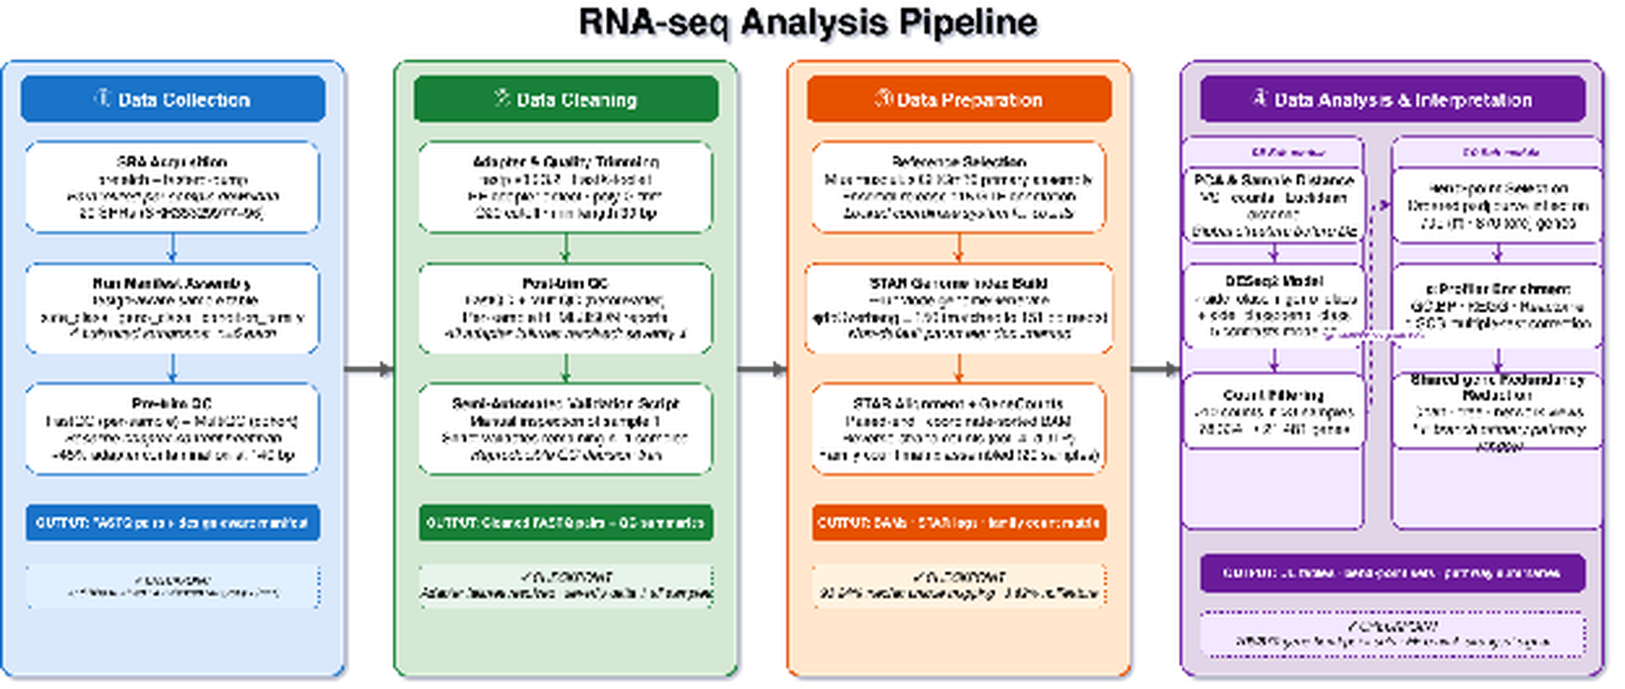
Figure 1. Overview ribbon summarizing the four computational stages and their stage-owned handoffs in the mouse_new
The workflow was structured into four connected stages, each with explicit checkpoints and handoffs. The Collection stage used prefetch and fasterq-dump to assemble the sample table and family manifest, retaining 20 SRRs across four balanced subgroups (n = 5 each). The Cleaning stage applied FastQC, MultiQC, and fastp, generating the QC summaries that documented adapter remediation before alignment. The Preparation stage used STAR with GeneCounts to produce coordinate-sorted BAM files, STAR alignment summaries, and per-sample count tables. The Analysis stage used DESeq2, bend-point follow-up, and g:Profiler to generate the differential expression and enrichment outputs used in later interpretation (Andrews, 2010; Ewels et al., 2016; Chen et al., 2018; Dobin et al., 2013; Love et al., 2014; Kolberg et al., 2020).
Table 2. Representative command examples for the tools used in the mouse_new
Stage | Tool | Representative command/code example
Collection | prefetch + fasterq-dump | prefetch SRR35329980 &&\\ fasterq-dump SRR35329980 --split-files -O fastq/
Cleaning | FastQC | fastqc raw/*.fastq.gz trimmed/*.fastq.gz --outdir fastqc_reports/
Cleaning | MultiQC | multiqc fastqc_reports/ fastp_reports_full/ -o multiqc/
Cleaning | fastp | fastp -i sample_R1.fastq.gz -I sample_R2.fastq.gz\\ -o clean_R1.fastq.gz -O clean_R2.fastq.gz\\ --detect_adapter_for_pe --trim_poly_g\\ --cut_mean_quality 20 --length_required 30\\ -h sample.html -j sample.json
Preparation | STAR | STAR --runThreadN 8 --genomeDir star_index\\ --readFilesIn clean_R1.fastq.gz clean_R2.fastq.gz\\ --readFilesCommand zcat\\ --sjdbGTFfile Mus_musculus.GRCm39.115.gtf\\ --outSAMtype BAM SortedByCoordinate\\ --quantMode GeneCounts
Analysis | DESeq2 | dds <- DESeqDataSetFromMatrix(countData, colData,\\ design = side_class * geno_class);\\ dds <- DESeq(dds)
Analysis | bend-point script | python3 run_bendpoint_followup.py\\ --contrast ipsi_vs_contra_in_ff\\ --padj-column padj
Analysis | g:Profiler | gp.profile(organism = "mmusculus",\\ query = selected_genes,\\ sources = c("GO:BP","KEGG","REAC"))

Workflow reproducibility and version tracking. To keep the paper reproducible at a grad-level standard, the main software tools and reference resources used in the local mouse RNA-seq workflow were tracked alongside the command-level examples. The draft explicitly records fastp v0.23.2 and the GRCm39 / Ensembl release 115 reference pair, and the remaining tools below summarize the same implementation path used across download, QC, alignment, differential expression, and enrichment interpretation (NCBI, 2026; Andrews, 2010; Ewels et al., 2016; Chen et al., 2018; Dobin et al., 2013; Ensembl, 2025; Love et al., 2014; Kolberg et al., 2020).
Table 3. Software, reference resources, and releases used in the mouse RNA-seq workflow.
Stage | Tool / resource | Version, release, or implementation used
Collection | SRA Toolkit (prefetch, fasterq-dump) | SRA Toolkit workflow used for SRP618841 download and FASTQ generation
Cleaning | FastQC | FastQC workflow used for raw and post-trim quality control
Cleaning | MultiQC | MultiQC workflow used for cohort-level QC summaries
Cleaning | fastp | v0.23.2
Preparation | STAR | STAR workflow used for paired-end alignment and GeneCounts output
Preparation | Ensembl mouse reference genome | Mus musculus GRCm39 primary assembly
Preparation | Ensembl gene annotation | Release 115
Analysis | R / DESeq2 | R-based DESeq2 workflow used for count-based differential expression analysis
Analysis | Python | Python 3 workflow used for bend-point follow-up scripting and output consolidation
Analysis | g:Profiler | 2021 update web service used for functional enrichment follow-up

Data Collection: SRA acquisition and sample organization. Public runs were retrieved using project wrappers around prefetch and fasterq-dump, and the local workflow retained 20 paired-end NovaSeq X libraries from the one-day post-injury DRG subset. After download, metadata were consolidated into a design-aware sample table with side_class (ipsilateral or contralateral), geno_class (WT or cKO), and derived condition-family labels. This preserved a balanced 2 2 design and created a reusable manifest for downstream notebooks (NCBI, 2026; NCBI SRA, 2026; NCBI BioProject, 2026; NCBI GEO, 2026).
Data Cleaning: quality control and read trimming. Raw read quality was evaluated with FastQC, and cohort-level summaries were consolidated with MultiQC (Andrews, 2010; Ewels et al., 2016). The local workflow used fastp v0.23.2 as the canonical cleanup tool because it provided a reproducible paired-end workflow, generated per-sample reports, and reduced adapter-related signal more effectively than the earlier baseline (Chen et al., 2018). The retained configuration used paired-end adapter detection, poly-G trimming, a mean quality cutoff of 20, a minimum retained length of 30 bases, and per-sample HTML and JSON reporting.
Data Preparation: reference selection and alignment. Trimmed read pairs were aligned to the Mus musculus GRCm39 primary assembly with the matching Ensembl release 115 annotation (Ensembl, 2025). The reference pair used in the local workflow consisted of Mus_musculus.GRCm39.dna.primary_assembly.fa and Mus_musculus.GRCm39.115.gtf. A STAR genome index was generated with sjdbOverhang = 150 to match the 151-bp paired-end reads. Alignment was performed with gzip-aware input handling, coordinate-sorted BAM output, and GeneCounts (Dobin et al., 2013).
Data Analysis and Interpretation: differential expression and functional analysis. The merged family count matrix was analyzed with DESeq2 using an interaction design formula (~ side_class * geno_class), so that the effect of side could differ by genotype; all five contrast branches were extracted from a single fitted model (Love et al., 2014). Low-support genes were filtered before modeling, reducing the tested set from 78,334 to 21,481 genes while retaining all 20 DRG samples. Five contrasts were then evaluated: ipsilateral vs contralateral in WT, ipsilateral vs contralateral in cKO, WT vs cKO in contralateral, WT vs cKO in ipsilateral, and the interaction term.
Downstream interpretation followed a PCA-first, branch-priority logic. PCA was used to evaluate sample structure before emphasizing long differential-expression tables, and the two side-specific branches (ipsi_vs_contra_in_ff and ipsi_vs_contra_in_cre) were then carried forward as the primary follow-up path because they matched the strongest sample-structure signal. To avoid reducing very large DE outputs to unstructured gene lists, the workflow applied the same bend-point rule to the ordered adjusted-p-value curve for each contrast, marking the transition between the steep high-confidence portion of the ranked list and the flatter long tail. The resulting follow-up sets were then submitted to g:Profiler using GO Biological Process, KEGG, and Reactome layers (Kolberg et al., 2020; Gene Ontology Consortium, 2021; Kanehisa et al., 2025; Gillespie et al., 2022).

Results

Quality Control and Trimming of RNASeq Data
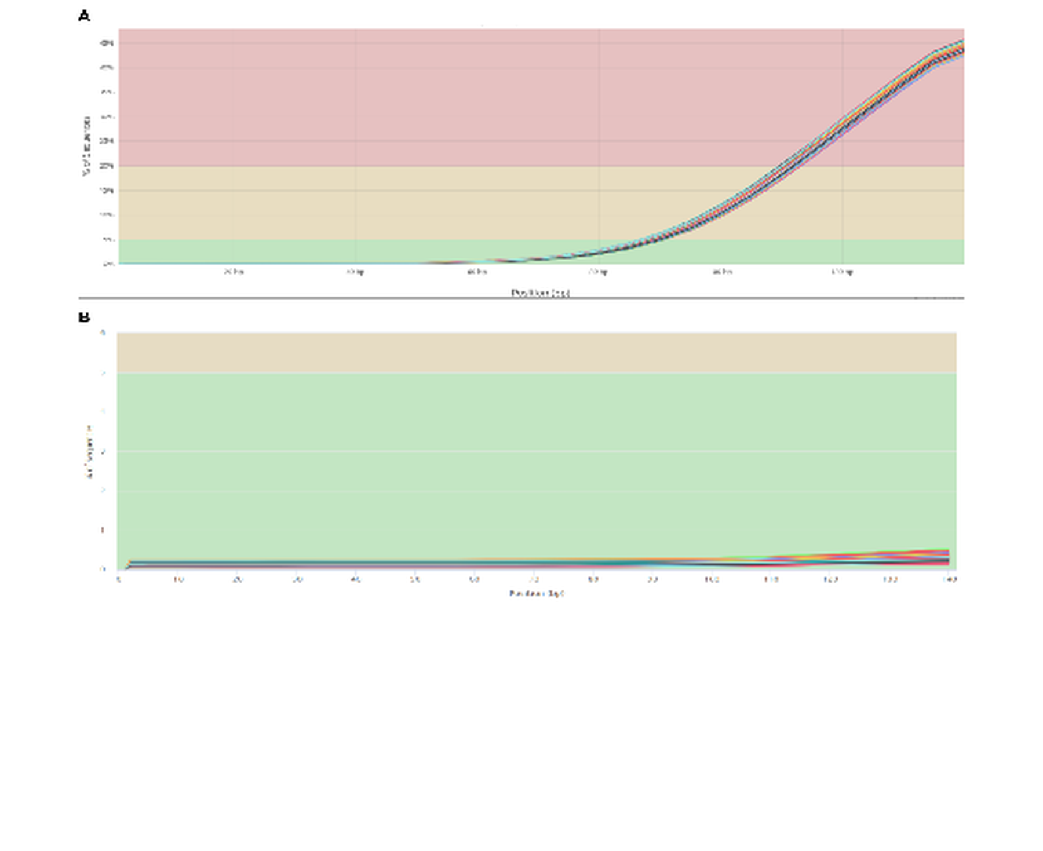
Figure 2. Adapter content present in the RNA-seq samples before trimming (A) and after trimming (B). The pre-trim panel shows strong adapter-associated signal near the read end, whereas the post-trim panel shows that this signal was largely removed.
Before downstream analysis, the raw dataset was evaluated to identify the main quality issues present in the reads. MultiQC provided a cohort-level view of those problems and showed substantial adapter content in the raw data, with roughly 45% of sequences carrying adapter-associated signal near the 140-bp region. Although some adapter signal is expected after RNA-seq library preparation, the size and consistency of this pattern justified an explicit trimming step before alignment.
After trimming, the adapter-associated signal dropped to below 1% across the retained cohort. This improvement showed that trimming successfully removed the dominant QC problem and produced a cleaner dataset for downstream analysis. The pre- and post-trim comparison therefore supports the use of the cleaned reads for alignment and later differential expression modeling.
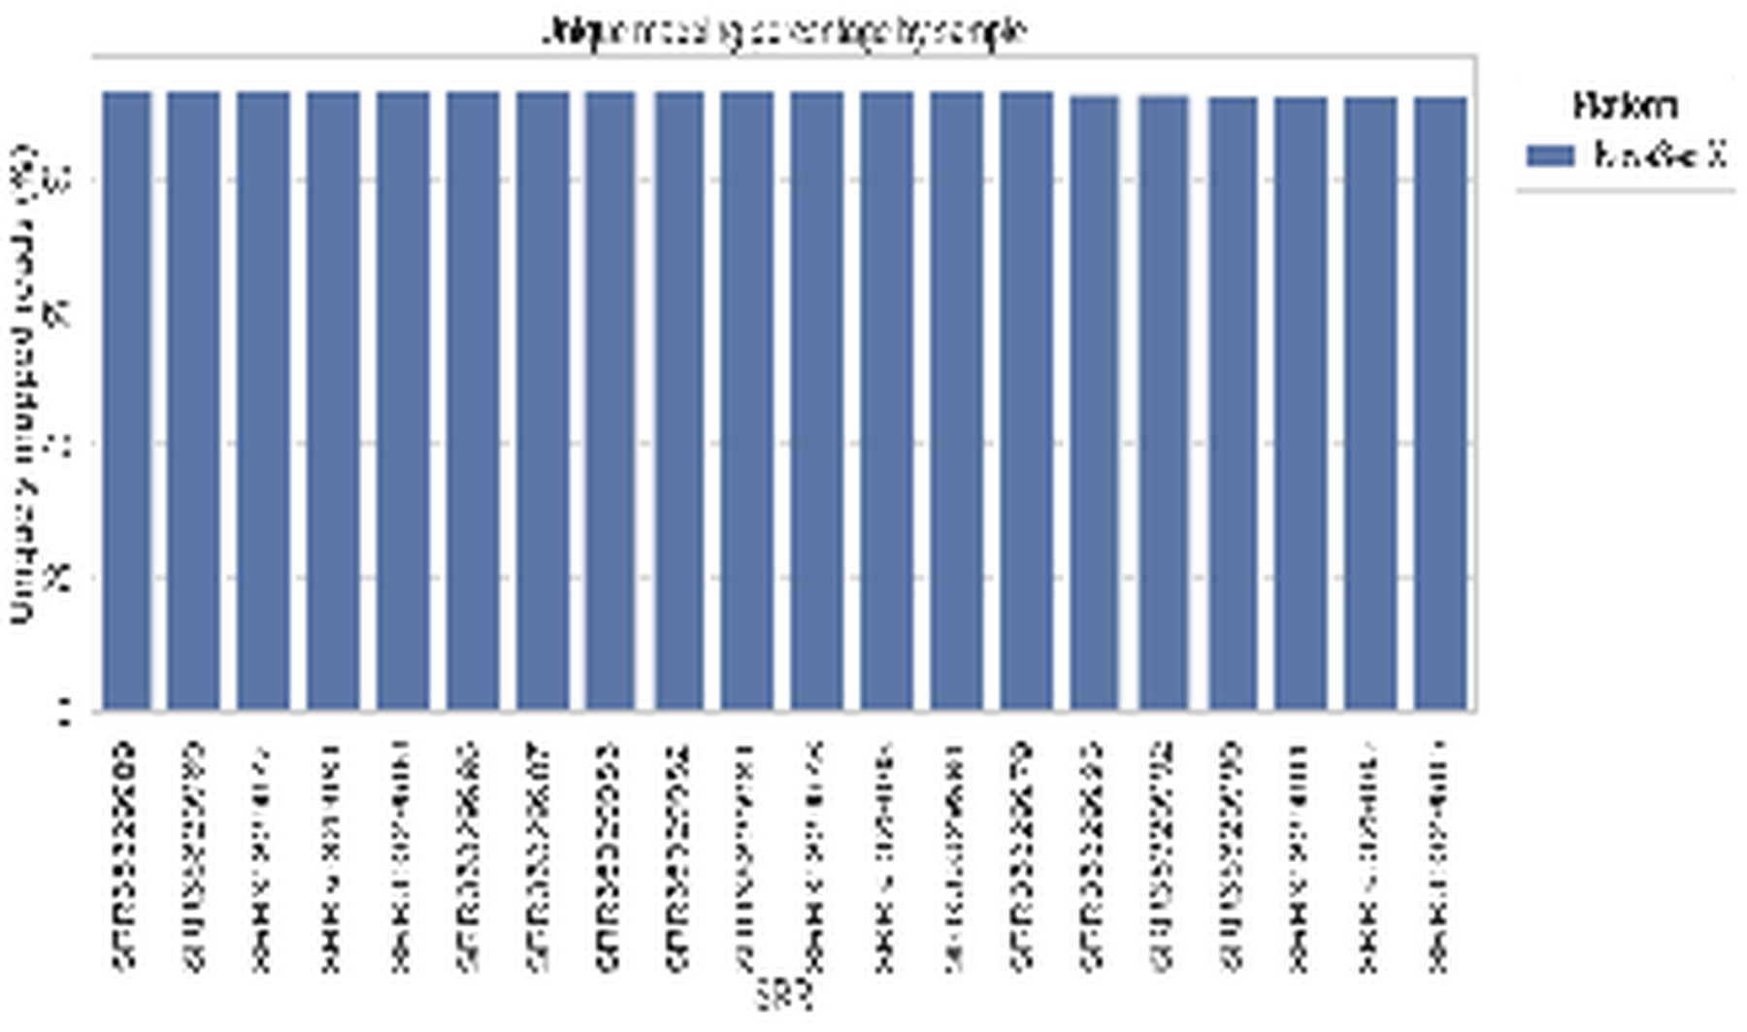 | 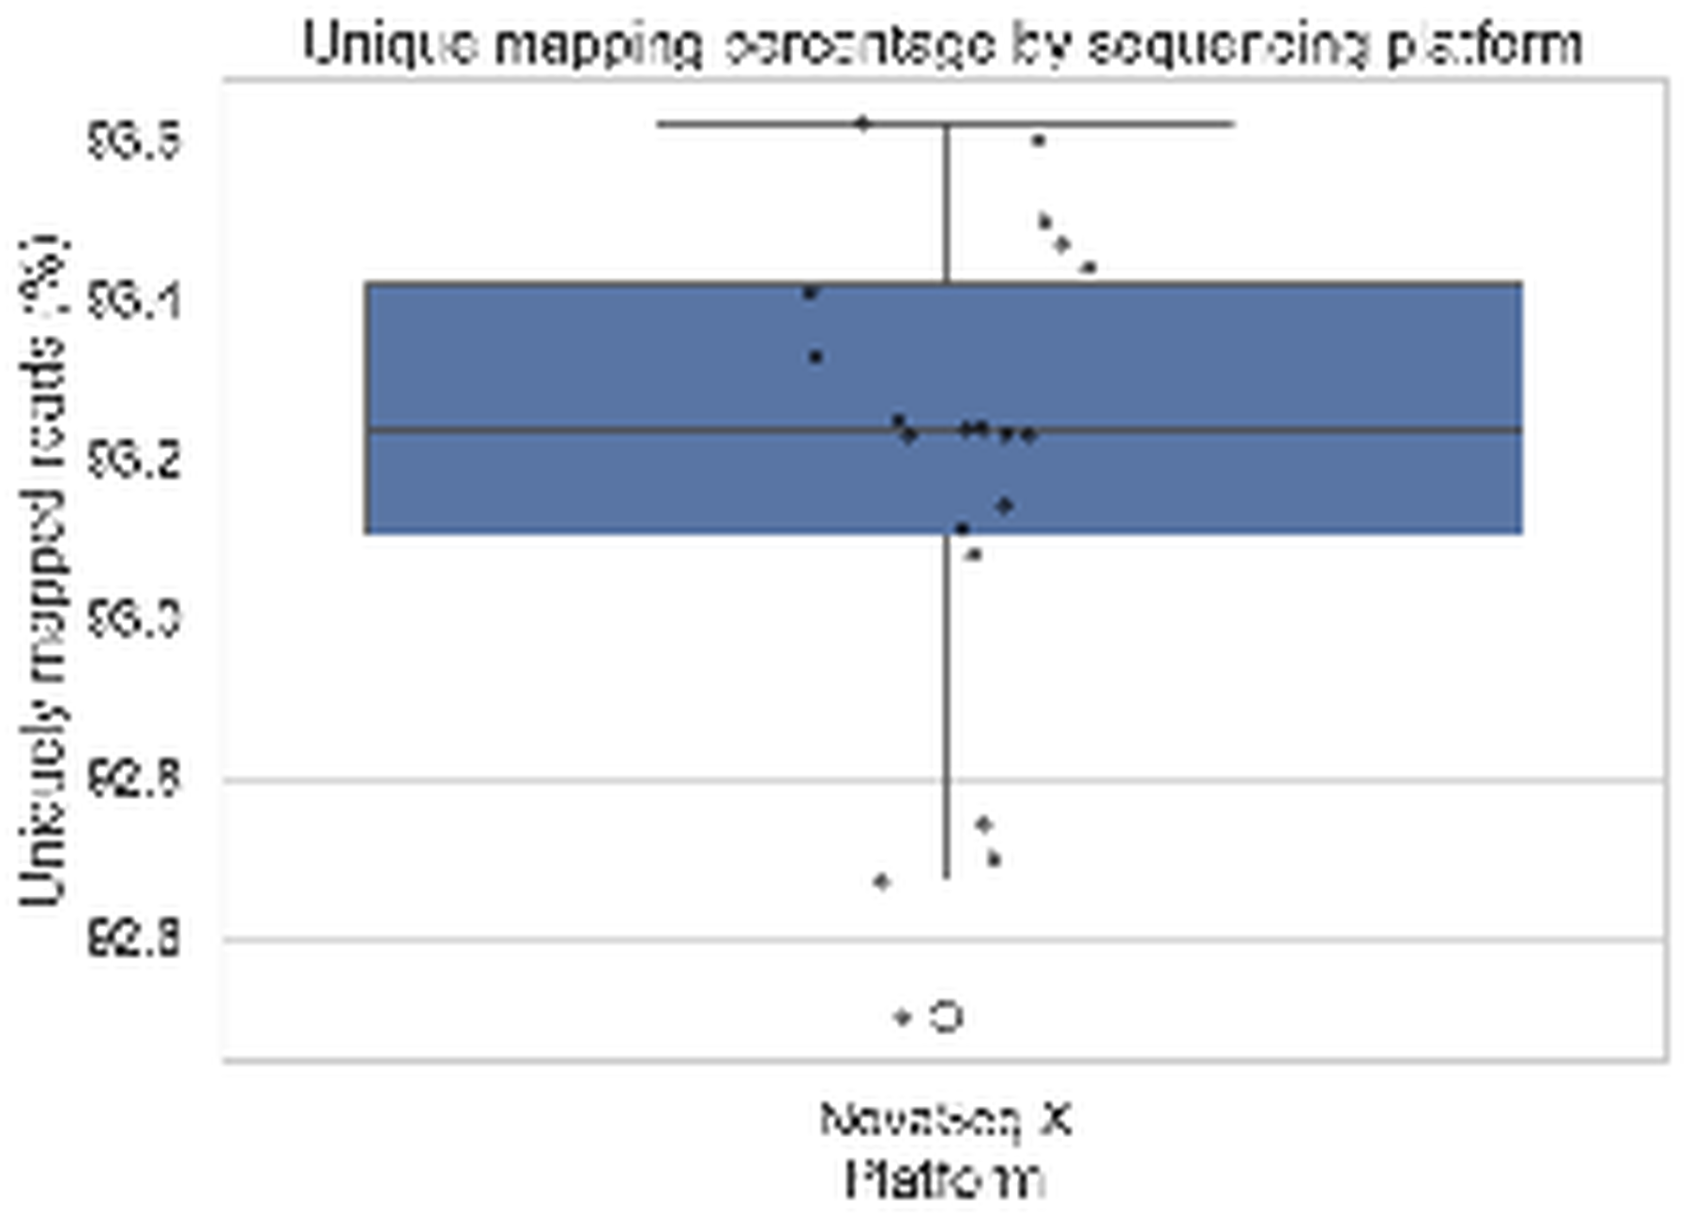
Figure 3. Alignment statistics after mapping the trimmed reads to the GRCm39 Mus musculus
Alignment of the trimmed reads to the GRCm39 reference genome produced consistently high mapping performance. Every sample exceeded 90% uniquely mapped reads, with a median unique-mapping rate of 93.24% and an interquartile range of 93.10--93.42%. The lowest observed value was just below 92.6%, but it remained within a high-quality alignment range relative to the rest of the cohort. These alignment metrics provided sufficient confidence to proceed with differential expression analysis.
Together, the QC and alignment checkpoints showed that the retained 20-sample subset was technically stable enough for downstream modeling. With the preprocessing concerns resolved, the next question became whether the biological structure of the dataset was driven more strongly by injury side or by genotype.

Differential Expression Analysis
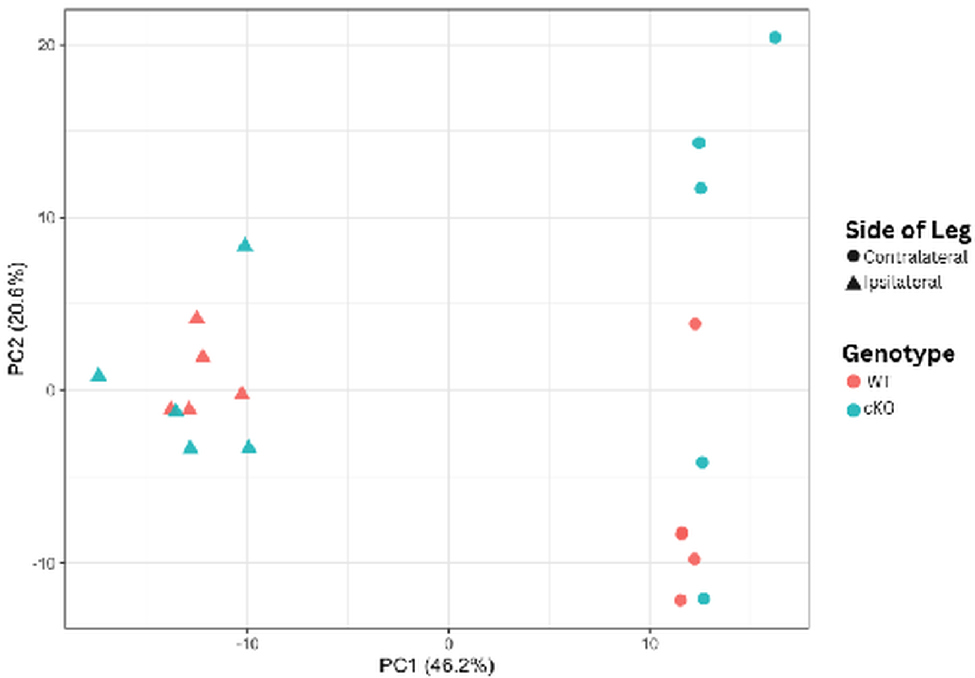
Figure 4. Principal Component Analysis (PCA) of DRG transcriptomes. Samples are plotted along the first two principal components, which capture 46.2% and 20.6% of the variance, respectively. Shapes represent injury side and colors represent genotype.
PCA was used to reduce the dimensionality of the dataset, which contained approximately 21,000 modeled genes across 20 mouse samples. The first two principal components captured 66.8% of the variance. Samples separated more clearly by injury side (ipsilateral vs contralateral) than by genotype, with PC1 carrying the dominant side-associated structure and genotype contributing a weaker secondary pattern.
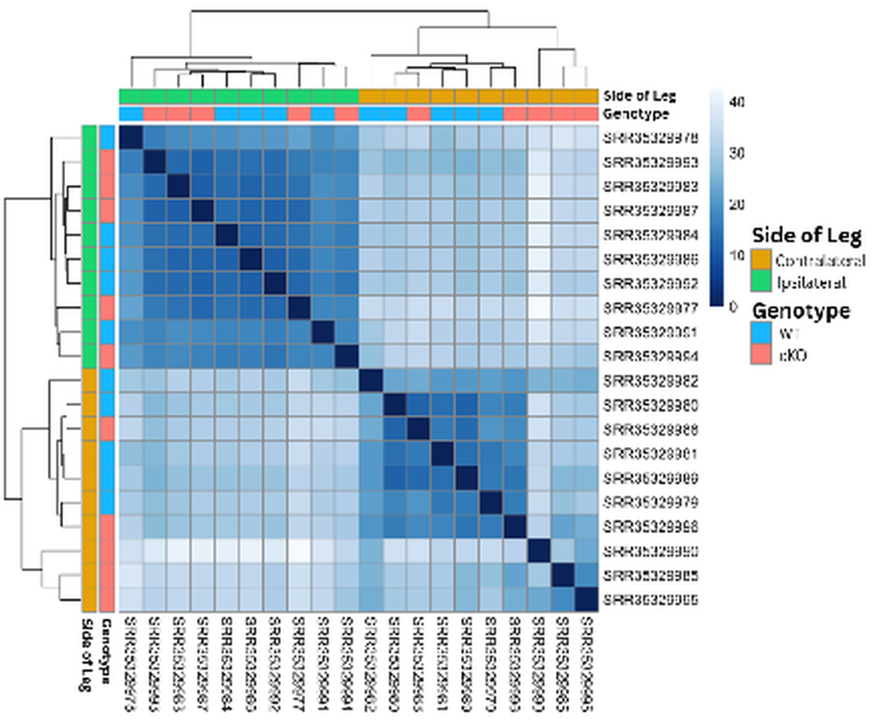
Figure 5. Sample-to-sample distance heatmap of DRG transcriptomes. Euclidean distances were calculated from regularized log-transformed counts. Darker blue indicates higher similarity, and lighter blue indicates lower similarity.
The sample-to-sample distance heatmap supported the same overall interpretation. Samples clustered primarily by injury side, with ipsilateral and contralateral samples forming the clearest separation in the matrix. Genotype still contributed structure within those broader groups, but it did not override the side-based organization. The agreement between the PCA and distance heatmap made side-specific contrasts the most defensible main path for follow-up analysis.
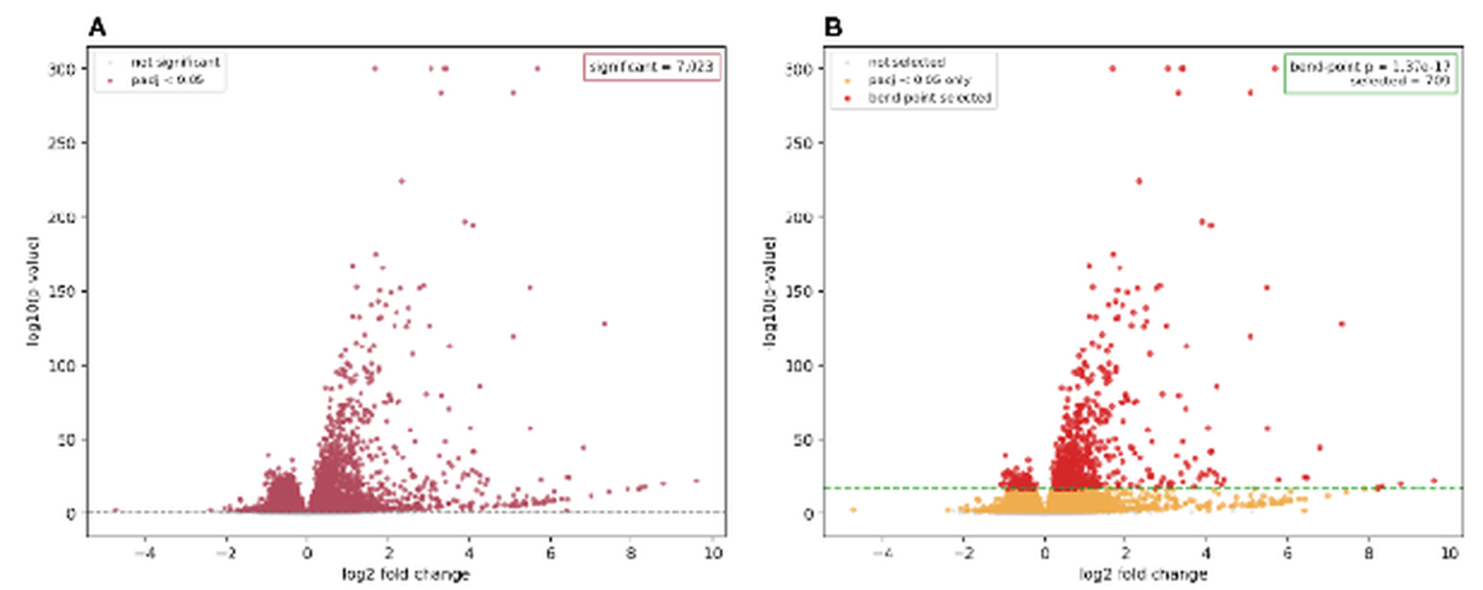
Figure 6. Comparison of volcano plots for the ipsi_vs_contra_in_ff
Once the technical QC checks and sample-structure plots agreed that injury side dominated the global signal, the differential-expression results could be interpreted in a more disciplined way. Rather than treating every modeled contrast as equally central, the analysis prioritized the two side-specific branches and then used bend-point narrowing to convert those very large DE outputs into smaller follow-up sets suitable for pathway-level interpretation.
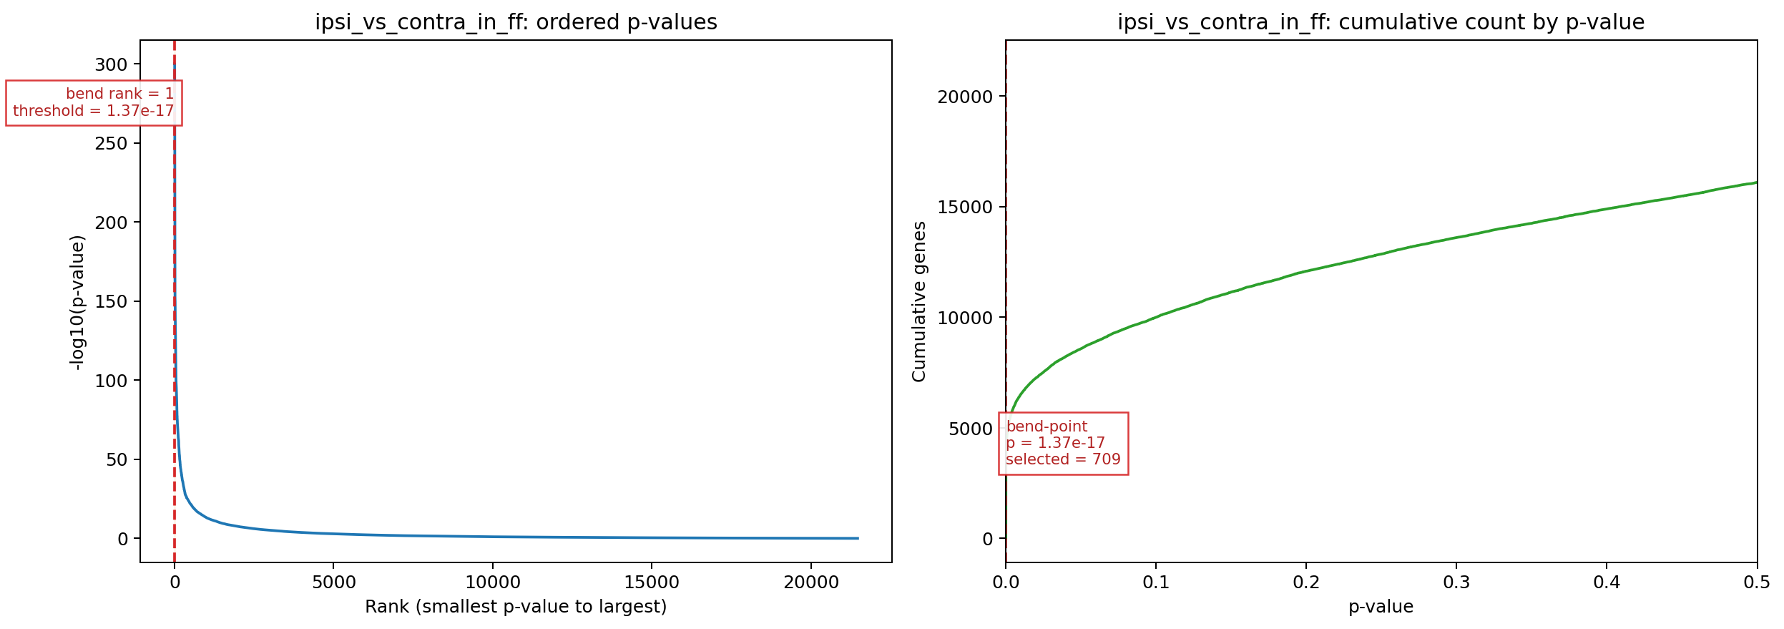
Figure 7. Ordered adjusted-p
Because the side-specific contrasts produced very large sets of significant genes, a bend-point rule was used to reduce those outputs to more interpretable follow-up sets. In the ipsi_vs_contra_in_ff branch, the bend point occurred at an adjusted-p-value threshold of 1.37 10^-17, reducing the broader significant set to 709 genes. This narrowed subset still captured strongly supported differential expression while removing much of the dense background that made the full result harder to interpret biologically.
The same narrowing rule was then applied to the ipsi_vs_contra_in_cre branch, which began with 7,541 significant genes and converged to an 870-gene follow-up set at a branch-specific bend point of 8.40 10^-17. This second branch did not come from a different dataset or a separate ad hoc analysis; it came from the same fitted DESeq2 model and the same ordered adjusted-p-value procedure used for the WT branch. That parallel treatment is important because it shows that the side-specific injury signal remains strong in cKO as well, while also leaving room to compare how genotype background expands or shifts the follow-up set (Love et al., 2014).
Comparison of the two narrowed side-specific branches showed that 620 genes were shared between the 709-gene WT set and the 870-gene cKO set, leaving 89 WT-only genes and 250 cKO-only genes in the follow-up comparison. This pattern indicates that the cKO branch largely preserves the same core injury-response program seen in WT, but it also extends beyond that shared core enough to justify explicit genotype-background follow-up in later pathway interpretation.

Gene Ontology Analysis
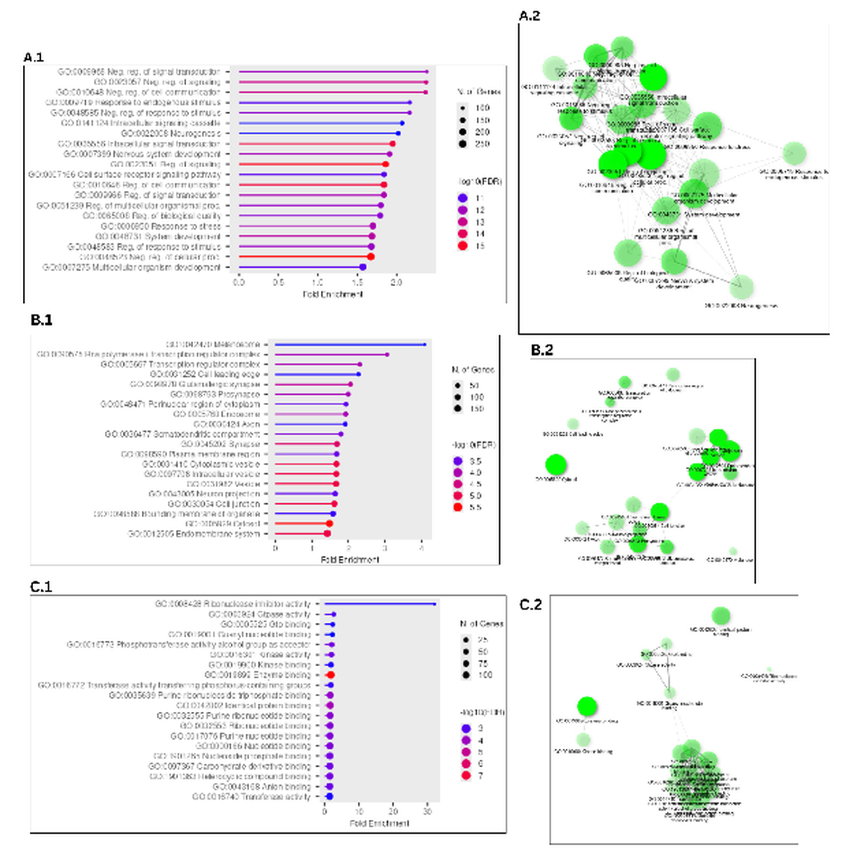
Figure 8. Gene Ontology (GO) analysis of the 709-gene ipsi_vs_contra_in_ff
Gene Ontology analysis was used to connect the 709-gene follow-up set to broader biological processes. Among the three GO categories, Biological Process provided the clearest and most coherent signal. The top enriched terms repeatedly pointed toward signaling and regulation, response to stimulus, morphogenesis, and stress-related remodeling, and the accompanying network view showed that many of those terms were connected through overlapping gene membership rather than representing isolated pathway stories.
Cellular Component and Molecular Function results were more variable than Biological Process, but they still added context to the follow-up set. Cellular Component included more localized structural themes, while Molecular Function contained a smaller and less internally consistent set of enriched labels. Taken together, the GO results supported the view that the strongest FF branch signal was not just a list of highly significant genes, but a connected injury-response program that became easier to interpret after bend-point narrowing.
The cKO branch was carried forward as a supporting extension of that same logic rather than as a competing main story. Weekly follow-up comparisons showed that most of the WT branch was preserved inside the cKO set, but that the additional 250 cKO-only genes were sufficient to introduce branch-specific pathway expansion, particularly around phosphorylation-related and phosphate-containing compound metabolic terms. In that sense, the 870-gene branch is useful not because it overturns the WT-centered story, but because it shows how a shared injury-response backbone can broaden under the cKO background when the same narrowing method is applied consistently.

Discussion
The most robust finding in this dataset was that side-specific injury contrasts carried the strongest signal. Early QC and alignment checkpoints supported retaining this 20-sample DRG subset for downstream modeling, but the main interpretive shift came from the PCA-first review: side separated more clearly than genotype, while genotype behaved as a secondary axis with substantial overlap between paired WT and cKO samples. The PCA and sample-distance views converged on the same conclusion, making side-specific contrasts the most defensible primary path for interpretation.
This PCA-first reading disciplined the interpretation of the differential-expression output. Rather than treating all modeled contrasts as equally informative, the workflow converged on a branch-priority logic in which ipsi_vs_contra_in_ff and ipsi_vs_contra_in_cre served as the main follow-up branches, while WT vs cKO in contralateral remained the strongest supporting genotype comparison. These secondary branches indicate that genotype effects are present, but they do not displace the side-specific injury signal as the dominant story.
The bend-point step marked the transition from broad differential-expression output to a smaller and more interpretable follow-up set. For the two main side-specific contrasts, the ordered adjusted-p-value curve reduced 7,023 and 7,541 significant genes to 709 and 870 genes, respectively. These smaller sets remained strongly supported statistically while becoming practical for pathway-level analysis. In that sense, the bend-point step made the most robust results easier to interpret against known injury and regeneration mechanisms.
Among the follow-up branches, ipsi_vs_contra_in_ff remained the clearest pathway-level result. It combined a strong side-driven separation, a large but reducible differential-expression set, and the most coherent enrichment profile. Once shared-gene structure was examined through the chart, tree, and network views, the strongest upregulated terms converged around signaling, migration, morphogenesis, stress response, and neurogenic remodeling. That convergence made the WT branch the strongest biological centerpiece for the discussion and extended the original paper's candidate-gene logic into a broader transcriptomic context (Halawani et al., 2023).
These results still need to be read with caution. GO redundancy can make the functional signal look broader than it really is when overlapping labels are treated as independent findings, and the pathway summaries are persuasive only because they were interpreted after the PCA-first and bend-point-guided narrowing steps. Within those limits, however, the main discussion claim remains clear: this workflow converged on a robust side-specific injury-response program, and the WT branch provided the clearest pathway-level view of that response.

References
Andrews, S. (2010). FastQC: A quality control tool for high throughput sequence data.
Chen, S., Zhou, Y., Chen, Y., & Gu, J. (2018). fastp: An ultra-fast all-in-one FASTQ preprocessor. Bioinformatics, 34(17), i884-i890. https://doi.org/10.1093/bioinformatics/bty560
Dobin, A., Davis, C. A., Schlesinger, F., Drenkow, J., Zaleski, C., Jha, S., Batut, P., Chaisson, M., & Gingeras, T. R. (2013). STAR: Ultrafast universal RNA-seq aligner. Bioinformatics, 29(1), 15-21. https://doi.org/10.1093/bioinformatics/bts635
Ewels, P., Magnusson, M., Lundin, S., & Kaller, M. (2016). MultiQC: Summarize analysis results for multiple tools and samples in a single report. Bioinformatics, 32(19), 3047-3048. https://doi.org/10.1093/bioinformatics/btw354
Gillespie, M., Jassal, B., Stephan, R., et al. (2022). The Reactome pathway knowledgebase 2022. Nucleic Acids Research, 50(D1), D687-D692. https://doi.org/10.1093/nar/gkab1028
Halawani, D., Wang, Y., Li, J., et al. (2023). AhR restricts axon regeneration by balancing neuronal stress and growth response after injury. bioRxiv. https://doi.org/10.1101/2023.11.04.565649
Kanehisa, M., Furumichi, M., Sato, Y., Kawashima, M., & Ishiguro-Watanabe, M. (2025). KEGG for taxonomy-based analysis of pathways and genomes. Nucleic Acids Research, 53(D1), D545-D552. https://doi.org/10.1093/nar/gkae987
Kolberg, L., Raudvere, U., Kuzmin, I., Vilo, J., & Peterson, H. (2020). g:Profiler—Interoperable web service for functional enrichment analysis and gene identifier mapping (2021 update). Nucleic Acids Research, 48(W1), W191-W198. https://doi.org/10.1093/nar/gkaa427
Love, M. I., Huber, W., & Anders, S. (2014). Moderated estimation of fold change and dispersion for RNA-seq data with DESeq2. Genome Biology, 15(12), 550. https://doi.org/10.1186/s13059-014-0550-8
National Center for Biotechnology Information. (2026). BioProject PRJNA1322439. https://www.ncbi.nlm.nih.gov/bioproject/PRJNA1322439
National Center for Biotechnology Information. (2026). GEO series GSE243308. https://www.ncbi.nlm.nih.gov/geo/query/acc.cgi?acc=GSE243308
National Center for Biotechnology Information. (2026). Sequence Read Archive study SRP618841. https://www.ncbi.nlm.nih.gov/Traces/study/?acc=SRP618841
The Gene Ontology Consortium. (2021). The Gene Ontology resource: Enriching a GOLD mine. Nucleic Acids Research, 49(D1), D325-D334. https://doi.org/10.1093/nar/gkaa1113
Wirth, R., & Hipp, J. (2000). CRISP-DM: Towards a standard process model for data mining. In Proceedings of the 4th International Conference on the Practical Applications of Knowledge Discovery and Data Mining (pp. 29-39).

