Nikhi Boggavarapu
Sam Kopelev
Piter Garcia
NGS Reanalysis Study On Identification Using Global DEG Discovery of DRG Mouse Dataset
Introduction
The history of the human race is defined by a persistent struggle for survival. A particular victory has been achieved primarily through the evolution of medicine. Furthermore, some of the most detrimental types of injuries humans experience are of the neurological nature. Thus, research that aims to further the field of neurology and patient recovery is of the utmost importance. One aspect this research delves into pertains to the dorsal root ganglion (DRG) and how it can inform us about motor recovery after spinal cord injuries. Evidence has been found that certain mechanistic manipulations and stimulation of DRGs have produced responses from motor neurons. Further studies are needed to solidify our understanding of this relationship. To understand the mechanism that balances the stress response and regenerative demands of neurons once injured. The role of aryl hydrocarbon receptor (Ahr) is known to function as a control for the stress and growth factors during neuron injury.
The paper we based our RNA-seq analysis on acts as a detective. The researchers' goal was to understand the AhR pathway. This pathway was identified by a previous study that looked at neuronal injury response, such as growth factors and stress factors, after injury. This previous study (Zuo et al.) identified transcription factors (TFs), key players in growth and regeneration, specifically Smad1/ATF3/Jun. Additionally, an outlier pathway, AhR, was revealed; however, the function was unknown. The main study we looked at; its goal to identify the role of AhR. This current study performed a protein-protein network analysis (STRING Analysis); it revealed regeneration TFs such as Smad1, ATF3, and Jun (Zuo et al.) were all highly interconnected. However, this analysis confirmed that AhR functions as a distinct outlier, operating independently from the growth response hub identified by Zuo et al. To investigate this further, the researchers utilized a conditional knockout (cKO) model, which ultimately revealed a competitive relationship between the AhR pathway and the established pro-regenerative transcription factors.
After bridging this knowledge gap as to how Ahr was related to the previously identified TFs, the study looked beyond gene identification and focused on exploring mechanisms. This mechanistic phase of the study revealed that the AhR was not in fact regulating growth, but rather it was involved in regulating cellular stress response, translation, and proteostasis. Establishing AhR as a functionally entirely separate network driven by HIF-1α, Bmal1, and stress-response TFs like ATF4 and ATF6. Typically (with Ahr intact), once a nerve is injured, Ahr will suppress protein synthesis; in contrast, when Ahr is cut out, protein synthesis is increased substantially to a very active de novo translation state. The overall design of the study aimed to investigate the AhR pathway in the context of proteostasis and neuron regeneration. This AhR pathway dictates whether the organism will engage in cellular stress response or regenerative axon growth. The study confirmed that cutting out the Ahr mechanism allowed for switching off the “stress preservation” state and activating a “pro-growth” state. This is one step closer to treating spinal cord injuries and peripheral nerve damage.
To investigate the effects of uninhibited regeneration of neurons, researchers analyzed the dorsal root ganglia (DRG)--clusters of sensory neurons whose peripheral branches possess a unique capacity for regrowth–– following the targeted knockout of AhR. The study performed two surgeries on each of the twenty mice, one on each leg. The ipsilateral side refers to the controlled nerve crush injury, whereas the contralateral side indicates the side opposite to the crushed nerve. Because full body knockout promoted demyelinating disease (fatty insulation around the neuron), axonal regrowth detected in Ahr cKO mice arises from a neuron-intrinsic mechanism rather than altered immune or Schwann cell responses, like in the full body KOs.
FF is an abbreviation for fl/fl, referring to the homozygous "floxed" state. "Floxed" indicates "flanked by loxP". loxP is a biochemical tagging mechanism used by researchers. This tag by itself has no effect-- de facto acting as a wildtype-- rather, when a certain additional enzyme is introduced, then the tag plays a role as a beacon where the said enzyme should cut. Cre stands for "Cre recombinase," referring to the DNA-cutting enzyme. This enzyme is guided by the loxP sites to specifically cut out genes set between the sites. The Cre recombinase is attached to a cell-specific promoter. In this study, they used Thy1-CreERT2 and Nestin-Cre to ensure the Cre enzyme is only produced inside neurons.
Firstly, we wanted to reproduce the study's findings, specifically the DEGs. Even though the study used response-shift scores (RSS) as a filter for DEGs, we did a global differential expression analysis on the genes and identified 709 statistically significant genes. Secondly, we want to cross-reference these genes, and then look at the validated and unique genes (we found), and then compare which gene ontology category each belongs to to understand the different processes at play.
We use the paper as a guide to understanding what biological processes are happening and how they differ from our global DE approach. With their data specifically looking at genes correlated to AhR(RSS filter), we can compare them to the global level.

Keeping our goals for the paper in mind, we were able to complete the basic steps of RNASeq analysis, including trimming and alignment. We also conducted a thorough differential expression analysis comparing the differences across the different experimental conditions, ipsilateral versus contralateral, and the wildtype versus conditional knockout genotypes. Beyond differential expression, we were able to conduct a gene ontology analysis to evaluate the biological context of the significant genes, providing more insight into the genes that stood out in the experiment.

Materials and Methods

This project reanalyzed mouse DRG bulk RNA-seq data collected after sciatic nerve injury using a four-stage computational workflow: Data Collection, Data Cleaning, Data Preparation, and Data Analysis and Interpretation. This structure was used to keep accession tracking, quality control, alignment review, and downstream modeling as explicit and reproducible checkpoints, while allowing the same analysis path to be reused after earlier dataset-selection issues without rebuilding the workflow from scratch.
The working subset comprised 20 Illumina NovaSeq X paired-end libraries from SRP618841 (BioProject PRJNA1322439; GEO GSE243308), representing L4–L6 dorsal root ganglion samples collected 1 day after sciatic nerve injury (SRA; BioProject; GEO). The local subset was organized as a balanced side-by-genotype design within the family_drg_novaseqx family, with equal representation of ipsilateral and contralateral samples and of wildtype and cKO genotype classes before quality control, alignment, and differential expression analysis. At each stage, outputs were reviewed and advanced through defined checkpoints to maintain consistency and reproducibility throughout the analysis.

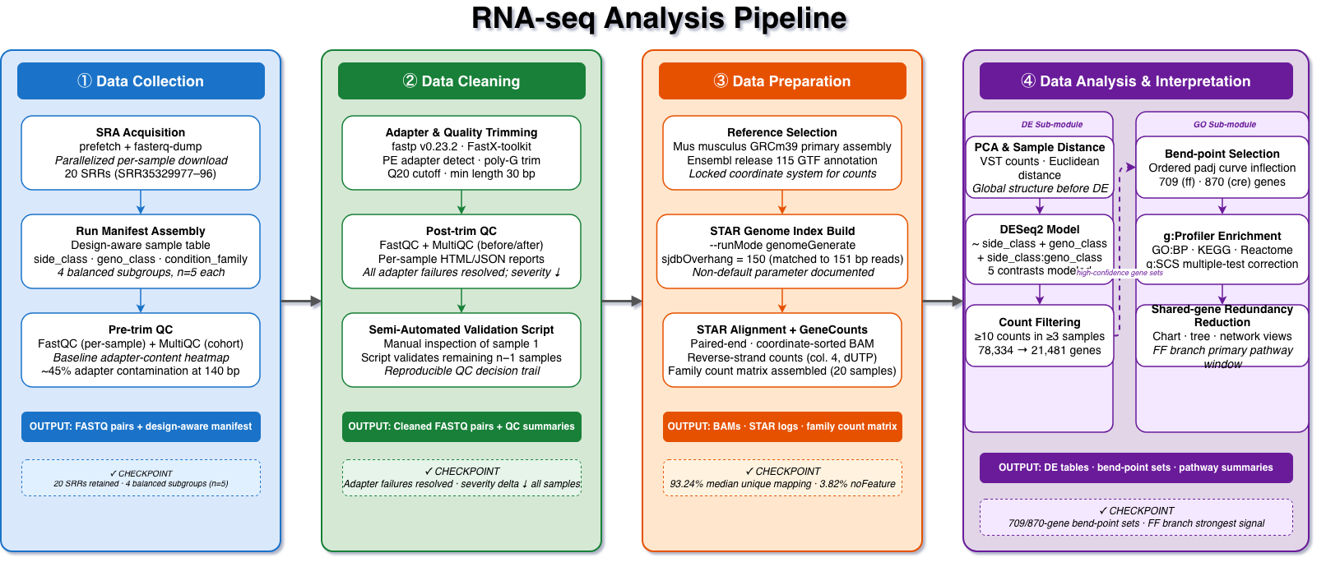Figure 1. Overview ribbon summarizing the four computational stages and their stage in the mouse

The workflow was structured as four connected stages with explicit checkpoints and handoffs. The Collection stage used prefetch and fasterq-dump to assemble the sample table and family manifest, retaining 20 SRRs across four balanced subgroups (n = 5 each) and producing the FASTQ.gz pairs and manifest used throughout the pipeline. The Cleaning stage applied FastQC, MultiQC, and fastp, generating the QC heatmap and severity-delta summary and showing that the raw adapter-content failures were resolved after trimming, with cleaned read pairs and per-sample QC reports passed forward. The Preparation stage used STAR with GeneCounts to generate the unique-mapping plot and STAR median summary, with a median unique-mapping rate of 93.24% and median noFeature rate of 3.82%, and produced the sorted BAMs, STAR logs, count tables, and family matrix used downstream. Finally, the Analysis stage used DESeq2, bend-point follow-up, and g:Profiler to generate the filtering summary, analysis summary, and enrichment-source tables, reducing the tested set from 78,334 to 21,481 genes across five modeled contrasts and producing the DE tables, bend-point follow-up sets, and enrichment summaries used for interpretation.

Representative Command Examples
The corresponding table summarizes representative examples of the commands used to execute the main workflow stages, with emphasis on the computational path and key non-default parameters.
Table 2. Representative command examples for the tools used in the mouse_new
Stage | Tool | Representative command/code example
Collection | prefetch + fasterq-dump | prefetch SRR35329980 && fasterq-dump SRR35329980 --split-files -O fastq/
Cleaning | FastQC | fastqc raw/*.fastq.gz trimmed/*.fastq.gz --outdir fastqc_reports/
Cleaning | MultiQC | multiqc fastqc_reports/ fastp_reports_full/ -o multiqc/
Cleaning | fastp | fastp -i sample_R1.fastq.gz -I sample_R2.fastq.gz -o clean_R1.fastq.gz -O clean_R2.fastq.gz --detect_adapter_for_pe --trim_poly_g --cut_mean_quality 20 --length_required 30 -h sample.html -j sample.json
Preparation | STAR | STAR --runThreadN 8 --genomeDir star_index --readFilesIn clean_R1.fastq.gz clean_R2.fastq.gz --readFilesCommand zcat --sjdbGTFfile Mus_musculus.GRCm39.115.gtf --outSAMtype BAM SortedByCoordinate --quantMode GeneCounts  
Analysis | DESeq2 | dds <- DESeqDataSetFromMatrix(countData, colData, design = side_class * geno_class); dds <- DESeq(dds)
Analysis | bend-point script | python3 run_bendpoint_followup.py --contrast ipsi_vs_contra_in_ff --padj-column padj
Analysis | g:Profiler | gp.profile(organism = "mmusculus", query = selected_genes, sources = c("GO:BP","KEGG","REAC"))

Data Collection: SRA Acquisition and Sample Organization
The analysis began with the published DRG RNA-seq study SRP618841, linked to BioProject PRJNA1322439 and GEO series GSE243308. Public runs were retrieved using the project wrappers around prefetch and fasterq-dump, and the local workflow retained 20 paired-end NovaSeq X libraries from the 1-day-post-injury DRG subset. Recording this accession lineage was important because the pipeline had to remain reusable across candidate mouse datasets; explicit accession-to-run tracking prevented later stages from being tied to an ambiguous source dataset.
After download, metadata were consolidated into a design-aware sample table. Each retained sample was annotated by side_class (ipsilateral or contralateral), geno_class (WT or cKO), and the derived condition_family. This step established a balanced 2 × 2 experimental design, with two genotypes (WT, cKO) by two sides (ipsilateral, contralateral) and five samples per group, which was then used in the DESeq2 model and subsequent interpretation. It also created a reusable family manifest that could be re-read by downstream notebooks without reconstructing group identity from filenames.

Data Cleaning: Quality Control and Read Trimming
Raw read quality was evaluated with FastQC (FastQC), and cohort-level summaries were consolidated with MultiQC (MultiQC). This stage was treated as a documented checkpoint, so pre- and post-trimming QC outputs were retained to show the effect of trimming explicitly. The local workflow used fastp v0.23.2 as the canonical cleanup tool because it provided a reproducible paired-end workflow, generated per-sample reports, and resolved adapter-related signal more effectively than the earlier baseline (fastp).
The retained fastp configuration used paired-end adapter detection, poly-G trimming, a mean-quality cutoff of 20, a minimum retained length of 30 bases, and per-sample HTML/JSON reporting. In the accompanying figure, the left panel shows the module-status heatmap, and the right panel shows the SRR-level severity-change plot. Together, these outputs document a consistent improvement in read quality across the cohort before alignment. Retaining both the raw and trimmed checkpoints also made this stage reusable for later dataset screening, because poor candidate subsets could be rejected or repaired using the same QC evidence.
Data Preparation: Reference Selection and Alignment
Trimmed read pairs were aligned to the Mus musculus GRCm39 primary assembly with the matching Ensembl release 115 annotation. The reference pair used in the local workflow consisted of Mus_musculus.GRCm39.dna.primary_assembly.fa and Mus_musculus.GRCm39.115.gtf. A STAR genome index was generated with sjdbOverhang = 150 to match the 151-bp paired-end reads. Alignment was performed with STAR using gzip-aware input handling, coordinate-sorted BAM output, and GeneCounts, so that the same run also produced per-sample count tables (STAR).
This stage linked cleaned reads to downstream modeling through a stable alignment handoff. For each sample, the workflow retained three key outputs: a coordinate-sorted BAM file, a STAR Log.final.out summary, and a ReadsPerGene.out.tab count table. These outputs provided both the alignment checkpoint and the count-level handoff used to assemble the final family matrix for the DRG subset. Reverse-stranded counts (column 4 of each ReadsPerGene.out.tab file) were used as the input for downstream DESeq2 modeling, consistent with the strandedness assumption used in the project workflow. Treating alignment review and count-matrix assembly as explicit handoffs also made the same preparation stage reusable across candidate datasets.

Data Analysis and Interpretation: Differential Expression and Functional Analysis
The merged family count matrix was analyzed with DESeq2 using the explicit side-by-genotype design carried forward from the sample manifest (DESeq2). An interaction design formula (~ side_class * geno_class) was specified so that the effect of side could differ by genotype, while all five contrast branches were extracted from a single fitted model. Before modeling, low-support genes were filtered, reducing the tested set from 78,334 to 21,481 genes while retaining all 20 DRG samples. Five contrasts were then evaluated: ipsilateral vs contralateral in WT, ipsilateral vs contralateral in cKO, WT vs cKO in contralateral, WT vs cKO in ipsilateral, and interaction. This contrast inventory was kept fixed so that later interpretation did not drift when one branch became more interpretable than another.
Downstream interpretation followed a PCA-first, branch-priority logic. PCA was used to evaluate sample structure before long DE tables were emphasized, and the side-specific branches were then carried forward as the primary follow-up path. To avoid reducing very large DE outputs to unstructured gene lists, the workflow applied a bend-point rule to the ordered adjusted-p-value curve for each contrast. These bend-point-derived follow-up sets were reported alongside the padj < 0.05 results. For the two primary side-specific contrasts, this step retained 709 and 870 genes, respectively.
The resulting follow-up sets were then submitted to g:Profiler using GO Biological Process, KEGG, and Reactome layers (g:Profiler). In the WT branch, which remained the clearest pathway-level follow-up, enrichment outputs were further summarized using shared-gene chart, tree, and network views to reduce redundancy among overlapping GO labels. These enrichment products are described here as downstream summaries of the differential-expression workflow rather than as final biological claims.

Results
Quality Control and Trimming of RNASeq Data
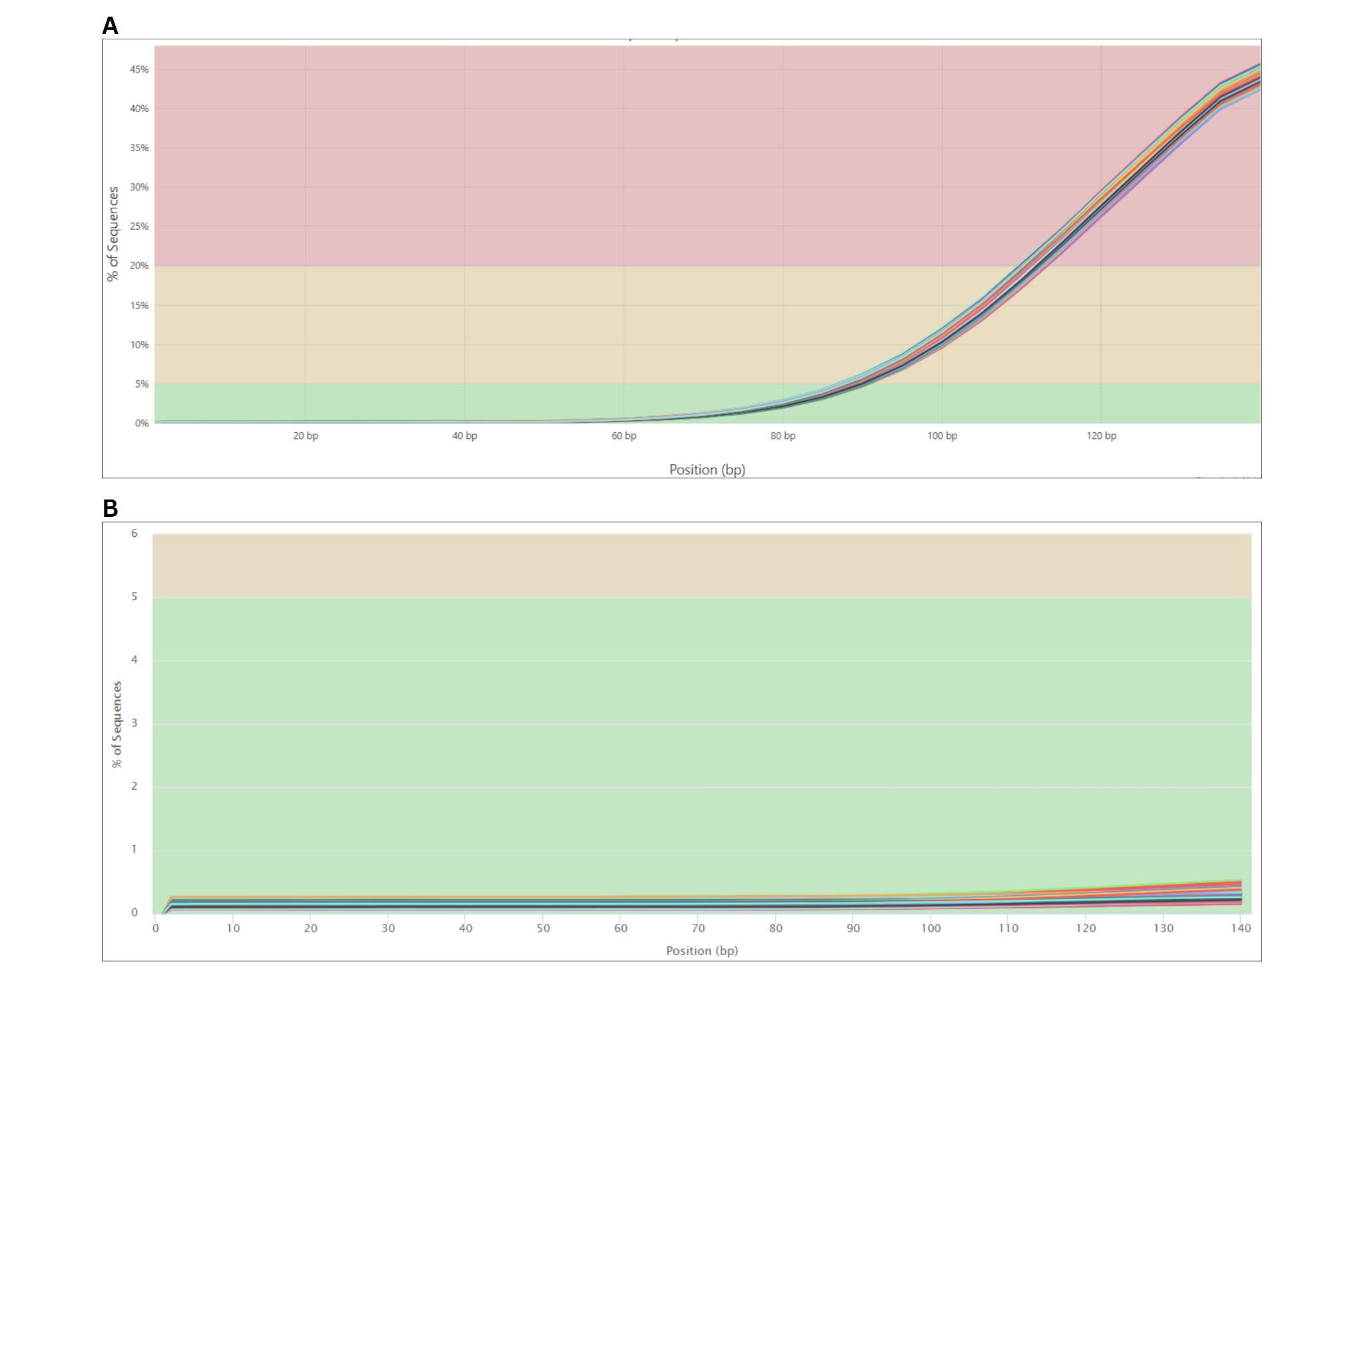
Figure X. Plots displaying adapter content present in the RNASeq samples pre-trim (A) and post-trim (B). The plots demonstrate the percentage of sequences that have the adapter content due to RNASeq steps, where the post-trim plot has significantly less adapter content present.

To proceed with using the dataset, it was important to evaluate the dataset before trimming to see what issues lie in the raw data. MultiQC was used to interpret the data with a holistic approach. The data initially showed that there was an issue with adapter content in the post-sequencing data from the paper, with about 45% of sequences having adapter sequences present around the 140 bp mark (Fig.XA). However, this is expected after RNASeq due to the adapters required for sequencing. To resolve this issue, the dataset was trimmed to clear the adapter issues along with overrepresented sequences and sequence duplication. After trimming, the number of sequences with adapter sequences fell below 1% (Fig.XB).

A. B.
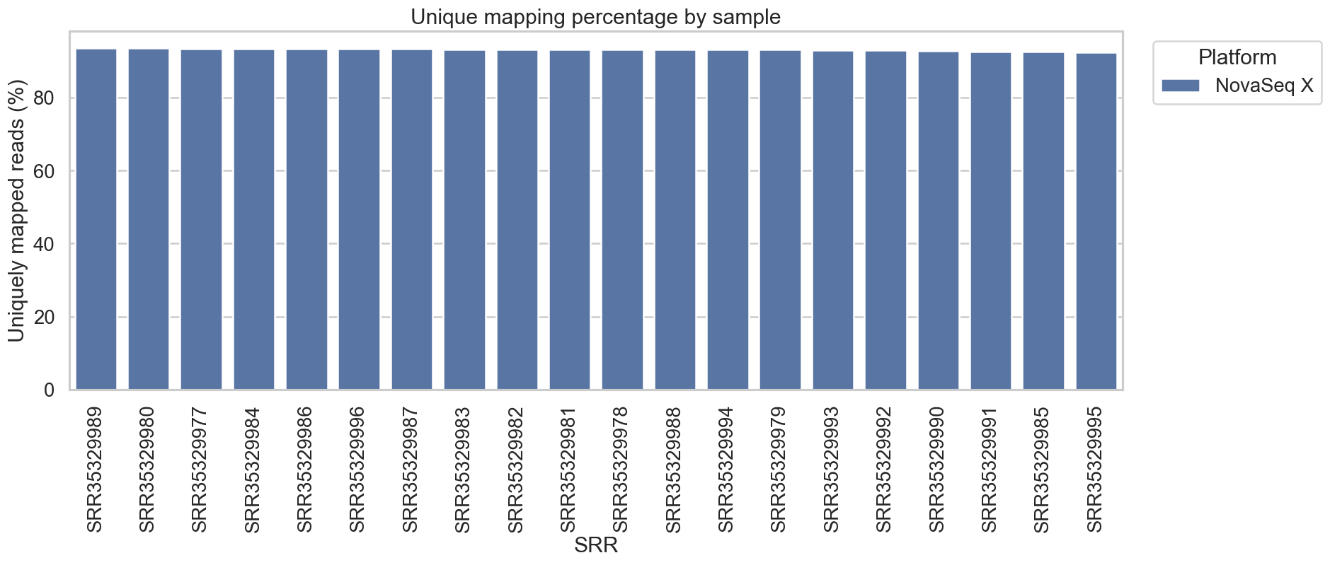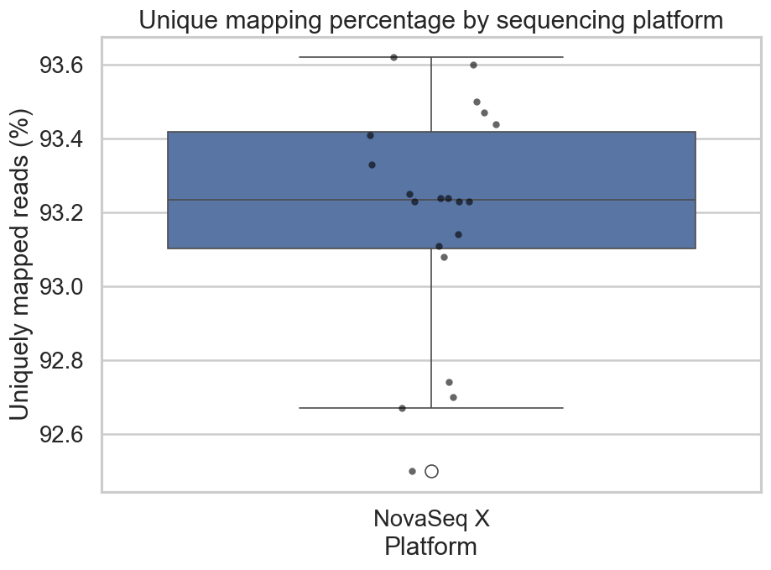
Figure X. Display of statistics after completing alignment of RNASeq data to the GRCm39 Mus musculus reference genome. Figure A displays the unique mapping percentages across each read, and Figure B displays a box plot showing the distribution of the uniquely mapped reads.

Alignment statistics recorded once aligning the trimmed reads to the reference genome displayed a high-quality alignment. Each read had a uniquely mapped read percentage above 90%, which is a high number for alignment (Fig.XA). The lowest percentage was below 92.6%, which seems to be more of an outlier when comparing it to the rest of the reads (Fig.XB). Most of the reads were placed between 93.1% and just a little above 93.4%. The alignment metrics show that this is a high-quality dataset, and gave us confidence to proceed with more differential expression analysis steps.

Differential Expression Analysis
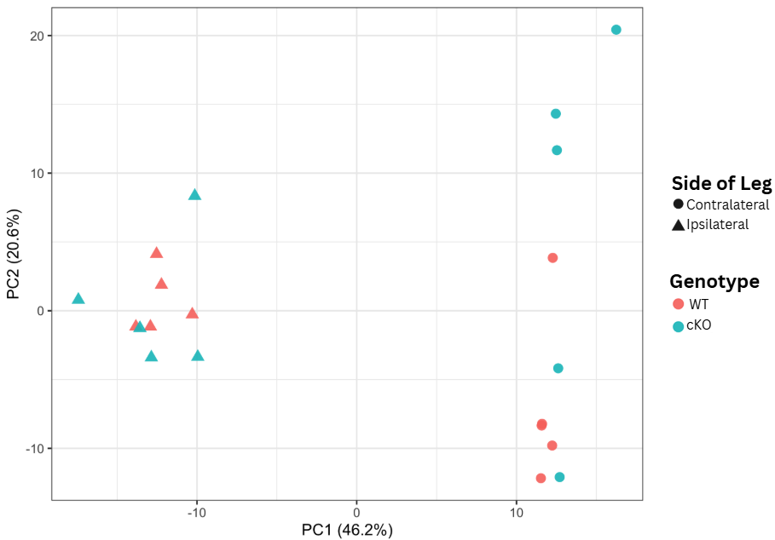
Figure X. Principal Component Analysis (PCA) of DRG Transcriptomes. Samples are plotted along the first two principal components, which capture 46.2% and 20.6% of the total variance, respectively. The shapes represent the injury state (circle: contralateral; triangle: ipsilateral) and colors represent genotype (coral: wildtype; teal: AhR cKO).

PCA was performed to reduce the dimensionality of the dataset, which contained ~21,000 genes across twenty mouse samples (Fig. X). The PCA consolidated the ~21,000 genes into two primary components that represent 66.8% of the total biological signal. PC1 (46.2%) represents the primary variance driven by the response to nerve injury (contralateral vs. ipsilateral), while PC2 (20.6%) represents the secondary variance driven by the Ahr genotype (WT vs. cKO).

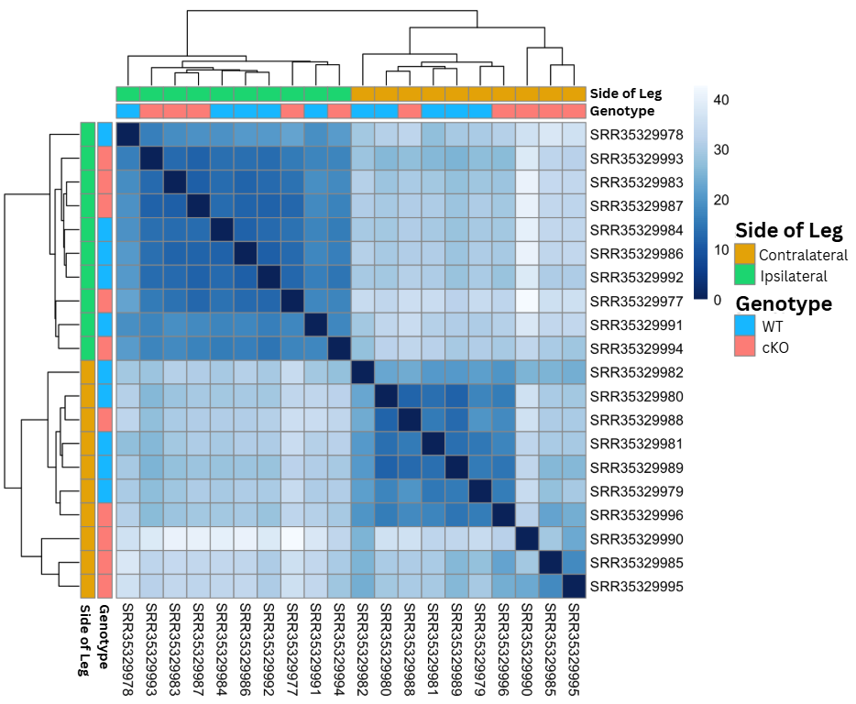
Figure X. Sample-to-Sample Distance Heatmap of DRG Transcriptomes. Euclidean distances between samples were calculated based on the regularized log-transformed (rlog) count data. Darker blue indicates higher similarity (lower distance), while lighter blue indicates lower similarity (higher distance). Samples are hierarchically clustered, revealing a primary separation by nerve injury (ipsilateral vs. contralateral) and secondary clustering by genotype (wildtype vs. cKO).

To assess global transcriptomic similarity, we generated a sample-to-sample distance heatmap based on Euclidean distance metrics (Fig. X). The results demonstrate clear and distinct unsupervised clustering based primarily on the experimental condition, with ipsilateral (green) and contralateral (gold) samples forming two highly cohesive blocks. Within these primary clusters, samples were further partitioned by genotype (blue: wildtype; pink: AhR cKO), indicating that the AhR knockout introduces a consistent transcriptional shift. The high degree of similarity between biological replicates and the lack of anomalous clustering confirm the high quality and reproducibility of the sequencing data.

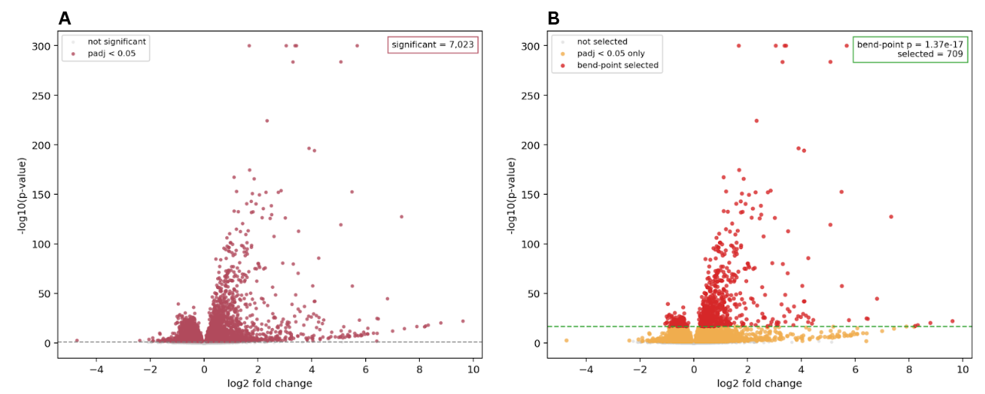
Figure X. Comparison of volcano plots between all significant genes (A) and highlighting the genes present at the identified bend-point (B). The volcano plot is observing all the genes that were significantly expressed and had a p-value under 0.05 (A). The second volcano plot highlights the genes under the new p-value threshold in red to identify the genes being used for further analysis.

This dataset was looking at a vast number of genes, so the bend-point was determined to cut down the number of significant genes being analyzed. The bend point occurred at a p-value of 1.37e⁻¹⁷ (Fig.X). At this p-value, about 709 genes appeared. In the volcano plot representing the genes that are being represented, it can be visualized that the dense pack of genes is now being ignored because of the new p-value threshold, and instead highlights genes that are differentially expressed more significantly. These 709 genes will allow for more targeted analysis, provided that they are highly significant and mark exactly where the change begins to occur.

Gene Ontology Analysis
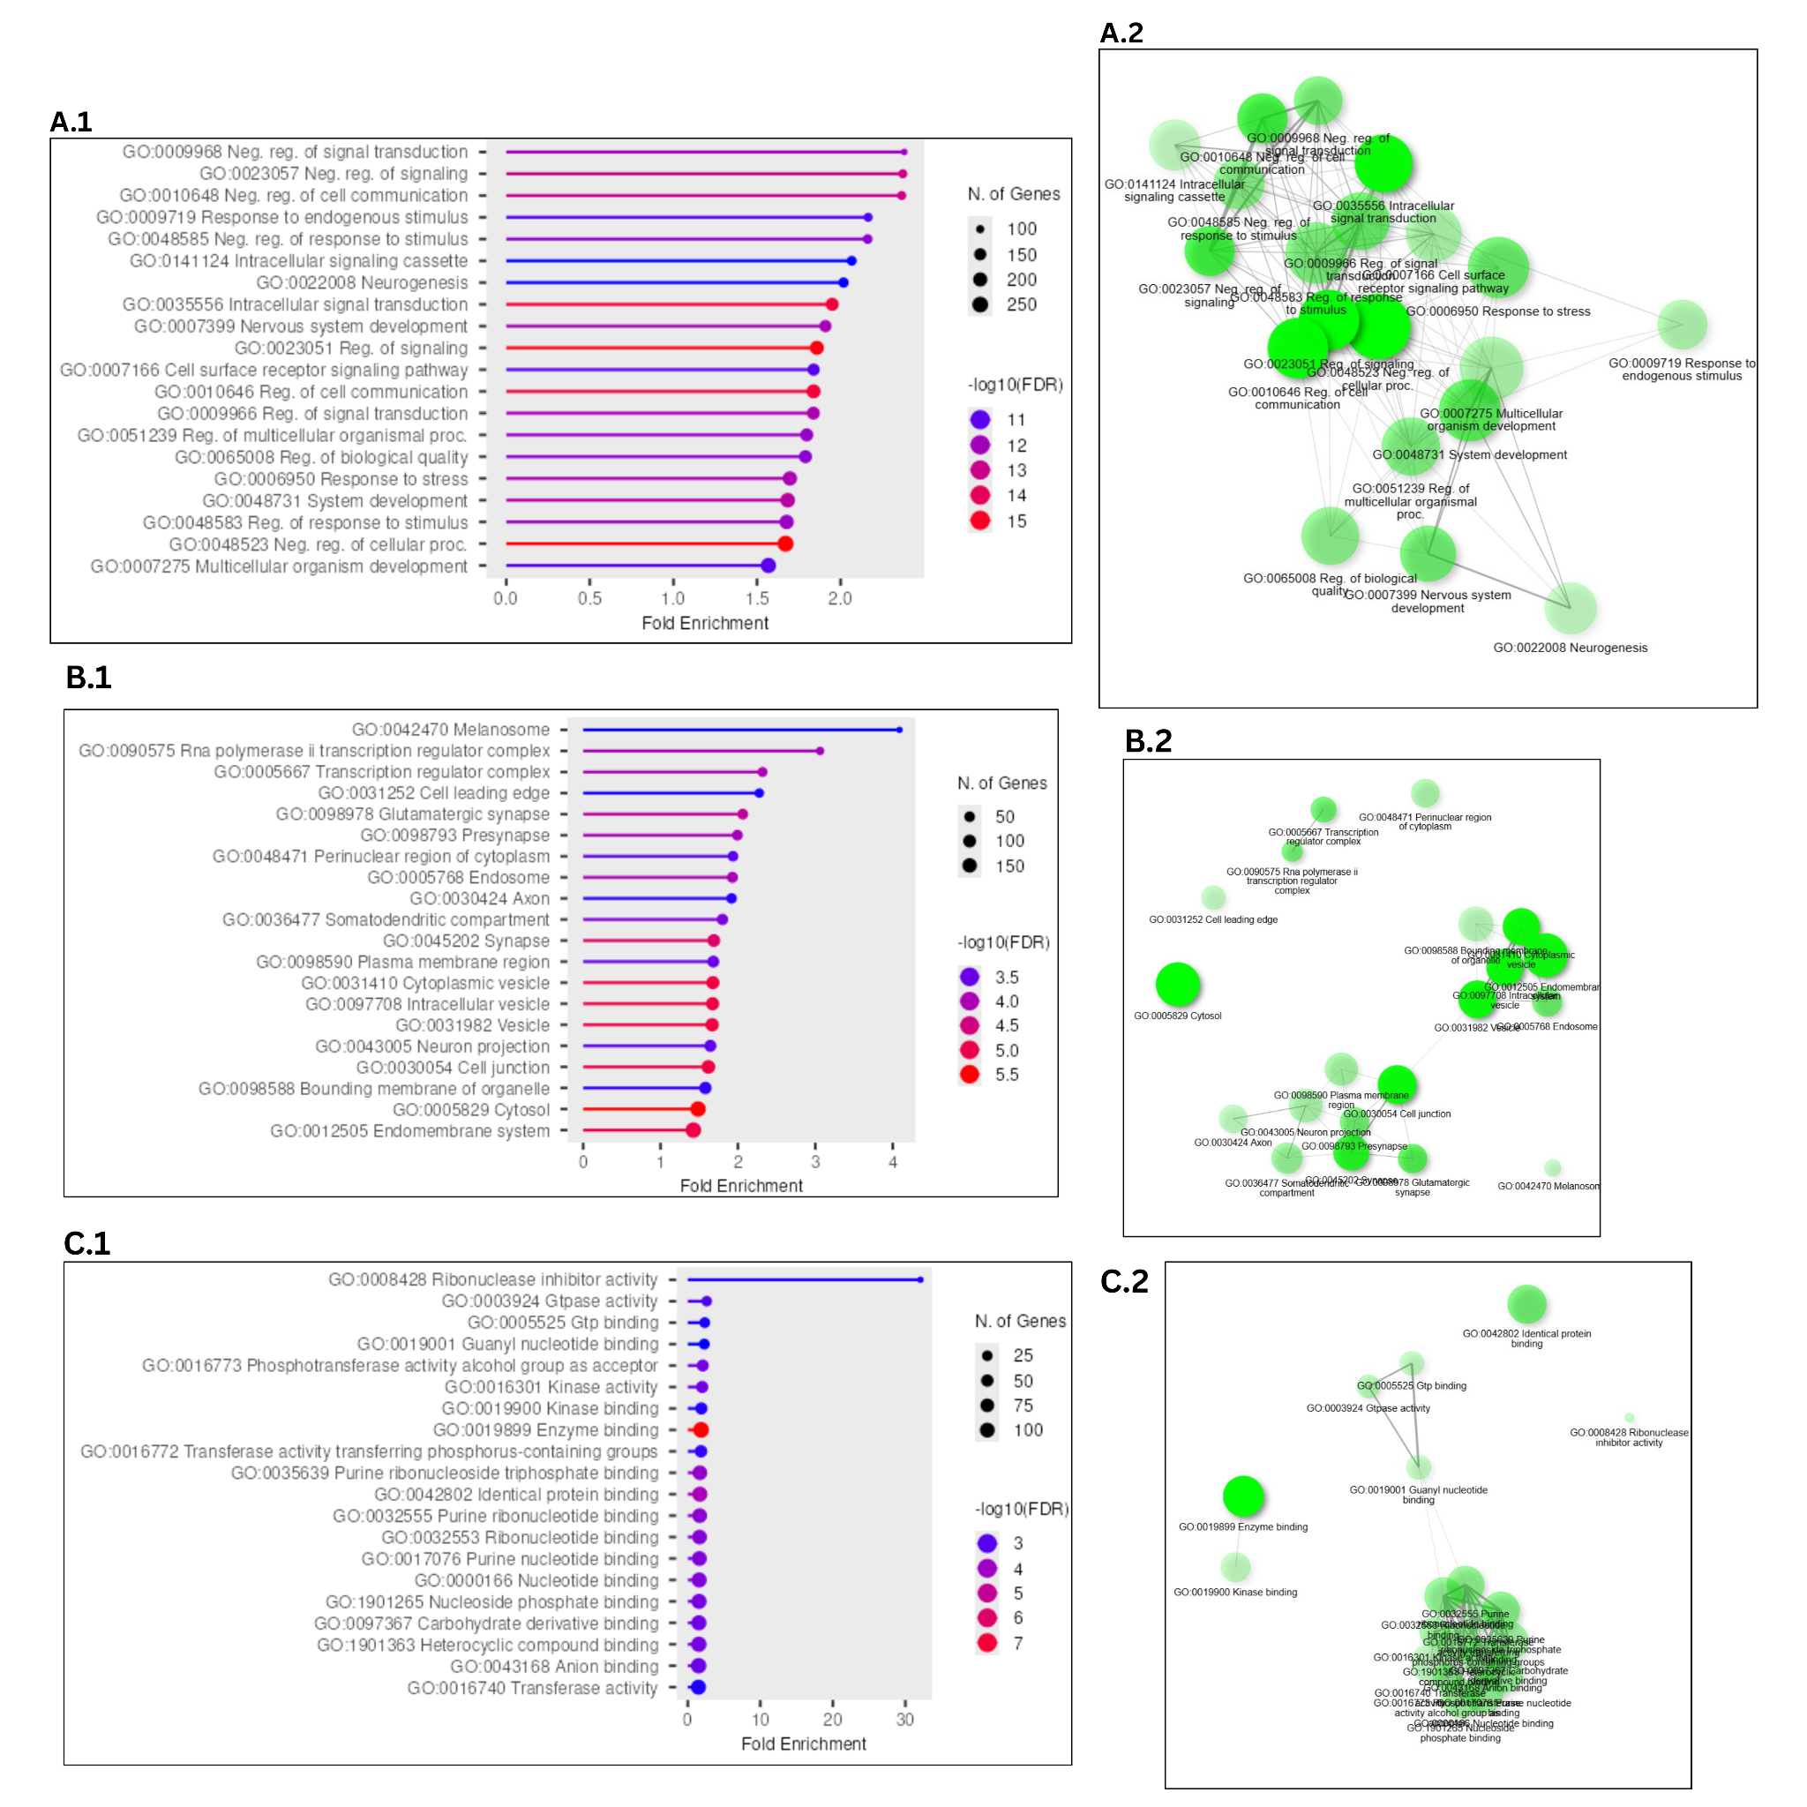
Figure X. Gene Ontology (GO) analysis of 709 differentially expressed genes selected from the dataset. The genes were evaluated in three different categories, Biological Process (A), Cellular Component (B), and Molecular Function (C), and demonstrated through lollipop charts (1) and network plots (2). The 20 most significant FDR terms were selected in each category.

Gene Ontology Analysis (GOA) was conducted to see which biological processes were most enriched based on significant genes, and also to provide some biological context on the functions of the genes. Both lollipop plots and network charts were used to understand the significance of the gene appearing and how it correlated with the other genes based on the pathways they are involved with. Separated into three categories, the first category that was observed was Biological Process (BP).
The BP analysis seemed to be the most consistent across all the terms listed as significant. Each term had a minimum of 100 genes that would be classified as such, with the max being about 250 (Fig.XA.1). The highest false discovery rate (FDR) was -log(11), which means these are fairly accurate. However, the most significantly enriched term is close to a fold enrichment (FE) of 2.5, which is lower than the other categories. Across the terms present in the top 20 enriched terms, many are correlated with the negative regulation of cell signaling and communication, or correlated with responses to stimuli. With this in mind, it makes sense for all the pathways to be connected through shared genes, as displayed in the network (Fig.XA.2).
The cellular component (CC) analysis was less consistent than BP, but many of the enriched terms were still connected. Fewer genes could be grouped into this category, but the ones that did had an FE as high as 4 and an FDR rate as low as -log10(5.5) (Fig.XB.1). The most enriched term was Melansome, but terms were corresponding to axon components and transcription regulators. However, as a whole list, it does correspond with different groups, which can be observed in the network (Fig.XB.2). There are also two groups present, corresponding with vesicles and neurons, and a couple of outliers. Overall, the terms are less connected.
The molecular function (MF) component analysis contained the least consistency, compared to BP and CC. One term, Ribonuclease inhibitor activity (RIA), was the most enriched with an FE above 30 (Fig.XC.1). It also contains the lowest FDR, -log10(3), compared to the rest, and there isn’t a high number of genes associated with it. The rest of the pathways that appeared under MF had an FE below 5. The genes with the lower FE were more connected in the network, while RIA is not connected with the rest (Fig.XC.2). These genes are more correlated with the binding of molecules.
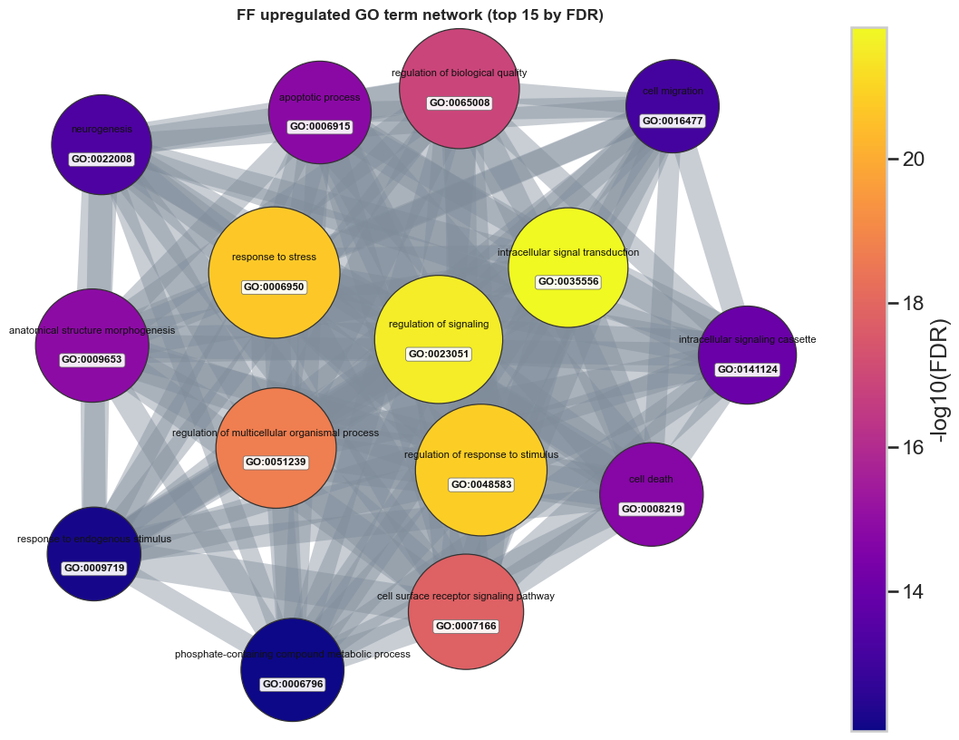

Discussion
The most stable finding in this dataset was that the side-specific injury contrasts carried the strongest structure. The early QC and alignment checkpoints supported keeping this 20-sample DRG subset for downstream modeling. The main interpretive shift came from the PCA-first review: side separated more clearly than genotype, while genotype behaved as a secondary axis with substantial overlap between paired WT and cKO samples. That same pattern is still visible across the DE, bend-point, and GO follow-up analyses. The PCA and sample-distance views pointed to the same conclusion: ipsilateral versus contralateral structure was clearer than genotype structure, making the side-specific contrasts the most defensible main path for interpretation.
This PCA-first reading disciplined the interpretation of the large DE output; the analysis converged on a branch-priority logic in which ipsilateral vs contralateral in WT and ipsi_vs_contra_in_cre served as the primary follow-up branches, while WT vs cKO in contralateral was retained as the strongest supporting genotype comparison. The secondary branches show that genotype effects are not absent, but they do not displace the side-specific injury signal as the main story.
The bend-point step marked the transition from broad DE output to a smaller and more interpretable follow-up set. The workflow used the ordered adjusted-p-value curve as a reproducible narrowing rule for the two main side-specific contrasts, which reduced 7,023 and 7,541 significant genes to 709 and 870, respectively. These smaller sets remained strongly supported statistically while becoming more practical for pathway-level follow-up. In that sense, the bend-point step made the strongest part of that result easier to interpret against known injury and regeneration mechanisms.
Among the follow-up branches, ipsilateral vs contralateral in WT remained the clearest pathway-level result. It combined a strong side-driven separation, a large but reducible DE set, and the most coherent enrichment profile. GO Biological Process dominated the enrichment summary, and the WT GO follow-up made it clear that the large number of enriched terms should not be read as many unrelated pathway stories. Once shared-gene structure was examined through the chart, tree, and network views, the strongest upregulated terms converged around signaling, migration, morphogenesis, stress response, and neurogenic remodeling. That convergence made the WT branch the strongest biological centerpiece for the Discussion.
The ipsilateral vs contralateral in cKO branch still strengthens the overall argument because it reproduces the same side-specific logic and retains a substantial bend-point set, but it is slightly less clean than the main pathway branch. Likewise, WT vs cKO in contralateral remains useful supporting material because it preserves a genotype-specific signal under contralateral conditions, but it works better as context.
These results still need to be read with some caution. First, GO redundancy can make the functional signal look broader than it really is when overlapping labels are counted as if they were independent findings. Second, the pathway summaries are only persuasive here because they were interpreted after the PCA-first and bend-point-guided narrowing steps. Third, branch prioritization in this project reflects consistency, interpretability, and alignment with the visible sample structure; this does not mean the other modeled contrasts are biologically unimportant. Within those limits, the strongest discussion claim is still clear: this workflow converged on a robust side-specific injury-response program, and the WT branch provided the clearest pathway-level view of that response.
References
Intro sources: The Dorsal Root Ganglion as a Novel Neuromodulatory Target to Evoke Strong and Reproducible Motor Responses in Chronic Motor Complete Spinal Cord Injury: A Case Series of Five Patients, publication + ref 20 in publication.

