NGS Reanalysis Study on Global DEG Discovery in a DRG Mouse Dataset
BIOL550 Group Paper
Draft 2 Research Paper

Authors
Nikhi Boggavarapu
Sam Kopelev
Piter Garcia

Author Contribution Reference
This working draft is submitted as a collaborative BIOL550 group paper with contributions attributed to Nikhi Boggavarapu, Sam Kopelev, and Piter Garcia.

Introduction
We reanalyzed a published mouse dorsal root ganglion (DRG) RNA-seq dataset to examine how injury responses and regeneration are balanced after peripheral nerve damage, with particular attention to the aryl hydrocarbon receptor (Ahr). The original study used a neuronal conditional Ahr knockout because DRGs are a useful model for peripheral axon regrowth after sciatic nerve injury, and the conditional design helps isolate neuron-intrinsic effects more cleanly than a constitutive knockout background (Halawani et al., 2023).
The paper that guided our RNA-seq analysis sought to clarify the role of the AhR pathway. Earlier work by Zuo et al. examined neuronal injury responses and identified transcription factors associated with growth and regeneration, particularly Smad1, ATF3, and Jun. That study also highlighted AhR as an outlier pathway, but its function remained unclear. The main study addressed this question through protein-protein interaction network analysis using STRING, which showed that Smad1, ATF3, and Jun formed a highly interconnected pro-regenerative hub. In contrast, AhR remained distinct from this network, suggesting that it operates independently from the established growth-response pathway (Halawani et al., 2023).
After addressing how AhR relates to the previously identified transcription factors, the study moved beyond gene identification to investigate mechanism. This phase showed that AhR does not directly regulate growth; instead, it regulates cellular stress responses, translation, and proteostasis. AhR was therefore positioned as a functionally distinct network driven by HIF-1α, Bmal1, and stress-response transcription factors such as ATF4 and ATF6. Under normal conditions, when AhR is intact, nerve injury suppresses protein synthesis. In contrast, when AhR is removed, protein synthesis increases substantially, shifting the cell toward a highly active de novo translation state (Halawani et al., 2023).
To investigate the effects of uninhibited neuronal regeneration, the researchers analyzed dorsal root ganglia (DRG)—clusters of sensory neurons whose peripheral branches have a unique capacity for regrowth—following the targeted knockout of AhR. Each of the twenty mice underwent two surgeries, one on each leg. The ipsilateral side refers to the controlled nerve crush injury, whereas the contralateral side refers to the side opposite the crushed nerve. Because whole-body knockout promoted demyelinating disease, the axonal regrowth detected in Ahr cKO mice was interpreted as arising from a neuron-intrinsic mechanism rather than from altered immune or Schwann cell responses (Halawani et al., 2023).
FF is an abbreviation for fl/fl, referring to the homozygous floxed state. Floxed indicates that a gene is flanked by loxP sites. loxP functions as a biochemical tag used by researchers. On its own, this tag has no direct effect and behaves as wild type; however, when Cre recombinase is introduced, the loxP sites act as beacons that mark where the enzyme should cut. Cre stands for Cre recombinase, the DNA-cutting enzyme guided by the loxP sites to remove the gene between them. In this study, the researchers used Thy1-CreERT2 and Nestin-Cre to ensure that the Cre enzyme was produced specifically in neurons (Halawani et al., 2023).
First, we aimed to reproduce the study’s findings, particularly the differentially expressed genes (DEGs). Although the study used response-shift scores (RSS) to filter DEGs, we performed a global differential expression analysis and identified 709 statistically significant genes. Second, we aimed to cross-reference those genes, identify validated and unique genes from our global analysis, and compare the gene ontology categories to which they belong in order to understand the biological processes involved (Halawani et al., 2023).
We use the source paper as a guide for understanding the biological processes involved and how they differ from our global differential expression approach. Because the original study focused specifically on genes correlated with AhR through the RSS filter, our broader reanalysis provides a way to compare that targeted view with a transcriptome-wide interpretation (Halawani et al., 2023).

With these goals in mind, we completed the core steps of RNA-seq analysis, including trimming and alignment. We also conducted a differential expression analysis comparing ipsilateral versus contralateral samples and wild-type versus conditional knockout genotypes. Beyond differential expression, we carried out gene ontology analysis to place the strongest gene sets into biological context and to better understand the functional roles of the genes highlighted by the experiment (Halawani et al., 2023; Love et al., 2014; Kolberg et al., 2020).

Materials and Methods

This project reanalyzed mouse DRG bulk RNA-seq data collected after sciatic nerve injury using a four-stage computational workflow: Data Collection, Data Cleaning, Data Preparation, and Data Analysis and Interpretation. This structure was used to keep accession tracking, quality control, alignment review, and downstream modeling as explicit and reproducible checkpoints, while allowing the same analysis path to be reused after earlier dataset-selection issues without rebuilding the workflow from scratch (Wirth & Hipp, 2000).
The working subset comprised 20 paired-end Illumina NovaSeq X libraries from SRP618841 (BioProject PRJNA1322439; GEO GSE243308), representing L4–L6 dorsal root ganglion samples collected 1 day after sciatic nerve injury (Halawani et al., 2023; National Center for Biotechnology Information [NCBI], 2026a, 2026b, 2026c). The local subset was organized as a balanced side-by-genotype design within the family_drg_novaseqx family, with equal representation of ipsilateral and contralateral samples and of wild-type and cKO genotype classes before quality control, alignment, and differential expression analysis. At each stage, outputs were reviewed and advanced through defined checkpoints to maintain consistency and reproducibility throughout the analysis.

Figure 1. Overview ribbon summarizing the four computational stages in the mouse_new workflow.

The workflow was structured as four connected stages with explicit checkpoints and handoffs. The Collection stage used prefetch and fasterq-dump to assemble the sample table and family manifest, retaining 20 SRRs across four balanced subgroups (n = 5 each) and producing the FASTQ.gz pairs and manifest used throughout the pipeline. The Cleaning stage applied FastQC, MultiQC, and fastp, generating the QC heatmap and severity-delta summary and showing that the raw adapter-content failures were resolved after trimming, with cleaned read pairs and per-sample QC reports passed forward. The Preparation stage used STAR with GeneCounts to generate the unique-mapping plot and STAR median summary, with a median unique-mapping rate of 93.24% and a median noFeature rate of 3.82%, and produced the sorted BAMs, STAR logs, count tables, and family matrix used downstream. Finally, the Analysis stage used DESeq2, bend-point follow-up, and g:Profiler to generate the filtering summary, analysis summary, and enrichment-source tables, reducing the tested set from 78,334 to 21,481 genes across five modeled contrasts and producing the differential expression tables, bend-point follow-up sets, and enrichment summaries used for interpretation (Andrews, 2010; Chen et al., 2018; Dobin et al., 2013; Ewels et al., 2016; Kolberg et al., 2020; Love et al., 2014).

Representative Command Examples
The corresponding table summarizes representative examples of the commands used to execute the main workflow stages, with emphasis on the computational path and key non-default parameters.
Table 2. Representative command examples for the tools used in the mouse_new
Stage | Tool | Representative command/code example
Collection | prefetch + fasterq-dump | prefetch SRR35329980 && fasterq-dump SRR35329980 --split-files -O fastq/
Cleaning | FastQC | fastqc raw/*.fastq.gz trimmed/*.fastq.gz --outdir fastqc_reports/
Cleaning | MultiQC | multiqc fastqc_reports/ fastp_reports_full/ -o multiqc/
Cleaning | fastp | fastp -i sample_R1.fastq.gz -I sample_R2.fastq.gz -o clean_R1.fastq.gz -O clean_R2.fastq.gz --detect_adapter_for_pe --trim_poly_g --cut_mean_quality 20 --length_required 30 -h sample.html -j sample.json
Preparation | STAR | STAR --runThreadN 8 --genomeDir star_index --readFilesIn clean_R1.fastq.gz clean_R2.fastq.gz --readFilesCommand zcat --sjdbGTFfile Mus_musculus.GRCm39.115.gtf --outSAMtype BAM SortedByCoordinate --quantMode GeneCounts
Analysis | DESeq2 | dds <- DESeqDataSetFromMatrix(countData, colData, design = side_class * geno_class); dds <- DESeq(dds)
Analysis | bend-point script | python3 run_bendpoint_followup.py --contrast ipsi_vs_contra_in_ff --padj-column padj
Analysis | g:Profiler | gp.profile(organism = "mmusculus", query = selected_genes, sources = c("GO:BP","KEGG","REAC"))

Data Collection: SRA Acquisition and Sample Organization
The analysis began with the published DRG RNA-seq study SRP618841, linked to BioProject PRJNA1322439 and GEO series GSE243308. Public runs were retrieved using the project wrappers around prefetch and fasterq-dump, and the local workflow retained 20 paired-end NovaSeq X libraries from the 1-day-post-injury DRG subset. Recording this accession lineage was important because the pipeline had to remain reusable across candidate mouse datasets; explicit accession-to-run tracking prevented later stages from being tied to an ambiguous source dataset (National Center for Biotechnology Information, 2026a, 2026b, 2026c, 2026d).
After download, metadata were consolidated into a design-aware sample table. Each retained sample was annotated by side_class (ipsilateral or contralateral), geno_class (WT or cKO), and the derived condition_family. This step established a balanced 2 × 2 experimental design, with two genotypes (WT, cKO) by two sides (ipsilateral, contralateral) and five samples per group, which was then used in the DESeq2 model and subsequent interpretation. It also created a reusable family manifest that could be re-read by downstream notebooks without reconstructing group identity from filenames.

Data Cleaning: Quality Control and Read Trimming
Raw read quality was evaluated with FastQC, and cohort-level summaries were consolidated with MultiQC. This stage was treated as a documented checkpoint, so pre- and post-trimming QC outputs were retained to show the effect of trimming explicitly (Andrews, 2010; Ewels et al., 2016). The local workflow used fastp v0.23.2 as the canonical cleanup tool because it provided a reproducible paired-end workflow, generated per-sample reports, and resolved adapter-related signal more effectively than the earlier baseline (Chen et al., 2018).
The retained fastp configuration used paired-end adapter detection, poly-G trimming, a mean-quality cutoff of 20, a minimum retained length of 30 bases, and per-sample HTML/JSON reporting. In the accompanying figure, the left panel shows the module-status heatmap, and the right panel shows the SRR-level severity-change plot. Together, these outputs document a consistent improvement in read quality across the cohort before alignment. Retaining both the raw and trimmed checkpoints also made this stage reusable for later dataset screening, because poor candidate subsets could be rejected or repaired using the same QC evidence.

Data Preparation: Reference Selection and Alignment
Trimmed read pairs were aligned to the Mus musculus GRCm39 primary assembly with the matching Ensembl release 115 annotation. The reference pair used in the local workflow consisted of Mus_musculus.GRCm39.dna.primary_assembly.fa and Mus_musculus.GRCm39.115.gtf. A STAR genome index was generated with sjdbOverhang = 150 to match the 151-bp paired-end reads. Alignment was performed with STAR using gzip-aware input handling, coordinate-sorted BAM output, and GeneCounts, so that the same run also produced per-sample count tables (Dobin et al., 2013; Ensembl, 2025).
This stage linked cleaned reads to downstream modeling through a stable alignment handoff. For each sample, the workflow retained three key outputs: a coordinate-sorted BAM file, a STAR Log.final.out summary, and a ReadsPerGene.out.tab count table. These outputs provided both the alignment checkpoint and the count-level handoff used to assemble the final family matrix for the DRG subset. Reverse-stranded counts (column 4 of each ReadsPerGene.out.tab file) were used as the input for downstream DESeq2 modeling, consistent with the strandedness assumption used in the project workflow. Treating alignment review and count-matrix assembly as explicit handoffs also made the same preparation stage reusable across candidate datasets.

Data Analysis and Interpretation: Differential Expression and Functional Analysis
The merged family count matrix was analyzed with DESeq2 using the explicit side-by-genotype design carried forward from the sample manifest (Love et al., 2014). An interaction design formula (~ side_class * geno_class) was specified so that the effect of side could differ by genotype, while all five contrast branches were extracted from a single fitted model. Before modeling, low-support genes were filtered, reducing the tested set from 78,334 to 21,481 genes while retaining all 20 DRG samples. Five contrasts were then evaluated: ipsilateral versus contralateral in WT, ipsilateral versus contralateral in cKO, WT versus cKO in contralateral, WT versus cKO in ipsilateral, and interaction. This contrast inventory was kept fixed so that later interpretation did not drift when one branch became more interpretable than another.
Downstream interpretation followed a PCA-first, branch-priority logic. PCA was used to evaluate sample structure before long DE tables were emphasized, and the side-specific branches were then carried forward as the primary follow-up path. To avoid reducing very large DE outputs to unstructured gene lists, the workflow applied a bend-point rule to the ordered adjusted-p-value curve for each contrast. These bend-point-derived follow-up sets were reported alongside the padj < 0.05 results. For the two primary side-specific contrasts, this step retained 709 and 870 genes, respectively.
The resulting follow-up sets were then submitted to g:Profiler using GO Biological Process, KEGG, and Reactome layers (Gene Ontology Consortium, 2021; Gillespie et al., 2022; Kanehisa et al., 2025; Kolberg et al., 2020). In the WT branch, which remained the clearest pathway-level follow-up, enrichment outputs were further summarized using shared-gene chart, tree, and network views to reduce redundancy among overlapping GO labels. These enrichment products are described here as downstream summaries of the differential-expression workflow rather than as final biological claims.

Results
The results are presented in the same order as the workflow described in the Methods section, moving from data quality and alignment to differential expression and functional interpretation.

Quality Control and Trimming of RNASeq Data
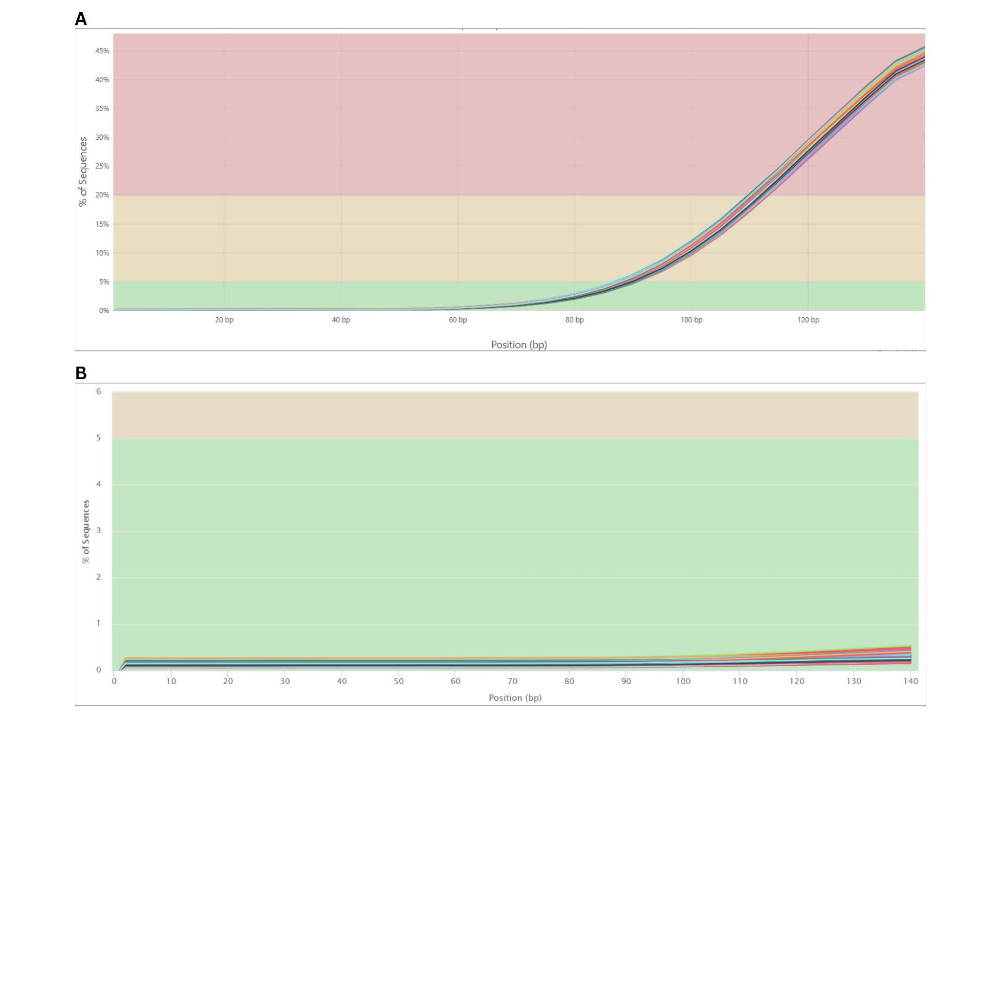
Figure X. Plots displaying adapter content present in the RNASeq samples pre-trim (A) and post-trim (B). The plots demonstrate the percentage of sequences that have the adapter content due to RNASeq steps, where the post-trim plot has significantly less adapter content present.

Before using the dataset downstream, it was necessary to evaluate the raw data to identify any major quality issues. MultiQC was used to summarize the sequencing results at the cohort level. The initial review showed a clear adapter-content issue in the post-sequencing data, with about 45% of sequences containing adapter sequence near the 140-bp position (Fig. XA). This pattern is expected in RNA-seq because adapters are required during library preparation and sequencing. To address this issue, the dataset was trimmed to remove adapter contamination, overrepresented sequences, and excess sequence duplication. After trimming, the proportion of sequences containing adapters dropped to below 1% (Fig. XB).

A. B.
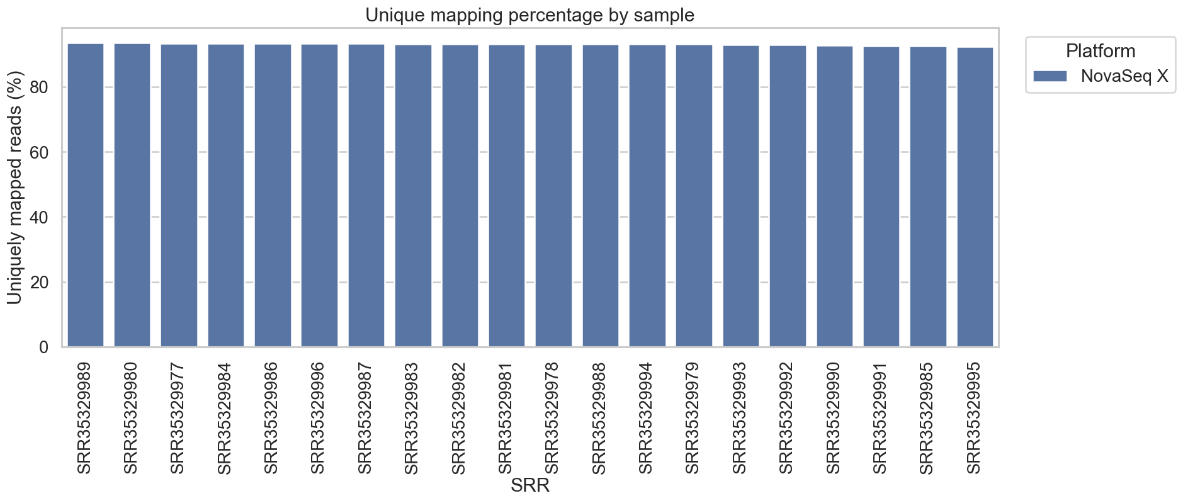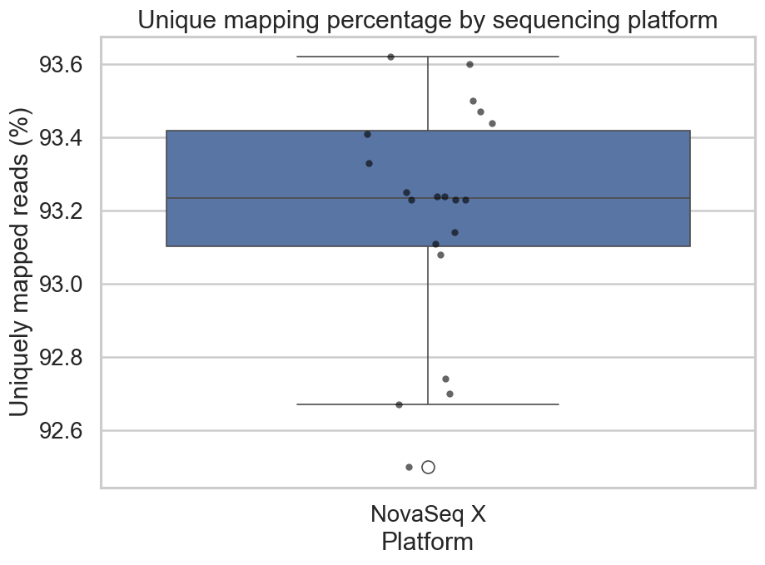
Figure X. Display of statistics after completing alignment of RNASeq data to the GRCm39 Mus musculus reference genome. Figure A displays the unique mapping percentages across each read, and Figure B displays a box plot showing the distribution of the uniquely mapped reads.

Alignment statistics recorded after mapping the trimmed reads to the reference genome indicated high-quality alignment. Each sample had a uniquely mapped read percentage above 90% (Fig. XA). The lowest value was just below 92.6%, which appears to be a mild outlier relative to the rest of the dataset (Fig. XB). Most samples clustered between 93.1% and slightly above 93.4%. Overall, these alignment metrics indicate that the dataset is high quality and support proceeding with downstream differential expression analyses.

Differential Expression Analysis
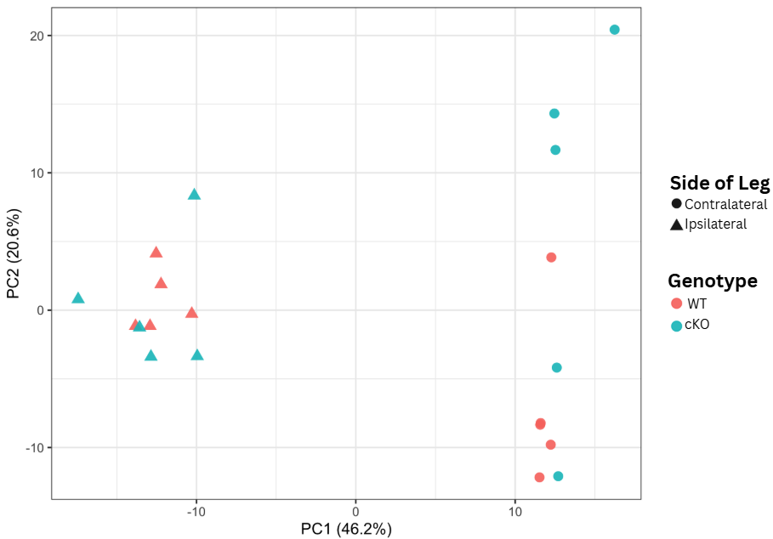
Figure X. Principal Component Analysis (PCA) of DRG Transcriptomes. Samples are plotted along the first two principal components, which capture 46.2% and 20.6% of the total variance, respectively. The shapes represent the injury state (circle: contralateral; triangle: ipsilateral) and colors represent genotype (coral: wildtype; teal: AhR cKO).

PCA was performed to reduce the dimensionality of the dataset, which contained ~21,000 genes across twenty mouse samples (Fig. X). The analysis condensed these data into two primary components that together explained 66.8% of the total biological variance. PC1 (46.2%) captured the primary variance associated with nerve injury state (contralateral vs. ipsilateral), whereas PC2 (20.6%) captured the secondary variance associated with genotype (WT vs. AhR cKO).

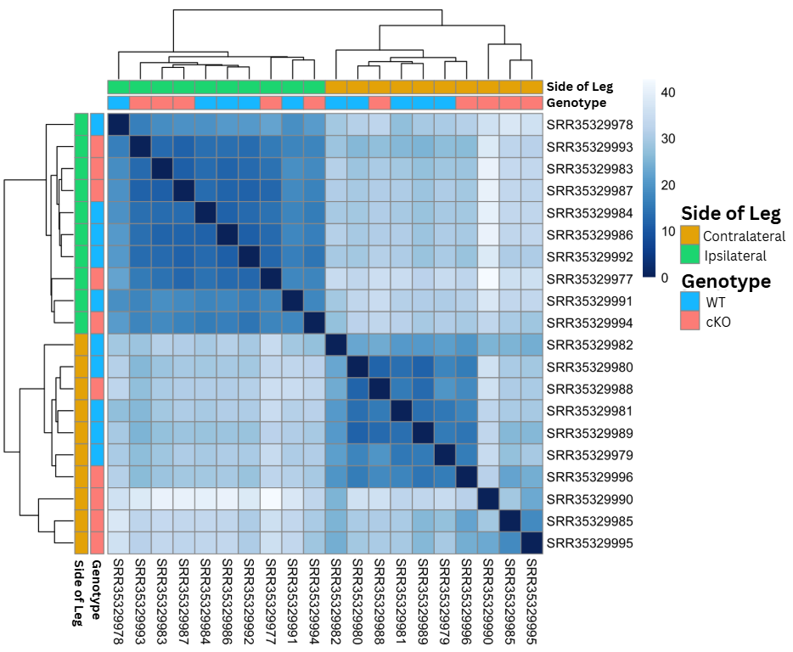
Figure X. Sample-to-Sample Distance Heatmap of DRG Transcriptomes. Euclidean distances between samples were calculated based on the regularized log-transformed (rlog) count data. Darker blue indicates higher similarity (lower distance), while lighter blue indicates lower similarity (higher distance). Samples are hierarchically clustered, revealing a primary separation by nerve injury (ipsilateral vs. contralateral) and secondary clustering by genotype (wildtype vs. cKO).

To assess global transcriptomic similarity, we generated a sample-to-sample distance heatmap based on Euclidean distance metrics (Fig. X). The results showed clear unsupervised clustering driven primarily by experimental condition, with ipsilateral and contralateral samples forming two cohesive blocks. Within these major clusters, samples were further separated by genotype, indicating that the AhR knockout introduced a consistent secondary transcriptional shift. The strong similarity among biological replicates, together with the absence of anomalous clustering, supports the overall quality and reproducibility of the sequencing data.

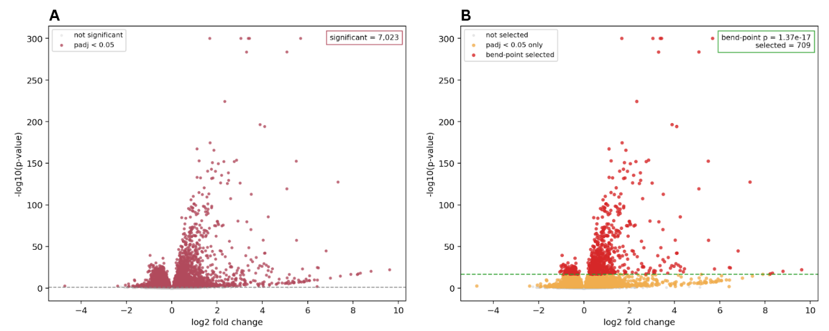
Figure X. Comparison of volcano plots between all significant genes (A) and highlighting the genes present at the identified bend-point (B). The volcano plot is observing all the genes that were significantly expressed and had a p-value under 0.05 (A). The second volcano plot highlights the genes under the new p-value threshold in red to identify the genes being used for further analysis.

This dataset contained a very large number of significant genes, so a bend point was used to reduce the list to a more interpretable set for follow-up analysis. The bend point occurred at a p-value of 1.37e-17 (Fig. X), corresponding to approximately 709 genes. In the volcano plot highlighting this threshold, the dense central cluster of genes is largely excluded, while the most strongly differentially expressed genes are retained for downstream analysis. These 709 genes provide a more targeted set for follow-up because they remain highly significant and reflect the point at which the strongest signal begins to separate from the broader background.

Gene Ontology Analysis
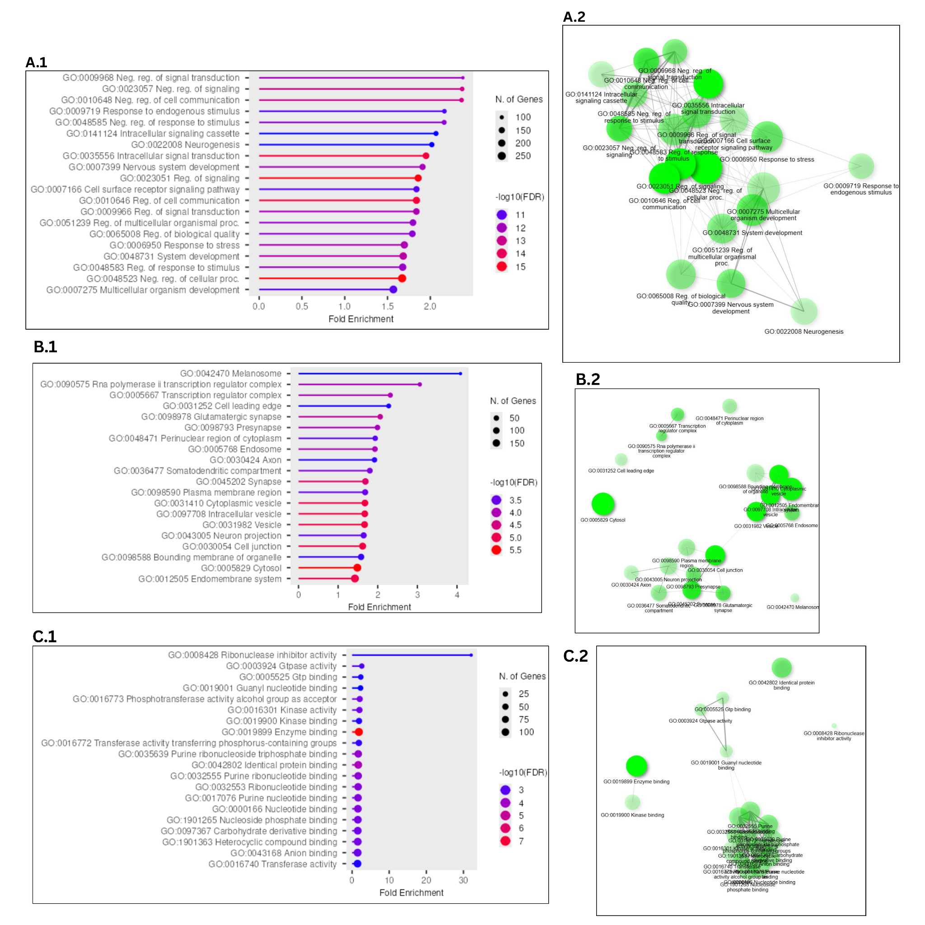
Figure X. Gene Ontology (GO) analysis of 709 differentially expressed genes selected from the dataset. The genes were evaluated in three different categories, Biological Process (A), Cellular Component (B), and Molecular Function (C), and demonstrated through lollipop charts (1) and network plots (2). The 20 most significant FDR terms were selected in each category.

Gene ontology analysis (GOA) was conducted to identify the biological processes most enriched among the significant genes and to provide functional context for the observed expression patterns. Lollipop plots and network plots were used to evaluate both term significance and relationships among enriched terms. The analysis was divided into three categories: Biological Process (BP), Cellular Component (CC), and Molecular Function (MF).
The BP analysis was the most consistent across the enriched terms. Each term included at least 100 associated genes, with some including as many as 250 (Fig. XA.1). The strongest false discovery rate corresponded to approximately −log10(11), indicating strong statistical support, although the most enriched terms reached fold-enrichment values of only about 2.5. Across the top 20 terms, many were associated with negative regulation of cell signaling, cell communication, or responses to stimuli. This functional similarity is reflected in the network plot, where the terms are extensively connected through shared genes (Fig. XA.2).
The cellular component analysis was less consistent than the BP analysis, although many enriched terms still formed related groups. Fewer genes were assigned to this category, but the enriched terms reached fold-enrichment values as high as 4 and false discovery values near −log10(5.5) (Fig. XB.1). The most enriched term was melanosome, while other terms were associated with axonal structures and transcriptional regulators. Overall, the network plot suggests weaker connectivity than in the BP analysis, with two main groupings—one related to vesicles and another related to neuronal structures—plus a small number of outliers (Fig. XB.2).
The molecular function analysis was the least consistent of the three categories. One term, ribonuclease inhibitor activity, was the most enriched, with a fold-enrichment value above 30 (Fig. XC.1). It also had the lowest false discovery rate, near −log10(3), although only a small number of genes were assigned to it. The remaining MF terms had fold-enrichment values below 5 and were more interconnected in the network plot, while ribonuclease inhibitor activity remained isolated from the rest (Fig. XC.2). Overall, these terms were more heavily associated with different forms of molecular binding.
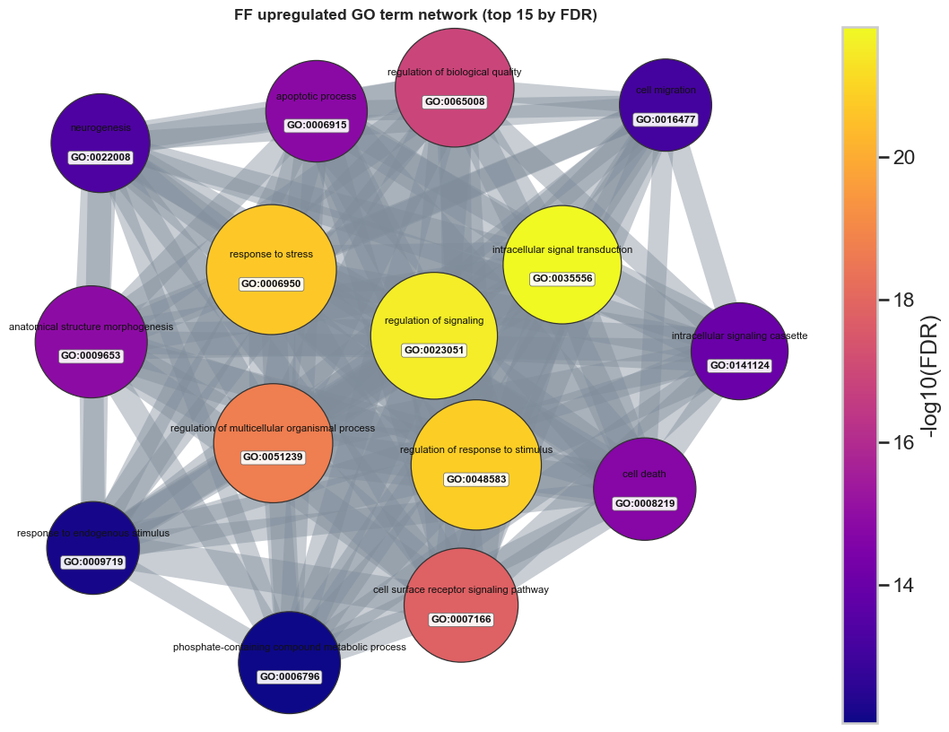
Taken together, these results support carrying the side-specific injury signal forward as the central interpretive thread of the paper, with genotype retained as a secondary but still informative layer.

Discussion
The most stable finding in this dataset was that the side-specific injury contrasts carried the strongest structure. The early QC and alignment checkpoints supported keeping this 20-sample DRG subset for downstream modeling. The main interpretive shift came from the PCA-first review: side separated more clearly than genotype, while genotype behaved as a secondary axis with substantial overlap between paired WT and cKO samples. That same pattern remains visible across the differential expression, bend-point, and gene ontology follow-up analyses. The PCA and sample-distance views pointed to the same conclusion: ipsilateral versus contralateral structure was clearer than genotype structure, making the side-specific contrasts the most defensible main path for interpretation (Halawani et al., 2023).
This PCA-first reading disciplined the interpretation of the large differential expression output; the analysis converged on a branch-priority logic in which ipsilateral versus contralateral in WT and ipsilateral versus contralateral in cKO served as the primary follow-up branches, while WT versus cKO in the contralateral condition was retained as the strongest supporting genotype comparison. The secondary branches show that genotype effects are not absent, but they do not displace the side-specific injury signal as the main story.
The bend-point step marked the transition from broad DE output to a smaller and more interpretable follow-up set. The workflow used the ordered adjusted-p-value curve as a reproducible narrowing rule for the two main side-specific contrasts, which reduced 7,023 and 7,541 significant genes to 709 and 870, respectively. These smaller sets remained strongly supported statistically while becoming more practical for pathway-level follow-up. In that sense, the bend-point step made the strongest part of that result easier to interpret against known injury and regeneration mechanisms.
Among the follow-up branches, ipsilateral versus contralateral in WT remained the clearest pathway-level result. It combined a strong side-driven separation, a large but reducible differential expression set, and the most coherent enrichment profile. GO Biological Process dominated the enrichment summary, and the WT GO follow-up indicated that the large number of enriched terms should not be read as many unrelated pathway stories. Once shared-gene structure was examined through the chart, tree, and network views, the strongest upregulated terms converged around signaling, migration, morphogenesis, stress response, and neurogenic remodeling. That convergence made the WT branch the strongest centerpiece for the Discussion (Gene Ontology Consortium, 2021; Kolberg et al., 2020).
The ipsilateral versus contralateral cKO branch still strengthens the overall argument because it reproduces the same side-specific logic and retains a substantial bend-point set, but it is slightly less clean than the main pathway branch. Likewise, WT versus cKO in the contralateral condition remains useful supporting material because it preserves a genotype-specific signal under contralateral conditions, but it works better as context than as a competing central narrative.
These results still need to be read with some caution. First, GO redundancy can make the functional signal look broader than it really is when overlapping labels are counted as if they were independent findings. Second, the pathway summaries are only persuasive here because they were interpreted after the PCA-first and bend-point-guided narrowing steps. Third, branch prioritization in this project reflects consistency, interpretability, and alignment with the visible sample structure; this does not mean the other modeled contrasts are biologically unimportant. Within those limits, the strongest discussion claim remains clear: this workflow converged on a robust side-specific injury-response program, and the WT branch provided the clearest pathway-level view of that response.

References
Andrews, S. (2010). FastQC: A quality control tool for high throughput sequence data. https://www.bioinformatics.babraham.ac.uk/projects/fastqc/
Chen, S., Zhou, Y., Chen, Y., & Gu, J. (2018). fastp: An ultra-fast all-in-one FASTQ preprocessor. Bioinformatics, 34(17), i884–i890. https://doi.org/10.1093/bioinformatics/bty560
Dobin, A., Davis, C. A., Schlesinger, F., Drenkow, J., Zaleski, C., Jha, S., Batut, P., Chaisson, M., & Gingeras, T. R. (2013). STAR: Ultrafast universal RNA-seq aligner. Bioinformatics, 29(1), 15–21. https://doi.org/10.1093/bioinformatics/bts635
Ensembl. (2025). Mus musculus GRCm39 release 115. https://useast.ensembl.org/Mus_musculus/Info/Index
Ewels, P., Magnusson, M., Lundin, S., & Käller, M. (2016). MultiQC: Summarize analysis results for multiple tools and samples in a single report. Bioinformatics, 32(19), 3047–3048. https://doi.org/10.1093/bioinformatics/btw354
Gene Ontology Consortium. (2021). The Gene Ontology resource: Enriching a GOLD mine. Nucleic Acids Research, 49(D1), D325–D334. https://doi.org/10.1093/nar/gkaa1113
Gillespie, M., Jassal, B., Stephan, R., Milacic, M., Rothfels, K., Senff-Ribeiro, A., Griss, J., Sevilla, C., Matthews, L., Gong, C., Deng, C., Varusai, T., Ragueneau, E., Haider, Y., May, B., Weiser, J., Brunson, T., Sanati, N., Beckman, L., ... Hermjakob, H. (2022). The Reactome pathway knowledgebase 2022. Nucleic Acids Research, 50(D1), D687–D692. https://doi.org/10.1093/nar/gkab1028
Halawani, D., Wang, Y., Li, J., Halperin, D., Ni, H., Estill, M., Ramakrishnan, A., Shen, L., Sefiani, A., Geoffroy, C. G., Friedel, R. H., & Zou, H. (2023). AhR restricts axon regeneration by balancing neuronal stress and growth response after injury. bioRxiv. https://doi.org/10.1101/2023.11.04.565649
Kanehisa, M., Furumichi, M., Sato, Y., Kawashima, M., & Ishiguro-Watanabe, M. (2025). KEGG for taxonomy-based analysis of pathways and genomes. Nucleic Acids Research, 53(D1), D545–D552. https://doi.org/10.1093/nar/gkae987
Kolberg, L., Raudvere, U., Kuzmin, I., Vilo, J., & Peterson, H. (2020). g:Profiler—Interoperable web service for functional enrichment analysis and gene identifier mapping (2021 update). Nucleic Acids Research, 48(W1), W191–W198. https://doi.org/10.1093/nar/gkaa427
Love, M. I., Huber, W., & Anders, S. (2014). Moderated estimation of fold change and dispersion for RNA-seq data with DESeq2. Genome Biology, 15(12), 550. https://doi.org/10.1186/s13059-014-0550-8
National Center for Biotechnology Information. (2026a). Sequence Read Archive study SRP618841. https://www.ncbi.nlm.nih.gov/Traces/study/?acc=SRP618841
National Center for Biotechnology Information. (2026b). BioProject PRJNA1322439. https://www.ncbi.nlm.nih.gov/bioproject/PRJNA1322439
National Center for Biotechnology Information. (2026c). GEO series GSE243308. https://www.ncbi.nlm.nih.gov/geo/query/acc.cgi?acc=GSE243308
National Center for Biotechnology Information. (2026d). SRA Toolkit. https://github.com/ncbi/sra-tools
Wirth, R., & Hipp, J. (2000). CRISP-DM: Towards a standard process model for data mining. In Proceedings of the 4th International Conference on the Practical Applications of Knowledge Discovery and Data Mining (pp. 29–39).

