Materials and Methods Draft
Mouse DRG RNA-seq Follow-up Project
Piter Garcia
Draft prepared for BIOL550

Materials and Methods
This project reanalyzed mouse DRG bulk RNA-seq after sciatic nerve injury using a four-stage workflow modeled after a CRISP-style progression: Data Collection, Data Cleaning, Data Preparation, and Data Analysis and Interpretation crispdm2000. That structure reflects how the mouse_new workflow was built and refined across the weekly deliverables, where each stage owned a specific deliverable, a checkpoint artifact, and a reusable output for the next stage. This staged structure made it possible to reuse the pipeline after earlier dataset-selection problems, because accession tracking, QC review, alignment review, and downstream modeling were separated into explicit, repeatable, and reproducible checkpoints.
The working subset comprised 20 NovaSeq X paired-end libraries from SRP618841 (BioProject PRJNA1322439; GEO GSE307639), representing L4--L6 dorsal root ganglion samples collected 1 day after sciatic nerve injury halawani2023ahr,sraStudySRP618841,bioprojectPRJNA1322439,geoGSE307639. The local subset was organized as a balanced side-by-genotype design within the family_drg_novaseqx family, with equal representation of ipsilateral and contralateral samples and of ff and cre genotype classes before quality control, alignment, and differential expression analysis. At each stage, outputs were reviewed and advanced through defined checkpoints to maintain consistency and reproducibility throughout the analysis.
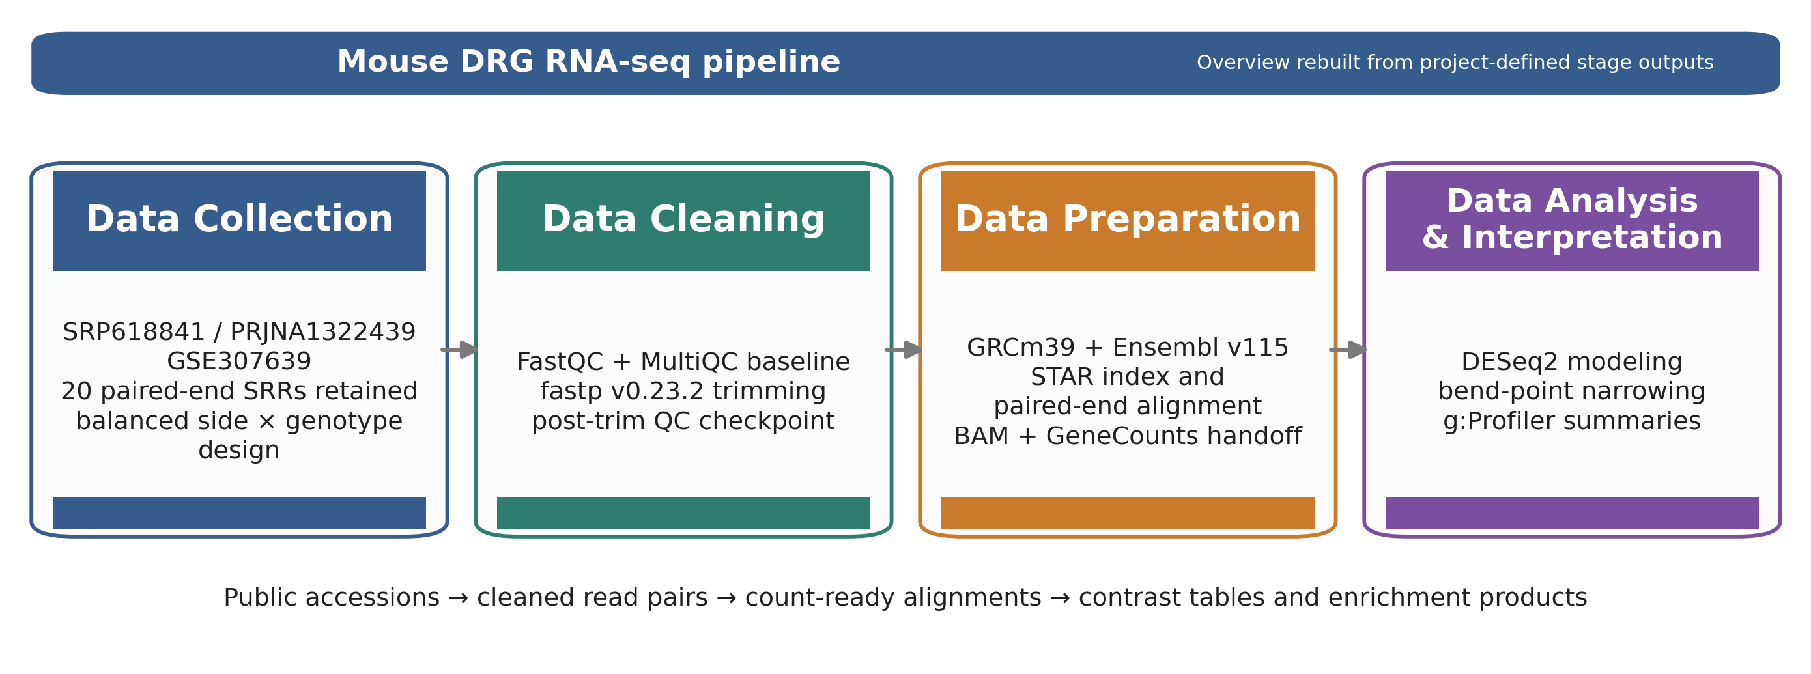
Figure 1. Overview ribbon summarizing the four computational stages and their stage-owned handoffs in the mouse_new
Table 1. Pipeline checkpoint table used to anchor the Methods section to stage-specific evidence.
Stage | Primary artifacts | Core tools | Checkpoint metric | Handoff
Collection | sample table; family manifest | prefetch + fasterq-dump | 20 SRRs retained; 4 balanced subgroups (n=5 each) | FASTQ.gz pairs + manifest
Cleaning | QC heatmap; severity delta summary | FastQC + MultiQC + fastp | raw adapter-content failures resolved after trimming | trimmed read pairs plus per-sample QC reports
Preparation | unique-mapping plot; STAR median summary | STAR + GeneCounts | 93.24% median unique mapping; 3.82% median noFeature | sorted BAMs, STAR logs, count tables, and family matrix
Analysis | filtering summary analysis summary g:Profiler source tables | DESeq2 + bend-point + g:Profiler | 78,334 -> 21,481 genes after filtering; 5 modeled contrasts | DE tables, bend-point follow-up sets, and enrichment summaries

Representative command examples
The corresponding table summarizes representative examples of the commands used to execute the main workflow stages, with emphasis on the computational path and key non-default parameters.
Table 2. Representative command examples for the tools used in the mouse_new
Stage | Tool | Representative command / code example
Collection | prefetch fasterq-dump | prefetch SRR35329980 && fasterq-dump SRR35329980 --split-files -O fastq/
Cleaning | FastQC | fastqc raw/*.fastq.gz trimmed/*.fastq.gz --outdir fastqc_reports/
Cleaning | MultiQC | multiqc fastqc_reports/ fastp_reports_full/ -o multiqc/
Cleaning | fastp | fastp -i sample_R1.fastq.gz -I sample_R2.fastq.gz -o clean_R1.fastq.gz -O clean_R2.fastq.gz --detect_adapter_for_pe --trim_poly_g --cut_mean_quality 20 --length_required 30 -h sample.html -j sample.json
Preparation | STAR | STAR --runThreadN 8 --genomeDir star_index --readFilesIn clean_R1.fastq.gz clean_R2.fastq.gz --readFilesCommand zcat --sjdbGTFfile Mus_musculus.GRCm39.115.gtf --outSAMtype BAM SortedByCoordinate --quantMode GeneCounts
Analysis | DESeq2 | dds <- DESeqDataSetFromMatrix(countData, colData, design = side_class * geno_class); dds <- DESeq(dds)
Analysis | bend-point script | python3 run_bendpoint_followup.py --contrast ipsi_vs_contra_in_ff --padj-column padj
Analysis | g:Profiler | gp.profile(organism = "mmusculus", query = selected_genes, sources = c("GO:BP","KEGG","REAC"))

Data Collection: SRA Acquisition and Sample Organization
The analysis began with the published DRG RNA-seq study SRP618841, linked to BioProject PRJNA1322439 and GEO series GSE307639 halawani2023ahr,sraStudySRP618841,bioprojectPRJNA1322439,geoGSE307639. Public runs were retrieved using the project wrappers around prefetch and fasterq-dump sratoolkit, and the local workflow retained 20 paired-end NovaSeq X libraries from the 1-day-post-injury DRG subset. Recording this accession lineage was important because the pipeline had to remain reusable across candidate mouse datasets; explicit accession-to-run tracking prevented later stages from being tied to an ambiguous source dataset.
After download, metadata were consolidated into a design-aware sample table. Each retained sample was annotated by side_class (ipsi or contra), geno_class (ff or cre), and the derived condition_family. This step established a balanced 2 2 experimental design, with two genotypes (ff, cre) by two sides (ipsi, contra) and five samples per group, which was then used in the DESeq2 model and subsequent interpretation. It also created a reusable family manifest that could be re-read by downstream notebooks without reconstructing group identity from filenames.
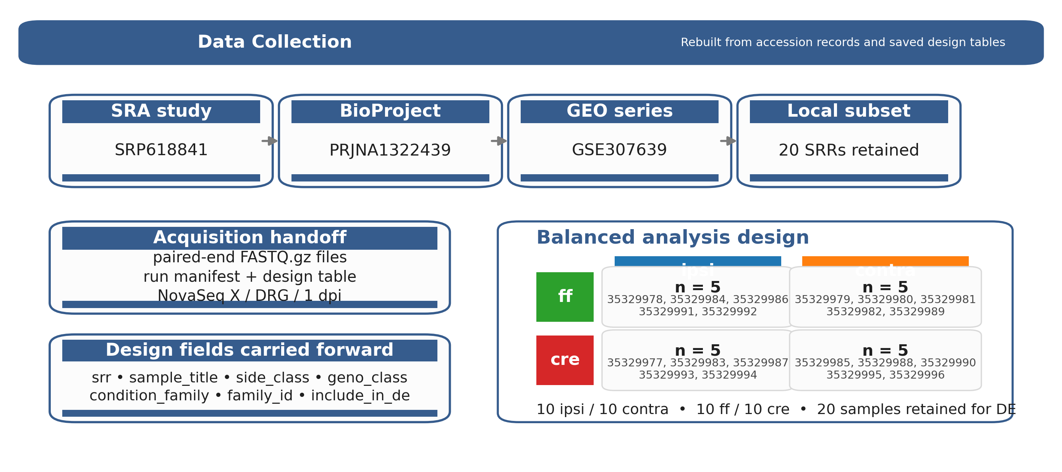
Figure 2. Rebuilt Data Collection stage figure derived from the saved project metadata and design tables.
Table 3. Data Collection stage table.
Substage | Input | Tool | Checkpoint artifact / evidence | Why it mattered
Study provenance | public accession records | SRA / GEO review | accession lineage shown in the corresponding figure: SRP618841 -> PRJNA1322439 -> GSE307639 | anchors the Methods section to the exact source study
Run acquisition | public SRA runs | prefetch fasterq-dump | paired-end FASTQ.gz files plus the local run manifest; 20 retained SRRs from the DRG / NovaSeq X subset | creates the fixed read set used throughout the pipeline
Design mapping | run manifest + sample titles | local manifest assembly | design table and family manifest; 5 samples in each subgroup | makes the side/genotype structure explicit before PCA and DE modeling

Data Cleaning: Quality Control and Read Trimming
Raw read quality was evaluated with FastQC fastqc, and cohort-level summaries were consolidated with MultiQC multiqc. This stage was treated as a documented checkpoint, so pre- and post-trimming QC outputs were retained to show the effect of trimming explicitly. The local workflow used fastp v0.23.2 as the canonical cleanup tool because it provided a reproducible paired-end workflow, generated per-sample reports, and resolved adapter-related signal more effectively than the earlier baseline fastp.
The retained fastp configuration used paired-end adapter detection, poly-G trimming, a mean-quality cutoff of 20, a minimum retained length of 30 bases, and per-sample HTML/JSON reporting. In the corresponding figure, the left panel shows the module-status heatmap and the right panel shows the SRR-level severity-change plot. Together, these artifacts document a consistent improvement in read quality across the cohort before alignment. Retaining both the raw and trimmed checkpoints also made this stage reusable for later dataset screening, because poor candidate subsets could be rejected or repaired using the same QC evidence.
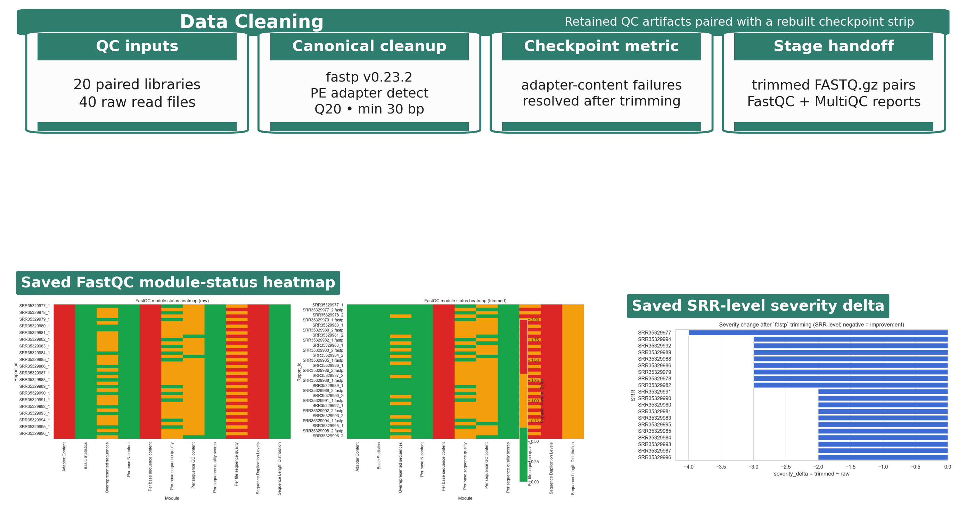
Figure 3. Data Cleaning stage figure using retained QC artifacts and a rebuilt checkpoint strip.
Table 4. Data Cleaning stage table.
Substage | Input | Tool | Checkpoint artifact / evidence | Why it mattered
Raw QC | raw paired-end reads | FastQC + MultiQC | raw module-status heatmap and cohort QC summary; adapter-content failures across all 40 raw read files | establishes the baseline quality state before trimming
Read trimming | raw FASTQ.gz pairs | fastp v0.23.2 | trimmed read pairs per-sample HTML/JSON reports; PE adapter detect, Q20 cutoff, min length 30 bp, poly-G trimming | standardizes cleanup across all retained libraries
Post-trim checkpoint | trimmed read pairs | FastQC + MultiQC | SRR-level severity summary: all retained severity deltas shifted in the negative direction after trimming | justifies using the cleaned reads, not the raw reads, for alignment

Data Preparation: Reference Selection and Alignment
Trimmed read pairs were aligned to the Mus musculus GRCm39 primary assembly with the matching Ensembl release 115 annotation ensemblRelease115. The reference pair used in the local workflow consisted of Mus_musculus.GRCm39.dna.primary_assembly.fa and Mus_musculus.GRCm39.115.gtf. A STAR genome index was generated with sjdbOverhang = 150 to match the 151-bp paired-end reads. Alignment was performed with STAR using gzip-aware input handling, coordinate-sorted BAM output, and GeneCounts, so that the same run also produced per-sample count tables star.
This stage linked cleaned reads to downstream modeling through a stable alignment handoff. For each sample, the workflow retained three key outputs: a coordinate-sorted BAM file, a STAR Log.final.out summary, and a ReadsPerGene.out.tab count table. These outputs provided both the alignment checkpoint and the count-level handoff used to assemble the final family matrix for the DRG subset. Reverse-stranded counts (column 4 of each ReadsPerGene.out.tab file) were used as the input for downstream DESeq2 modeling, consistent with the strandedness assumption used in the project workflow. Treating alignment review and count-matrix assembly as explicit handoffs also made the same preparation stage reusable across candidate datasets.
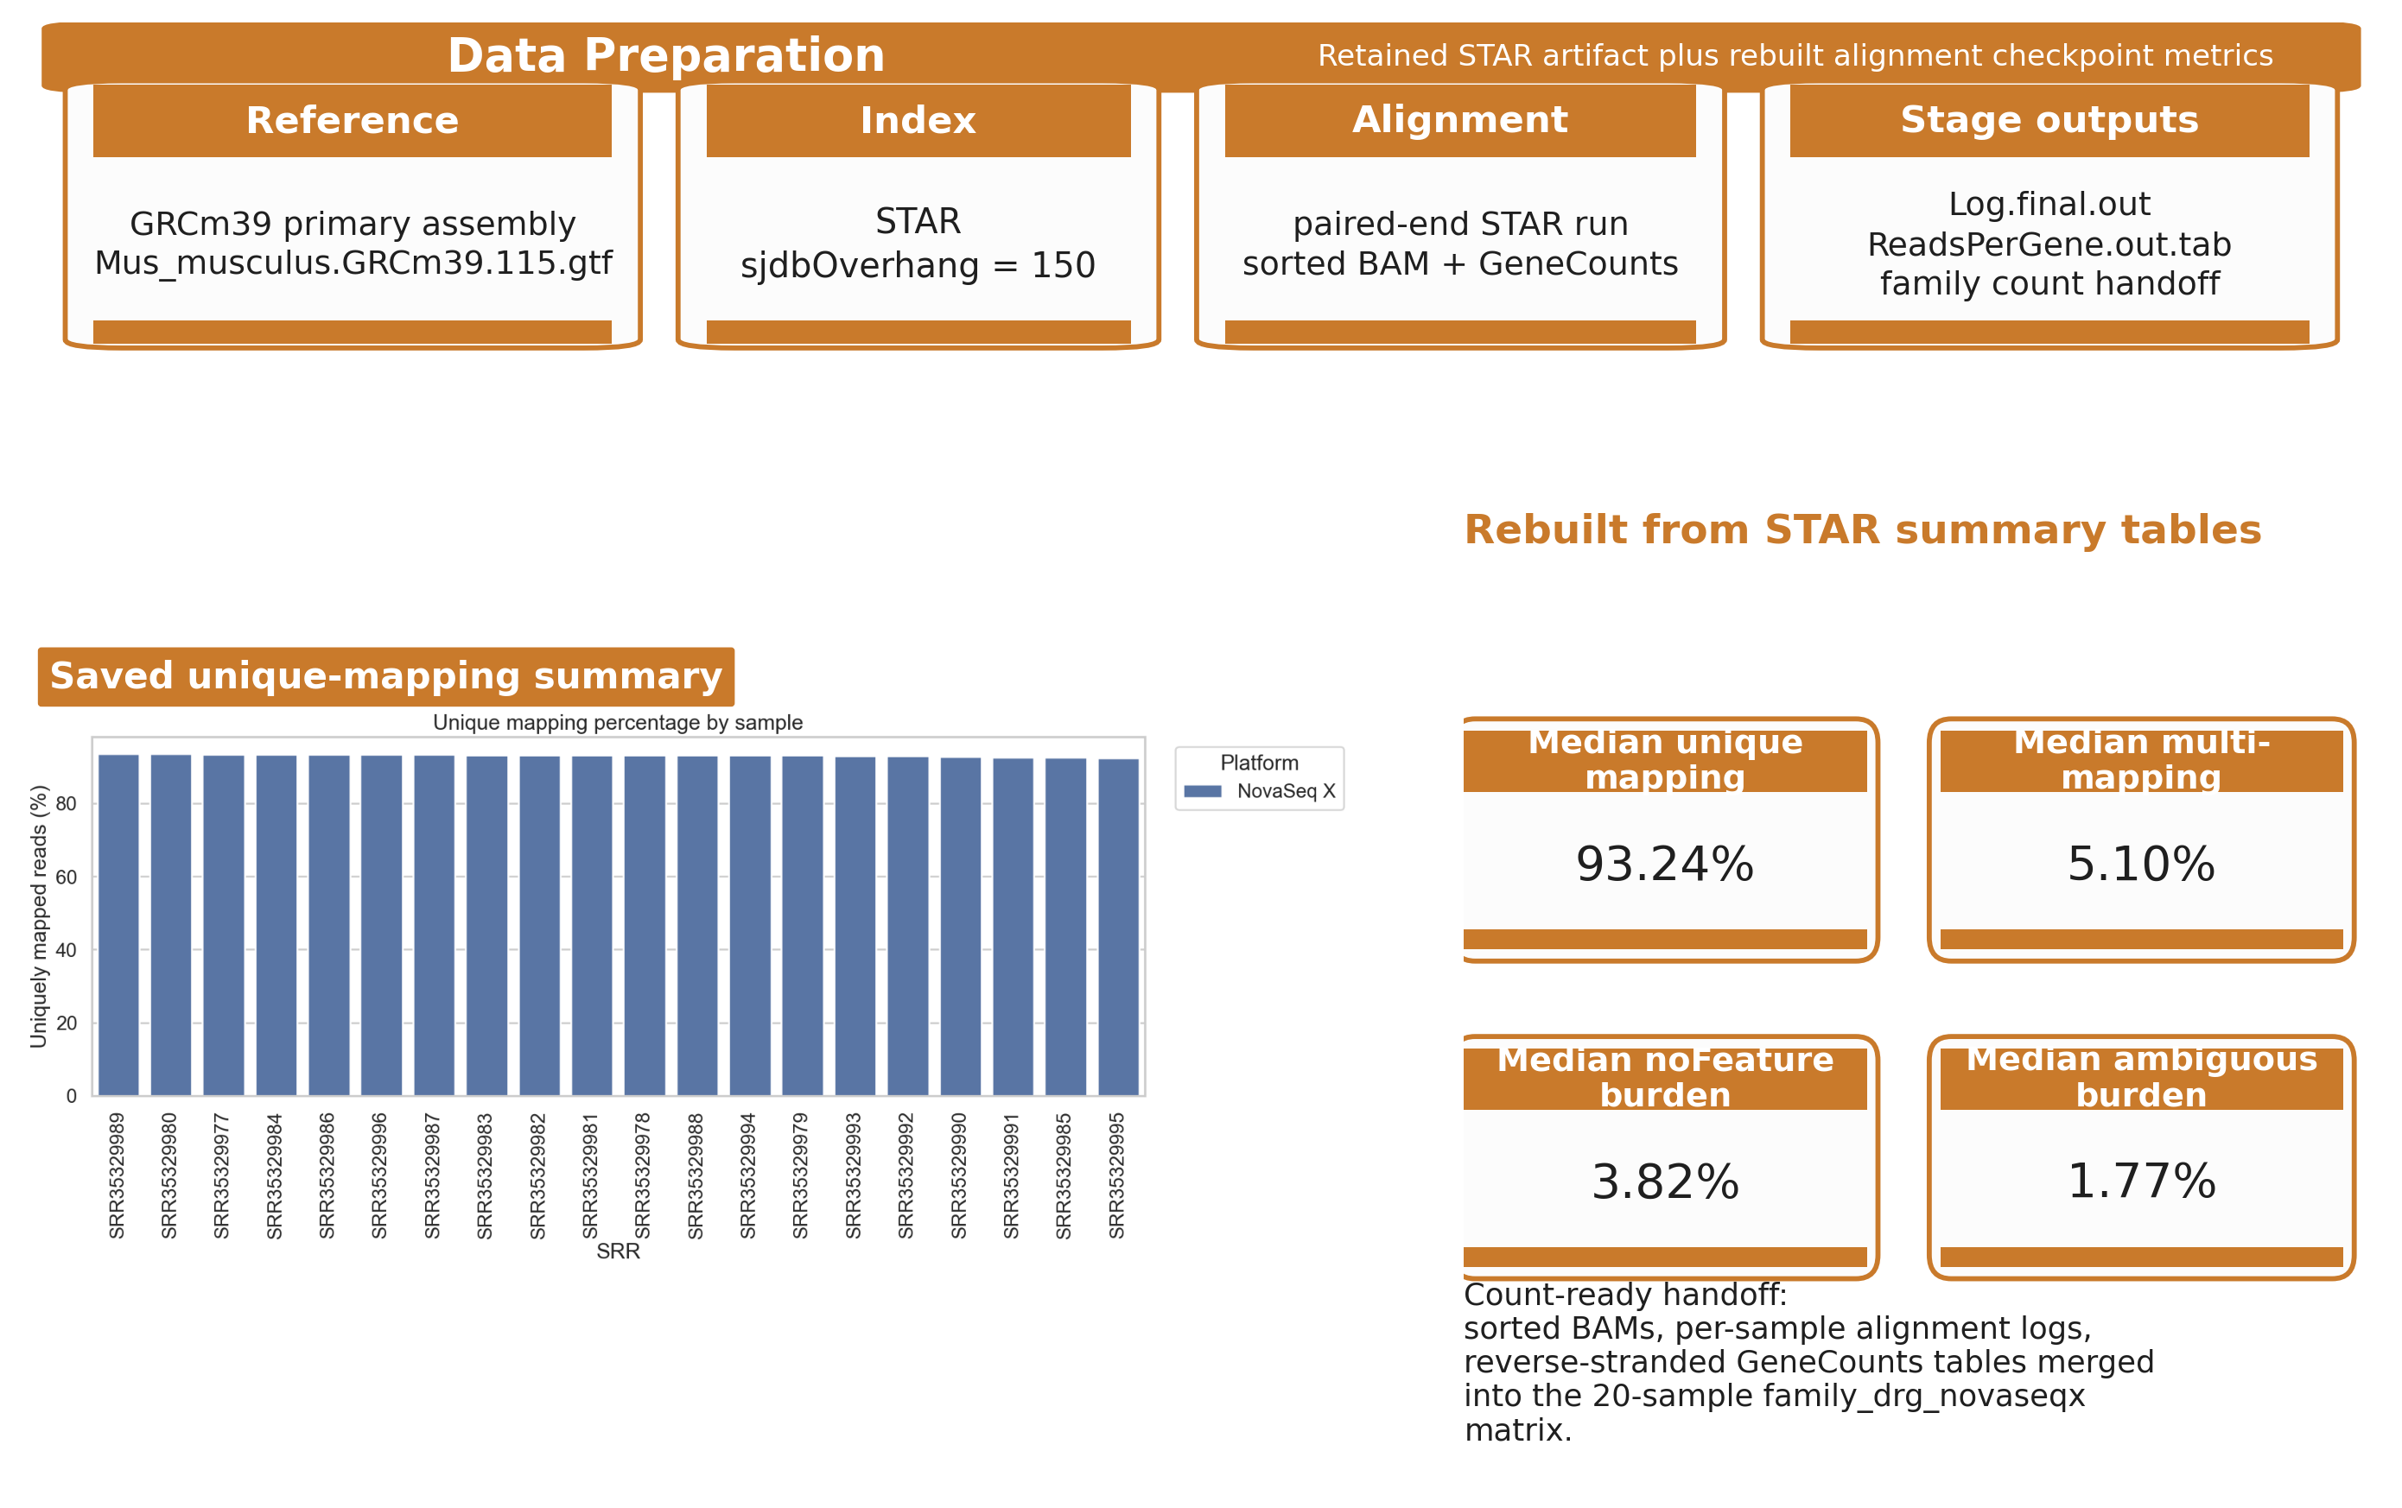
Figure 4. Data Preparation stage figure built from retained STAR outputs and rebuilt alignment checkpoint metrics.
Table 5. Data Preparation stage table.
Substage | Input | Tool | Checkpoint artifact / evidence | Why it mattered
Reference choice | mouse genome + annotation | Ensembl reference selection | reference FASTA/GTF pair for GRCm39 primary assembly + Ensembl v115 annotation | locks the coordinate system used by STAR and downstream counts
stageprepSTAR index \ | run | trimmed read pairs + reference | STAR | sorted BAM, Log.final.out, and ReadsPerGene.out.tab; sjdbOverhang = 150 and paired-end alignment/counting in one run | produces the alignment checkpoint and the count-ready artifacts in one run
Alignment checkpoint | saved STAR summaries | local alignment review | retained unique-mapping plot plus the STAR median summary table; unique 93.24%, multi 5.10%, noFeature 3.82%, ambiguous 1.77% | confirms the cleaned reads mapped well enough to move into DESeq2
Count handoff | per-sample count outputs | local merge scripts / notebooks | family-level count matrix for family_drg_novaseqx; 20 samples retained in the final family matrix | converts per-sample STAR outputs into the DE-ready family matrix

Data Analysis and Interpretation: Differential Expression and Functional Analysis
The merged family count matrix was analyzed with DESeq2 using the explicit side-by-genotype design carried forward from the sample manifest deseq2. An interaction design formula ( side_class * geno_class) was specified so that the effect of side could differ by genotype, while all five contrast branches were extracted from a single fitted model. Before modeling, low-support genes were filtered, reducing the tested set from 78,334 to 21,481 genes while retaining all 20 DRG samples. Five contrasts were then evaluated: ipsi_vs_contra_in_ff, ipsi_vs_contra_in_cre, geno_in_contra, geno_in_ipsi, and interaction. This contrast inventory was kept fixed so that later interpretation did not drift when one branch became more interpretable than another.
Downstream interpretation followed a PCA-first, branch-priority logic. PCA was used to evaluate sample structure before long DE tables were emphasized, and the side-specific branches were then carried forward as the primary follow-up path. To avoid reducing very large DE outputs to unstructured gene lists, the workflow applied a bend-point rule to the ordered adjusted-p-value curve for each contrast. These bend-point-derived follow-up sets were reported alongside the padj < 0.05 results. For the two primary side-specific contrasts, this step retained 709 and 870 genes, respectively.
The resulting follow-up sets were then submitted to g:Profiler using GO Biological Process, KEGG, and Reactome layers gprofiler2021,geneOntology2021,kegg2025,reactome2022. In the ff branch, which remained the clearest pathway-level follow-up, enrichment outputs were further summarized using shared-gene chart, tree, and network views to reduce redundancy among overlapping GO labels. These enrichment products are described here as downstream summaries of the differential-expression workflow rather than as final biological claims.
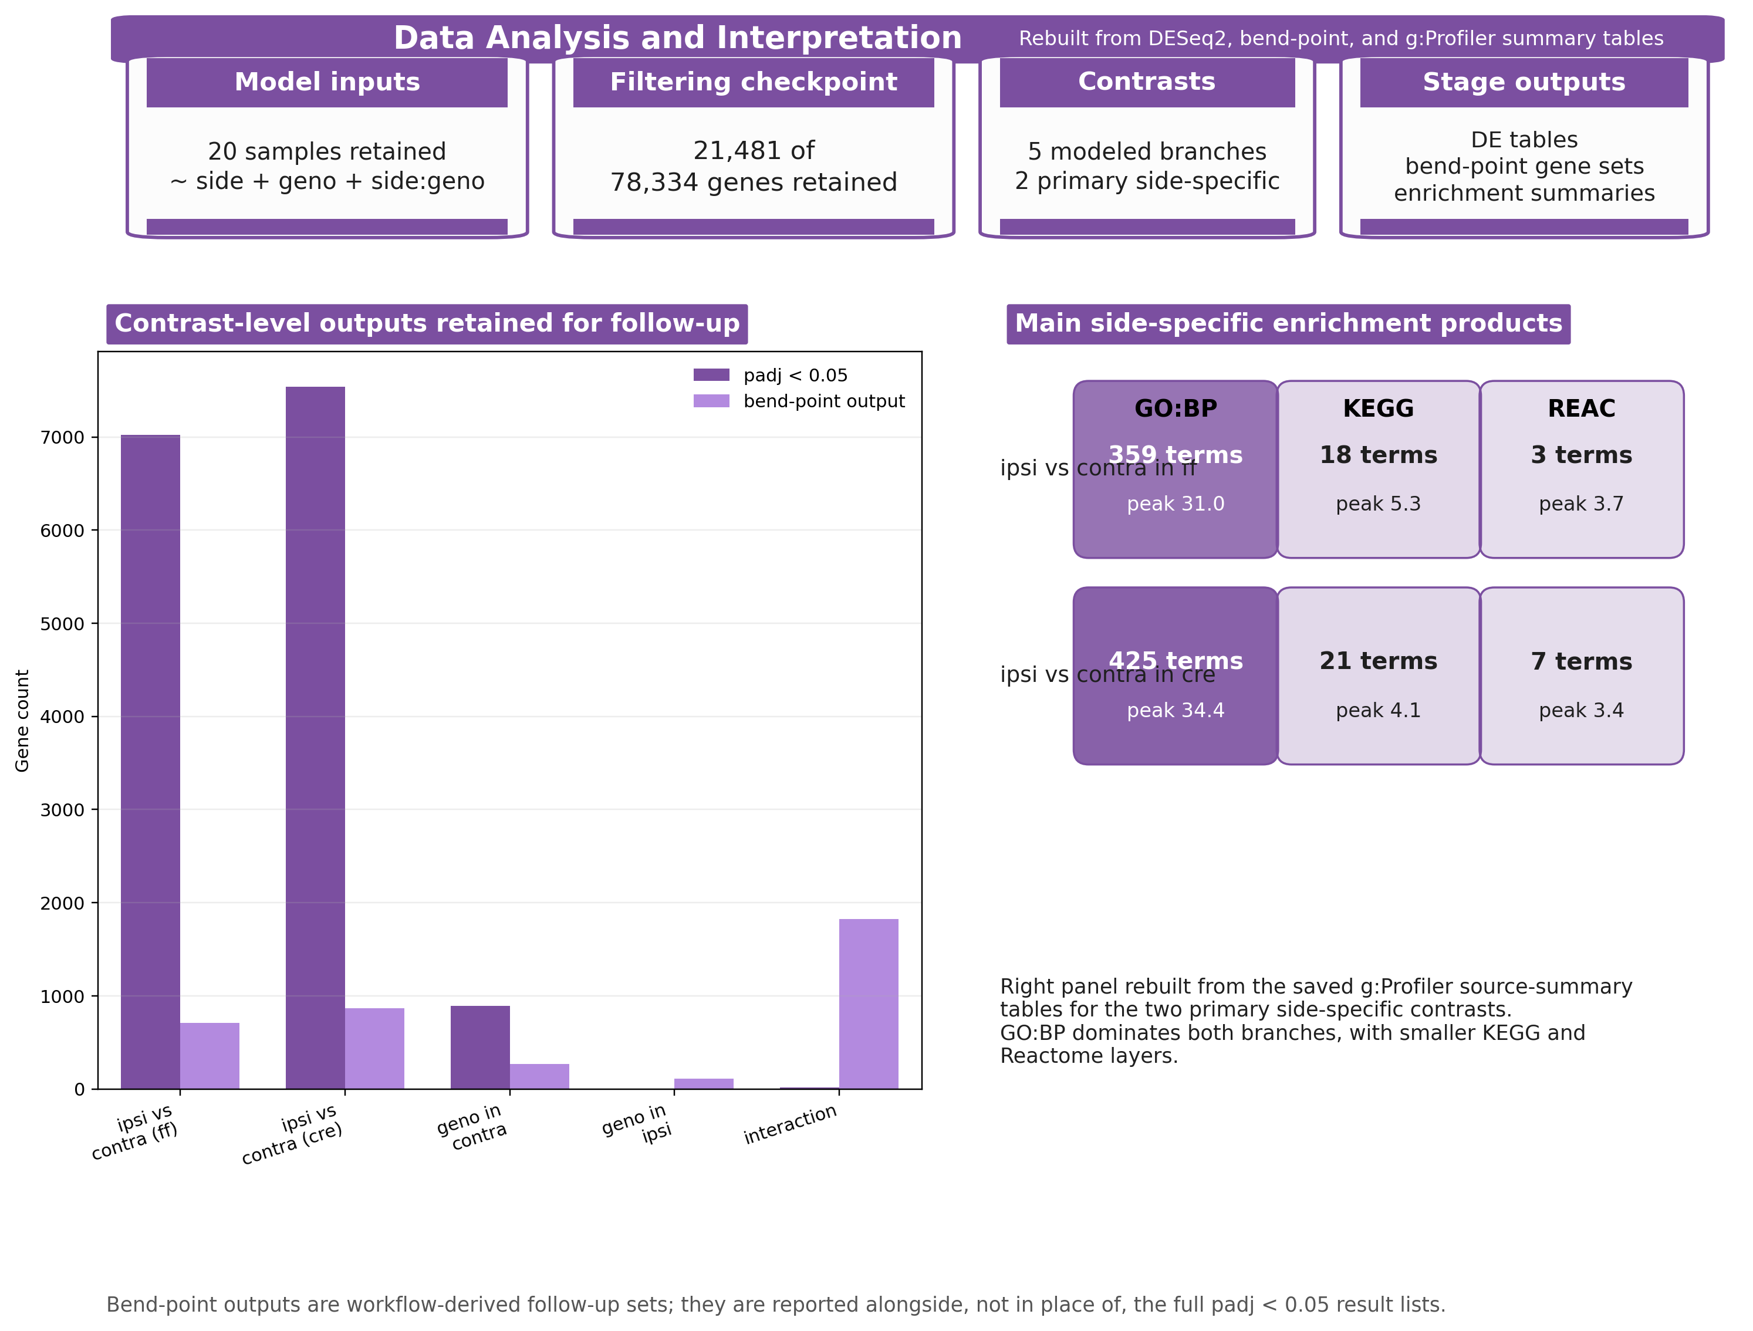
Figure 5. Rebuilt Data Analysis and Interpretation stage figure derived from saved DESeq2
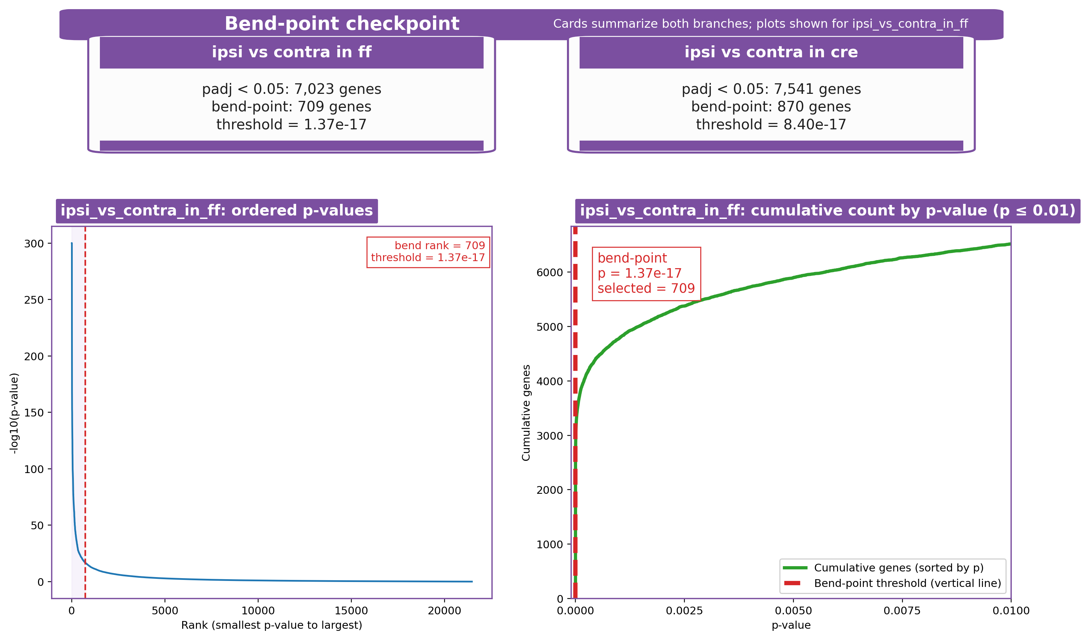
Figure 6. Retained bend-point checkpoint summary for the two primary side-specific branches (cards). The ordered p-value and cumulative-count plots are shown for the ipsi_vs_contra_in_ff
Table 6. Data Analysis and Interpretation workflow table.
Substage | Input | Tool | Checkpoint artifact / evidence | Why it mattered
Model setup | family count matrix + design table | DESeq2 | normalized counts, VST matrix, and contrast-level result tables; 20 samples retained and 78,334 -> 21,481 genes after filtering | defines the inferential base for every contrast and downstream plot
Contrast production | filtered model outputs | DESeq2 contrast manifest | five saved contrast branches; two primary side-specific and three supporting genotype / interaction branches | keeps the main and supporting stories explicit before list narrowing
Bend-point selection | ordered adjusted-p tables | local bend-point scripts | analysis-summary and per-contrast bend-point summary tables; primary side-specific follow-up sets of 709 genes in ff and 870 genes in cre | turns very large DE lists into smaller reproducible follow-up sets
Enrichment layer | bend-point-selected gene sets | g:Profiler | g:Profiler source-summary and enrichment tables; the main ff branch retained 359 GO:BP, 18 KEGG, and 3 Reactome terms | captures the terminal functional-summary products without replacing the gene-level story

Table 7. Primary side-specific follow-up summary carried out during the Data Analysis stage.
Branch | padj < 0.05 genes | Bend-point genes | Threshold | GO:BP | KEGG | REAC
ff side branch | 7,023 | 709 | 1.37e-17 | 359 | 18 | 3
cre side branch | 7,541 | 870 | 8.40e-17 | 425 | 21 | 7

Discussion
Across the weekly reports, the most stable shared finding was that the side-specific injury contrasts carried the clearest structure in the mouse_new dataset. The early alignment and QC checkpoints supported using this 20-sample DRG subset for downstream modeling, but the stronger discussion point emerged only after the PCA-first review: side separated more clearly than genotype, while genotype behaved as a secondary axis with substantial overlap between paired ff/cre samples. That pattern was already visible in the project’s first differential-expression checkpoint and remained consistent through the later bend-point and GO follow-up reports. Nikhi’s intermediate report reached the same practical conclusion from the PCA and sample-distance views, namely that ipsilateral-versus-contralateral structure was clearer than genotype structure and therefore more defensible as the main biological path for interpretation.
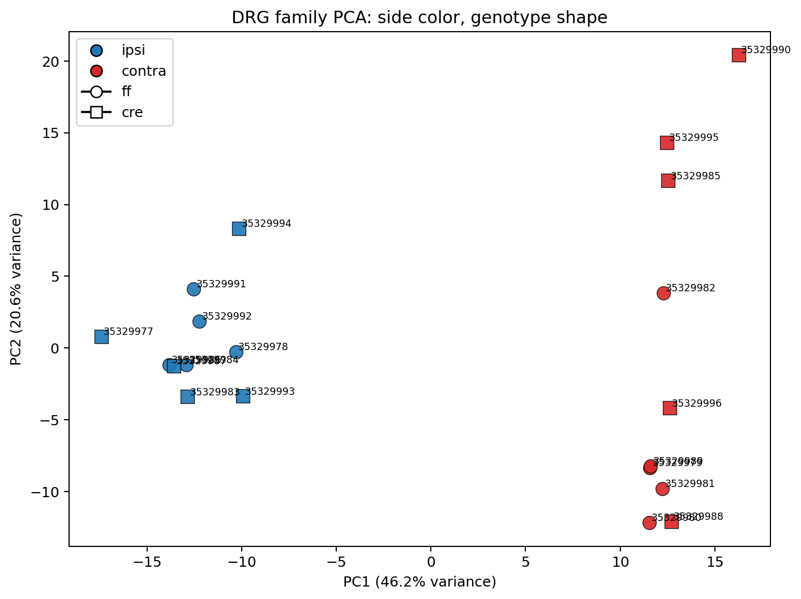
Figure 7. PCA-first view of the family_drg_novaseqx
The PCA-first reading mattered because it disciplined how the large DE outputs were interpreted. Instead of treating every modeled contrast as equally informative, the reports converged on a branch-priority logic in which ipsi_vs_contra_in_ff and ipsi_vs_contra_in_cre served as the primary follow-up branches, while geno_in_contra was retained as the best supporting genotype comparison. This common structure also explains why the later discussion should emphasize what the reports share instead of over-weighting report-specific exploratory details. The secondary branches are still informative, especially when they help show that genotype effects are not absent, but they do not displace the side-specific injury signal as the central story.
The bend-point step was the key transition from broad differential-expression output to a more interpretable follow-up set. Both the weekly reports and the internal notebooks used the ordered adjusted-p-value curve as a reproducible narrowing rule rather than relying only on arbitrary top-\(N\) lists or on raw padj < 0.05 counts. For the two main side-specific contrasts, that rule reduced 7,023 and 7,541 significant genes to 709 and 870 genes, respectively, producing smaller sets that were still strongly supported statistically and were practical for pathway analysis. Nikhi’s follow-up report highlighted the same value of this reduction step: it preserved a highly significant subset while making pathway-level interpretation manageable enough to compare against known injury and regeneration mechanisms.
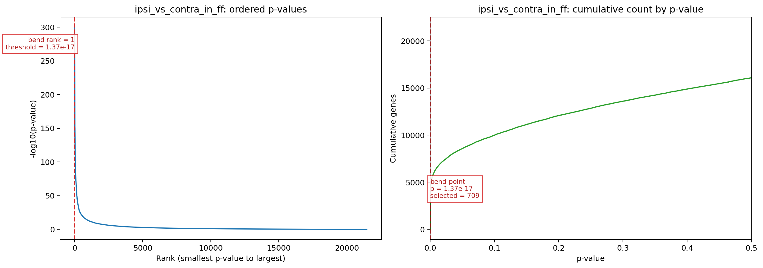
Figure 8. Bend-point diagnostic for ipsi_vs_contra_in_ff
Among the follow-up branches, ipsi_vs_contra_in_ff remained the clearest pathway-level result. The reports consistently showed that this branch combined a strong side-driven separation, a large but reducible DE set, and the most coherent enrichment profile. GO Biological Process dominated the enrichment summary, and the later FF GO follow-up clarified that the apparent abundance of terms was not best understood as many unrelated pathways. Instead, once shared-gene structure was examined through the chart, tree, and network views, the strongest upregulated terms clustered around signaling, migration, morphogenesis, stress-response, and neurogenic remodeling themes. This convergence made the FF branch the most defensible biological centerpiece for Discussion.
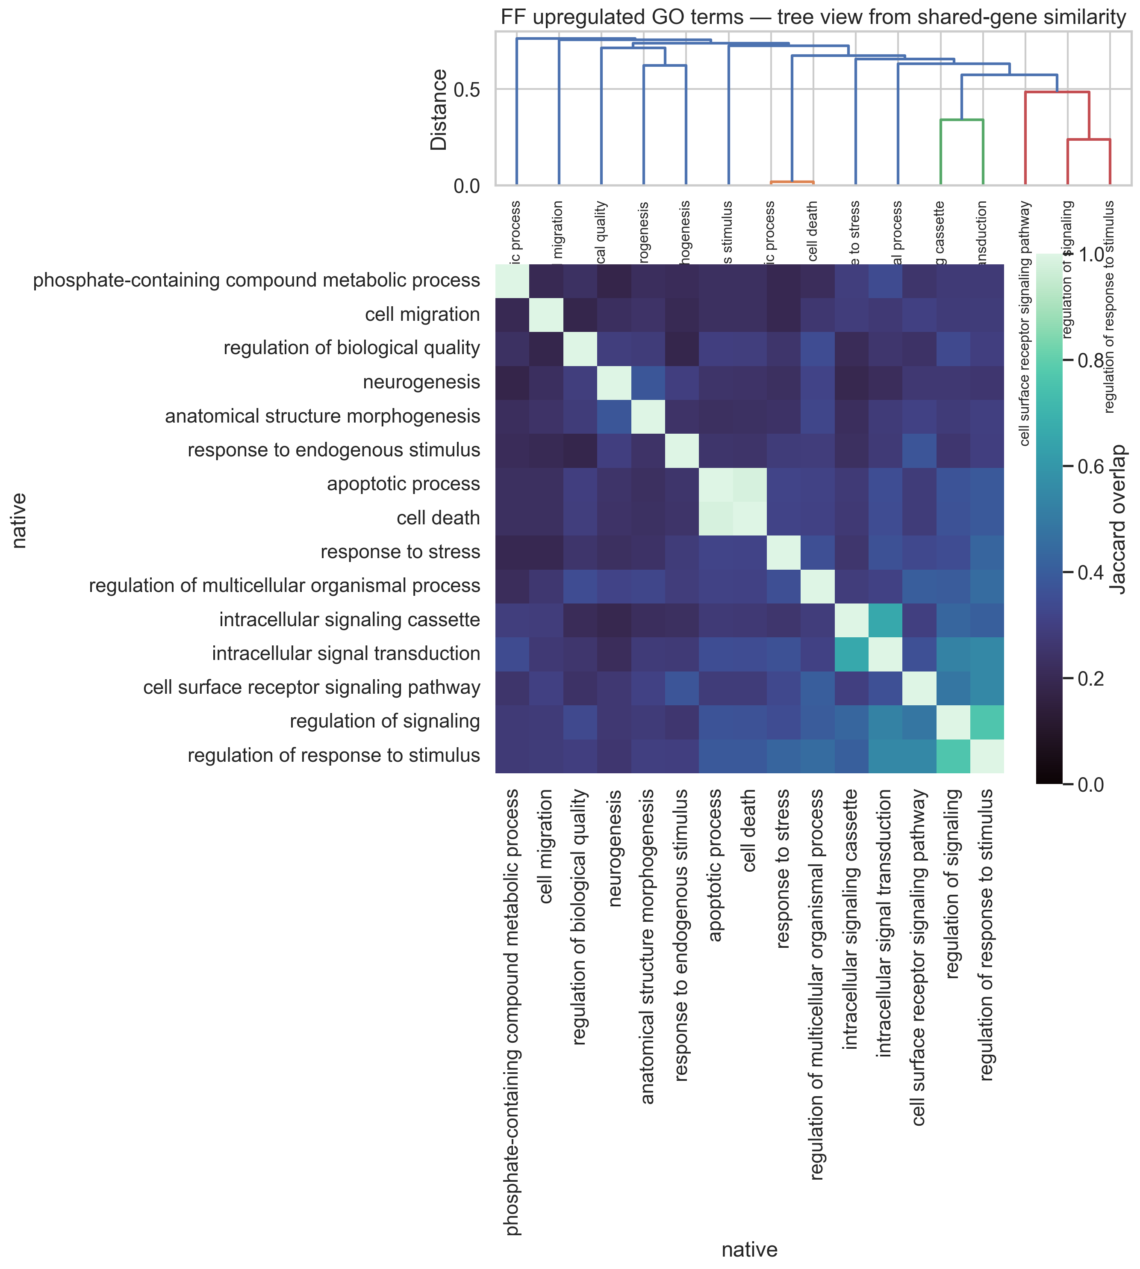
Figure 9. Shared-gene tree view for the upregulated ipsi_vs_contra_in_ff
The ipsi_vs_contra_in_cre branch still strengthens the overall argument because it reproduces the same side-specific logic and retains a substantial bend-point set, but it is slightly less clean as the headline pathway branch. Likewise, geno_in_contra is useful supporting material because it preserves a genotype-specific signal under contralateral conditions, yet it worked best in the weekly reports as contextual support rather than as a competing main narrative. This common-ground framing keeps the discussion aligned with what multiple checkpoints actually support and avoids over-extending weaker or more exploratory contrasts.
These results should also be interpreted with caution. First, GO redundancy can make the functional signal look broader than it really is when overlapping labels are counted as if they were independent findings. Second, pathway summaries are only persuasive here because they were applied after the PCA-first and bend-point-guided narrowing steps. Third, branch prioritization in this project reflects consistency, interpretability, and alignment with the visible sample structure; it does not imply that the other modeled contrasts are biologically unimportant. Within those limits, however, the weekly reports support a coherent discussion claim: the mouse_new workflow converged on a robust side-specific injury-response program, and the FF branch provided the clearest pathway-level window into that response.
[title=References]

