CHAPTER 25
All-Pairs Shortest Paths

25.2 The Floyd-Warshall algorithm

We will use a different dynamic-programming formulation to solve the all-pairs shortest-paths problem on a directed graph G = (V, E). The resulting algorithm, known as the
Floyd-Warshall algorithm, runs in Θ(V³) time.
As before, negative –weight edges may be present, but we assume that there are no negative-weight cycles.
We shall follow the dynamic programming process to develop the algorithm. After studying the resulting algorithm, we shall present a similar method for finding the transitive closure of a directed graph.
النجاح سلم لا تستطيع تسلقه ويداك في جيبك.

The structure of a shortest path
In the Floyd-Warshall algorithm, we use a different characterization of the structure of a shortest path than we used in the matrix-multiplication-based all-pairs algorithms. The algorithm considers the “intermediate” vertices of a shortest path, where an intermediate vertex of a simple path
p = ‹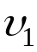, 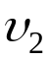, …, 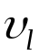› is any vertex of p other thanor , that is, any vertex in the set {, 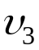, …, 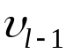}.
The Floyd-Warshall algorithm is based on the following observation. Under our assumption that the vertices of G are
V = {1, 2, …, n}, let us consider a subset {1, 2, …, k} of vertices for some k. For any pair o vertices i, j 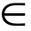V, consider all paths from i to j whose intermediate vertices are all drawn from
{1, 2, …, k}, and let p be a minimum-weight path from among them. (path p is simple.)

The Floyd-Warshall algorithm exploits a relationship between path p and shortest paths from i to j with all intermediate vertices in the set {1, 2, …, k}.

The relationship depends on whether or not k is an intermediate vertex of path p.

- If k is not an intermediate vertex of path p, then all intermediate vertices of path p are in the set {1, 2, …, k} is also a shortest path from i to j with all intermediate vertices in the set {1, 2, …, k}.
لأن تكون سلحفاة في الطريق الصحيح خير من أن تكون غزالاً في الطريق الخطأ.

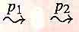
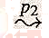
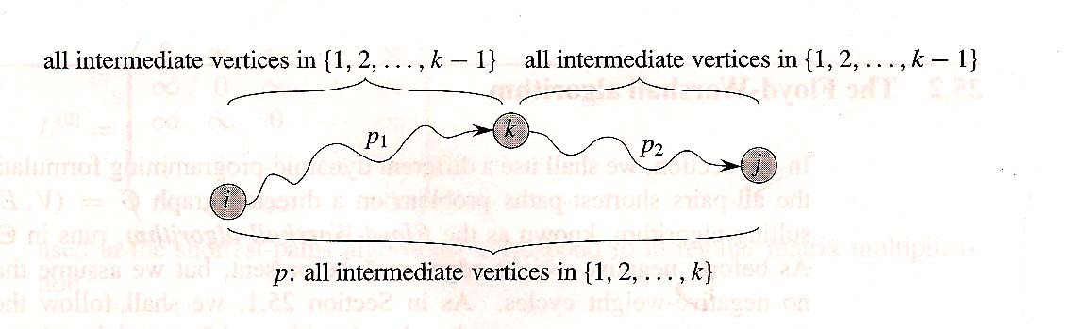
- If k is an intermediate vertex of path p, then we break p down into i k j as shown in the following figure.
P₁ is a shortest path from i to k with all intermediate vertices in the set {1, 2, …, k}. Because vertex k is not an intermediate vertex of path p₁, we see that p₁ is a shortest path from i to k with all intermediate vertices in the set {1, 2, …, k – 1}. Similarly, p₂ is a shortest path from vertex k to vertex j with all intermediate vertices in the set {1, 2, …, k – 1}.

A recursive solution to the all-pairs shortest-paths problem

Based on the above observations, we
التلفاز من أكثر مضيعات للوقت، وكذاك العلاقات الاجتماعية غير الهادفة.
define a recursive formulation of shortest-path
estimates that is different from the one in
Section 25.1.
Let 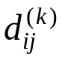be the weight of a shortest path from vertex i to vertex j for which all intermediate vertices are in the set
{1, 2, …, k}. When k = 0, a path from vertex i to vertex j with no intermediate vertex numbered higher than 0 has no intermediate vertices at all. Such a path has at most one edge, and hence 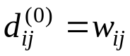.

A recursive definition following the above discussion is given by
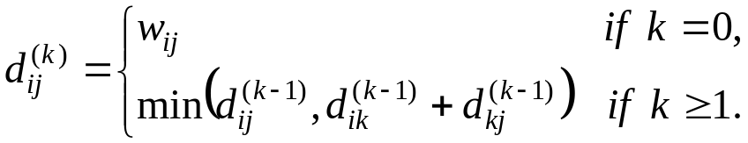

Because for any path, all intermediate vertices are in the set {1, 2, …, n}, the matrix 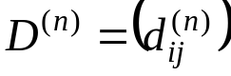 gives the final answer: 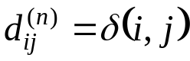 for all i, j 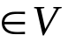.
لن تستطيع أن تمنع طيور الهم أن تحلق فوق رأسك، لكنك تستطيع أن تمنعها من أن تعشش في رأسك.

Computing the shortest-path weights bottom up

Based on recurrence (25.5), the following bottom-up procedure can be used to compute the values in order of increasing values of k. Its input is an n × n matrix W defined as in equation (25.1). The procedure returns the matrix 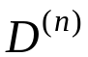of shortest- path weights.

FLOYD-WARSHALL (W)
- n ← rows [W]
- D⁽⁰⁾ ← W
- for k ← 1 to n
- do for i ← 1 to n
- do for j ← 1 to n.
- do ← min 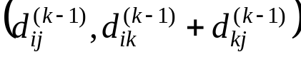
- return D^{(n)}
حان الوقت لكي نعيش الحياة التي تخيلناها.
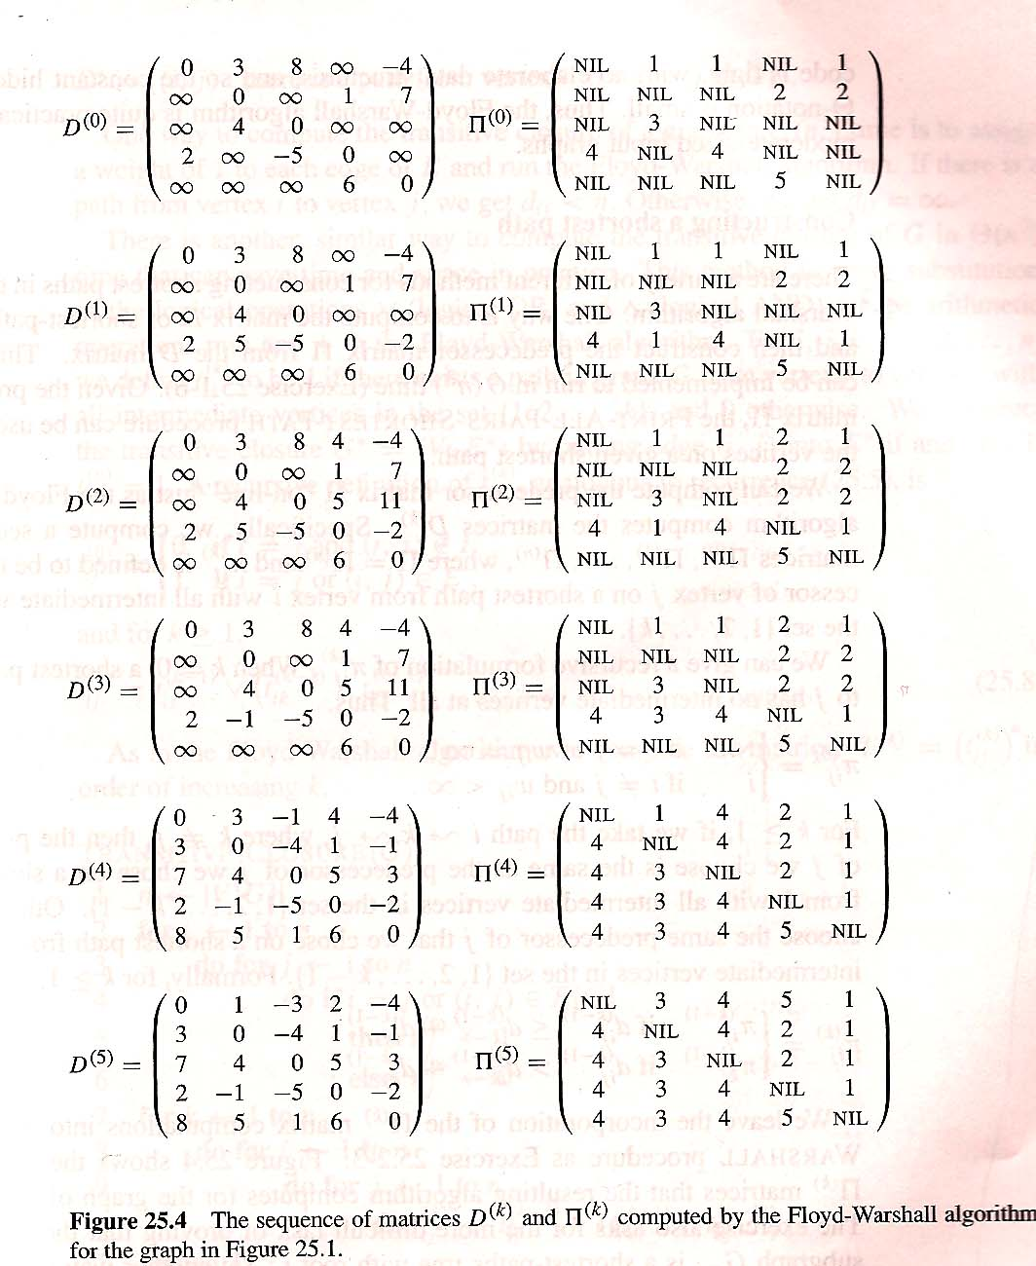

The figure shows the matrices D^{(n)} computed by the
Floyd-Warshall algorithm for the graph in the
previous figure.
لا أحد يتمتع بالحكمة والأمن إلا الصادقين.

The running time of the Floyd-Warshall algorithm is determined by the triply nested for loops of lines 3-6.
Because each execution of line 6 takes O(1) time, the algorithm runs in time Θ(n³). As in the final algorithm in Section 25.1, the code is tight, with no elaborate data structures, and so the constant hidden in the Θ-notation is small.
Thus, the Floyd-Warshall algorithm is quite practical for even moderate-sized input graphs.

Constructing a shortest path

There are a variety of different method for constructing shortest paths in the Floyd-Warshall algorithm.
One way is to compute the matrix D of shortest- path weights and then construct the predecessor matrix 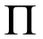 form the D matrix. This method can be implemented to run in O (n³) time. Given the predecessor matrix, the
PRINT-ALL-PAIRS-SHORTEST-PATH procedure
الخيال يعدو بأقصى سرعة، والمنطق يسير بالكاد.
can be used to print the vertices on a
given shortest path.

We can compute the predecessor matrix “on-line” just as the Floyd-Warshall algorithm computes the matrices D^{(k)}. Specifically, we compute a sequence of matrices
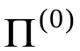, 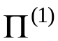, …,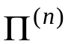, where =and 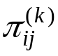is defined to be the predecessor of vertex j on a shortest path from vertex i with all intermediate vertices in the set {1, 2, …, k}.

We can give a recursive formulation of . When k = 0, a shortest path from i to j has no intermediate vertices at all. Thus,
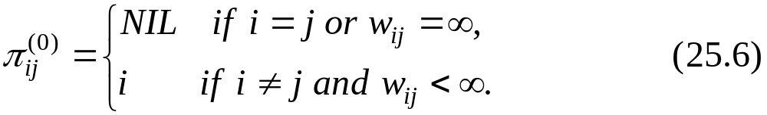
For k ≥ 1, if we take the path i k j, where k 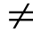j, then the predecessor of j we choose is the same as the predecessor of j we chose on a shortest path from k with all intermediate vertices in the set {1, 2, …, k – 1}.

Otherwise, we choose the same predecessor
of j that we chose on a shortest path from i
اجتهد أن يكون حب الناس لك لشخصك، وليس للمنفعة المترتبة من حبك.
with all intermediate vertices in the set
{1, 2, …, k – 1}. Formally, for k ≥1.
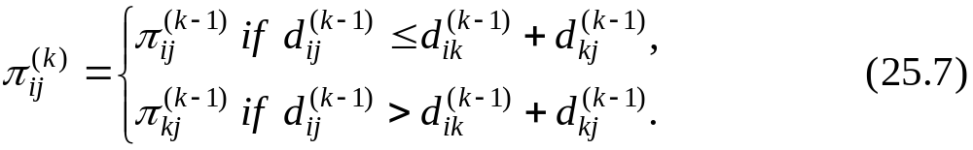
We leave the incorporation of the 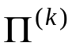matrix computations into the FLOYD-WARSHALL procedure as an exercise.

Transitive closure of a directed graph

Given a directed graph G = (V, E) with vertex set
V = {1, 2, …, n}, we may wish to find out whether there is a path in G from i to j for all vertex pairs i, j .
The transitive closure of G is defined as the graph G* = (V, E*), where E* = {(i, j)} : there is a path from vertex i to vertex j in G}.

One way to compute the transitive closure of a graph in Θ(n³) time is to assign a weight of 1 to each edge of E and run the Floyd-Warshall algorithm. If there is a path
إذا أردت أن تكون عظيما اعمل في صمت.
from vertex i to vertex j, we get d_{ij} < n.
Otherwise, we get d_{ij} = ∞.

There is another, similar way to compute the transitive closure of G in Θ (n³) time that can save time and space in practice. This method involves substitution of the logical operation (logical OR) and ^ (logical AND) for the arithmetic operations min and + in the Floyd-Warshall algorithm.

For i, j, k = 1, 2, …,n, we define 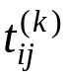to be 1 if there exists a path in graph G from vertex I to vertex j with all intermediate vertices in the set {1, 2, …, k}, and 0 otherwise.
We construct the transitive closure G* = (V, E*) by putting edge (i, j) into E* if and only if 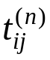= 1. A recursive definition of , is
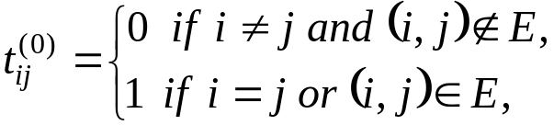

And for k ≥ 1,
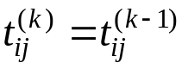 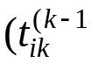^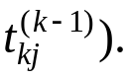

As in the Floyd-Warshall algorithm, we compute
إذا استيقظت متأخرا فستظل تركض طوال اليوم.
the matrices T^{(k)} = 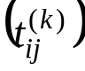 in order of
increasing k.

TRANSITIVE-CLOSURE (G)
- n ← 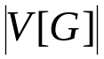
- for i ← 1 to n
- do for j ← to n
- do if i = j or (i, j) E[G]
- then 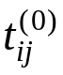 ← 1
- else ← 0
- for k ← 1 to n
- do for i ← 1 to n
- do for j ← 1 to n
- do ← 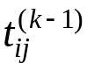 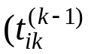^ 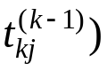
- return T^{(n)}

The following figure shows the matrices T^{(k)} computed by the TRANSITIVE-CLOSURE procedure on a sample graph.
The TRANSITIVE-CLOSURE procedure, like the
القدرة على المواصلة بعد التعثر هي التي تحدد النجاح من عدمه.
Floyd-Warshall algorithm, runs in Θ (n³) time.

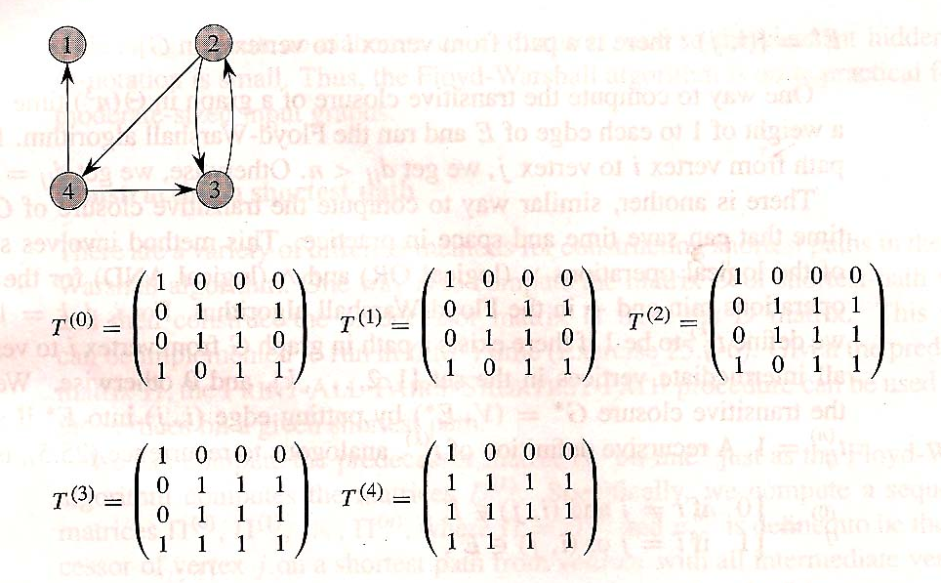

On some computers, though, logical operations on single-bit values execute faster than arithmetic operations on integer words of data. Moreover, because the direct transitive-closure algorithm uses only Boolean values rather than integer values, its space requirement is less than the Floyd-Warshall algorithm’s by a factor corresponding to
the size of a word of computer storage.
هل تعلم أنك إذا نويت خيرا يكتب لك؟
الآن تخيل أن حصلت على مليون دينار،
بكم ستتبرع؟

Exercise 25.2-1
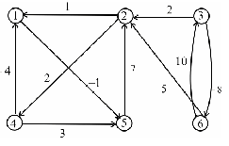
Run the Floyd-Warshall algorithm on the weighted, directed graph of the shown figure. Show the matrix D^{(K)} that results for each iteration of the outer loop.
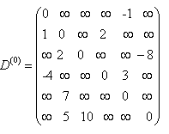
Solution

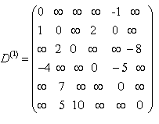
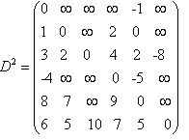

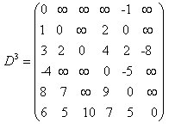
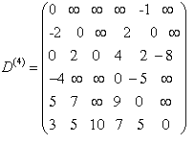

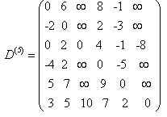
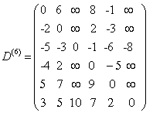

Exercise 25.2-6
How can he output of the Floyd-Warshall algorithm be used to detect the presence of a negative-weight cycle ?

Solution
The presence of a negative weight cycle can be determined by looking at the diagonal of the matrix computed by an all-pairs shortest path algorithm. If the diagonal contains any negative number, there must be a negative=weight cycle.
الرغبة هي نقطه البداية.
لا يمكنك أن تصنع
ما هو أكثر حماقة من أن تجلس على جانب الطريق حتى يأتيك أحدهم، ويحاول مساعدتك.
Exercise 25.2-7
Another way to reconstruct shortest paths in the
Floyd-Warshall algorithm uses values Φ^{(k)}_{ij} for i, j, k = 1, 2, …, n, where Φ^{(k)}_{ij} is the highest-numbered intermediate vertex of a shortest path from i to j in which all intermediate vertices are in the set {1,2, …,k}. Give a recursive formulation for Φ^{(k)}_{ij}, modify the FLOYD-WARSHALL procedure to compute the Φ^{(k)}_{ij} values, and rewrite the PRINT-ALL-PAIRS-SHORTEST-PATH procedure to take the matrix Φ = (Φ^{(n)}_{ij}) as an input.
Solution
NIL if k = 0
max(d^{k-1}_{y},k) if k ≥ and d^{k-1}_{y} > d^{k-1}_{ik} + d^{k-1}_{kj}
Φ^{k-1}_{y} if k ≥ and d^{k-1}_{y} ≤ d^{k-1}_{ik} + d^{k-1}_{kj}

Φ^{k}_{ij} =

Floyd-Warshall-Modified
b ← rows[w]
الاعتماد علي القروض لا يرسخ الأمان.
D⁽⁰⁾ ← W
for k ← 1 to n
Continue
do for i ← 1 to n
do for j ← 1 to n
do if d^{k-1}_{ij} > d^{k-1}_{ik} + d^{k-1}_{kj}
then d^{k}_{ij} = d^{k-1}_{ik} + d^{k-1}_{kj}
Φ^{k}_{ij} = max (Φ^{k-1}_{ij},k)
else d^{k}_{ij} = d^{k-1}_{ij}
Φ^{k}_{ij} = Φ^{k-1}_{ij}
الفارق بين الإصرار والعناد هو أن الأول غالبا ما ينبع من إرادة قوية، والآخر ينبع من عدم وجود إرادة.

Exercise 25.2-8
Give an O(V E)-time algorithm for computing the transitive closure of a directed graph G = (V,E).

Solution
Construct a new graph G* = (V,E*) where E* is initially empty. For each vertex v traverse the graph G adding edges for every node encountered in E*. This takes O(VE) time.
لا شيء يأتي بالمجان.
قد تخسر 14
جولة بمبارة ملاكمة
لكنك إن أسقطت
منافسك بالضربة
القاضية بآخر جولة فستصبح الفائز.

Exercise 25.2-9
Suppose that the transitive closure of a directed acyclic graph can be computed in f(|V|,|E|) time, where f is a monotonically increasing function of |V| and |E|.
Show that the time to compute the transitive closure G* = (V,E)* of a general directed graph G = (V,E) is F(|V|,|E|) + O(V + E*).

Solution
If we have an algorithm to compute the transitive closure of a directed graph, we can use it to calculate the transitive closure of any directed graph. We first decompose the directed graph G into its strongly connected component graph G_{SCC}.
This runs in O(V_E) time and results in a graph with at most V vertices and E edges. We keep track of which set of vertices in G map to each vertex in G_{SCC.} ( All this G(v) which returns a strongly connected component in G_{SCC}) We can then call the transitive closure algorithm on the graph G_{SCC}.
This runs in the O(f(|V|,|E|)). All that is left is to convert back from the strongly connected component graph’s
الإنسان الذي لا يخاطر بشيء، لا يفعل شيئاً.
transitive closure to G’s transitive closure.

Continue
There’s an edge (u,v) in the transitive closure of G if there’s an edge (g(u),g(v)) in the graph G_{SCC.} The forward direction is easy. If there is a path from u to v in G, then there must be a path between the component that u belongs to and the one that v belongs to in G_{SCC}. The reverse direction is equally easy.
If there is a path between u’s strongly connected component and v’s strongly connected component in G_{SCC} when there is a path between some vertex a in g(u) and some vertex b in g(v) in G. But, since u and a are in the same G_{SCC}, there is a path from u → a and since v and b are in the same SCC, there is a path from v → b. Therefore, there is a path u → a → b → v in G.
To actually calculate the transitive closure of G this way would require time V² since we need to look at all pairs. Insread, we will look at the transitive closure of G_{scc}. For each edge (a.b) in the transitive closure of G_{SCC}, we assume that we know the set of vertices in G that map to a and b, call these sets g⁻¹(a) and
g⁻¹(b) respectively. We will add the edge (x,y) for all vertices c in g ⁻¹(a) and y in g⁻¹(b). This will take time equal to the
الجميع ينسون هذا الأمر الأساسي : لن يحبك الآخرون إلا إذا أحببتهم.
number of edges in the transitive closure of
G, O(E*).

Continue
Therefore the total running time for the algorithm is the time to build the strongly connected components (O(V+E)), the time to run the transitive closure algorithm on G_{SCC} is (O(f(|V|,|E|)), and the time to convert back to transitive closure of G(O(E*)). Since we know that E < E*, the total time is
O(F(|V|,|E|) + V + E*).
انتبه! فطفلك يعدك أحكم الحكماء.
لقد علمنا التاريخ أن
أغلب العظماء هم الذين واجهوا عقبات كئودة وضربات قاصمة قبل
أن يحققوا النصر.

